# **Finding and Connecting to the HPCC (or another endpoint) Using Globus**

Go to the Globus File Manager page (<https://app.globus.org/file-manager>) and log in with your MSU credentials if necessary.

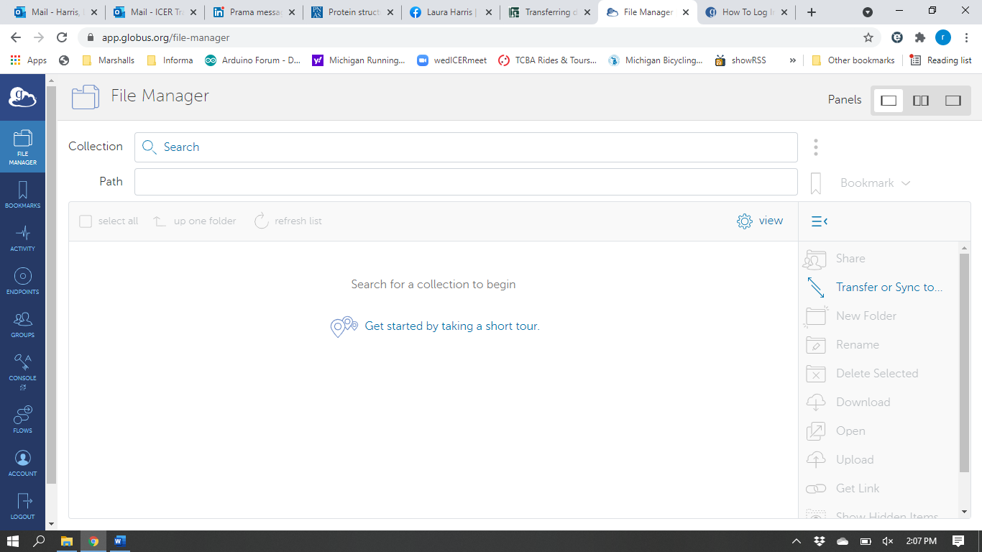,

Type msu#hpcc in the Collection Search box (black arrow above) and click the magnifying glass. Find the matching connection and click on it (black arrow below). A collection is a named location containing data you can access with Globus. Collections can be hosted on many kinds of systems, including campus storage, HPC clusters, laptops, Amazon S3 buckets, Google Drive, and scientific instruments. When you use Globus, you do not need to know a physical location or details about storage. You only need a collection name. A collection allows authorized Globus users to browse and transfer files. Collections can also be used for sharing data with others. Globus Connect is used to host collections.

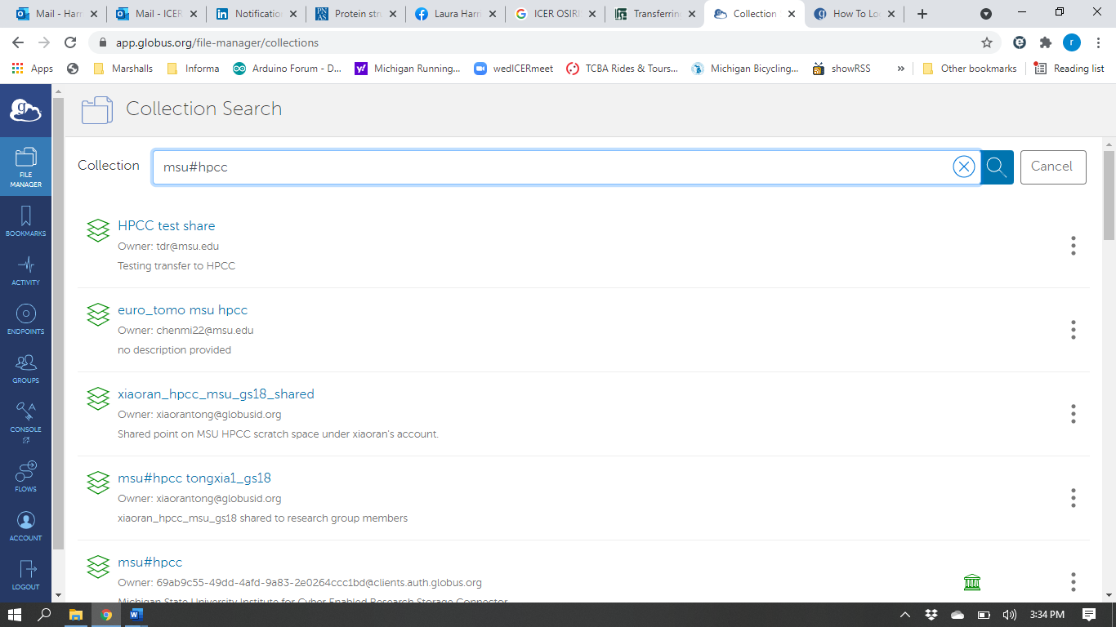

This will pull up an authentication window. Use your MSU NetID for the username, and your MSU NetID password for the passphrase. This will set up an authenticated session that will last the length of time specified in the Credential Lifetime field, up to a limit of 2 weeks.

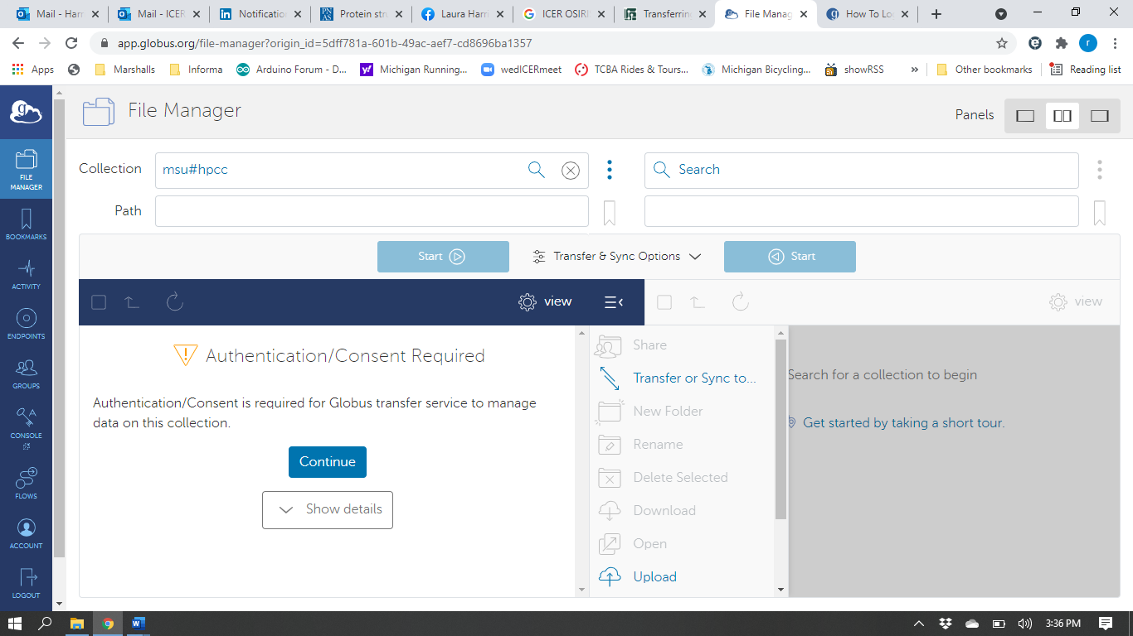

After authentication, you will be able to access files and directories in your folder on ICER’s HPCC.

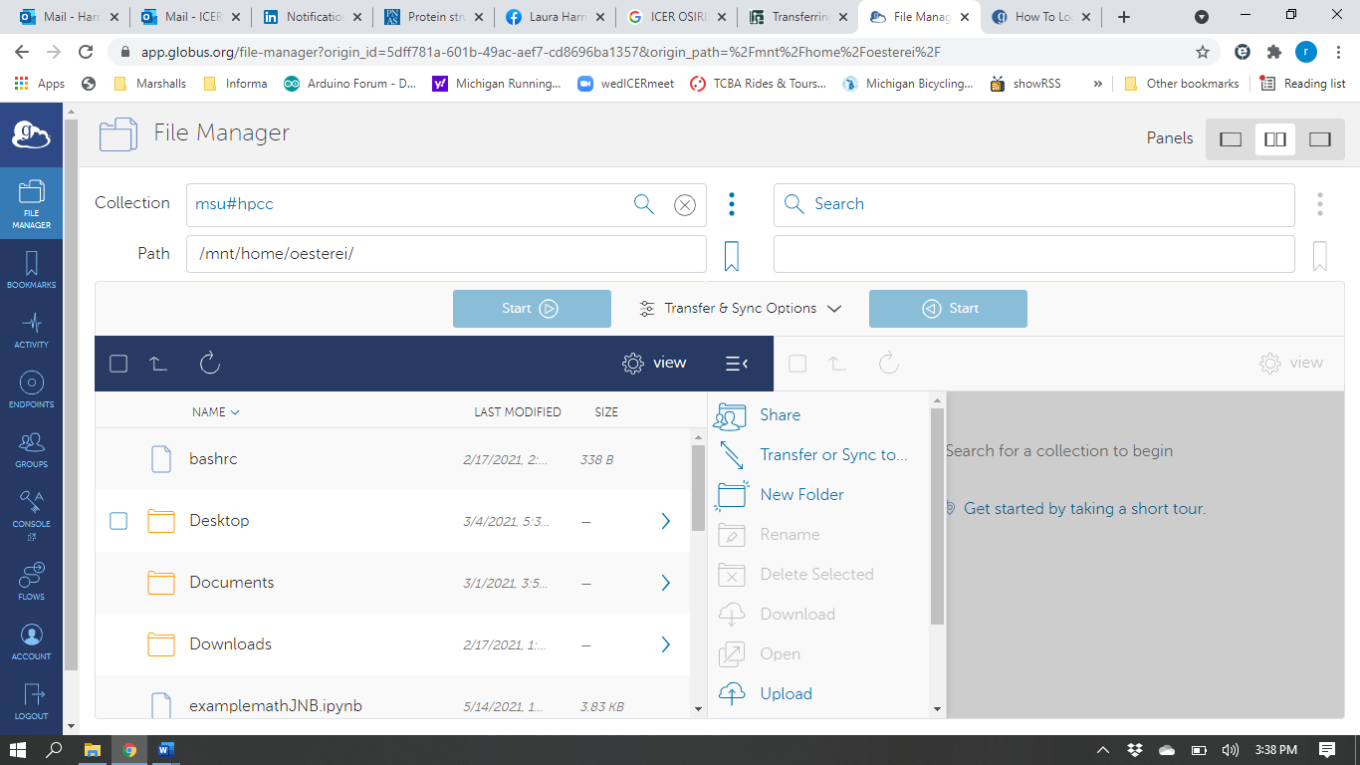

For more information, visit <https://docs.globus.org/how-to/get-started/>