# **How do I transfer files from my personal computer to the HPCC?**

Open and log into Globus Connect Personal with your MSU credentials (white arrow).

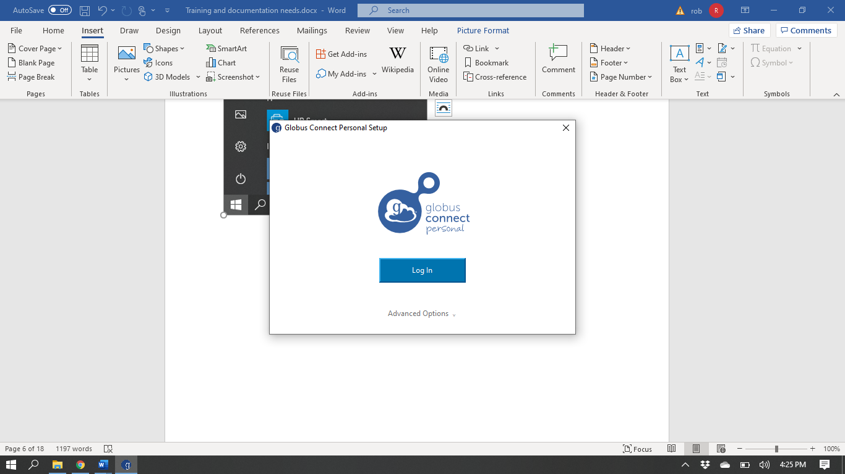

Complete the provided details and click Allow.

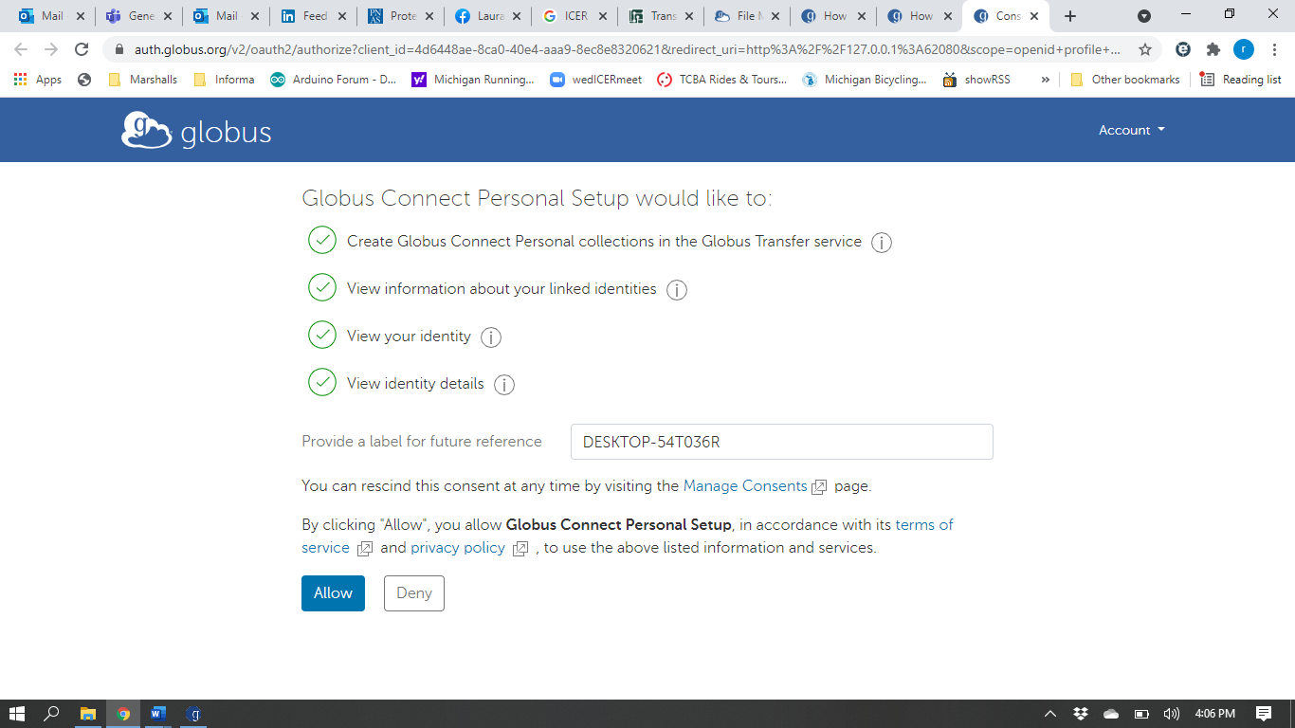

Complete the necessary details and click Save.

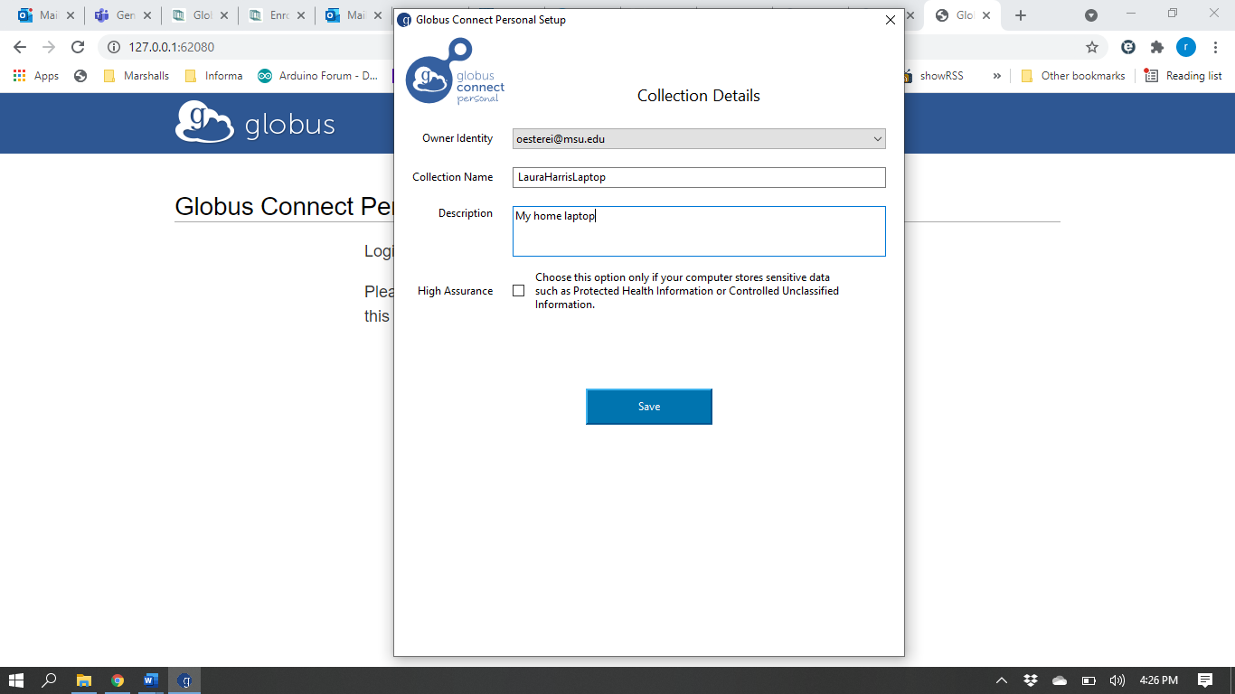

Globus Connect Personal will confirm when your personal computer is set-up to use Globus.

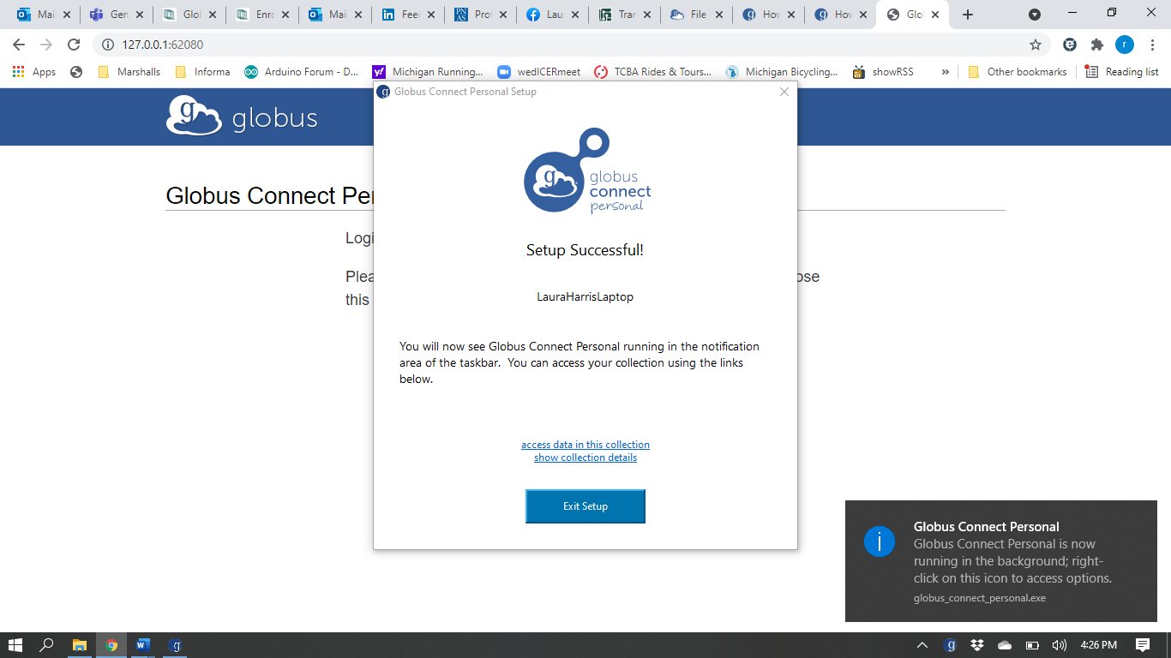

You will now see a Globus icon in your system (sys) tray:

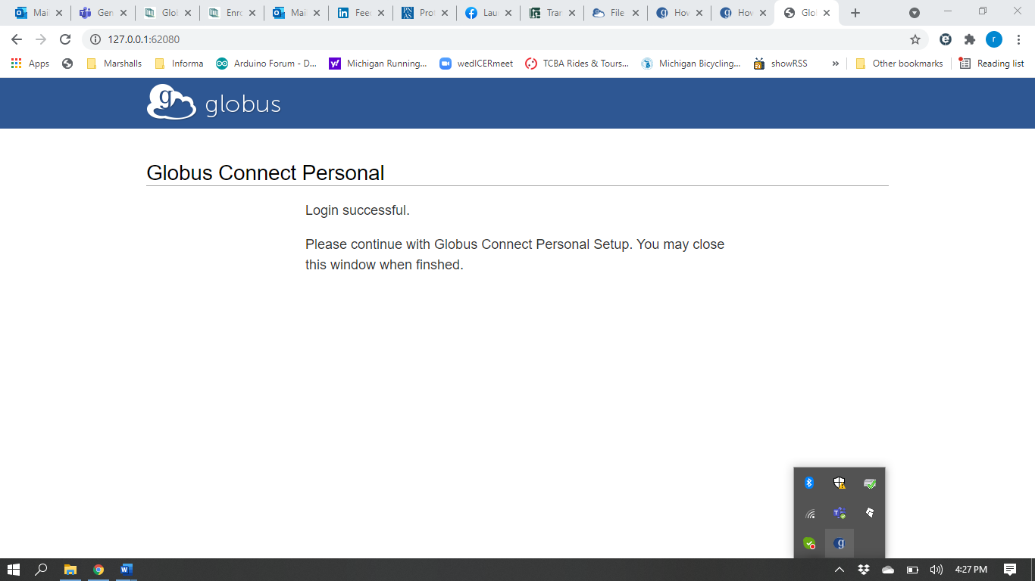

A connection notice may pop up if you click on the Globus icon in your sys tray:

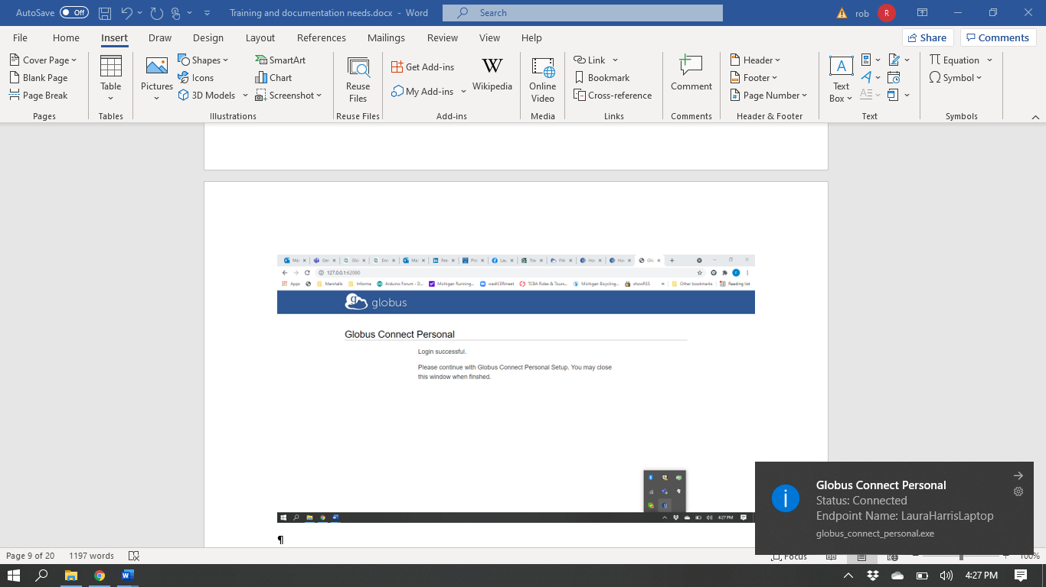

Open Globus and connect to the ICER HPCC.

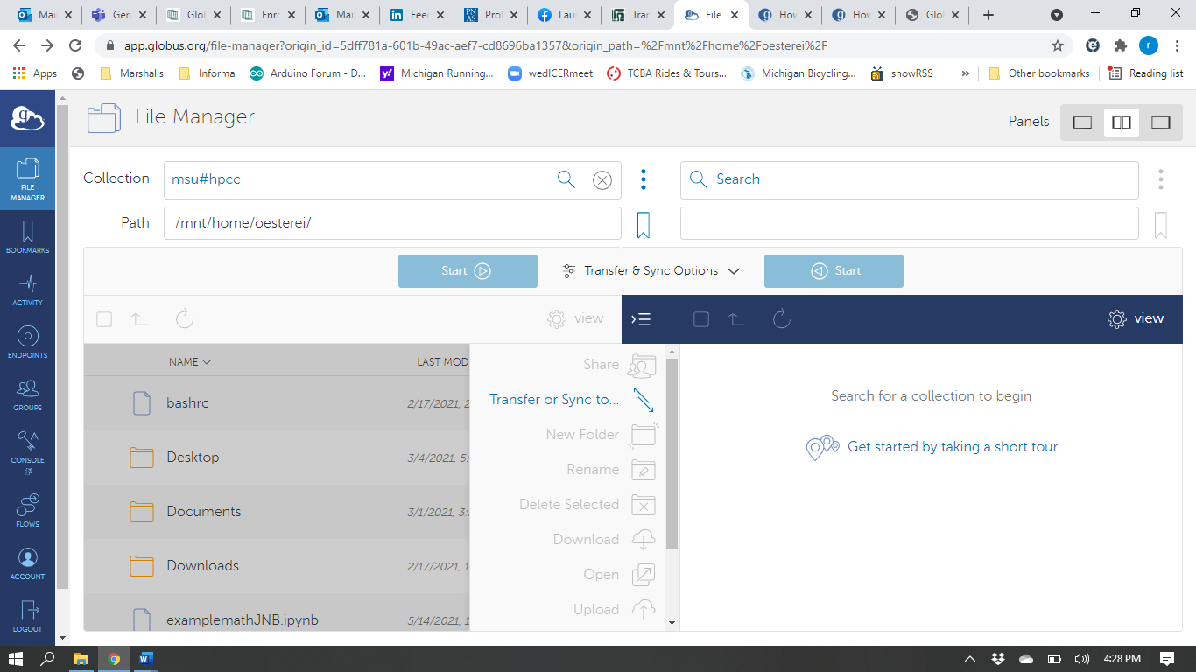

In the right-side Collection Search box (black arrow above), type the name of your personal computer. Click on the name of your personal computer in the search results (black arrow below).

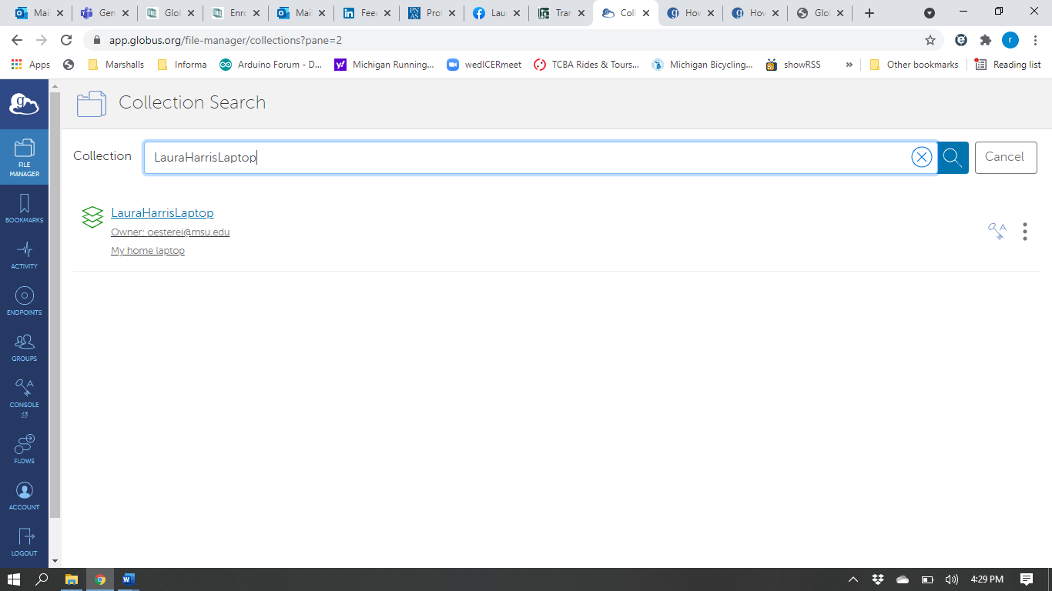

This will bring up your personal computer files in the second window.

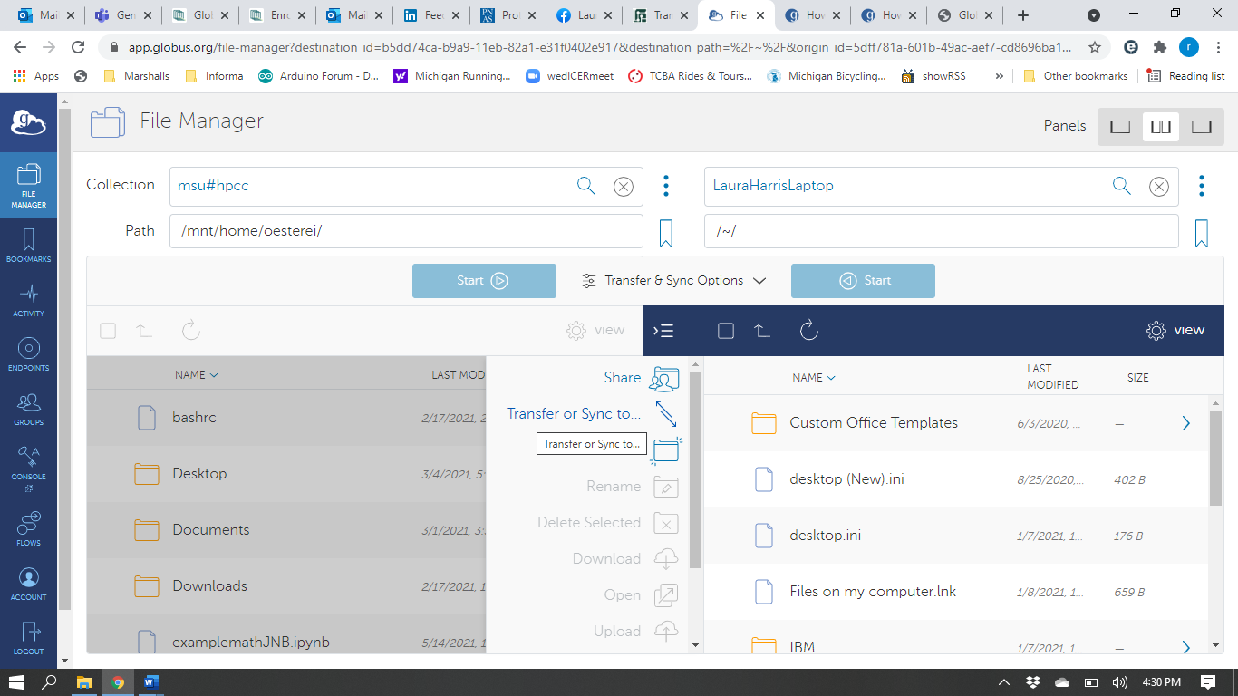

Please note that Globus Connect Personal **MUST** be running on your computer to access your personal computer files for transfer. An error message will occur if Globus Connect Personal is not actively running.

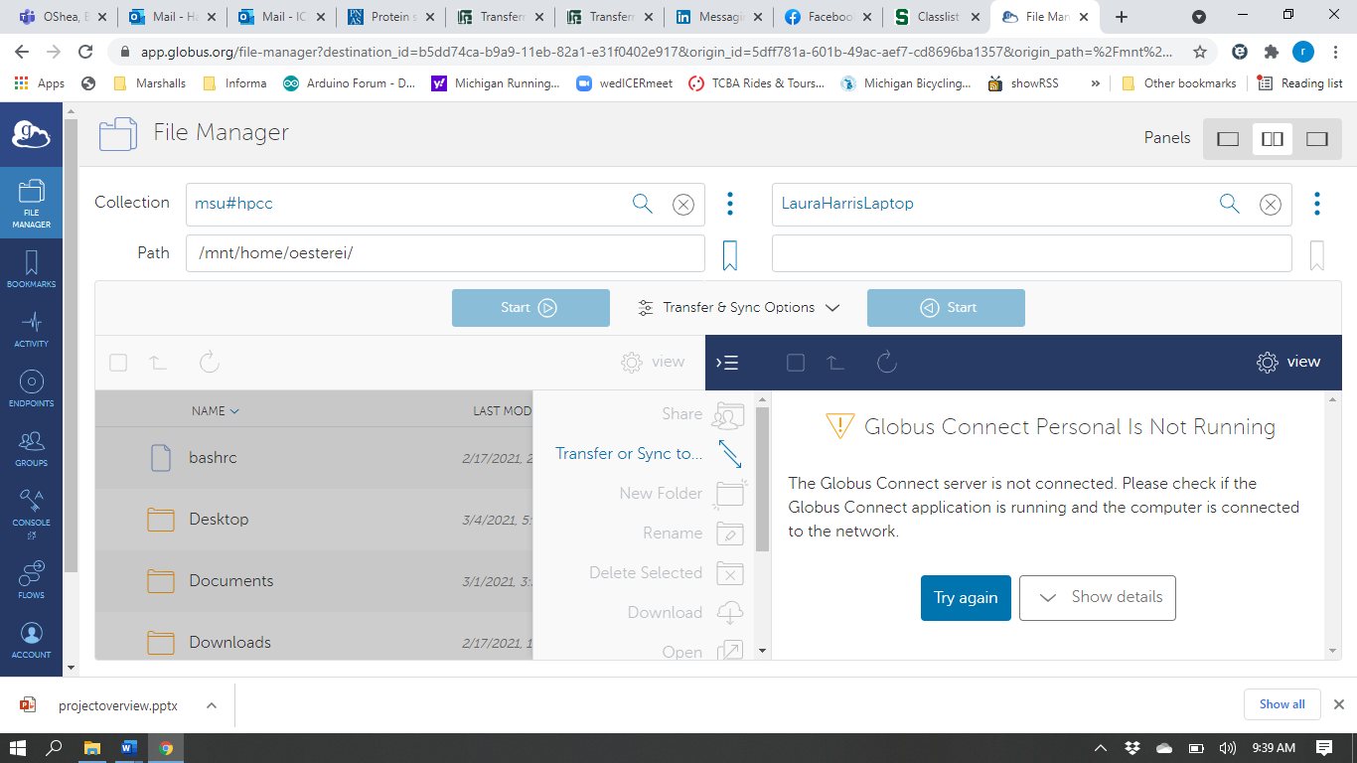

There are two ways to transfer files between Collections: 1) Drag and drop, or 2) Transfer & Sync. Select the file to transfer from your personal laptop window and drag it to the HPCC window. For more advanced transfer methods, you can select the file and Click Start (black arrow below) to initiate transfer of the file using user set options.

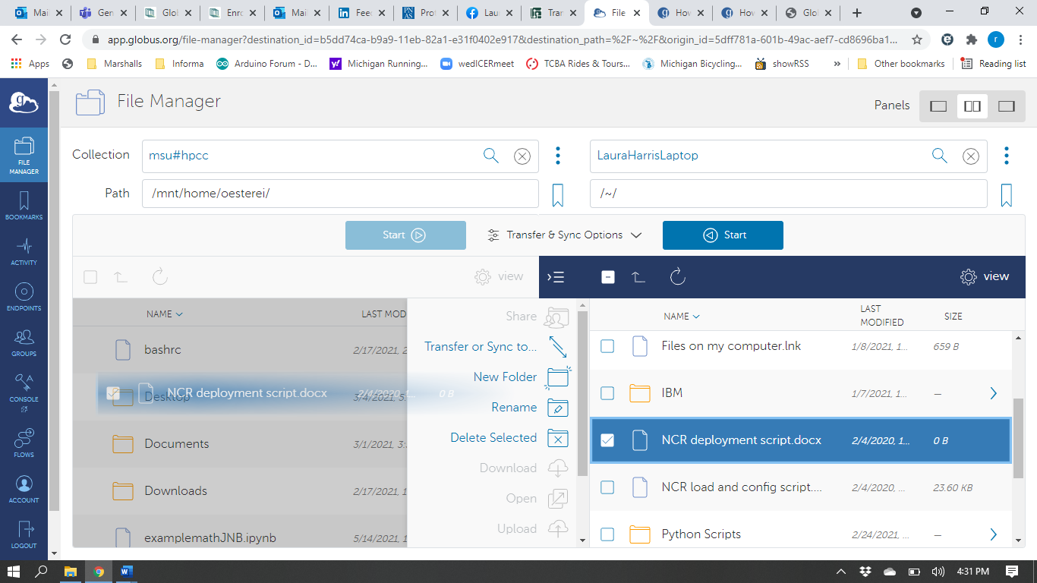

File transfer options set by user are found by clicking Transfer & Sync Options (orange oval above) before clicking Start.

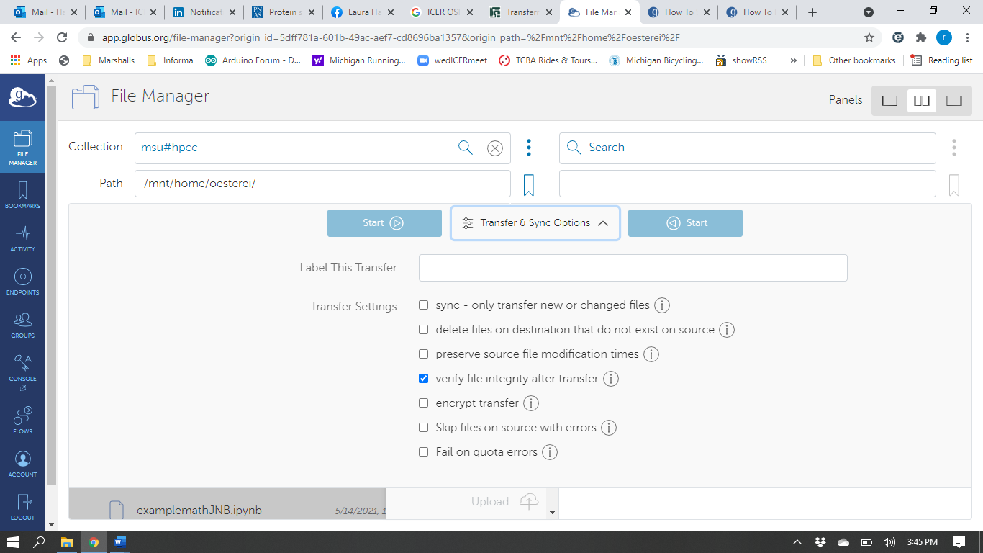

In the upper right corner, you receive a confirmation message and be allowed to view transfer details.

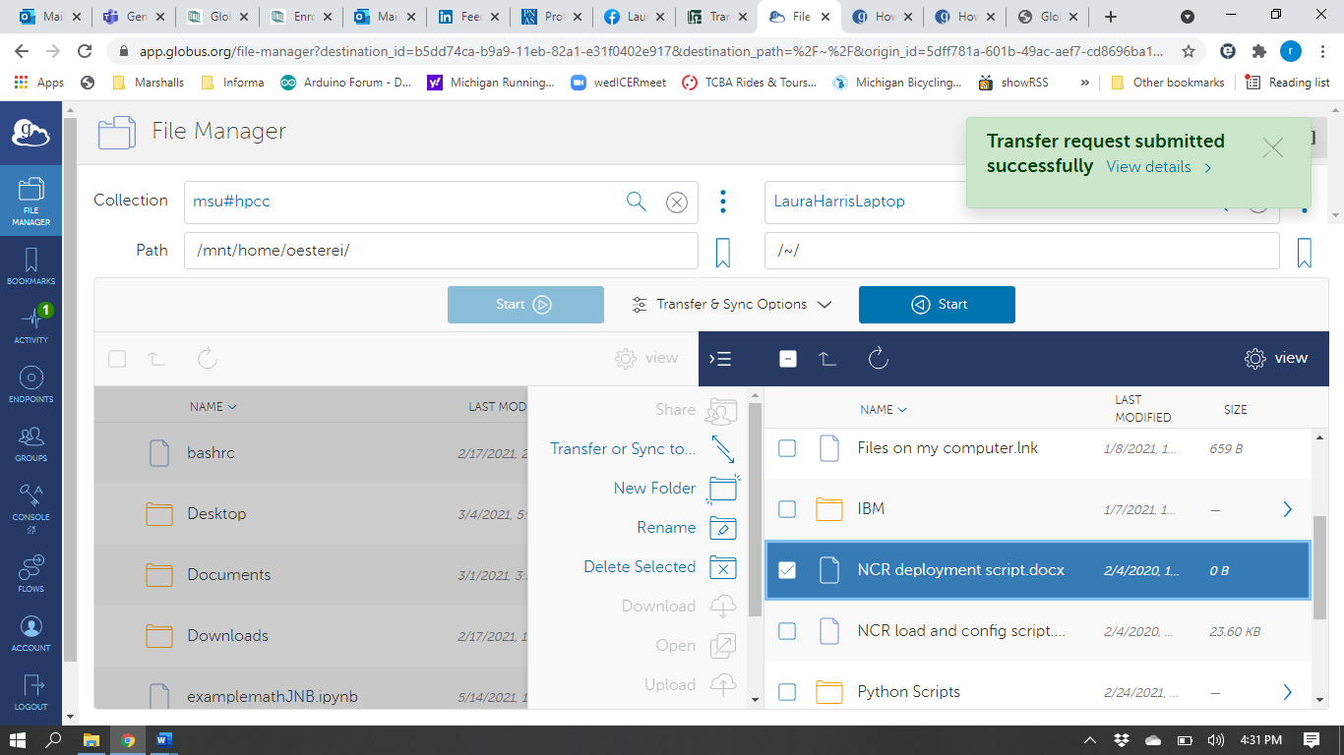

Transfer can occur in both directions using both methods.

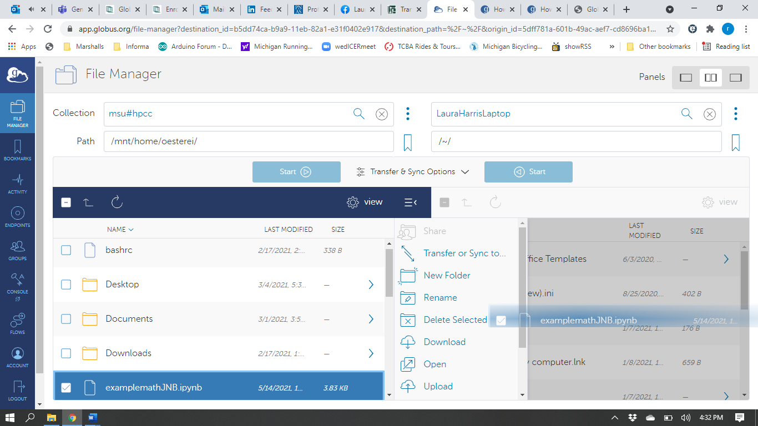

You can view the status of any transfer from the Activity tab on the left side of the screen.

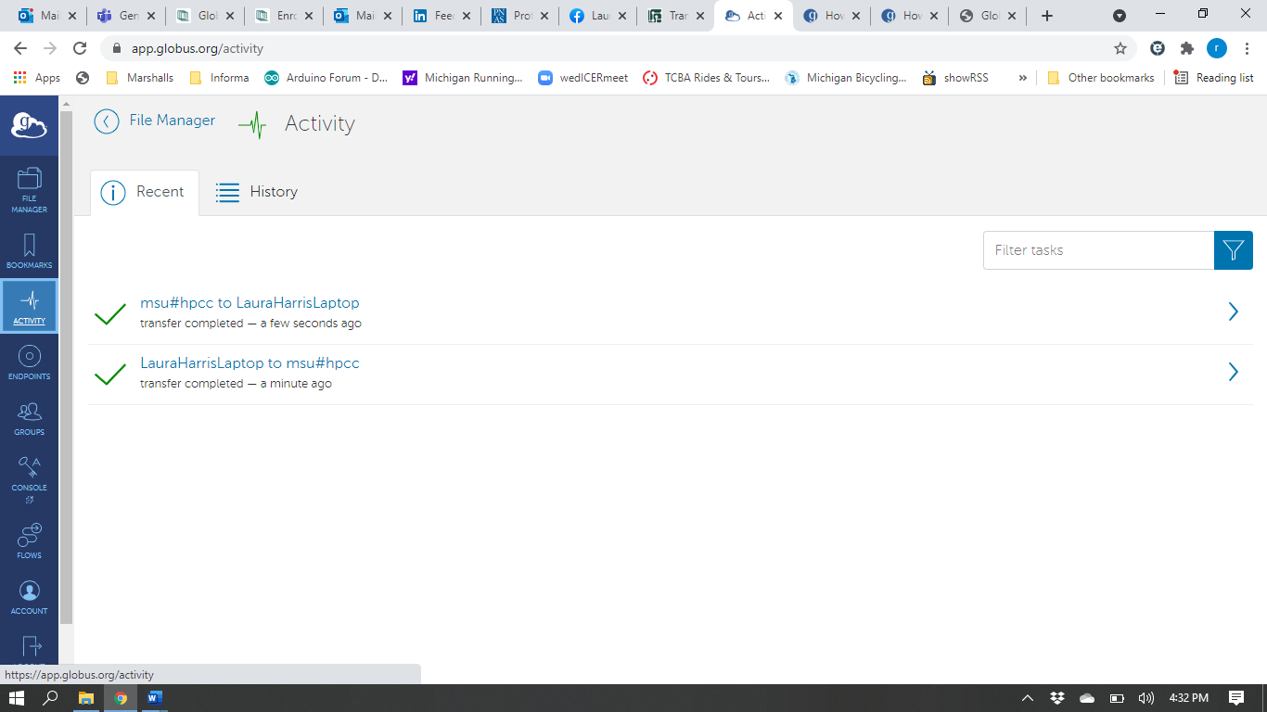

Clicking on the name of the appropriate transfer will provide transfer details.

