# **How do I transfer files between existing endpoints?**

Go to the Globus File Manager page (<https://app.globus.org/file-manager>) and log in with your MSU credentials if necessary. For this example, we will transfer files between the ICER’s HPCC and OSIRIS endpoints. First, connect to your drive space on ICER’s HPCC.

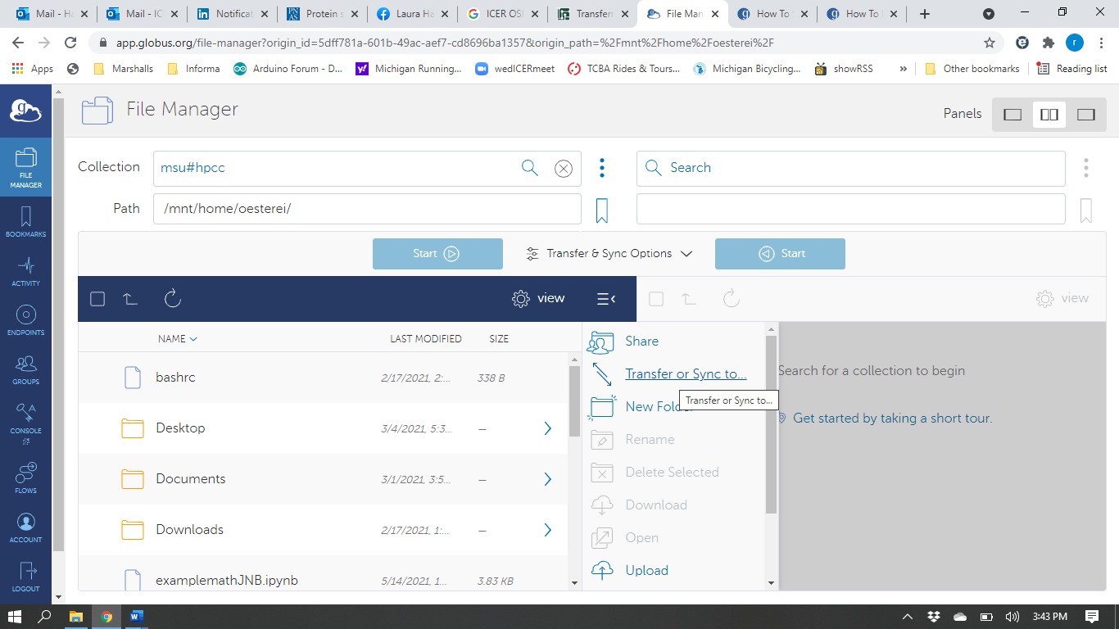

Use the Collection Search feature (black arrow above) to find your desired endpoint (*e.g.*, OSIRIS@msu). You may need to scroll down to find the desired endpoint. When found, click on the Collection name to open it.

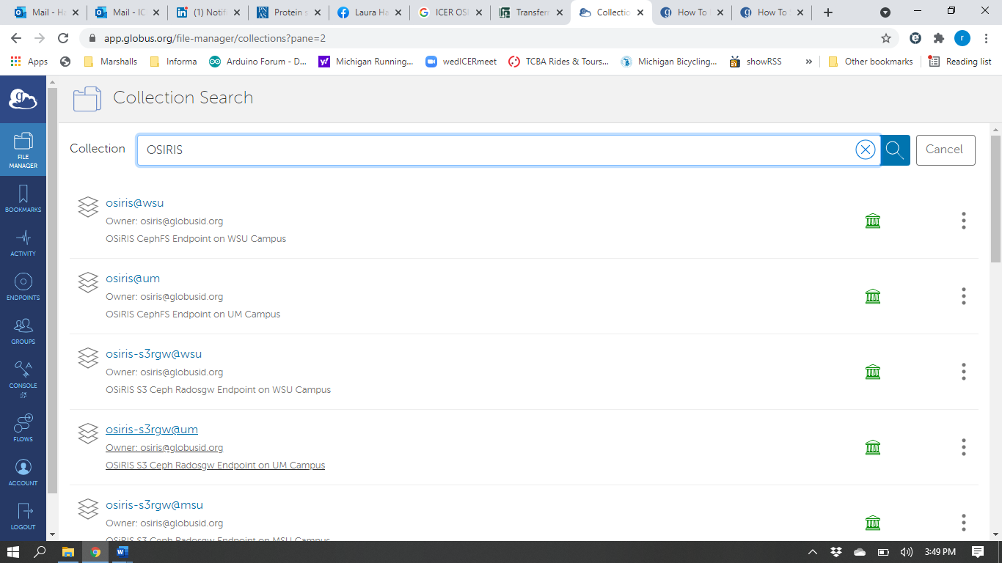

You may need to work with the owner of the desired endpoint to gain sufficient access.

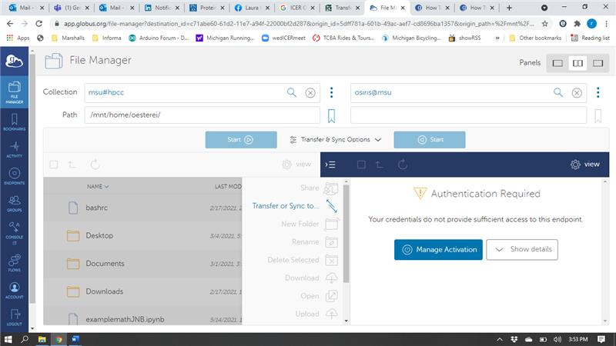

Once successfully logged into both endpoints, you will see their respective contents in a split screen. You can transfer folders and files using the two methods, 1) Drag and drop (not shown here), or 2) Transfer & Sync Options (orange oval and black arrow), detailed in the *How do I transfer files from my personal computer to the HPCC?* video and document.

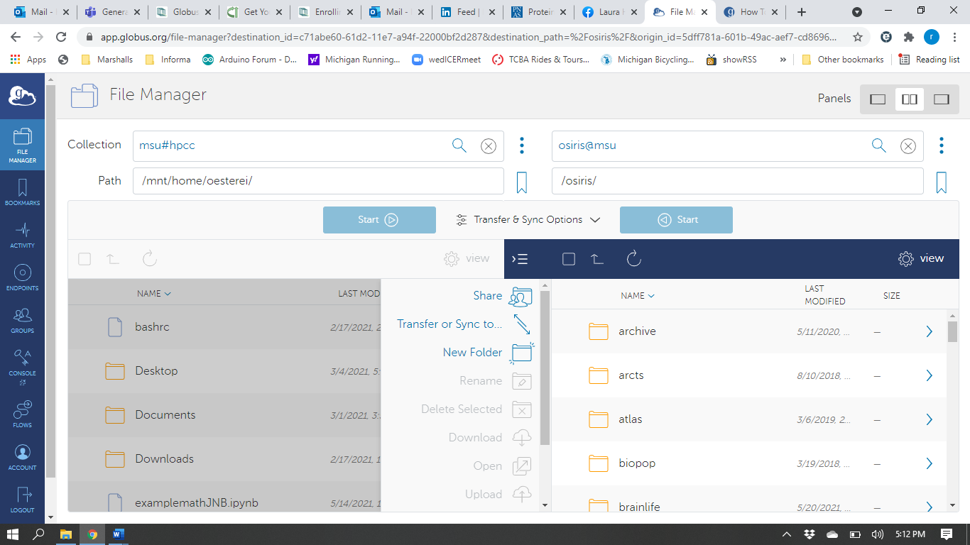

For more information on transferring files with Globus, please refer to <https://docs.globus.org/how-to/get-started/>