# **How do I share files using Globus?**

You can share data with other people using Globus. In this example, we will share a file already uploaded to ICER’s HPCC. The same process will apply for sharing files from any endpoint (*e.g.*, personal computer, etc.). First open Globus, log in with your MSU credentials if necessary, and connect to the endpoint where the file you want to share is located. Select the file(s) or folder(s) you want to share. In this example we will share the examplemathJNB.ipynb file (blue box). Click Share (orange oval).

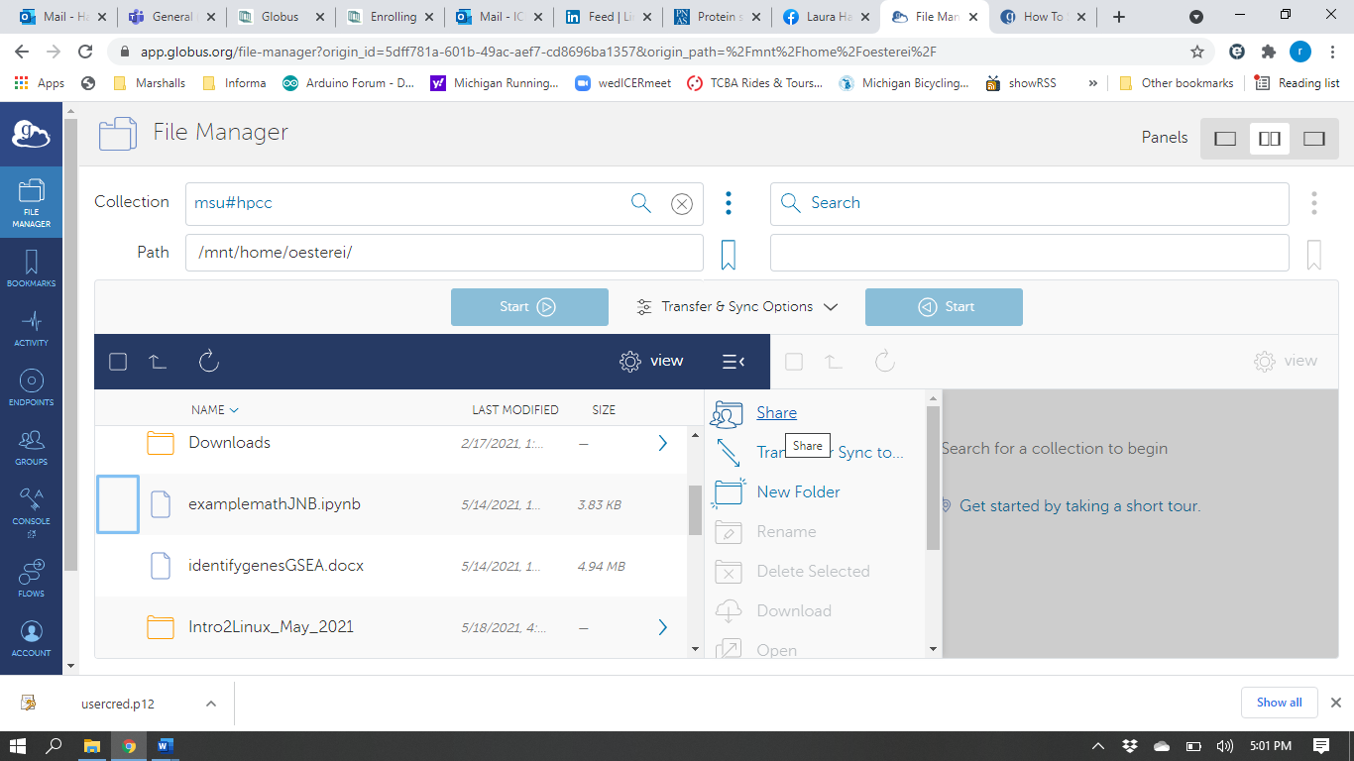

You may need to give authentication/consent. Click Continue (orange oval).

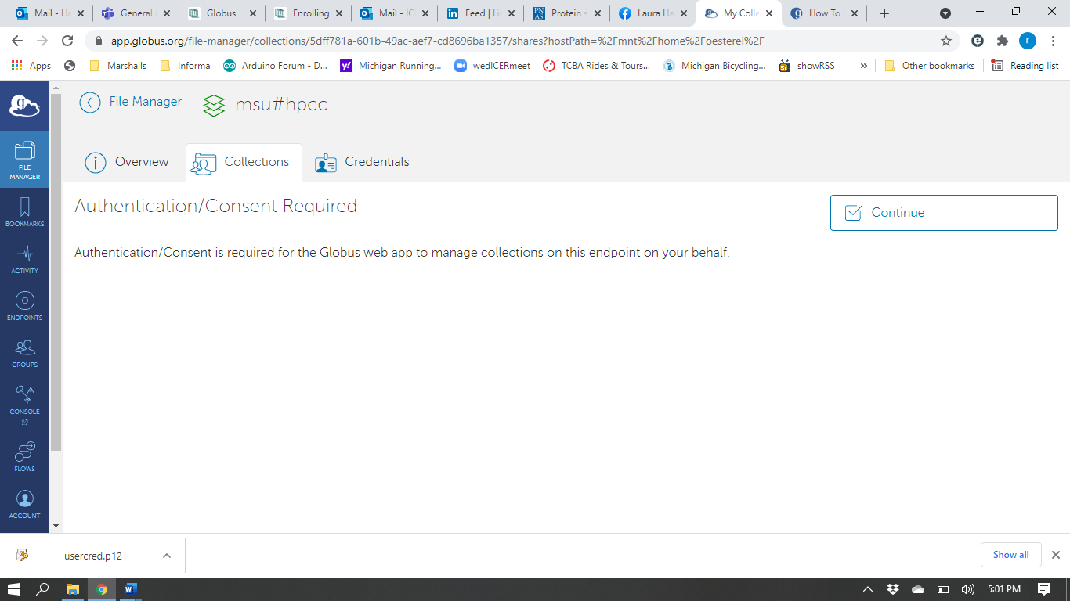

You may need to establish a guest collection. Click Add A Guest Collection (orange oval) and provide the necessary requested information.

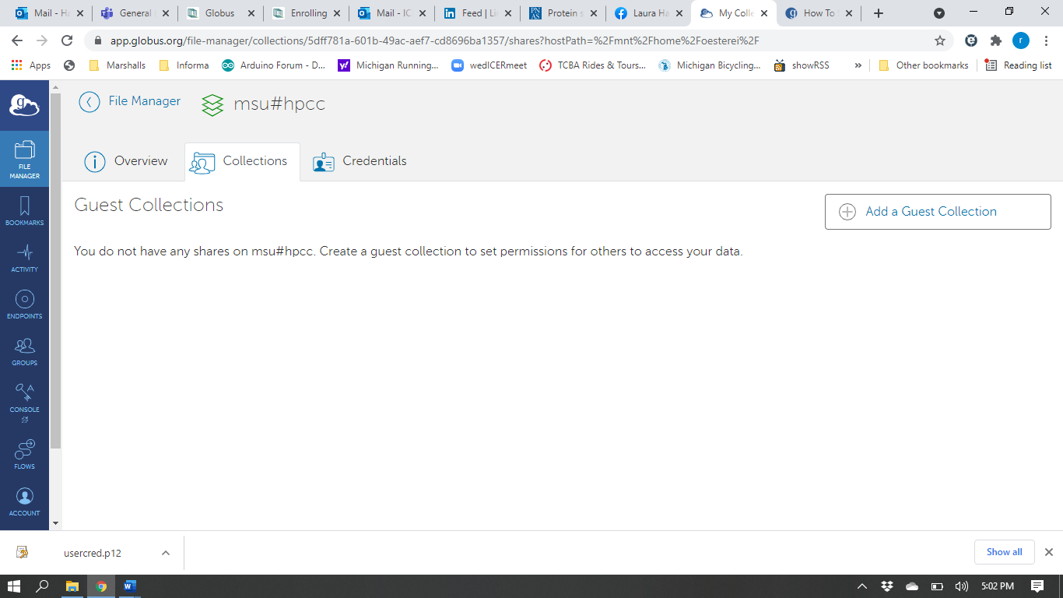

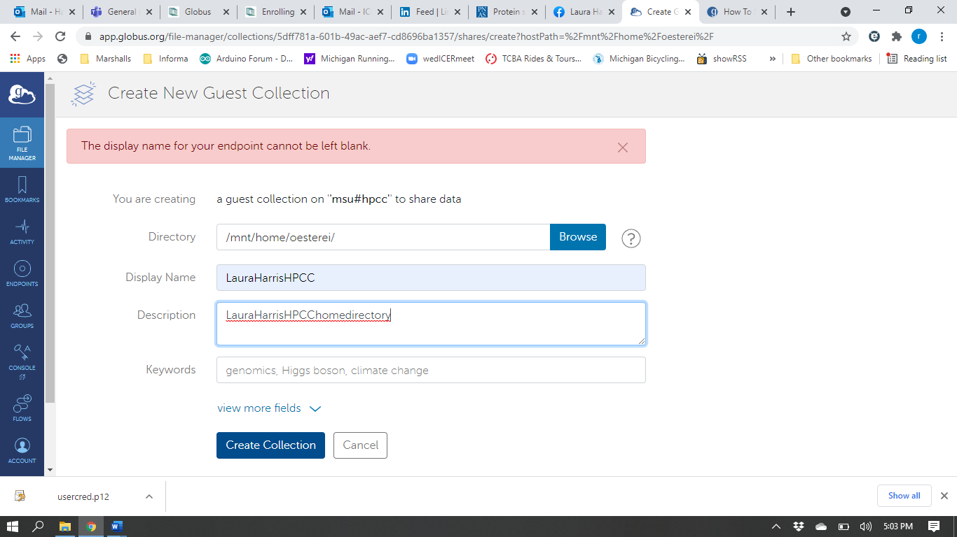

Once your guest collection is established, you can share it with other people by adding permissions to your guest collection (orange oval below).

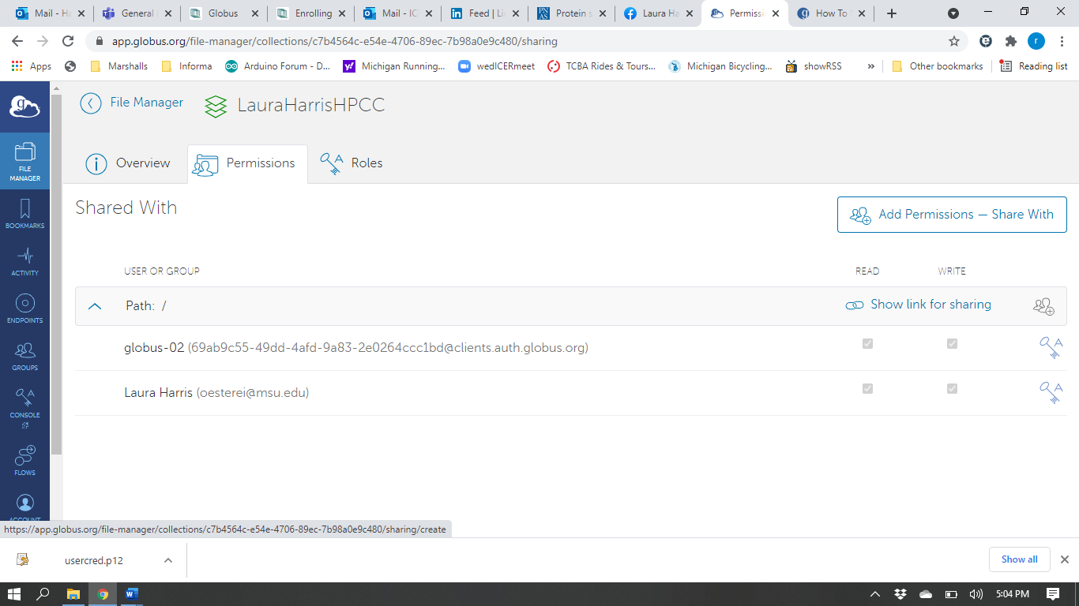

You will then establish the path of what you will share, sharing permissions, and the email of the person whom you wish to share the data.

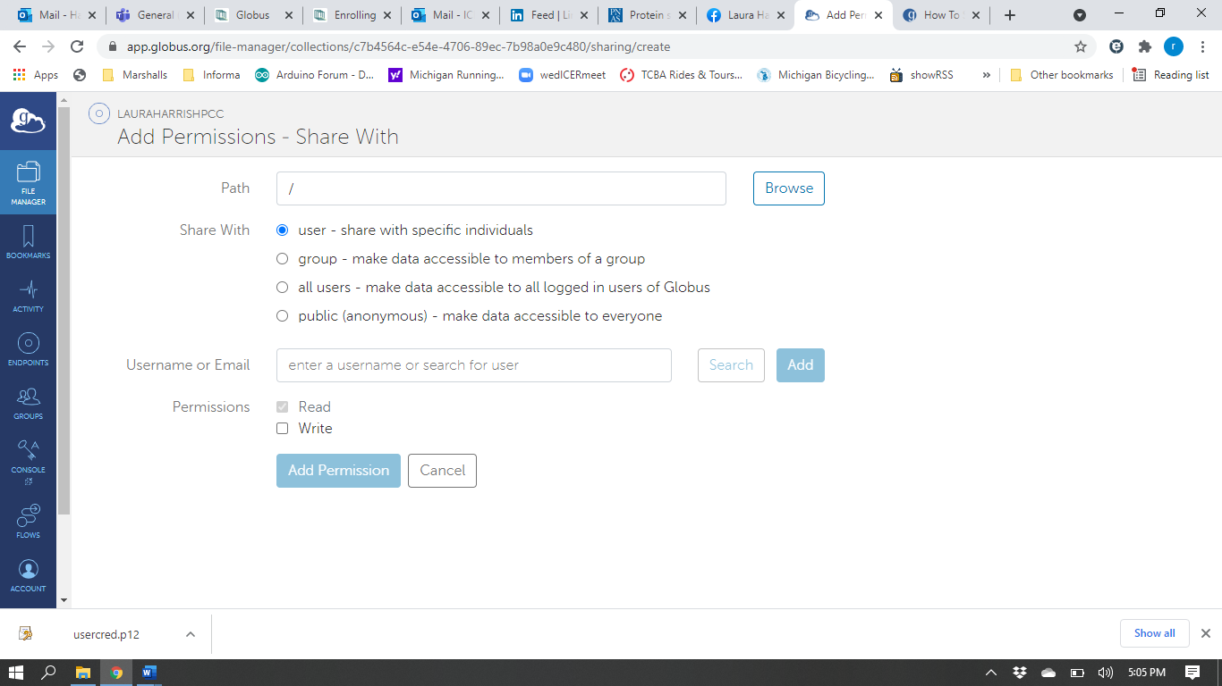

Do not forget to click the Add button for the email address (orange oval).

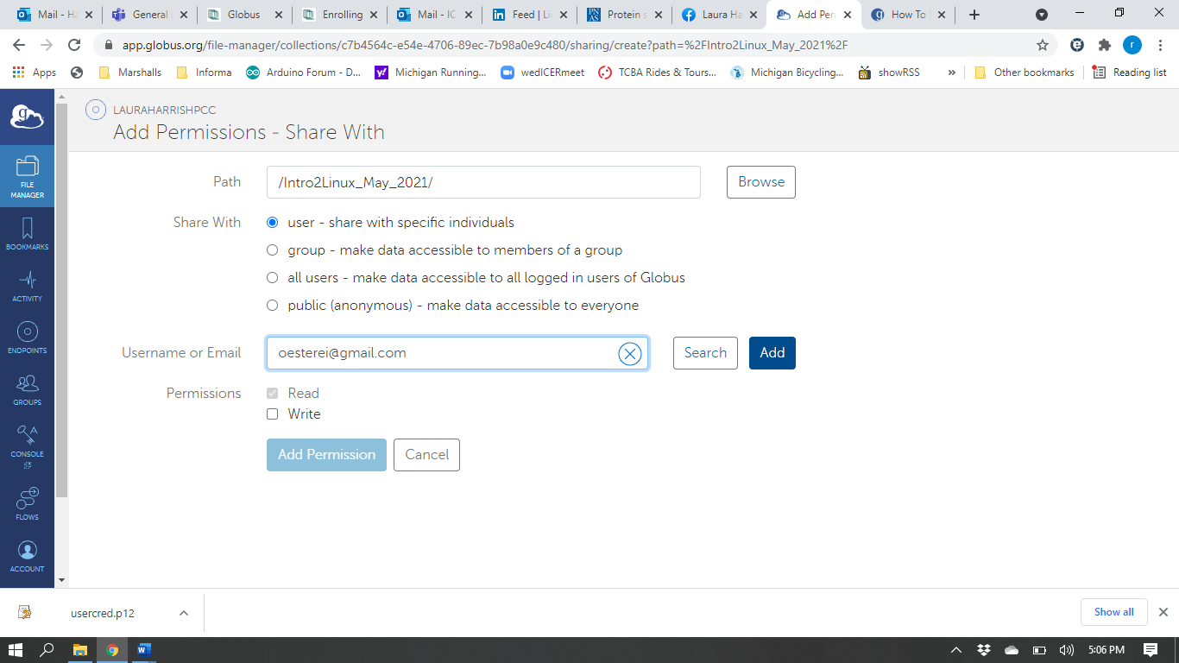

Click Add Permissions button when done.

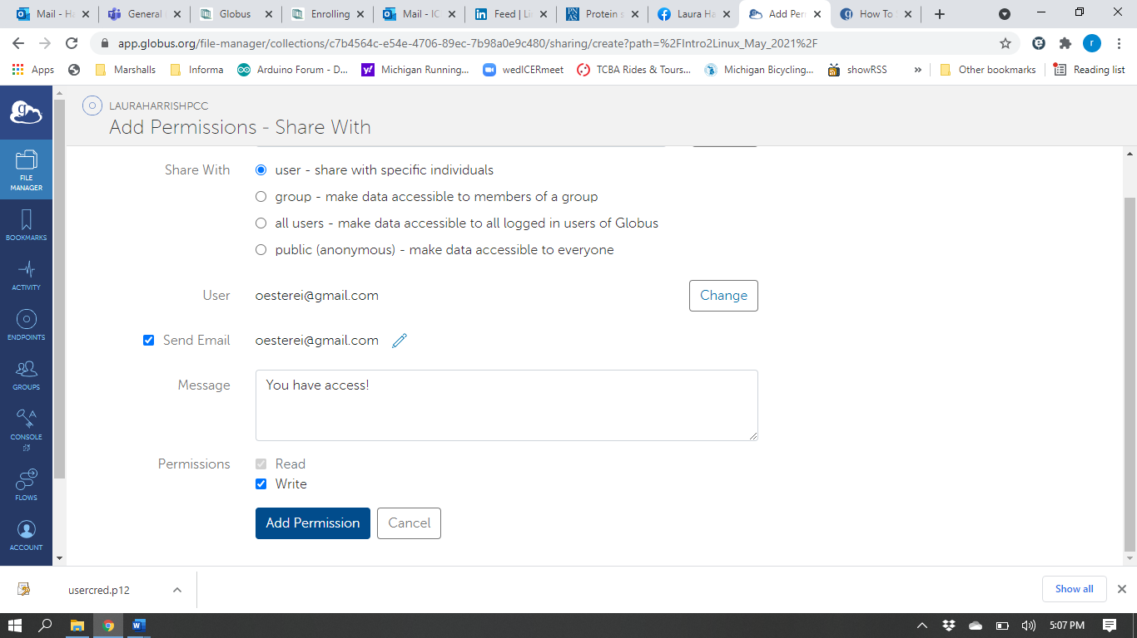

Now you can see the additional user on the Permissions tab. You can provide a link to the shared data by using Show Link for sharing (orange oval).

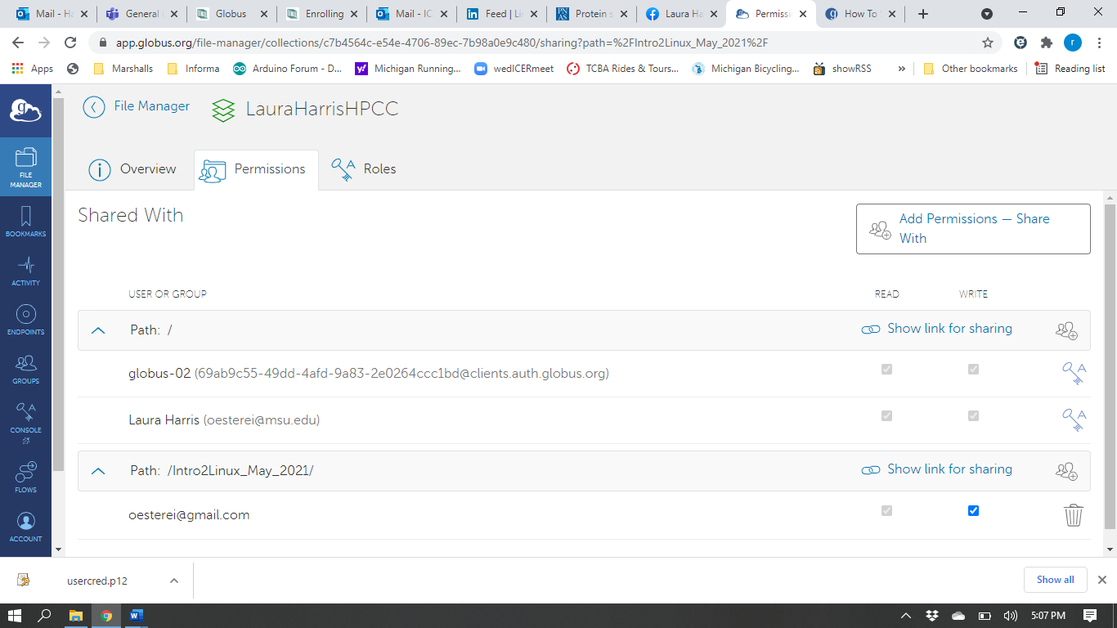

By going to the Roles tab, you can Assign New Role (orange oval) to a user or group of users in your guest collection.

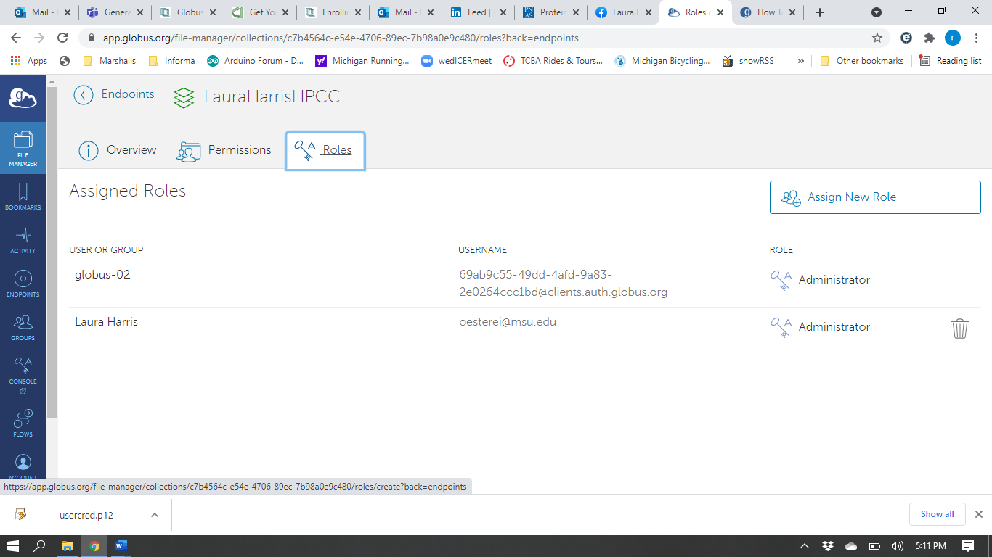

You then can assign users or user groups different accessibility to view or modify data in the guest connection. Do not forget to click the Add button for the email address (orange oval).

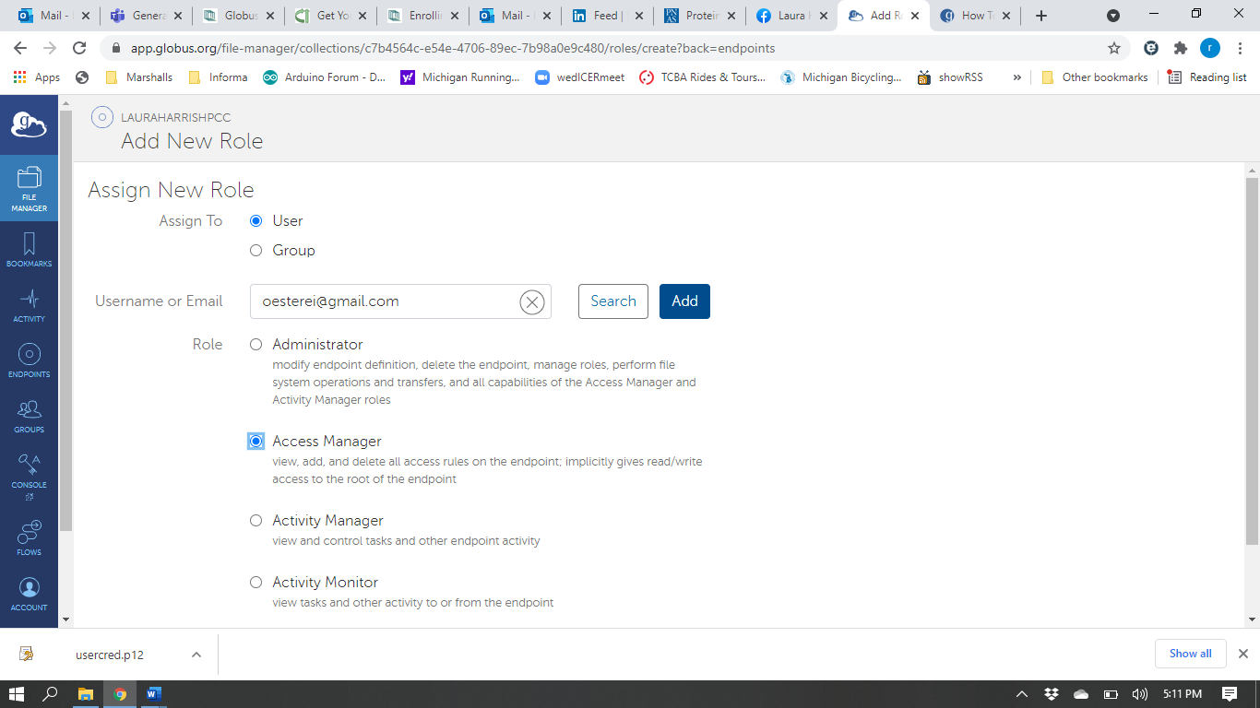

Click Add Role to confirm changes.

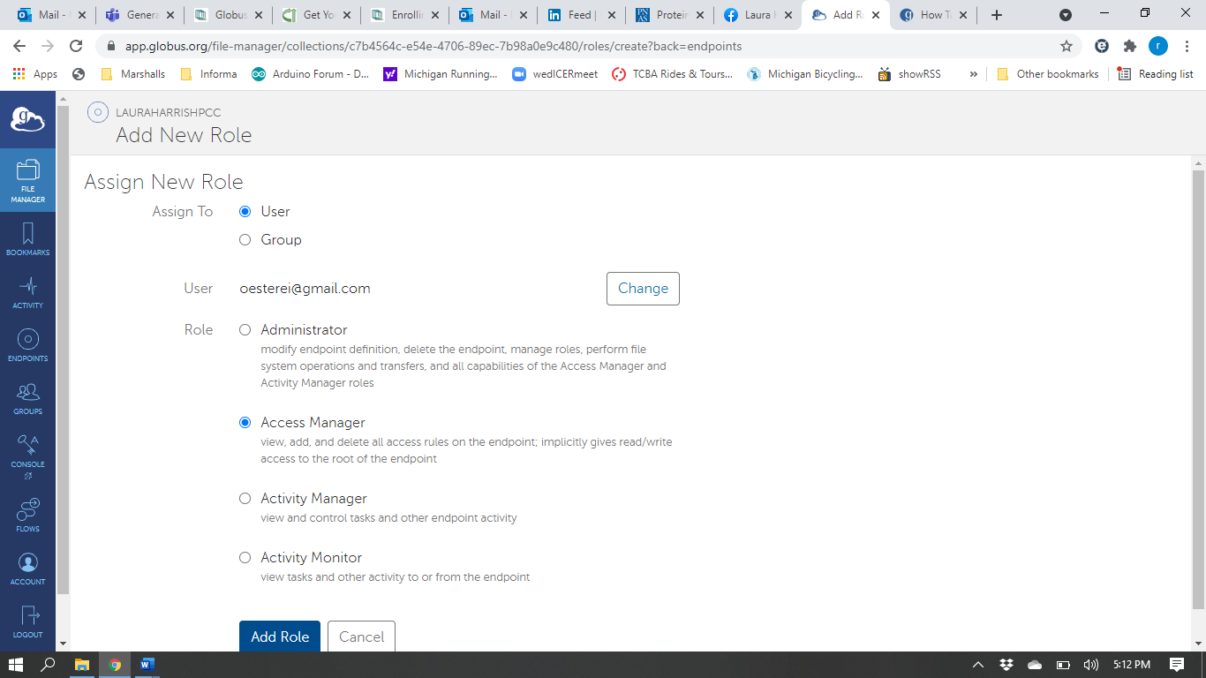

For more information on sharing files using Globus, please see <https://docs.globus.org/how-to/share-files/>.