Random Stuff

This document contains some random content, primarily for testing purposes related to file creation metadata.

* This is a sample list item.
* Another item in the list.
* A third and final list item.

Here's a simple table:

| Column 1 | Column 2 | Column 3 |
| --- | --- | --- |
| Data A | Data B | Data C |
| Data D | Data E | Data F |

This paragraph serves as additional content within the document. It does not have any specific meaning and is here to contribute to the document's overall size and structure.

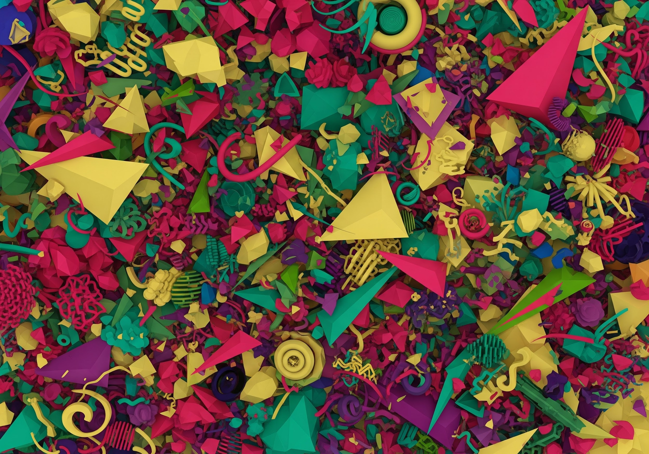

We hope this document is useful for your metadata reading needs.