The crowdfunding platform Kickstarter has provided an alternative model for sponsorship of artistic projects since 2009. Hundreds of thousands of campaigns have been conducted, but many have failed to reach their fundraising goal. In order to examine factors that may contribute to the success of a Kickstarter campaign, a sample of campaign data was collected and analyzed. As explained below, analysis of the sample showed that the sub-category of the campaign appeared to be the key factor in success, with most sub-categories either entirely successful or entirely unsuccessful. Additional factors such as the time of year in which the campaign was conducted or the country from which the campaign originated also play a role. Kickstarter, like many other recently created platforms, may experience significant maturation that may substantially alter the factors leading to success in coming years. Nonetheless, the data analysis described below provides useful information for understanding some of the factors that can lead to a successful campaign.

Of the 4,114 campaigns surveyed, slightly more than half (2,185) successfully met or exceeded their fund-raising goal. Both the number and proportion of successful campaigns varied significantly by category, as noted in Figure 1, with “theater”, “film and video”, and “music” being the categories with the highest number of projects. The “music” category had the highest proportion of successful completed projects (540 out of 680), and “food” having the lowest proportion of completed projects (34 out of 194). Although the “journalism” category had no successful campaigns, all campaigns in the category were canceled, so a simple inference on the success rate of projects in that category was not provided by the data set.

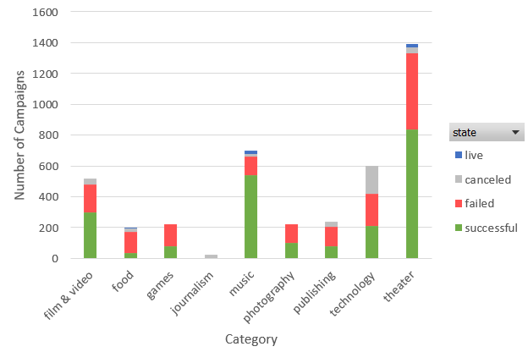

Figure 1. Overview of campaigns and their outcome by category

Looking beyond the top-level categories, however, revealed a remarkable divergence of outcomes at the sub-category level. The entire set of campaigns within a given sub-category tended either to be uniformly successful or uniformly non-successful (“non-successful” in this context means campaigns either failed to reach their fund-raising goal or were canceled). For instance, within the “food” category, only 34 of 194 completed campaigns were successful. However, all 34 successful campaigns were in the “small batch” sub-category. while absolutely none of the 160 campaigns in the category of “food” but in other sub-categories including “restaurants” and “food trucks” were successful. In fact, only 8 of the 41 sub-categories surveyed contained a mixture of successful and non-successful campaigns. The eight categories with mixed success outcomes included all three sub-categories of the “theater” category along with the “indie rock”, “photobooks”, “makerspaces”, “space exploration”, and “wearables” sub-categories.

Other factors appear less important (assuming the campaigns were sampled randomly). Considering countries, only three (the United States, Canada, and Great Britain) had a sample of over 100 projects (large enough to enable robust comparison). The United States had 1,651 successful projects (out of 3,005 completed), a 55% success rate, while Great Britain had 366 successful projects (out of 596 completed), a 61% success rate. Canada had 64 successful projects (out of 145 completed), a 44% success rate. Along similar lines, there are apparent differences in success based on the month in which the campaign was started, as summarized by Figure 2. Using only the years 2010-2016 (to eliminate effects due to partial year coverage), the month of May had more than twice as many successful campaigns started as the month of December, while the number of failed and canceled campaigns remained relatively constant throughout the year.

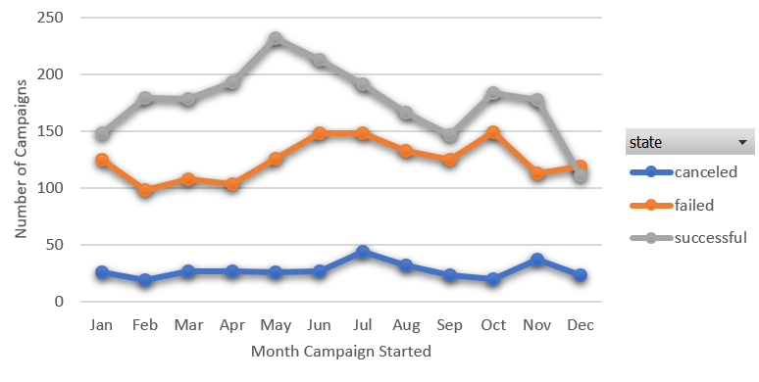

Figure 2. Kickstarter campaign outcome by starting month (full-year 2010 to 2016 data).

Although secondary factors such as the timing and location of campaigns could be significant, because there is such a strong variation of success rate by sub-category, the apparent effects of campaign time and place might simply reflect a propensity for successful sub-categories at certain times and locations.

In order to control for sub-category effects, data for the single sub-category “plays” (which contains over 1,000 campaigns in total) were examined. Figure 3 shows the success rate (successful campaigns divided by completed campaigns) in the sub-category “plays” within the “theater” category. The “theater” category is the only one in which the effects of sub-categories were relatively subdued, with success rates between 43% and 66% for sub-categories (as opposed to the “all or nothing” outcomes by sub-categories elsewhere in the data set), so the results are much less likely to be sensitive to the sub-category classification scheme. Unlike in the previous analysis, in Figure 3, data for all dates were used because the success rate (unlike the absolute number of projects) is not directly related to the number of years of data.



Figure 3. Success rate for Kickstarter campaigns in the “plays” sub-category by country and month in which the campaign started.

Although the data for Canada, which had only 30 projects in tis category, is quite noisy (with no projects started in June), the data for Great Britain and the United States do show significant effects. The success rate for campaigns from Great Britain was higher in every month, typically by 10-20 percentage points compared to the United States. (A paired t-test was significant at >99.9% confidence.) Although the month of May does not show an unusually high success rate, the month of December does show a success rate about 20 percentage points below the other months in both countries. Using a simple regression classification approach on data from the United States and Great Britain only, in which the two factors were 1) whether or not the campaign started in December, and 2) country, both factors were significant at >99.9% confidence. Using this model, a “play” campaign started in December in the United States had an estimate success rate of 45%, while a campaign started in Great Britain in a month other than December had an estimated success rate of 79%. Thus, at least some country-of-origin and time-of-year effects do reflect more than a propensity for successfully picking sub-categories

Other analyses of Kickstarter projects, such as the one conducted by Ethan Mollick in 2012 (SSRN 2088298), showed that success is negatively correlated with the amount requested (a finding that was replicated with the data set provided), and positively correlated with the length of the campaign. According to Mollick, the success rate also jumped from 30% to 89% when the campaign was featured on the site.

Although the data set provides a large sample of the hundreds of thousands of projects featured on Kickstarter, it does have some limitations. For one, Kickstarter has only existed since 2009, and did not expand outside the United States until late in 2012. Like all crowdfunding project, Kickstarter is likely to evolve rapidly over time, so the first few years of data may not provide stable guidance for future years. In particular, Kickstarter is likely to continue becoming more global over time, and, because project success does vary across countries in at least some cases, the current data set is not likely to be valid for countries outside of those that have a large number of examples. Detailed analysis at the sub-category level, which is clearly important, also requires a larger data set for all but the most popular sub-categories, especially for countries outside of the United States. The data set also does not include factors that likely are important, such as experience level of the campaign organizers, whether the organizers employed professional consultants to manage their campaigns, and the extent to which the artistic content reflected topics that were popular at the time of the campaign.

Additional data analyses that would be of interest, beyond those presented here, include the relative impact of factors (such as whether the campaign was a staff pick) for those sub-categories and countries where success or failure was not uniform, as determined by regression analysis. A simple graphic comparing success rates for campaigns launched in December as opposed to any other time of year would convey an important message in a simple visual way. Lastly, a graphic illustrating the proportion of campaigns from the United States by year would serve to illustrate how the national origin of campaigns is evolving over time, highlighting a key limitation of the data set.

To summarize, according to the data set analyzed, sub-categories appear to be an especially important determinant of success in Kickstarter campaigns, based on the data set analyzed, with most sub-categories showing a remarkable 100% or 0% success rate. Other factors, such as the time of year when a campaign is started, appear to be important factors for success (December in particular is a bad month to hold a campaign). One key limitation of the data (an intrinsic issue with Kickstarter rather than specific to the data set) which is likely to be important is the short time span covered, particularly for campaigns originating outside the United States. Kickstarter is likely to be a rapidly evolving crowdfunding platform, and as such, the factors that led to successful campaigns in its early years may not persist as the platform matures.