**Problem 1**: Understanding Temporal Logic

Interpret the following LTL properties in your own words. Come up with your own real-life propositions for each property. For example, for Gp, you might write,

"The drone is always 5 feet or more above the ground",

where p is the proposition "5 feet or more above the ground.

1. G(p -> q)

2. F(p ^ q)

3. p ^ q

4. Xp v GFq

5. ~FG(p ^ Xq)

**Problem 2**. Converting Specifications to Temporal Logic.

Write an LTL property for each of the following specifications. Make sure to describe in English what each of your atomic propositions mean.

1. If the requester makes a request then the server is available.

2. At some point it will be the case that the server has low load until the client's stress test begins.

3. Currently, the screen is on and the average frame rate is 30fps.

4. Currently, the task is scheduled in the next step or it will be scheduled infinitely often in the future.

5. At no point in the future will it be that it's always the case that the client makes a request and the request is handled in the next step.

**Problem 3**. Designing Models from Specifications.

Design an automata for traffic light control that satisfies the following:

If a car waits in the northbound direction then eventually the northbound green light will be on. If a car waits in the eastbound direction then eventually the eastbound green light will be on. It is never the case that the northbound green light is on and the eastbound green light is on. It is never the case that the northbound green light is on and the northbound red light is on. It is never the case that the eastbound green light is on and the eastbound red light is on. If the northbound green light is on then the eastbound red light is on. If the eastbound green light is on then the northbound red light is on.

**Problem 4**. Understanding model behaviors.

Consider the following automaton:

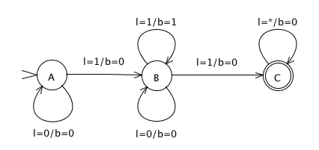

*Inputs*: (l) lightswitch: {0, 1} = {off, on}

*Outputs*: (b) bulb: {0, 1} = {off, on}

Which of the following are valid behaviors for the machine?

(a) The lightswitch is off for the first 4 cycles and then turns on for the next cycle and remains on. The bulb is on for the first cycle, turns off for 3 cycles and then turns on for the next cycle and remains on.

(b) The lightswitch is on for the first cycle, turns off for 1 cycle, turns on for 1 cycle, turns off for 1 cycle and then turns on for the next cycle and remains on. The bulb is on for the first cycle, turns off for 1 cycle and then turns on for the next 3 cycles and remains on.

**Problem 5**. Understanding high-level system behavior.

Consider the automaton,

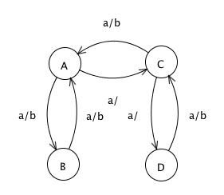

input *a*: pure

output *b*: pure.

Describe in words the input/output behavior of this machine.