**Problem 1**: *Understand Temporal Logic*

Write an intuitive understanding of the following LTL properties in your own words.  Use concrete, real-life atomic propositions that this property would verify.

For example, for *Gp*, you might write,

"The drone is always 5 feet or more above the ground", where *p* represents the condition "5 feet or more above the ground".

(a) G(p ⇒ q)

(b) F(p U q)

(c) p & q

(d) Xp + GFq

(e) ¬FG(p ^ Xq)

**Problem 2**: *Embody Specifications in Logical Grammar*

Write an LTL property for each of the following specifications.  Clearly define what conditions each of your atomic propositions represent:

(a) At no time after the pedestrian arrives is the traffic light green.

(b) The main program eventually reaches line 143.

(c) After a link operation has been terminated, an error during link initialization, or a system reset, the ErrorReset state is entered.

(d) When the robot is facing an obstacle, eventually it moves at least 5 cm away from the obstacle.

**Problem 3**: *Design Automata from Specifications*

Design an automaton for controlling a car that satisfies the following:

(a) *Dome light controller*: The dome light is on when any door is open. It stays on for 1 cycle after all doors are shut.

(b) *Beeper controller*: When the engine is started, if not all passengers have their seat belt buckled, a beeper sounds.  If the seat belts are not buckled, the beeper sounds for 2 steps exactly.  If the seat belts are buckled, the beeper stops.

(c) *Warning light controller*: When the engine is started, if not all passengers have their seat belt buckled, a red warning light warning is on. The warning light as long as the seat belt is unbuckled.

**Problem 4**: *Understand possible model behaviors*

Take the following state machine:

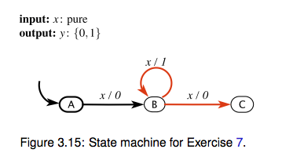

Which of the following fragments of behaviors are prefixes to behaviors in the state machine's language?

(a) x = (p, p, p, p, p); y = (0, 1, 1, 0, 0)

(b) *x* is present for all states;*y* is off for one cycle, turns on for 2 cycles, turns off for a cycle, and then is absent for the last cycle;

(c) x = (a, p, a, p, a); y = (a, 1, a, 0, a)

(d) *x* is present for all states; *y* is off for two cycles, then absent for the last three cycles.

(e) *x* is present for all states; *y* is off for the first cycle, then absent for one cycle, then off for the third cycle, and then absent for the last two cycles

**Problem 5**: *Describe high-level system behavior*

You are given the following automaton,

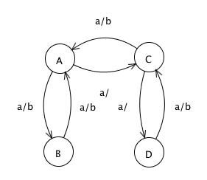

with input *a*: pure and output *b*: pure.

Describe in words the input/output behavior of this machine.