**Problem 1**: *Understanding Temporal Logic*

Interpret the following LTL properties in your own words.  Come up with your own real-life propositions to verify for each property. For example, for *Gp*, you might write,

"The drone is always 5 feet or more above the ground",

where *p* is the proposition "5 feet or more above the ground".

(a) G(p ⇒ q)

(b) F(p U q)

(c) p & q

(d) Xp + GFq

(e) ¬FG(p ^ Xq)

**Problem 2**: *Converting Specifications to Temporal Logic*

Write an LTL property for each of the following specifications.  Make sure to describe in English what each of your atomic propositions mean.

(a) The main program eventually reaches line 143.

(b) At no time after the pedestrian arrives is the traffic light green.

(c) After a link operation has been terminated, an error during link initialization, or a system reset, the ErrorReset state is entered.

(d) When the robot is facing an obstacle, eventually it moves at least 5 cm away from the obstacle.

**Problem 3**: *Designing Automata from Specifications*

Design an automaton for controlling a car that satisfies the following:

(a) *Dome light controller*: The dome light is on when any door is open. It stays on for 1 cycle after all doors are shut.

(b) *Alarm controller*: When the engine starts, if not all passengers have their seat belt buckled, a beeper sounds.  If the seat belts are not buckled, the beeper sounds for 2 steps exactly.  If the seat belts are buckled, the beeper stops.

(c) *Warning light controller*: When the engine is started, if not all passengers have their seat belt buckled, a red warning light warning is on. The warning light as long as the seat belt is unbuckled.

**Problem 4**: *Understanding model behaviors*

Take the following state machine:

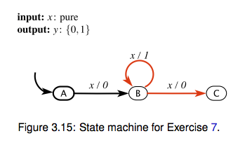

Which of the following are valid behaviors for the state machine?

(a) x = (p, p, p, p, p, ...); y = (0, 1, 1, 0, 0, ...)

(b) *x* is present for all states;*y* is off for one cycle, turns on for 2 cycles, turns off for a cycle, and then is absent starting in the last cycle;

(c) x = (a, p, a, p, a, ...); y = (a, 1, a, 0, a, ...)

(d) *x* is present for all states; *y* is off for two cycles, then absent for the last three cycles and all cycles henceforth.

(e) *x* is present for all states; *y* is off for the first cycle, then absent for one cycle, then off for the third cycle, and then absent for the last two cycles and all cycles henceforth.

**Problem 5**: *Understanding high-level system behavior*

Consider the automaton,

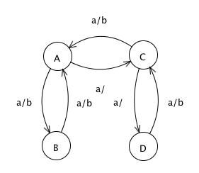

input *a*: pure

output *b*: pure.

Describe in words the input/output behavior of this machine.