**CSC 4370/6370 WEB PROGRAMMING**

**Summer 2020 Assignment 1**

**DUE DATE 06/26/2020 @ 11:59 pm**

Create a home page (Website) that is viewable by anyone anywhere who can browse the Web. This home page is to be named index.html and placed in your public_html directory. The URL of this page will be – **codd.cs.gsu.edu/~campusid/Assignments/1/index.html** .

Please read all the submission requirements and guidelines. Failure to adhere to them will result in loss of points.

Submission Requirements and guidelines.

1. Replace the campusid with your own id in the above link. Please check the link before you submit it. If the link doesn’t work, you will get a 0 (ZERO) even though, you submitted the files on codd server.
2. On Codd Server, you must create an Assignments directory under public_html. Inside the Assignments directory, create another directory named 1. Name your main html page as index.html and also put all the required files, images and html pages you are referencing in your index.html in the same directory. Re-check all the links and images before you submit the link.
3. Change the permissions of all the files to 777, if you get a 403/ 404 error.
4. You will only submit the link - **codd.cs.gsu.edu/~campusid/Assignments/1/index.html**
5. Use External Stylesheet: Your page must be controlled by an external stylesheet!  
   Note: You must add a link to your external stylesheet from your page so it can be viewed.
6. A total of 3 tabs must be present on your html page. 1) Home 2) Resume 3) External CSS . **Look at the following image just for the example of tabs.**

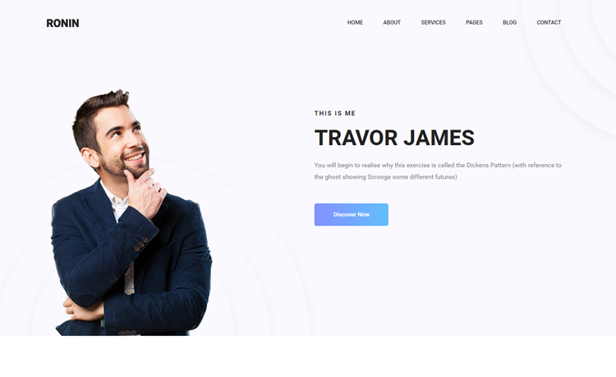

1. You can use an image as a background; please ensure that the image is not overpowering but pleasant to display the text, links, images etc.
2. Add a title and heading to your web page, and make sure you can view it. Make up a clever title for your web page, and put it in the title element. – Be Creative
3. A link to the Computer Science Department's main home page, which is <http://www.cs.gsu.edu/>
4. A head shot (Photo of you) on the right side of the page and on the left side add your details – Full Name, Major, Year, Panther Id, Email Address, Github Link to your profile, LinkedIn Url.

Maybe something like this – This example is from google, but you can be creative with the design. It should look professional and authentic.

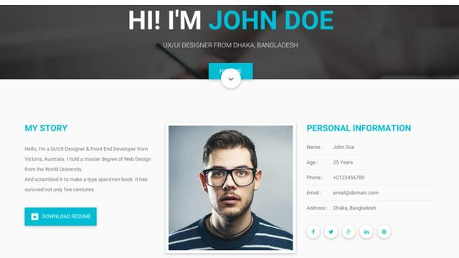

1. A list of your favorite movies displayed as an HTML unordered list and a list of your favorite TV series as ordered list (each list must have 5 list items).
2. Create a section that will have all links that will take me to Assignments and Projects, In Class Activity and Final Project using a table with borders (be creative and it should look good), every other row is a different color. The table should have the following details. Here is an example of what the table must have

|  |  |  |
| --- | --- | --- |
| # | Server Link | Github link |
| Assignments | | |
| 1 |  |  |
| 2 |  |  |
| 3 |  |  |
| Projects | | |
| 1 |  |  |
| 2 |  |  |

1. Create another Tab called Resume and once I open that tab, I should be able to see your Resume. Completely write your resume using html tags. It should look like resume you send out for job interviews. Very professional.
2. You should include a favorite quote (e.g., a poem or line from a movie) using a DIV element
3. There should be at least 3 external links to other websites of interest.
4. Setup your links to use the “: hover” pseudo-class (use a: hover so that only the links are effected). How the link changes when the mouse moves on top of it is up to you, but if you’re short on ideas, just have the link change colors.
5. Add tags and setup your style sheet so that every time the word “Georgia State, Computer Science and 2 more words of your choice” appears, it is in red and is in bold.
6. All HTML pages must pass the official HTML5 specifications via <http://validator.w3.org/>
7. All CSS files must pass the official CSS validation via <http://jigsaw.w3.org/css-validator/>
8. **You cannot use frames.**
9. **You cannot use any styling element for any purpose (e.g., <strong>, <em>, <font>,<center>). All styling must be defined in CSS.**
10. **You cannot use any styling attribute in elements (e.g., <h3 align="center">).**
11. **You cannot use front-end frameworks such as Bootstrap.**
12. **You cannot use other people's CSS files.**
13. **You cannot use JavaScript (or jQuery for that matter; considering we have not covered JavaScript yet!).**
14. **Do not use spaces in any filenames. If the link doesn’t work, it’s a ZERO for the entire assignment.**
15. All Your content must be stored in the github repo as well. Follow the same folder structure as your codd server. Your repo/ Assignments/1/. Place all your files under 1 directory.
16. Specifically, do not use frames or JavaScript YOU WILL LOOSE POINTS.
17. Absolutely no plagiarism.