Vivo — Vial Label SOP
How to apply the brand design elements to a peptide vial label.
Worked example: BPC-157, 5 MG, on Clay Burgundy #7B3B34. Version 1.0 — June 2026.

1. Purpose
This SOP defines the fixed recipe for laying out a Vivo vial label so any product reads as one family. Follow the element order, spacing, color logic, and type rules below. Only two things change between products: the product name / dose and the category color (Section 7). Everything else stays constant.

2. The reference layout
Every label is a single vertical stack on a full-bleed color field. The logo anchors the top; the product name and dose anchor the bottom; the middle stays empty. This negative space is the brand — do not fill it.
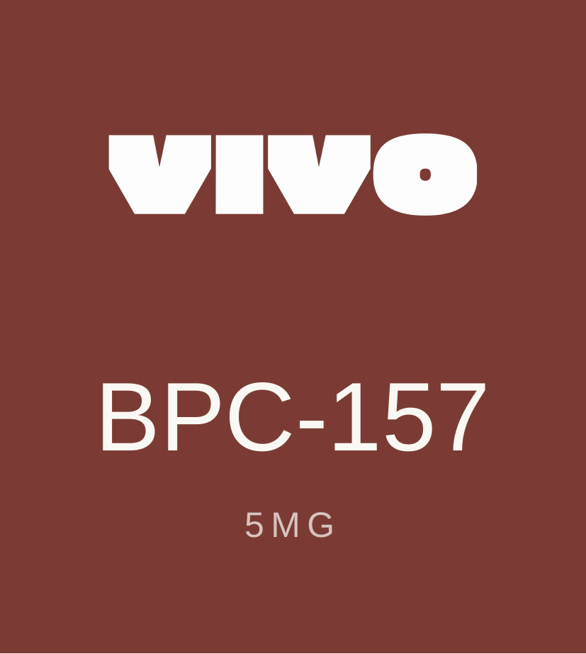
Reference build of the supplied tile — logo top, name + dose bottom, empty middle.

3. Apply the elements (in order)
- Set the canvas. Fill the entire label with one flat brand color, edge to edge, no gradient or texture. For this product the field is Clay Burgundy #7B3B34. The color is chosen by category (Section 7), not by preference.
- Place the logo. Use the white wordmark (logo_white.png) centered horizontally, sitting in the top third. Width ≈ 60% of the label width. Pick the logo color by background lightness (Section 6) — white on dark fields, clay or black on light fields.
- Set the product name. Centered, directly readable, in the functional sans (SF Pro Display, Medium). It is the largest type on the label. Keep it on one line; hyphenate the compound exactly as the molecule is written (BPC-157).
- Set the dose. Centered, below the name, in all caps with wide letter-spacing (≈ 3 px / 0.2em). Format as number + unit with no space: 5MG. Tone is muted — warm-white at ~70% opacity — so it reads as a quiet sub-line, not a headline.
- Lock the spacing. Equal side margins. Logo group pinned to the top, name+dose group pinned to the bottom, both with matching breathing room from their edges. The vertical gap between name and dose is small (one rhythm unit); the gap between logo and name is large (the empty middle).

4. Element specification
Element | Specification | Notes
Background | Flat fill, full bleed. Category color (e.g. Clay #7B3B34). | No gradient on the flat tile. No border.
Logo | Wordmark, centered, top third. Width ≈ 60% of label width. | Color chosen by contrast — see Section 6.
Product name | SF Pro Display Medium, centered, largest type, one line. | Warm-white #FAF8F4. Never pure white.
Dose | All caps, ~0.2em tracking, number+unit no space (5MG). | Muted: warm-white at ~70% opacity, or champagne accent.
Margins | Equal left/right. Logo and name+dose groups pinned to top/bottom. | Protect the empty middle.

5. Color & contrast rule
Backgrounds are never pure black or white. Type is warm-white #FAF8F4 or warm-black #1C1A17. The accent color (used for the dose or a rule) must clear WCAG AA contrast on its field:
- On dark fields (clay, sage, slate): use Champagne #E4BC7A for accents — ~4.7:1, passes AA.
- Do not use Amber #C4913A as an accent on clay — it lands near 3:1 and fails AA.
- On light fields (sand, amber): use Clay #7B3B34 or deep clay as the accent.

6. Logo color selection
Field lightness | Logo file | Examples
Dark field | logo_white.png | Clay, Sage, Slate
Light field | logo_black.png or logo_clay.png | Sand, Amber

7. Category-color system
Color carries meaning: each product category owns one field color. Match the molecule to its category color so the shelf reads as a coded set. The supplied tile pairs BPC-157 with clay — see the flag in Section 9 before locking that pairing.
Category | Field color |  | Logo | Accent
Recovery & Healing | Sage #3D5C36 |  | White | Champagne #E4BC7A
Skin & Anti-Aging | Amber #C4913A |  | Black | Deep clay #5C2A24
Mind, Mood & Sleep | Slate #3A5268 |  | White | Champagne #E4BC7A
Weight & Metabolism | Clay #7B3B34 |  | White | Champagne #E4BC7A
Muscle & Performance | Sand #EDE4D0 |  | Clay | Clay #7B3B34

8. Do & don't
Do | Don’t
Keep the middle empty — it is the brand. | Crowd the label with extra lines or icons.
Center everything on one vertical axis. | Left-align or stagger the text.
Use warm-white / warm-black, never pure. | Use #000000 or #FFFFFF.
Verify accent passes AA on its field. | Put amber accents on clay (fails AA).
Keep the molecule name on one line. | Shrink or wrap the name to fit decoration.

9. Open decisions (flag before mass production)
Two divergences between the supplied tile and the existing 5-vial production lineup. Resolve them so the system stays coherent — either is defensible, but pick one and apply it everywhere.
- Type style. The supplied tile sets the product name in the functional sans, while the production vials set it in the Late Serif. One must win across the whole range. The serif reads more premium/editorial; the sans reads cleaner/clinical and matches this tile.
- Color–category pairing. The tile puts BPC-157 (Recovery) on clay, but in the lineup clay is owned by Weight & Metabolism (AOD-9604) and BPC-157 is sage. If color codes category, BPC-157 should be sage — otherwise the coding breaks.
- Stripped elements. The tile drops the category kicker, divider rule, descriptor, “Lyophilized,” and “Research Use Only” lines present on the production labels. Confirm whether this minimal face is the new standard or a marketing-only variant — “Research Use Only” in particular may be a compliance requirement.
Source files: _source/vials.html (label spec), logo_white / logo_black / logo_clay.png, brand palette per Vivo Brand Identity.

