

Auris COM Simulation

Testing Procedure

Andrew S Johnson  
[ansjohns@mtu.edu](mailto:ansjohns@mtu.edu)

Michigan Technological University

Aerospace Enterprise

1400 Townsend Dr.

Houghton, MI 49931

|  |  |
| --- | --- |
| **Author :** | Author Signature |
| **Team Leader :** | Team Leaders Signature |
| **Systems Engineer :** | Systems Engineers Signature |
| **Project Manager :** | PM Signature if needed |
| **Chief Engineer :** | CE Signature if needed |
| **Principle Investigator :** | PI Signature if needed |

Revision History

|  |  |  |  |
| --- | --- | --- | --- |
| **Revision** | **Revised By** | **Revised On** | **Changes** |
| 1 | A Johnson | 04 08 2018 | Initial writing |
| 2 | A Johnson | 04 10 2018 | Insert MTU Access Calculation |

List of Needed Components/Equipment

|  |  |  |  |  |
| --- | --- | --- | --- | --- |
| **Owner (Subteam)** | **Components/Equipment** | **Quantity** | **Reason** | **See Pages** |
| ME | Computer w/ STK | 1 | To run Simulation | 1 |

Table of Contents

Requirement Verification…………………………………………………………………………………2

List of Needed Components/Equipment…………………………………………………………….….3

Table of Contents…………………………………………………………………………………………4

1 Test Overview 5

1.1 Objectives 5

1.2 Test Schedule 5

2 Procedure 5

2.1 Assumptions 5

2.1.1 Assumption 1 5

2.1.2 Assumption 2 5

2.2 Preparation 5

2.2.1 Prep Step 1 6

2.2.2 Prep Step 2 6

2.2.3 Prep Step 3 6

2.2.4 Prep Step 4 6

2.2.5 Prep Step 5 7

2.2.6 Prep Step 6 7

2.3 Test Environment 8

2.4 Test Execution 8

▪ Major step 1 8

2.4.1 Major Step 2 8

3 Results 9

Appendix A Test Logs………………………………………………………………………………11

List of Figures

**No table of figures entries found.**

List of Tables

**No table of figures entries found.**

# Test Overview

The purpose of this test is to get an idea of the expected length of communications access windows between the ground station and the spacecraft.

## Objectives

This test will provide reference material to several sub-teams concerned with communicating data to and from the spacecraft in order to complete the mission (MOP, CDH, PYL, COM). This test is only a simulation and can not be used to verify any requirements.

## Test Schedule

1. Set and verify mission and environmental parameters in the scenario.
2. Compute access between the ground station and the spacecraft (Upstream and downstream)
3. Report results from the test.

# Procedure

## Assumptions

This test makes various assumptions about environmental conditions and communications system performance that may vary from the real world. It is assumed that the tester has a solid working knowledge of the STK software and how to accurately model the components of the communications system.

### Assumption 1

It is assumed that an up-to-date (as of this writing) mission scenario exists with all objects necessary to perform an analysis on the communications system already existing.

### Assumption 2

Due to the nature of the simulation software, it is assumed that a communications link will be established with the ground station the moment the spacecraft is within range. (Line of sight)

## Preparation

This test requires several environmental models that need to be enabled before the analysis is run. These models take into account RF signal propagation, attenuation from rain, clouds, fog, atmosphere, tropospheric scintillation and ionospheric fading. These models will be configured in the RF Environment section of the scenario properties window.

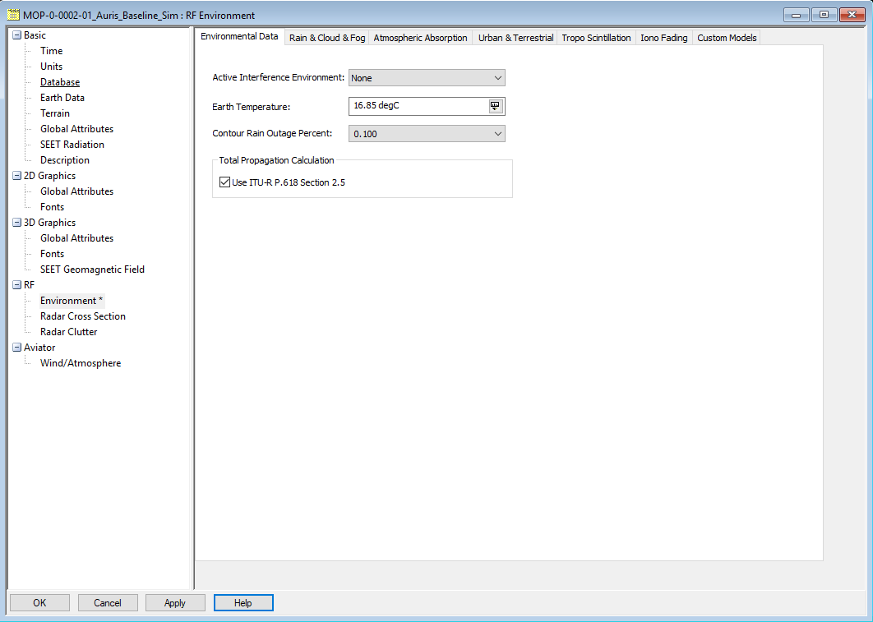

### Prep Step 1

In the Environmental Data tab, select “Use ITU-R P.618 Section 2.5” under “Total Propagation Calculation”. [1]

### Prep Step 2

In the “Rain & Cloud & Fog” tab, select “Use” under both the Rain Model section and the Clouds and Fog Model section. The Rain model to be used is ITU-R P618-12, Surface Temperature is set to 15.55 °C and “Enable Cross Polarization Loss” is checked.

ITU-R P840-6 is selected for the cloud and fog model with a cloud ceiling of 3km, a cloud layer thickness of 0.5km and a cloud temperature of 0°C. Liquid Water Content Density Value is set to 7.5 g/m­3 (standard ground-level surface water vapor density) [2].

### Prep Step 3

In the Atmospheric Absorption tab, “Use” is unchecked because the models are valid for a frequency range of 1 GHz to > 350 GHz. Auris will be communicating in the 450 MHz band.

### Prep Step 4

In the Tropo Scintillation tab, Use is enabled with ITU-R P618-12 set as the model. Compute deep fade is enabled with Surface temperature set to 15.55 °C, tropo fade outage a 0.1%, Percent Time Refractivity Gradient < -100N units/km set to 10%. Fade depth for the average year is selected.

### Prep Step 5

In the Iono Fading tab, Use model ITU-R P531-13 is enabled. [3]

### Prep Step 6

The components of the communications system are defined as indicated in the following tables.

#### Ground station receiver

|  |  |  |
| --- | --- | --- |
| **Parameter** | **Value** | **Unit** |
| Frequency | 455 | MHz |
| Antenna to LNA Line Loss | 0 | dB |
| LNA Gain | 0 | dB |
| LNA to Receiver Line Loss | 0 | dB |
| Rain Model Outage Percent | 0.1 | Percent |
| Link Margin C/N | 7 | dB |
| Noise Temperature | 290 | Kelvin |
| Demodulator | MSK | - |

#### Ground station transmitter

|  |  |  |
| --- | --- | --- |
| **Parameter** | **Value** | **Unit** |
| Frequency | 455 | MHz |
| Power | 50 | W |
| Data Rate | 9600 | bps |
| Modulation | MSK | - |
| Signal Bandwidth | 148.8 | kHz |

#### Ground station antenna

|  |  |  |
| --- | --- | --- |
| **Parameter** | **Value** | **Unit** |
| Type | Helix | - |
| Design Frequency | 455 | MHz |
| Diameter | 0.339 | m |
| Efficiency | 55 | Percent |
| Turn Spacing | 0.08 | M |
| Number of Turns | 28 | - |
| Back-lobe Gain | -30 | dB |

#### Space station receiver

|  |  |  |
| --- | --- | --- |
| **Parameter** | **Value** | **Unit** |
| Frequency | 455 | MHz |
| Antenna to LNA Line Loss | 0 | dB |
| LNA Gain | 0 | dB |
| LNA to Receiver Line Loss | 0 | Db |
| Rain Model Outage Percent | 0.1 | Percent |
| Link Margin C/N | 27.1 | dB |
| Noise Temperature | 581.2 | Kelvin |
| Demodulator | MSK | - |
| Receiver Bandwidth | 25 | kHz |

#### Space station transmitter

|  |  |  |
| --- | --- | --- |
| **Parameter** | **Value** | **Unit** |
| Frequency | 455 | MHz |
| Power | 3 | W |
| Data Rate | 9600 | bps |
| Modulation | MSK | - |
| Signal Bandwidth | 52.8 | kHz |

#### Space station antenna

|  |  |  |
| --- | --- | --- |
| **Parameter** | **Value** | **Unit** |
| Type | Isotropic | - |
| Design Frequency | 455 | MHz |
| Main-lobe Gain | 0 | dB |
| Efficiency | 100 | Percent |

## Test Environment

The test can be performed on any computer with a working copy of STK.

## Test Execution

### Major step 1

Using the access tool an access is calculated FROM the ground station receiver TO the space station transmitter.

The time-period for the access analysis is 14 Apr 2018 16:00:00.000 UTCG to 21 Apr 2018 16:00:00.000 UTCG.

Click “Compute”.

### Major Step 2

At the completion of the analysis, open the access report. Save as a txt file or csv file.

# Results

MTU_Rx1-To-AurisCom_Tx

----------------------

Access Start Time (UTCG) Stop Time (UTCG) Duration (min)

------ ------------------------ ------------------------ --------------

1 14 Apr 2018 16:40:09.797 14 Apr 2018 16:44:11.096 4.022

2 14 Apr 2018 18:12:17.872 14 Apr 2018 18:18:31.756 6.231

3 14 Apr 2018 18:18:35.031 14 Apr 2018 18:21:26.561 2.859

4 14 Apr 2018 19:49:02.599 14 Apr 2018 19:58:15.363 9.213

5 14 Apr 2018 21:28:41.194 14 Apr 2018 21:34:59.019 6.297

6 14 Apr 2018 23:06:57.122 14 Apr 2018 23:13:26.447 6.489

7 15 Apr 2018 00:44:26.823 15 Apr 2018 00:50:01.898 5.585

8 15 Apr 2018 02:18:58.924 15 Apr 2018 02:28:58.824 9.998

9 15 Apr 2018 03:57:04.393 15 Apr 2018 04:01:41.968 4.626

10 15 Apr 2018 16:04:52.872 15 Apr 2018 16:06:59.922 2.118

11 15 Apr 2018 17:38:47.952 15 Apr 2018 17:42:00.277 3.205

12 15 Apr 2018 17:42:04.152 15 Apr 2018 17:45:03.121 2.983

13 15 Apr 2018 19:12:49.246 15 Apr 2018 19:16:44.796 3.926

14 15 Apr 2018 19:16:56.546 15 Apr 2018 19:20:59.734 4.053

15 15 Apr 2018 20:51:31.932 15 Apr 2018 20:57:01.215 5.488

16 15 Apr 2018 22:30:34.455 15 Apr 2018 22:35:27.477 4.884

17 16 Apr 2018 00:06:39.410 16 Apr 2018 00:08:41.210 2.030

18 16 Apr 2018 00:08:57.335 16 Apr 2018 00:11:42.660 2.755

19 16 Apr 2018 00:11:57.410 16 Apr 2018 00:15:33.085 3.595

20 16 Apr 2018 01:43:08.055 16 Apr 2018 01:52:08.920 9.014

21 16 Apr 2018 03:19:40.152 16 Apr 2018 03:24:23.810 4.728

22 16 Apr 2018 17:00:44.388 16 Apr 2018 17:03:08.838 2.408

23 16 Apr 2018 17:05:08.388 16 Apr 2018 17:08:34.535 3.436

24 16 Apr 2018 18:36:24.414 16 Apr 2018 18:39:02.089 2.628

25 16 Apr 2018 18:39:06.639 16 Apr 2018 18:41:37.489 2.514

26 16 Apr 2018 18:41:42.589 16 Apr 2018 18:44:46.596 3.067

27 16 Apr 2018 20:14:10.601 16 Apr 2018 20:20:39.218 6.477

28 16 Apr 2018 21:54:03.758 16 Apr 2018 21:58:19.345 4.260

29 16 Apr 2018 23:30:25.182 16 Apr 2018 23:38:40.982 8.263

30 17 Apr 2018 01:07:36.486 17 Apr 2018 01:14:08.911 6.540

31 17 Apr 2018 02:43:02.427 17 Apr 2018 02:49:40.705 6.638

32 17 Apr 2018 16:24:45.350 17 Apr 2018 16:32:05.143 7.330

33 17 Apr 2018 17:59:55.821 17 Apr 2018 18:02:09.521 2.228

34 17 Apr 2018 18:02:12.621 17 Apr 2018 18:05:39.871 3.454

35 17 Apr 2018 18:05:43.771 17 Apr 2018 18:08:34.620 2.847

36 17 Apr 2018 19:36:54.565 17 Apr 2018 19:44:23.224 7.478

37 17 Apr 2018 21:17:30.250 17 Apr 2018 21:21:14.944 3.745

38 17 Apr 2018 22:54:05.926 17 Apr 2018 23:01:39.571 7.561

39 18 Apr 2018 00:31:43.902 18 Apr 2018 00:36:55.952 5.201

40 18 Apr 2018 00:37:01.152 18 Apr 2018 00:39:50.141 2.816

41 18 Apr 2018 02:07:31.500 18 Apr 2018 02:13:39.500 6.133

42 18 Apr 2018 15:48:52.611 18 Apr 2018 15:55:29.375 6.613

43 18 Apr 2018 17:23:30.163 18 Apr 2018 17:25:33.513 2.056

44 18 Apr 2018 17:25:36.063 18 Apr 2018 17:29:28.463 3.873

45 18 Apr 2018 17:29:32.013 18 Apr 2018 17:32:16.396 2.740

46 18 Apr 2018 19:00:08.507 18 Apr 2018 19:08:10.887 8.040

47 18 Apr 2018 20:40:27.486 18 Apr 2018 20:44:29.787 4.038

48 18 Apr 2018 22:17:47.308 18 Apr 2018 22:24:31.556 6.737

49 18 Apr 2018 23:53:39.063 18 Apr 2018 23:55:44.463 2.090

50 18 Apr 2018 23:55:52.663 18 Apr 2018 23:59:48.663 3.933

51 18 Apr 2018 23:59:53.363 19 Apr 2018 00:03:22.863 3.492

52 19 Apr 2018 01:31:49.792 19 Apr 2018 01:36:38.142 4.806

Global Statistics

-----------------

Min Duration 17 16 Apr 2018 00:06:39.410 16 Apr 2018 00:08:41.210 2.030

Max Duration 8 15 Apr 2018 02:18:58.924 15 Apr 2018 02:28:58.824 9.998

Mean Duration 4.612

Total Duration 350.538

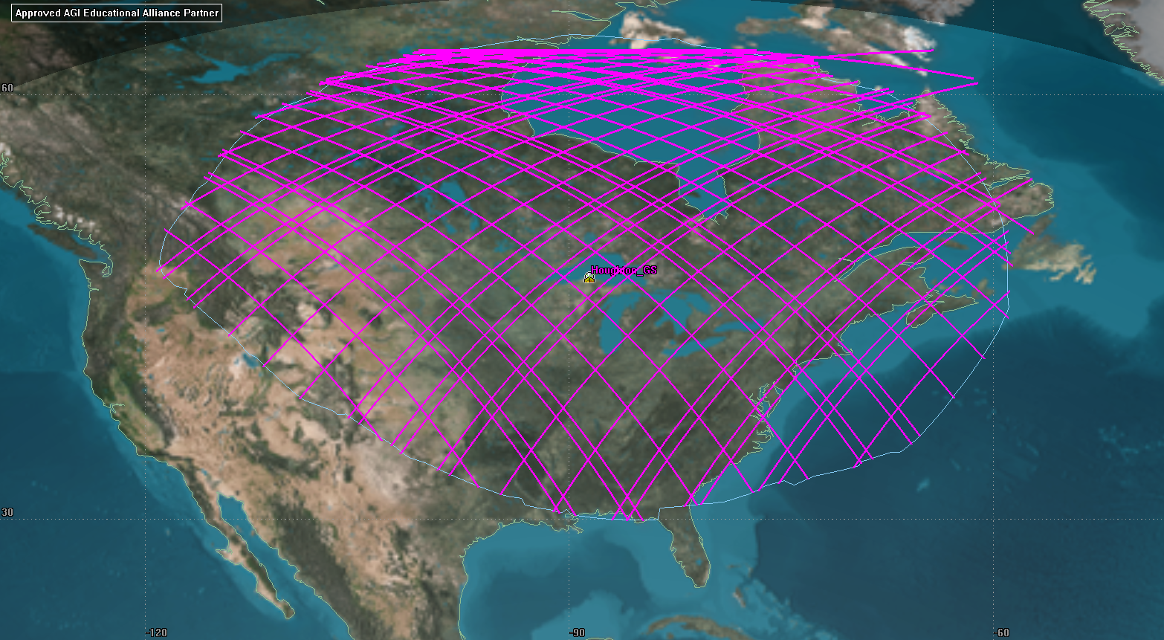

14 Apr 2018 16:12:11

Approved AGI Educational Alliance Partner

Facility-Houghton_GS-Receiver-MTU_Rx1-To-Satellite-Auris-Transmitter-AurisCom_Tx: Link Budget - Short Form

Time (UTCG) Rcvd. Frequency (MHz) Rcvd. Iso. Power (dBW) C/N (dB) Eb/No (dB) BER

------------------------ --------------------- ---------------------- -------- ---------- ------------

14 Apr 2018 16:40:09.797 455.001653 -176.902 4.0240 11.4276 6.782288e-08

14 Apr 2018 16:41:09.000 454.999173 -163.349 17.8195 25.2231 1.000000e-30

14 Apr 2018 16:42:09.000 454.996786 -161.286 19.8191 27.2227 1.000000e-30

14 Apr 2018 16:43:09.000 454.994830 -161.465 19.8017 27.2053 1.000000e-30

14 Apr 2018 16:44:09.000 454.993383 -170.393 10.8688 18.2724 1.000000e-30

14 Apr 2018 16:44:11.096 454.993341 -171.468 9.7937 17.1973 6.435405e-25

Appendix A: Test NOTES

ITU models are only valid and can only be computed through December of 2018, so analysis using those models was performed for the current year. It is assumed that there will be no shattering changes in the laws of physics between now and the time the mission will take place and so it can be assumed that results from this analysis will be typical of what can be expected at the time of the mission.

# References

|  |  |
| --- | --- |
| [1] | "Recommendation ITU-R P.618-13 Propagation data and prection methods required for the design of Earth-space telecommunication systems," International Telecommunication Union, Geneva, 2017. |
| [2] | "Recommendation ITU-R P.676-11 Attenuation by atmospheric gases," International Telecommunication Union, Geneva, 2016. |
| [3] | "Recommendation ITU-R P.531-13 Ionospheric propagation data and prediction methods required for the design of satellite services and systems," International Telecommunication Union, Geneva, 2016. |