# React Tutorial #1, Boiler-plating to Customizing With Props & Hooks

Welcome to React, one of the most popular libraries supporting JavaScript to create lean, modularized and effective web pages!

The average time to learn React ranges from 1 month to 6 months, ***learn*** meaning become an experienced react developer. So, consider the weeks we will spend building React sample applications, an introduction to thinking in components, and familiarization with the concepts and techniques used in a component based architecture.

Start by installing the ***React developer tools*** on your browser, so you can demonstrate what components have been activated in your application.

Here is what you will be doing in this tutorial:

1. you will use the ***npx*** utility, with ***create-react-app***, to scaffold a boiler-plate React application
2. you will use ***JSX*** to represent a variable on your web page
3. you will create your own ***component*** and add this to the application
4. you will use the ***props*** object to pass data between react components
5. you will use the ***JavaScript Array map method*** to create a list of objects
6. you will use JSX to create a list of components, based on one component declaration
7. you will ***style*** a React component
8. you will use a ***hook*** in React to coordinate changing the state of a variable, with an action in your application

## 1 : Scaffolding a React Application

Use the ***npx tool***, to run ***create-react-app*** in the node library. This creates a shell application with React and ReactDom installed, and a package.json file with scripts and dependencies.

*Why do we need both React and ReactDOM?*

***React****handles the logic and structure of the components, while****ReactDOM****takes care of rendering those components to the web page. This separation of concerns allows React to be used in different environments (like React Native for mobile apps) by swapping out ReactDOM for a different rendering engine.*

Run npx with create-react-app and the application name. We will build a sample meetings application, so let’s call this meeting_alerts. The folder/application name should use all lower case.

When the scaffolding process is complete, navigate to the folder you have created, in this case meeting_alerts.

Now open the folder with Visual Studio Code.



This opens up in VSCode.

and resolve any errors in the remaining files after the this content has been removed.

In App.css, give the header a new height, say 200px.

When all has been resolved, you should just see the following,

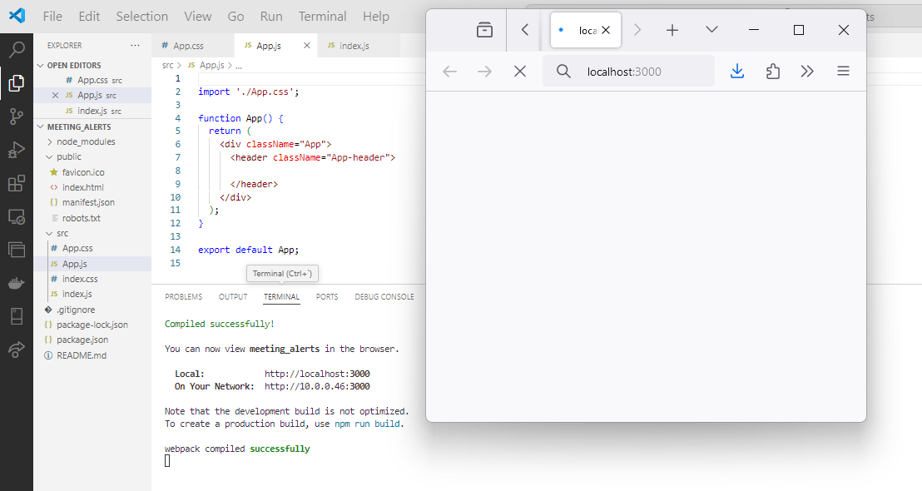

Add a heading to the header,

## 2: Using a variable with JSX, Representing JavaScript Content in JSX

Notice the markup being returned by function App? That is ***JSX***. Let’s use a variable instead of the hard-coded heading text. The variable is included by using the ***{…} notation***, which brings standard JavaScript into JSX.

## 3 : Custom Component

Let’s create the header as a component and include it inside the App component.

Create a new file, Header.js, and inside this add the content for the Header component, as follows.

Change the App.js file and component, to include the new Header component.

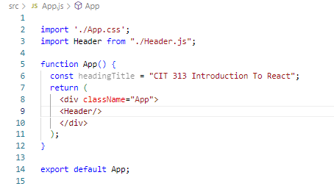

You will notice an error, because the title text is no longer local! We have created a new component, Header, and referenced a variable defined inside App.js.

This will be fixed in the next step.

## 4: The Props Object - Passing Data between Components

We have defined variable, headingTitle, with the title text for the heading, inside App.js. Yes, this could be moved to Header.js, but let’s use the title text as an example of how to pass data between components, as this is definitely required.

Modify App.js to pass the title text to the Header component.

… and modify the Header component to receive this data, through what is termed the ***props object***.

Now all the errors are resolved.

## 5: Add Styling

Let’s create 2 new components, a Card , used to represent meeting information, and a container to store multiple such cards, starting with a single card.

and add it to the public folder where it will be accessed by reference. We will deal with the button in a bit!

Note the ***inline styling*** for the MeetingCard component is specified using a style object, { …}, surrounded by the JSX { … }. Style rules can be integrated in several ways using react, including the use of a standard style file. Style objects can be created, assigned to variables and applied to elements.

Add the styles for the card and the card container, as ***external styling***, to App.css,

|  |  |
| --- | --- |
|  |  |

First, add the element of class meetings_container (the flex container represented by the MeetingList component) to the App component.

We are using the React recommended way of adding components in separate and distinct files, so make sure to import the MeetingList component into App.js.

Use inspect to investigate the page structure, and you can see that the element of class meetings_container has been successfully integrated.

The Components tab shows the App component, the Header component and the MeetingList component.

Now add a single Card component to the MeetingList component.

… and you should see this,

|  |  |
| --- | --- |
| Now, let’s change the title text before we move to the next step.  Do you know how? |  |

## 6: Using Iteration in JSX

We have more than 1 meeting(!), so let’s represent the meetings as an array of JavaScript objects, and we can add these to a new file in the src flolder, meetingData.js.

|  |  |
| --- | --- |
|  | const meetings = [    {      topic: "CIT Monthly Meeting",      dateTime: "Sept 19th 2024, 2pm-3pm",      location: "Knoy Hall West Lafayette",      parking: "Midway Garage",    },    {      topic: "Research In Higher Level Ed",      dateTime: "September 24th 2024, 1pm-5pm",      location: "Stuart Buildings, West Lafayette",      parking: "Street Level",    },    {      topic: "Curriculum Planning",      dateTime: "October 19th 2024, 4pm-6pm",      location: "IO 240, Indianapolis",      parking: "North Street Garage",    },  ];  export default meetings; |

Now, use the JavaScript array ***map*** method, which returns an object as it iterates over all of the elements in the array. In this case, the object being returned is a markup entity – a React component to which is passed the meeting information in the props object.

This operates on the content of the list and renders a Card for each item in the list.

Notice, in the code, we are using an index value in the map function



– this is a requirement for React, we have to use a unique value as we reference *list* content. Where did this come from? It is directly related to accessing each item in turn, selecting the correct item and making sure that the correct data is targeted.

Now let’s add some specific meeting information for each meeting object in the meeting list. We already have the meeting object, as it is passed in via props. So, we can use the meeting object and the dot access operator, to get the information from the object.

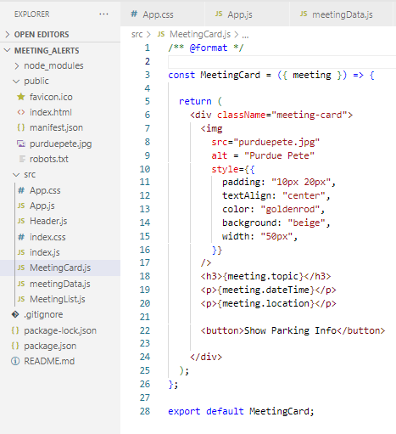

This should result in

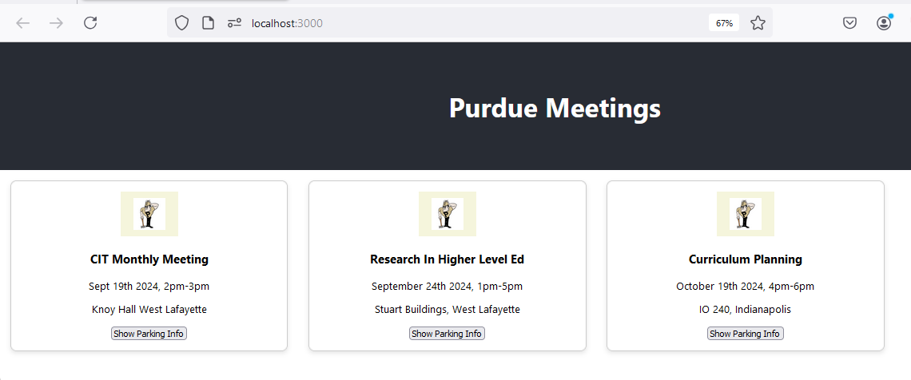

Any questions so far? Is it all wired together? Do you need any explanations?

The next step is the Parking modal.

The parking modal relates to the Meeting object and the Meeting Card, so it can be localized.

First, let’s discuss ***hooks*** in React. ***Hooks*** were added to React in version 16.8.

***Hooks allow components to be notified of changes, and to take action accordingly.*** There are multiple such hooks defined by React. Here, we will use the one that connects changing state, with a React function – ***useState***.

***useState*** integrates a variable with a function used to change the value (state) of the variable. The variable is given an initial value, and a function to set a new value.

As before, we insert the markup for a modal, and hide/show the content depending on a button click, or a state variable.

In order to use this hook, we need to include it. The parking modal button is in the MeetingCard component, so this is an appropriate place to add the registration for useState.

Below, the variable is *showModal*, and the function that sets it’s value is *setShowModal*. The initial value for showModal is false.

**const [showModal, setShowModal] = useState(false);**

The ***useState*** function returns an array, and here we are using array destructuring to assign the values to showmodal and the setShowModal function, respectively.

We have 2 functions that coordinate with the state variable to display or hide the modal, ***handleOpenModal*** and ***handleCloseModal*** – these 2 functions set the value of the state variable to either true or false. You can give them any title so long as they are used correctly!

When the parking button is clicked, the parking modal should open, so we should link the onClick event to the *handleOpenModal* function.



This function sets the value of the *showModal* state variable, to true.

If the *showModal* variable is true, then the modal should be visible. We can use a shorthand notation to set the display property to true, for the modal content.

 {***showModal &&*** (

        <div …..

Let’s add this content first and then style the modal appropriately.

|  |  |
| --- | --- |
|  | {showModal && (          <div className="modal-overlay" onClick={handleCloseModal}>            <div className="modal" onClick={(e) => e.stopPropagation()}>              <h4>Parking Information</h4>              <p>{meeting.parking}</p>              <button onClick={handleCloseModal}>Close</button>            </div>          </div>        )} |

Within the parking modal content, a close button calls the handleClose function.

            <button onClick={handleCloseModal}>Close</button>

Add the specific styling to the App.css file, feel free to re-style the parking modal !

|  |  |
| --- | --- |
|  | .modal {    position: fixed;    top: 10%;    left: 50%;    transform: translate(-50%, -50%);    background: white;    padding: 20px;    border-radius: 8px;    box-shadow: 0 4px 8px rgba(0, 0, 0, 0.1);    width: 300px;  }  .modal-overlay {    position: fixed;    top: 0;    left: 0;    width: 100%;    height: 100%;    background: rgba(0, 0, 0, 0.5);  } |

… and now you should see the parking modal become visible on clicking the

parking button - the modal content is displayed.

|  |  |
| --- | --- |
| App.css | .App {    text-align: center;  }  .App-header {    background-color: #282c34;    display: flex;    flex-direction: column;    align-items: center;    justify-content: center;    font-size: calc(10px + 2vmin);    color: white;    height: 200px;  }  .App-link {    color: #61dafb;  }  .meeting-card {    border: 1px solid #ccc;    border-radius: 8px;    padding: 16px;    margin: 16px;    width: 400px;    box-shadow: 0 4px 8px rgba(0, 0, 0, 0.1);  }  .meetings_container {    display: flex;    flex-wrap: wrap;    flex-direction: row;  }  .modal {    position: fixed;    top: 10%;    left: 50%;    transform: translate(-50%, -50%);    background: white;    padding: 20px;    border-radius: 8px;    box-shadow: 0 4px 8px rgba(0, 0, 0, 0.1);    width: 300px;  }  .modal-overlay {    position: fixed;    top: 0;    left: 0;    width: 100%;    height: 100%;    background: rgba(0, 0, 0, 0.5);  } |
| MeetingCard.js | import React, { useState } from "react";  import "./App.css";  const MeetingCard = ({ meeting }) => {    const [showModal, setShowModal] = useState(false);    const handleOpenModal = () => {      setShowModal(true);    };    const handleCloseModal = () => {      setShowModal(false);    };    return (      <div className="meeting-card">        <img          src="purduepete.jpg"          alt="Purdue Pete"          style={{            padding: "10px 20px",            textAlign: "center",            color: "goldenrod",            background: "beige",            width: "50px",          }}        />        <h3>{meeting.topic}</h3>        <p>{meeting.dateTime}</p>        <p>{meeting.location}</p>        <button onClick={handleOpenModal}>Show Parking Info</button>        {showModal && (          <div className="modal-overlay" onClick={handleCloseModal}>            <div className="modal" onClick={(e) => e.stopPropagation()}>              <h4>Parking Information</h4>              <p>{meeting.parking}</p>              <button onClick={handleCloseModal}>Close</button>            </div>          </div>        )}      </div>    );  };  export default MeetingCard; |