**Guide & Resources for RSoXS Simulation-Based Analysis**

Andrew Levin

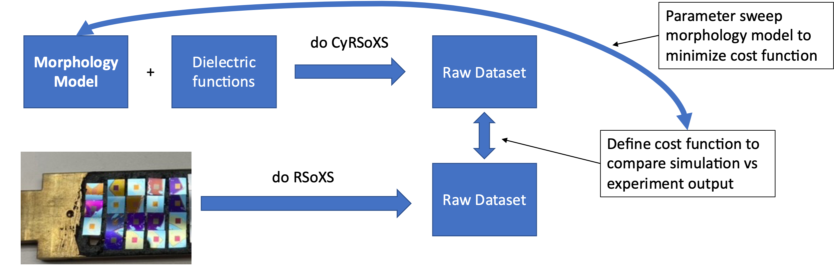**Workflow overview diagram:**

**Experimental side (measuring RSoXS & NEXAFS):**

**Useful resources:**

* NEXAFS: SST1 NEXAFS guide document from Peter Dudenas (“NEXAFSguide.pdf”)
* RSoXS: [Eliot's RSoXS Endstation Wiki](https://wiki-nsls2.bnl.gov/beamline7ID1/index.php?title=RSoXS_Endstation)
* Example reduction NSLSII JupyterHub notebook (“rsoxs_reduce_draft_andrew.ipynb”)
* [PyHyperScattering Read the Docs](https://pyhyperscattering.readthedocs.io/en/latest/source/intro.html)
* [PyHyperScattering GitHub](https://github.com/usnistgov/PyHyperScattering)
* Refer to [Xarray](https://docs.xarray.dev/en/stable/) documentation for understanding DataArrays & DataSets

**Doing the experiments overview:**

* Where:
  + RSoXS at Carbon edge available at NSLSII SST1 or ALS 11.0.1.2
  + SST1 experimental processing is more straightforward and gets better data
  + SST1 can be remote, from my understanding ALS is less automated and it’s better to be in-person
* RSoXS samples:
  + These are typically Norcada 5x5mm substrates: 5x5mm 200um-thick Si frame & 1.5x1.5mm 100nm-thick SiN window
  + **Thin** (<1 um) layer of interest on top of SiN window (via float-off or direct deposition, so long as the window doesn’t break…)
  + SST1 sample bar can hold 100+ samples, ALS can hold ~20 if I recall correctly
  + Store samples in original capsules they come in, **do not** get the capsules wet
* NEXAFS samples:
  + For doing NEXAFS in the SST1 RSoXS chamber, only TEY is available
  + Substrates must be conductive, most commonly I use 10x10mm Si
* Beamtime: (Eliot is super helpful with all of this)
  + SST1 RSoXS
    - Load all the samples on the sample bar and record positions
    - Fill in SST1 sample spreadsheet accordingly, Eliot can help with how to format the scans (but you should know what measurements you wanto)
    - Take photo for RSoXS instrument and load sample bar (Eliot does this)
    - Go through photo and select centers for each sample
    - Run spiral scans macro to take images at non-resonant energies to identify good/bad spots on the films
    - Select good spots and run experiment
  + SST1 NEXAFS in RSoXS Chamber (a specialized NEXAFS chamber is available, the scientist contact for it is Cherno Jaye)
    - Same process as RSoXS samples except spiral scans are not needed, and obviously different scan plan is needed

**RSoXS data processing (NEXAFS processing described in simulation side)**

* Can use Igor Pro and/or python
* Igor Pro is the older method and there is good documentation available via Eliot’s wiki
* Python
  + Workflows that are actively being developed
  + NSLSII has a database that stores all measured data indefinitely (allegedly)
  + Use the NSLS-II JupyterHub to work with data straight from the database
    - Currently computationally powerful: 8 CPUs & 32 GB RAM
    - Storage available in autogenerated user folder is 100 GB, though each SST1 proposal also creates a folder with more space than you’d ever need
  + Example rough draft notebook attached
* Each RSoXS scan yields a 1024x1024x128 DataArray
  + 1024x1024 pixels image, 128 energies
  + Each scan is at fixed polarization, so for each sample really have 1024x1024x128x2 DataArray if all the data is combined
  + Generally, for visualizing the data it is good to be able to process/output:
    - 2D plots
      * Intensity color scale, Qx and Qy (or pixels) axes, fixed energy
      * Intensity color scale, Chi and Q axes, fixed energy
      * Intensity color scale, Q and Energy axes, averaged chi ranges
      * Anisotropy ratio (AR) color scale, Q and Energy axes
    - 1D plots
      * Intensity vs Q, selected energies, selected chi ranges
      * AR vs Q, selected energies

**Simulation side:**

**Resources:**

* NEXAFS Theory (Bible):
* New “NIST RSoXS Simulation Suite” (NRSS)
  + [NRSS GitHub](https://github.com/usnistgov/NRSS)
  + [NRSS Read the Docs](https://nrss.readthedocs.io/en/latest/index.html) <- great! (check the Core-Shell Disk tutorial)
* Dean DeLongchamp’s NEXAFS example notebooks (“contrast_notebooks_dean”)
  + Really good walkthrough on how to get dielectric functions from NEXAFS data
* Andrew’s working NEXAFS notebook (to be included soon)
  + Will show how to properly normalize raw NEXAFS data
* Andrew’s example morphology model generation notebooks (to be included soon)
* CU Research Computing:

**Generate dielectric function plots from experimental NEXAFS**

* This can be done on local machine JupterLab
* First normalize raw NEXAFS data (refer to guide from Peter Dudenas)
* Then use Kramers-Kronig calculations (kkcalc package) to calculate dielectric functions, also called optical constants or complex indexes of refraction
* Highly sensitive to orientation, ideally export dielectric functions for perfectly isotropic samples and perfectly oriented samples (this requires mathematical corrections)

**Generate morphology models**

* Much more work needed on this still
* Generate models for morphology over relevant length scales that include size features that could appear in scattering
* Can be based on mathematical models and/or characterizations like AFM, TEM, etc.
* Assign material fractions, orientations, thicknesses, topology (for vacuum scattering)
* Can be 3D but best to start with 2D models and include volume fractions

**Running CyRSoXS**

* Will need to get access to CU Research Computing
* Currently installed on Andrew’s account, should be shareable to use though
* TBD

**Viewing CyRSoXS output**

* Simple notebook with warp_polar python package to do this
* PyHyperScattering gaining functionality to view simulation data the same way as experimental data
* TBD

**Comparing experiment & simulation:**

TBD