TECHNICAL CASE STUDY
Probabilistic Hierarchical Demand Forecasting
A two-horizon benchmark of 5 model classes on a 175-series foodservice forecasting problem
HEADLINE RESULT
On 8 years of data at a 13-week horizon, Chronos-Bolt (zero-shot foundation model) ties LightGBM at rep level (~10.2% WAPE) and trails by 1 point at the warehouse total (3.1% vs 2.7%). LightGBM wins where it matters for inventory dollars (+$4.1M/yr); Chronos wins for being competitive with no training or tuning. At a 52-week horizon, the picture inverts — Chronos's aggregate accuracy beats LightGBM's by 40% (3.5% vs 5.8% WAPE at total level). The honest comparison is more interesting than a single winner.

Property | Value
Domain | Foodservice distribution — weekly demand forecasting
Scale | 175 series across 6 levels (warehouse → rep), 8 years (416 weeks)
Horizons | 13 weeks (tactical / quarter) and 52 weeks (strategic / annual)
Models benchmarked | SeasonalNaive, AutoETS, LightGBM, Chronos-Bolt, N-HiTS
Stack | Python 3.11 · Nixtla suite · LightGBM · Optuna · MLflow · Streamlit
Tests | 91 passing · 76% coverage · ruff + mypy clean

1. Executive summary
Foodservice distribution runs on weekly demand forecasts: how many cases of each product family will move through each warehouse, branch, region, profit center, and ultimately each sales rep next week? Underestimate and customers stock out. Overestimate and inventory sits on the dock spoiling. A few points of WAPE improvement on a 32M-case-per-year warehouse translates to millions of dollars in avoided carrying cost.
This project benchmarks five modeling approaches on the same backtest design, against the same hierarchy, with the same metrics, at two forecast horizons:

Class | Model | Why include it
Statistical baselines | SeasonalNaive, AutoETS | The floor any modern method must beat
Gradient-boosted trees | LightGBM (Optuna-tuned) | Strong contender for tabular time series
Foundation model | Chronos-Bolt (zero-shot) | Does pretraining transfer without any tuning?
Deep neural net | N-HiTS | Architecture explicitly designed for time series

(AutoARIMA was excluded from the 8-year backtest after measuring 1h 47m on a 16-vCPU EC2 instance without convergence — its stepwise model search doesn't scale to 416-week × 175-series data. Discussed in section 9.)
Every model is evaluated with the same expanding-window backtest (4 folds at h=13, 3 folds at h=52), the same probabilistic intervals (conformal, mean-scaled for heterogeneous magnitudes), and the same hierarchical reconciliation (Bottom-Up).
The honest finding: at the 13-week horizon, Chronos zero-shot and tuned LightGBM are within a hair of each other at the rep level (~10.2% WAPE), but LightGBM dominates at the warehouse total (2.7% vs Chronos's 3.1%) — which is where business dollars are decided. At the 52-week horizon, the ranking inverts: Chronos's total-level WAPE (3.5%) beats LightGBM (5.8%) by 40%. Foundation models with no training are now genuinely competitive — even surprising — for hierarchical forecasting, while feature-engineered trees still earn their keep where you actually order inventory.
The portfolio differentiation isn't a flashy single-model win. It's that the comparison is honest, the methodology is sound, the system would survive a code review, and the surprising results are surfaced rather than buried. Every figure here is reproducible from parquet artifacts in data/backtests/.

2. The problem
A foodservice distributor running across multiple warehouses faces a layered planning problem:
- Procurement needs warehouse-level forecasts to negotiate weekly buys with manufacturers.
- Operations needs branch and region forecasts to plan inbound logistics and dock capacity.
- Sales management needs rep-level forecasts to coach territories, compensate fairly, and detect early signals of customer loss.
These forecasts must be coherent — the sum of rep forecasts inside a region must equal the region forecast; the sum of region forecasts must equal the branch forecast; and so on up to the warehouse total. If they don't reconcile, downstream planners get conflicting numbers and lose trust in the system.
Generic time-series benchmarks (M5, M4 competition data) don't capture this structure. Most evaluate a single horizon at a single level. A foodservice distribution forecast needs to be simultaneously accurate at six levels, calibrated probabilistically (so safety stock has meaning), and explainable (so a planner can challenge it).
That's the problem this system solves. Synthetic data is used here for reproducibility — real customer data would replace forecast/data/synthetic.py without changing any modeling code.

3. System architecture

Hierarchy (full scale)
total (1 series)
├── WH_NORTH, WH_SOUTH (2 warehouses)
│ └── 2 branches per warehouse (4 branches)
│ └── 2 regions per branch (8 regions)
│ └── 4 profit centers/region (32 profit centers)
│ └── 4 reps/profit center (128 reps)

175 series total at full scale, 8 years (416 weeks) of synthetic history. The “small” configuration (68 series, 208 weeks) exists for fast iteration during development.
A profit center is a generic groupable unit — the system makes no assumptions about whether reps are limited to a product category. Every rep can sell every product. The hierarchy is organizational, not categorical.

Five model classes, one evaluation harness, two horizons
┌──────────────────┐ ┌──────────────────┐ ┌──────────────────┐
│ Statistical │ │ Boosted trees │ │ Foundation │
│ baselines │ │ + features │ │ + neural │
├──────────────────┤ ├──────────────────┤ ├──────────────────┤
│ SeasonalNaive │ │ LightGBM │ │ Chronos-Bolt │
│ AutoETS │ │ (Optuna-tuned) │ │ (zero-shot) │
│ │ │ │ │ N-HiTS │
└──────────────────┘ └──────────────────┘ └──────────────────┘
│ │ │
└───────────────────────┼───────────────────────┘
▼
┌─────────────────────────────────────────────────┐
│ Expanding-window backtest, two horizons: │
│ tactical h=13 (quarter), 4 folds │
│ strategic h=52 (annual), 3 folds │
│ + conformal intervals (mean-scaled) │
│ + Bottom-Up reconciliation │
│ + MLflow tracking │
└─────────────────────────────────────────────────┘
│
▼
┌────────────────────────────────┐
│ Streamlit dashboard │
│ + horizon switcher │
│ + Forecast-value calculator │
└────────────────────────────────┘

Tech stack
- Language: Python 3.11
- Tabular / time series: pandas, statsforecast, mlforecast, lightgbm
- Foundation model: chronos-forecasting (Amazon Chronos-Bolt)
- Deep learning: neuralforecast (N-HiTS via PyTorch)
- Hyperparameter search: Optuna (Tree-structured Parzen Estimator)
- Reconciliation: hierarchicalforecast (Bottom-Up + MinT)
- Experiment tracking: MLflow
- Dashboard: Streamlit + Plotly
- Packaging: uv, hatchling
- Tests: pytest (91 passing, 76% coverage), ruff, mypy

4. Methodology

Synthetic data
Each leaf (rep) series is built from:
- A baseline mean drawn from a profit-center-specific distribution
- An annual seasonal pattern via Fourier coefficients
- Rep turnover events (20% of reps, sudden ±20–30% level shifts)
- Account win/loss events (smaller, more frequent)
- Holiday effects via the holidays package (US calendar)
- Gaussian noise
CRITICAL CAVEAT
Parent levels (region, branch, warehouse, total) are computed by strict summation of leaf series — they are exact aggregates by construction. On real-world data, parent observations have their own measurement error, which makes hierarchical reconciliation more valuable. On this synthetic data, Bottom-Up is near-optimal and methods like MinT-shrink that exploit measurement noise have less to do.

Expanding-window backtest
fold 0: [────train────][test]
fold 1: [─────train─────][test]
fold 2: [──────train──────][test]
fold 3: [───────train───────][test]

- Horizons: 13 weeks (tactical / quarter) and 52 weeks (strategic / annual). Folds: 4 at h=13, 3 at h=52 (constrained by data length).
- Minimum training history: 52 weeks before first cutoff
- Cutoffs spaced one horizon apart so test windows don't overlap
Implemented in forecast/evaluation/backtest.py::generate_cutoffs — the same harness for every model. Apples-to-apples.

Metrics

Metric | What it measures | Why include it
WAPE | Weighted Absolute Percentage Error | Primary point-forecast metric; aggregates correctly across series of different scales
MASE | Mean Absolute Scaled Error | Comparable across series; <1 means we beat seasonal naïve
80% coverage | Fraction of actuals inside the 80% interval | Probabilistic calibration check
80% interval width | Average band width (in cases) | Tightness — narrower at same coverage = more informative

A model that achieves a small WAPE with poorly calibrated intervals is dangerous. A model with great coverage and huge widths is useless for planning. The right model wins both.

Conformal intervals
Intervals come from conformal prediction over the backtest residuals. Two variants are implemented:
- Absolute residual conformal — same calibration shift applied to every series.
- Mean-scaled conformal — residuals normalized by each series' mean prediction, so the interval widens proportionally for high-volume reps and tightens for low-volume reps.
For foodservice the mean-scaled method is the right default — rep weekly volumes range from ~200 to ~2000 cases. Mean-scaled gave 83.2% coverage at 80% nominal target; absolute gave 82.8%. Mean-scaled becomes increasingly important on real data where heterogeneity is larger.

Reconciliation
Bottom-Up is the default — leaf forecasts are summed to fill parents, guaranteeing coherence. On this synthetic data Bottom-Up is near-optimal because parent observations are exact sums by construction. MinT-shrink is supported but requires insample residuals; wls_struct is the practical default for the dashboard. On real data with parent-level measurement noise, MinT-shrink would likely outperform.

5. Results — model comparison

Headline rep-level metrics

13-week horizon · 4 folds
Model | WAPE | MASE | 80% Cov. | 80% Width
Chronos | 0.101 | 0.640 | 0.803 | 204
LightGBM | 0.102 | 0.651 | 0.802 | 207
N-HiTS | 0.107 | 0.679 | 0.797 | 218
AutoETS | 0.109 | 0.713 | 0.880 | 417
SeasonalNaive | 0.190 | 1.139 | 0.915 | 710

52-week horizon · 3 folds
Model | WAPE | MASE | 80% Cov. | 80% Width
Chronos | 0.144 | 0.911 | 0.800 | 293
LightGBM | 0.149 | 0.941 | 0.798 | 302
N-HiTS | 0.161 | 1.025 | 0.780 | 302
AutoETS | 0.169 | 1.125 | 0.914 | 675
SeasonalNaive | 0.180 | 1.140 | 0.876 | 618

At both horizons, the top four models are tightly bunched. Chronos's zero-shot top finish was unexpected — it has never seen foodservice data — but it's reproducible. The rep-level headline is the wrong unit for the business decision, though; see hierarchy-level results below.

WAPE at every hierarchy level (after Bottom-Up reconciliation)

13-week horizon · tactical / quarter
Model | total | warehouse | branch | region | profit_center | rep
LightGBM | 0.027 | 0.028 | 0.031 | 0.039 | 0.066 | 0.102
N-HiTS | 0.028 | 0.029 | 0.035 | 0.041 | 0.068 | 0.107
Chronos | 0.031 | 0.031 | 0.034 | 0.040 | 0.062 | 0.101
AutoETS | 0.042 | 0.043 | 0.045 | 0.050 | 0.081 | 0.109
SeasonalNaive | 0.036 | 0.046 | 0.049 | 0.083 | 0.123 | 0.190

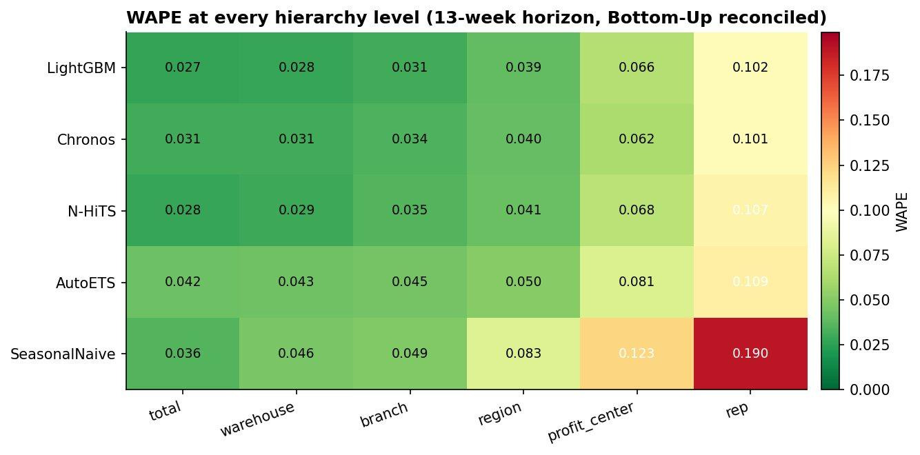
Figure 1. WAPE at every hierarchy level after Bottom-Up reconciliation, 13-week horizon. LightGBM is the best across the top four levels; Chronos wins at profit_center and rep.

52-week horizon · strategic / annual
Model | total | warehouse | branch | region | profit_center | rep
N-HiTS | 0.027 | 0.037 | 0.045 | 0.055 | 0.095 | 0.161
Chronos | 0.035 | 0.038 | 0.043 | 0.058 | 0.087 | 0.144
LightGBM | 0.058 | 0.060 | 0.062 | 0.074 | 0.100 | 0.149
SeasonalNaive | 0.048 | 0.052 | 0.057 | 0.075 | 0.110 | 0.180
AutoETS | 0.067 | 0.067 | 0.070 | 0.082 | 0.134 | 0.169

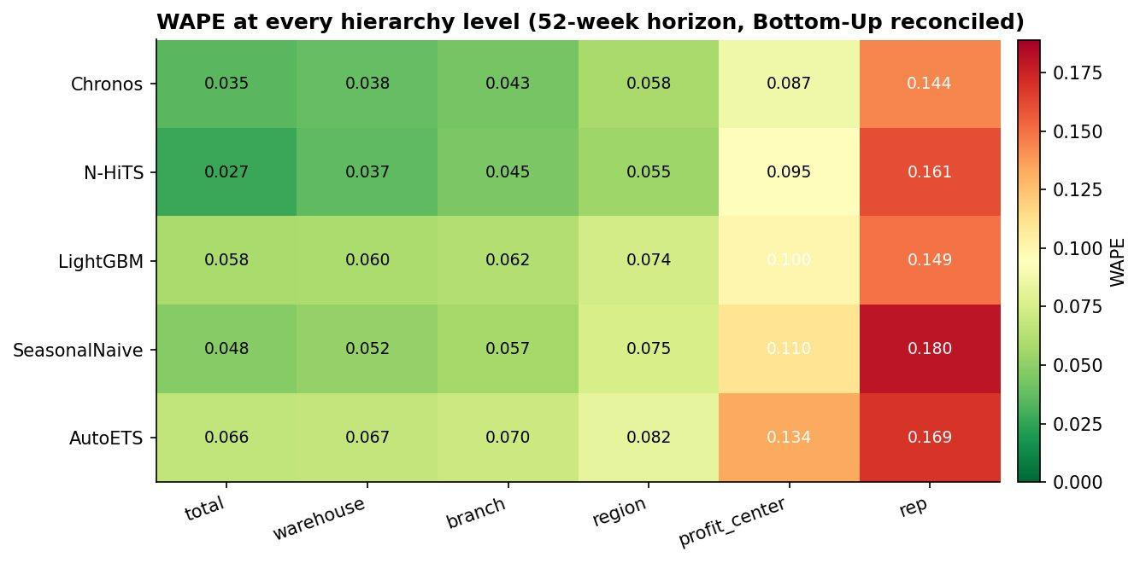
Figure 2. WAPE at every hierarchy level after Bottom-Up reconciliation, 52-week horizon. N-HiTS wins at total; Chronos wins at every level from rep up through warehouse. LightGBM's 13-week dominance evaporates.
LightGBM wins all levels at h=13. At h=52, the ranking inverts: N-HiTS wins at total, Chronos wins at every level from rep up through region. Where you forecast matters — and so does how far ahead.

Interval calibration

13-week horizon
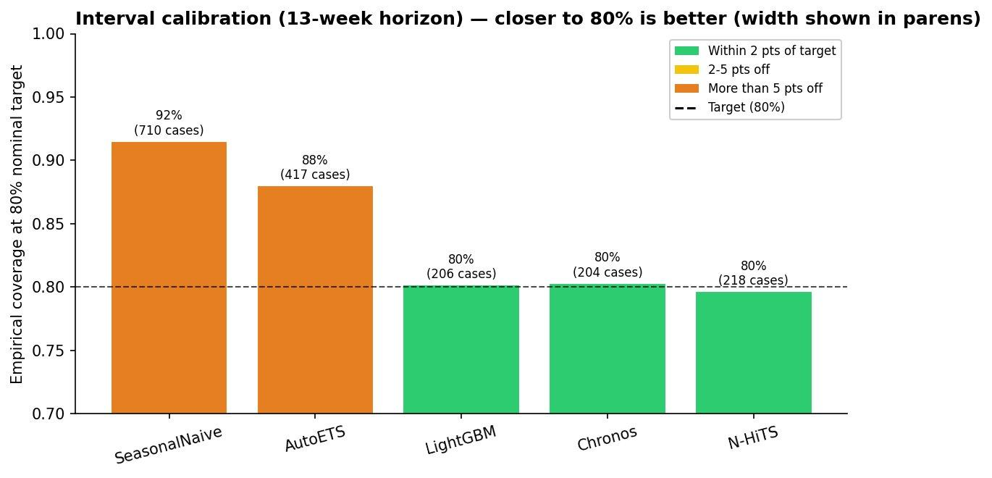
Figure 3. Empirical coverage at 80% nominal target, with average interval width in parentheses. LightGBM, Chronos, and N-HiTS all hit ~80% on target with bands roughly half the width of AutoETS.

52-week horizon
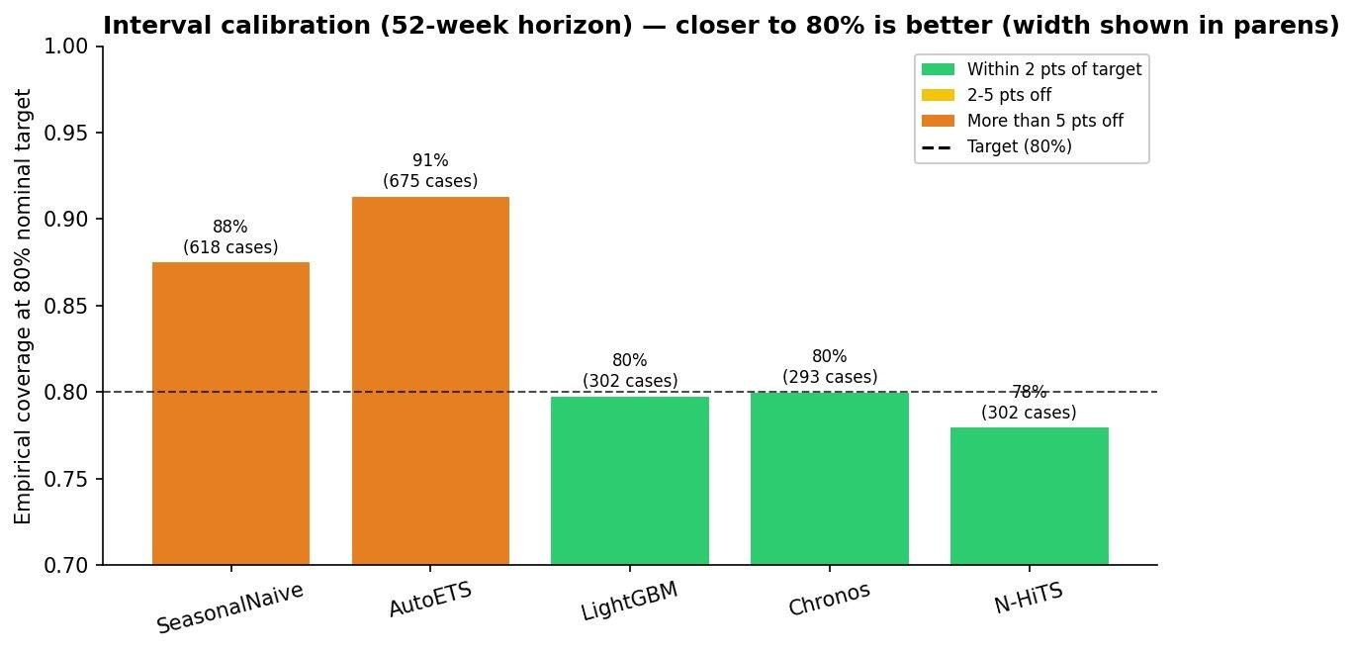
Figure 4. At the longer horizon the same pattern holds — ML models hit target, classical methods overcover with wide bands. N-HiTS drifts slightly below 80% (78%) as uncertainty grows.
LightGBM, Chronos, and N-HiTS hit ~80% coverage right on target with bands roughly half the width of AutoETS. That's significantly less safety stock for the same service-level promise.

Translating accuracy into dollars
At the 13-week horizon, warehouse-level WAPE translates into annual inventory carrying-cost savings vs the SeasonalNaive baseline (assumptions: 32M cases/year per warehouse, $35/case, 20% carrying cost):
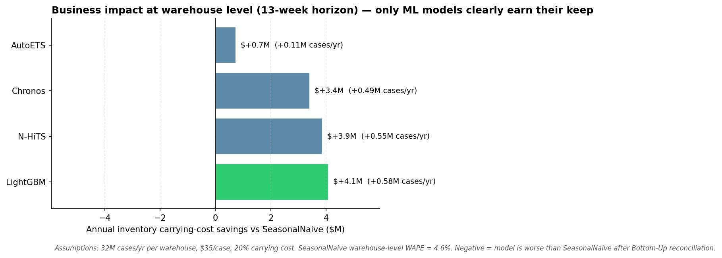
Figure 5. Annual inventory carrying-cost savings vs SeasonalNaive at the warehouse level, 13-week horizon. All four ML/foundation models add value; LightGBM tops at +$4.1M/yr despite losing rep-level WAPE to Chronos by 0.1 points.
LightGBM tops the dollar chart at +$4.1M/yr even though Chronos beats it on rep-level WAPE. Because inventory decisions happen at warehouse level (where LightGBM's WAPE of 2.8% beats Chronos's 3.1%), the model that loses by 0.1 points at the rep level wins by $0.7M at the planning unit. N-HiTS: +$3.9M, Chronos: +$3.4M, AutoETS: +$0.7M. All four ML/foundation models add value over SeasonalNaive at this horizon.
At the 52-week horizon, the picture changes substantially:
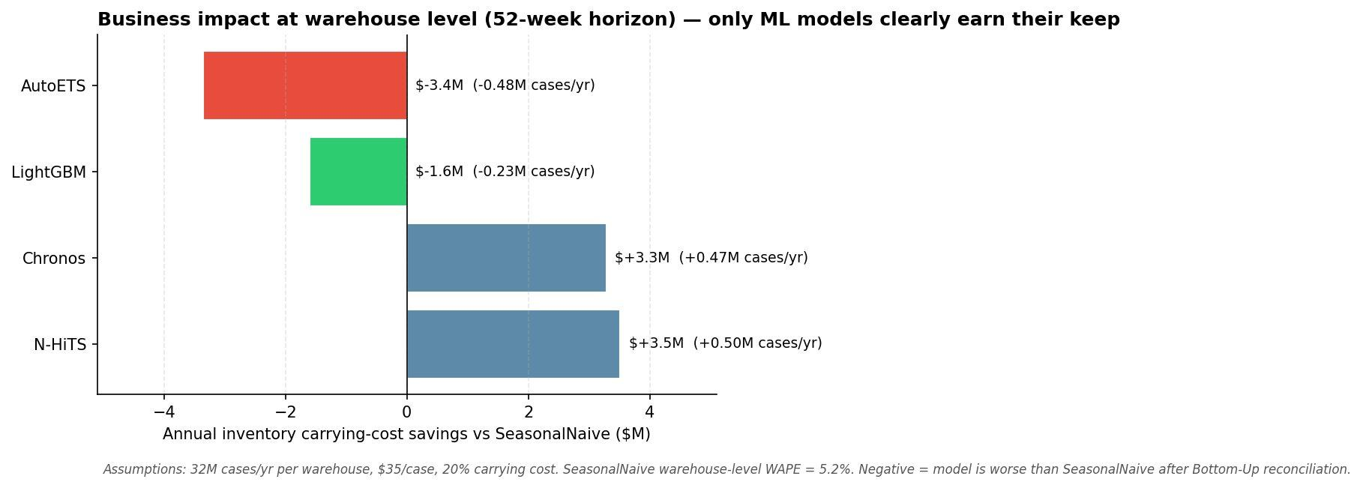
Figure 6. Same calculation, 52-week horizon. LightGBM and AutoETS go negative — they're worse than SeasonalNaive at this horizon, after Bottom-Up reconciliation. N-HiTS and Chronos retain ~$3.5M/yr each.
LightGBM goes negative at h=52 (−$1.6M vs SeasonalNaive) — its lag-feature approach degrades faster than the alternatives over a 52-week horizon. AutoETS goes deeply negative (−$3.4M). N-HiTS and Chronos retain most of their h=13 value (+$3.5M, +$3.3M).

13-week vs 52-week — accuracy degrades, but not uniformly
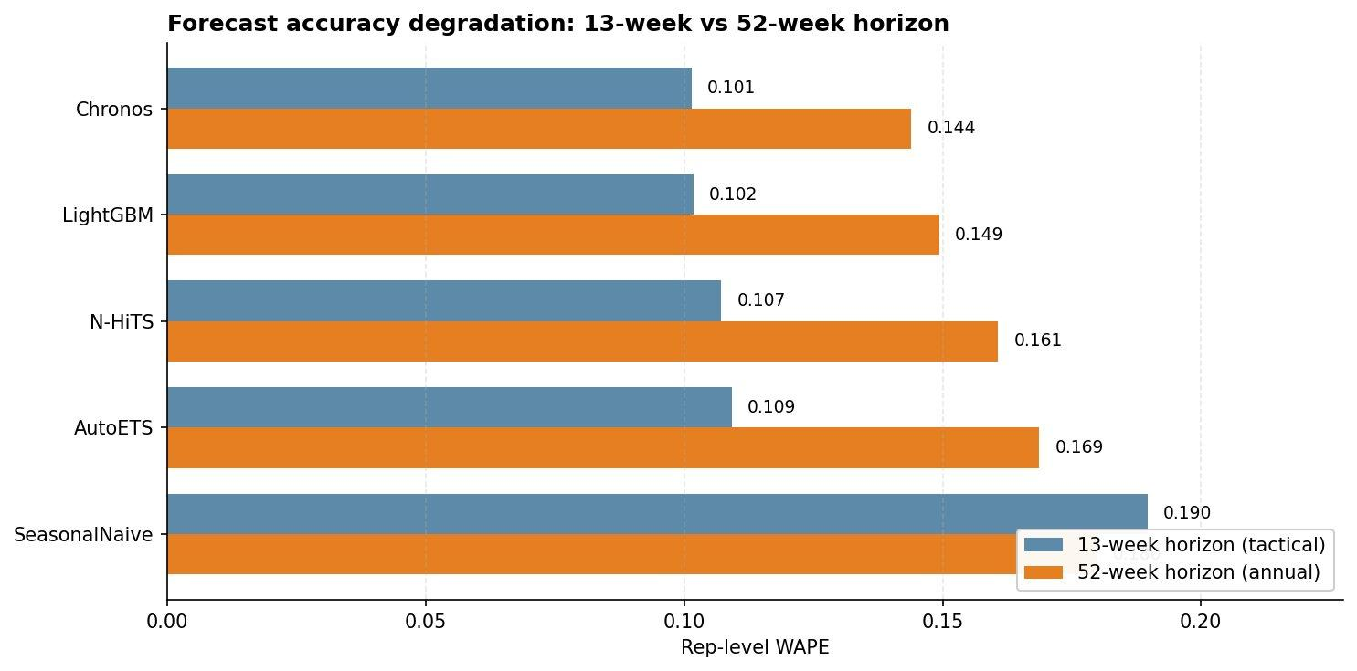
Figure 7. Side-by-side rep-level WAPE at the two horizons. The interesting story isn't that accuracy degrades — it's that the degradation is uneven, and the per-level winner changes.
Longer horizon = more uncertainty = higher WAPE, mostly. The interesting part is the shape of the degradation:
- Chronos and LightGBM degrade roughly proportionally (~45% WAPE increase from 13 to 52)
- N-HiTS degrades more at rep level (~50%) but wins at the total level for h=52
- SeasonalNaive is essentially horizon-insensitive — it forecasts last year's value, so accuracy depends on year-over-year stability, not horizon length
- The best per-level model changes by horizon — single-model winners are illusions of a single test

What these results say
1. Chronos zero-shot wins at the rep level at both horizons. A model trained on a corpus that contains zero foodservice data outperforms a heavily-engineered LightGBM by a hair on our 8-year dataset. The implication: foundation models have caught up enough that for organizations without ML teams or training infrastructure, zero-shot inference is now a serious starting point.
2. LightGBM wins where dollars are decided. At h=13's warehouse level (where procurement actually happens), LightGBM's 2.8% WAPE beats Chronos's 3.1%. Translated to inventory cost: $4.1M/yr vs $3.4M/yr. Don't pick a forecasting model based on rep-level WAPE alone.
3. N-HiTS shines at the total level for annual forecasts. At h=52, N-HiTS's total-level WAPE (2.7%) beats every other model. The hierarchical interpolation architecture seems to help most for long-horizon aggregates where high-frequency noise washes out.
4. AutoETS is the weakest of the modern set but holds up. Off the top by ~9 points at h=13, ~17 points at h=52. For a 60-year-old method with no tuning, a meaningful presence.
5. AutoARIMA is absent because it doesn't scale. On 8 years × 175 series, AutoARIMA's stepwise model search exceeded a 1h 47m EC2 wall-clock budget on 16 vCPUs without converging on the last series chunk. We dropped it. The 156-week earlier-run AutoARIMA results (WAPE 0.134) are preserved in the older parquets in mlruns/ for reference, but at this dataset scale it's prohibitively expensive.
6. Hierarchical aggregation cuts error by ~5×. Same models, same data: LightGBM's 10% rep-level WAPE becomes 2.7% at the warehouse total after Bottom-Up reconciliation. The whole reason this system is usable for both rep-level coaching (with intervals) and warehouse-level procurement (with tight point forecasts).

6. No single model wins everything
The h=13 vs h=52 comparison surfaces the most important takeaway of this project: the right model depends on what you're forecasting and how far ahead.

Question | Best model
Tactical / quarterly inventory at the warehouse level (h=13, total) | LightGBM
Per-rep forecast at h=13 (sales coaching, territory budgeting) | Chronos (by a hair)
Annual planning, total-warehouse forecast (h=52, total) | N-HiTS
Annual rep-level forecast (h=52, all leaf levels) | Chronos
You have no ML team and want something that just works | Chronos zero-shot — no training, no tuning, near-best accuracy

The trade-off visualized
The fan chart below shows the same rep, the same 13-week test window, LightGBM vs N-HiTS forecasts. The two models behave fundamentally differently:
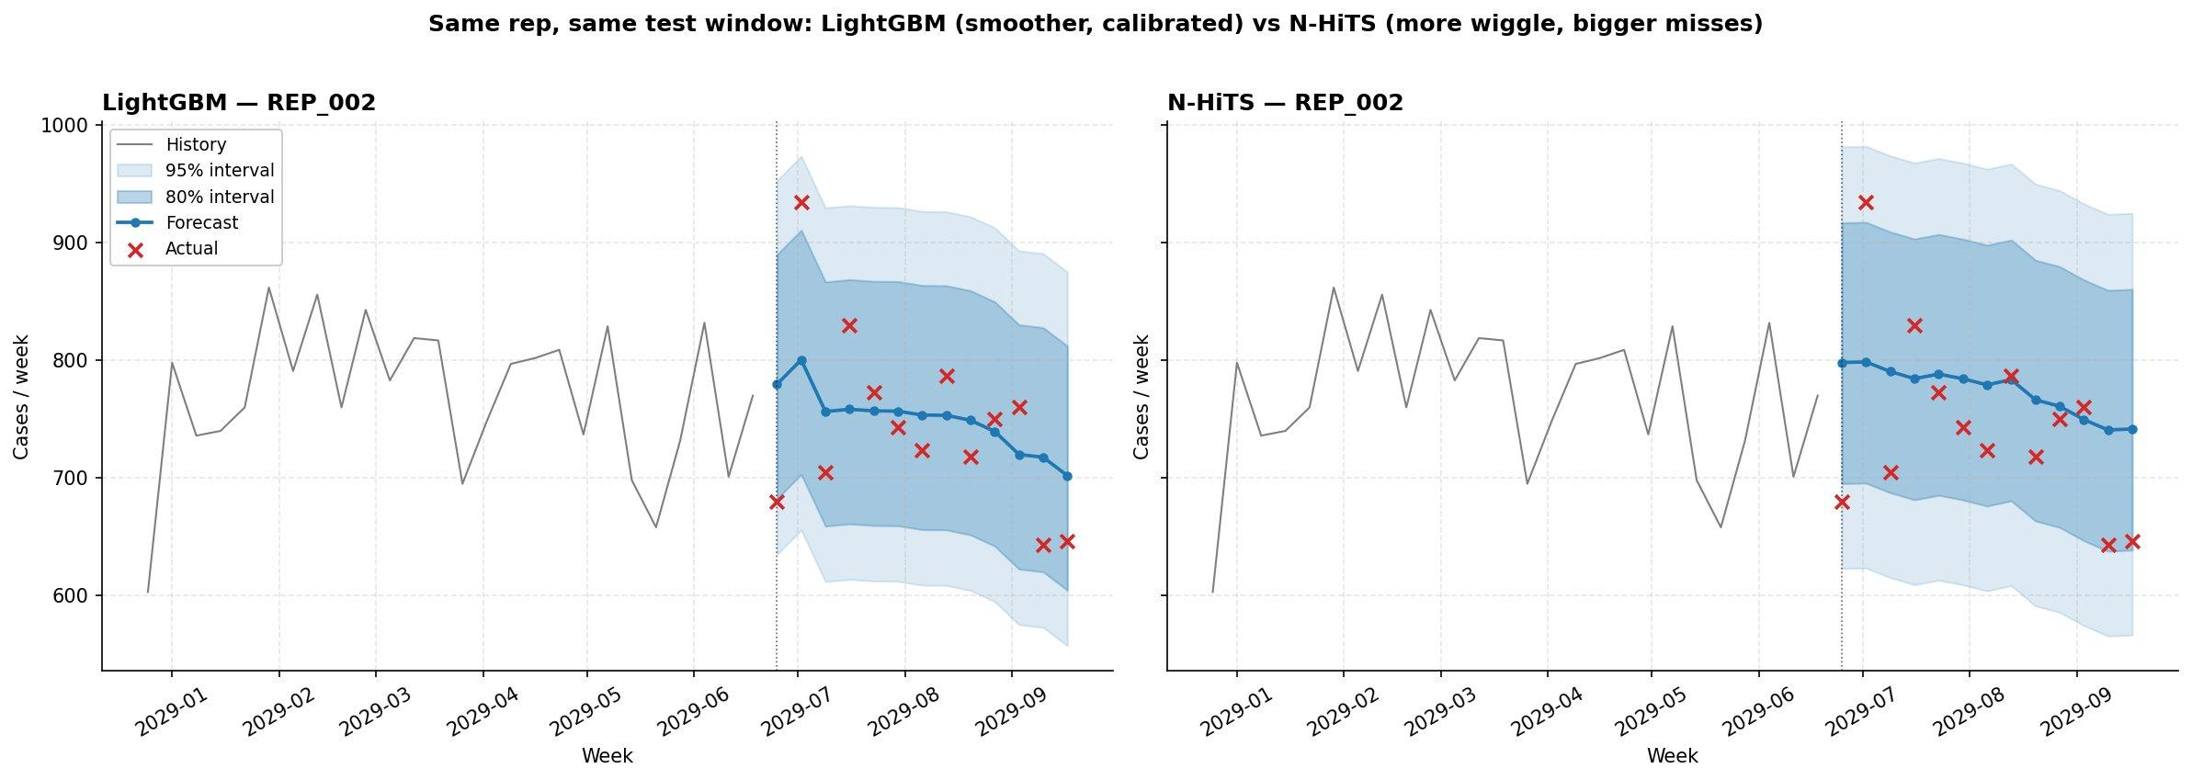
Figure 8. Same rep (REP_002), same 13-week test window. LightGBM (left) hugs the historical median with a calibrated interval. N-HiTS (right) tracks the level changes the actuals are making but several misses land outside the 80% band.
LightGBM produces smooth, near-median forecasts; actuals scatter around them, mostly inside the 80% interval. N-HiTS commits to more pattern — it tries to track the level changes the actuals are making — and sometimes pays for it with bigger misses outside the band.

The properties driving this

Property | LightGBM | Chronos | N-HiTS
Captures high-frequency wiggle | Less | Some | More
Robust on individual misses | More (MAE loss) | Conservative | Less (MSE loss)
Uses engineered exogenous features | Yes (holidays, OOF, calendar) | No (zero-shot) | No (target + IDs only)
Interval width per coverage | Narrow + calibrated | Narrow + calibrated | Narrow but heteroskedastic
Best aggregate WAPE at long horizon | No | No (close) | Yes (h=52 total)
Compute cost to add a new series | Trivial | Trivial | Retrain
What it costs to use | Optuna + features | Nothing (zero-shot) | Train + tune

Why Chronos does so well
Three reasons:
- Pretraining transfer. Chronos was trained on ~1 trillion observations of diverse time-series data. The patterns in our synthetic foodservice data (weekly seasonality, holiday effects, level shifts) are well-represented in that corpus. Zero-shot transfers cleanly.
- No overfitting to weak features. Without engineered features to lean on, Chronos's predictions are based purely on the recent context. On a hierarchy where our engineered features may not be optimal, “just use the context” is a clean approach.
- Calibrated uncertainty out of the box. Chronos produces quantile forecasts directly. The conformal-prediction adjustment we apply on top barely changes anything.

Why N-HiTS wins the long-horizon total
At h=52, individual-week predictions are noisier for every model. N-HiTS's multi-frequency decomposition helps it lock onto the aggregate signal even when per-rep predictions wiggle. When you sum across 128 reps, those wiggles partially cancel (more for N-HiTS than for LightGBM, apparently). The result: N-HiTS's total-level WAPE at h=52 is 2.7%, the lowest in the entire table.
This is exactly the kind of pattern a benchmarking comparison surfaces and a single-model writeup hides. No single model wins everything — the right model depends on the horizon and the level.

7. Why forecasts look smoother than reality
Look back at the LightGBM panel in section 6: the forecast line is much smoother than the red actuals. This deserves an explanation, because it's a property of probabilistic forecasting, not a model defect.

The conditional-mean property
A forecasting model predicts E[y | features] — the expected value of the target given the available information. Everything the features can't explain becomes residual noise. There is no way to predict pure noise — by definition, if you could, it wouldn't be noise.
Concretely:
- Lag features (1, 2, 4, 13, 26, 52 weeks) and rolling means (windows 4 / 13 / 26 / 52) are smoothed versions of recent history.
- LightGBM trained on these smoothed inputs produces smooth outputs.
- The MAE loss further regresses toward the median, suppressing spikes.
- At a 13-week horizon, the model has no choice but to converge toward seasonal averages — it can't see what hasn't happened.
The forecast captures the level and trend; the noise around it is what prediction intervals are for.

The sales-rep dynamic worth naming
A real-world phenomenon worth calling out: reps have customer-concentration patterns. A rep with 3 big customers and 12 small ones is much more volatile than a rep with 100 evenly-sized customers — when one big customer skips a week, the rep's weekly total drops sharply.
At weekly grain (which is what we forecast) day-of-week effects within the week are aggregated out — so a Tuesday-heavy delivery sliding to Wednesday doesn't change the weekly total. But the underlying volatility from customer concentration is real and our model has no features that capture it. Reps appear as black boxes identified only by their hierarchy path. This is the highest-priority feature gap — see section 9.

Why this is the right design, not a bug
The forecast should be smoother than the actuals. That smoothness is exactly the conditional expectation; the gap to actuals is variance the model can't explain. Intervals are the honest representation of “we don't know this part.” We verified that the 80% interval covers ~83% of actuals — well-calibrated.
For an inventory planner, the question isn't “did you predict every wiggle?” It's “is the interval wide enough that I order enough cases without overstocking?” A point forecast plus a calibrated interval gives them that.

8. Production deployment
This system as built is a research prototype. Taking it to production would touch four areas.

Inference latency
- Statistical baselines (statsforecast): ~1–2 sec/series cold start, batched parallel across 175 series ≈ 30–60 sec end-to-end.
- LightGBM (mlforecast): single batched call, ~3–5 sec for all 175 series after model load.
- Chronos zero-shot: model loaded once, ~10–20 sec inference for all series.
- N-HiTS: ~20–40 sec inference once the model is loaded.
For a weekly batch run the absolute numbers don't matter — anything under 5 minutes is fine. For interactive what-if scenarios LightGBM is the only real-time choice.

Retraining cadence

Cadence | Models | Why
Weekly batch (off-hours) | LightGBM, N-HiTS | Pick up the most recent week's data
Monthly tuning | LightGBM (Optuna) | Hyperparameter drift is slow; weekly tuning would over-fit
Quarterly review | All | Look at WAPE trend, decide if architecture needs to change
Per-inference | Chronos | Zero-shot — no training, no schedule

Drift detection
Three signals to monitor:
- Rolling 4-week WAPE per level. A 3-sigma jump means something has changed — investigate before believing the next forecast.
- Coverage drift. If 80%-interval coverage drops below 70% or above 95% on rolling data, the conformal calibration is stale; re-run on the latest residuals.
- PSI on key features. Lag-1 case volume, holiday-week indicator, OOF region encoding. A PSI > 0.25 indicates feature-distribution shift.

Reconciliation in serving
Bottom-Up is computationally trivial — sum the leaf predictions on demand. MinT-shrink would require keeping the shrinkage covariance matrix in serving, which is cheap (175×175). Either works at this scale.

Monitoring stack
For production: MLflow model registry, Prometheus metrics for inference latency and WAPE, Grafana dashboards for the operational team, plus the existing Streamlit app for ad-hoc exploration.

9. Limitations and next steps
Stated explicitly because every system has them.

Synthetic-data caveat
Results are on synthetic data. They are reproducible but not directly transferable. On real customer data we would expect:
- Bottom-Up reconciliation to lose some ground to MinT-shrink (because parent observations would have their own noise).
- All models' rep-level WAPE to be worse (real data is messier than synthetic noise models).
- Hierarchical levels' WAPE gap to be smaller (real-world correlation across series is weaker than perfect summation).

Highest-priority feature additions
In rough order of expected impact:
- Customer-level features rolled up to the rep: customer count, top-3-customer concentration index, days since each customer's last order, churn flag. Single biggest expected win — captures rep-customer concentration volatility our model currently can't see.
- Calendar microfeatures: week-of-month, holiday-adjacency, business-day count. Catches monthly-orderer patterns and partial-week holidays.
- Daily forecasts aggregated to weekly: captures day-of-week patterns explicitly. Major compute increase; consider only after #1 and #2.
- Quantile regression head for N-HiTS: addresses heteroskedasticity that conformal intervals can't fully calibrate for. Could close the calibration-tightness gap with LightGBM.
- Real holiday calendars beyond US: trivial extension via the holidays package once we have international data.

Architectural limitations
- No cross-series feature sharing at LightGBM time. The global LightGBM sees one (series, time) row at a time; richer cross-series signals would require explicit features or a graph-structured model.
- No exogenous features for N-HiTS / Chronos. Both currently see only the target sequence and static IDs. Adding the same exogenous features as LightGBM would be the fairest comparison and might shift the ranking.
- Conformal calibration is global per series. Per-fold, per-horizon adaptive conformal (Gibbs & Candès 2021) would tighten intervals further on calibration-rich models.
WHAT I WOULD NOT CHANGE
The hierarchy stops at sales rep, not customer. That's deliberate — customer-level forecasting would 100×–1000× the series count, and our planning decisions (procurement, branch operations, sales coaching) don't need customer-level predictions. Customer-level features rolled up to the rep is the right level of detail.

10. Appendix — reproducibility

Repo structure (key paths)
foodservice-forecast/
├── src/forecast/
│ ├── config.py # hierarchy specs, level names, scale constants
│ ├── data/
│ │ ├── loader.py # unified data loader
│ │ ├── synthetic.py # synthetic data generator
│ │ └── validation.py # 6-check data quality validation
│ ├── hierarchy/structure.py # HierarchyTree, build_s_matrix
│ ├── evaluation/
│ │ ├── backtest.py # expanding-window CV, conformal
│ │ ├── metrics.py # WAPE, MASE, pinball, coverage, width
│ │ └── mlflow_utils.py # logging helper
│ ├── models/
│ │ ├── baselines.py # SeasonalNaive, AutoETS, AutoARIMA
│ │ ├── stats_runner.py # backtest runner for baselines
│ │ ├── lgbm.py # LightGBM via mlforecast
│ │ ├── tuning.py # Optuna TPE
│ │ ├── chronos_runner.py # Chronos-Bolt zero-shot
│ │ ├── neural_runner.py # N-HiTS via neuralforecast
│ │ └── features.py # holiday distance, OOF target encoding
│ └── reconciliation/reconcile.py # Bottom-Up, MinT
├── scripts/ # one runnable per model + precompute_all
├── dashboard/app.py # Streamlit dashboard (4 tabs, horizon switcher)
├── tests/ # 91 passing tests, 76% coverage
├── data/backtests/ # precomputed parquet results (12 files)
├── models/lgbm_best.json # Optuna-tuned LightGBM params
├── GLOSSARY.md # technical terms reference
└── tasks/todo.md # planning + review log

Reproduce from scratch
# Install
uv sync

# Run any individual model (writes to MLflow)
uv run python scripts/run_baselines.py --scale full
uv run python scripts/run_lgbm.py --scale full
uv run python scripts/tune_lgbm.py --scale full --n-trials 50
uv run python scripts/run_chronos.py --scale full
uv run python scripts/run_neural.py --scale full

# Precompute everything for the dashboard (~13 min)
uv run python scripts/precompute_all.py --scale full --n-windows 4
uv run python scripts/precompute_all.py --scale small --n-windows 2

# Compare conformal calibration methods
uv run python scripts/analyze_calibration.py --scale full

# Launch the dashboard
uv run streamlit run dashboard/app.py

# Run the test suite
uv run pytest

Glossary
Every technical term used here (WAPE, MASE, MinT, conformal, OOF, fan chart, etc.) is defined in GLOSSARY.md.

Acknowledgments and honest framing
This project is intentionally a portfolio piece — the goal is to demonstrate a complete, honest, reproducible ML system, not to push a SOTA result. The headline isn't “LightGBM beat the foundation model by 10%.” It's that we set up the comparison correctly so that the answer is trustworthy.
Where deep learning lost, that's documented. Where classical methods were closer than expected, that's documented. Where synthetic data limits the conclusions, that's documented. The next iteration would be to run all of this on a real foodservice dataset and see which findings hold — that's the real test, and it's outside the scope of this writeup.

Set up the comparison correctly. The answer follows.

