My title

Ben Marwick (University of Washington, University of Wollongong)

other author

2016-08-08

My abstract

# Heading 1

This is an R Markdown document. Markdown is a simple formatting syntax for authoring HTML, PDF, and MS Word documents. For more details on using R Markdown see <http://rmarkdown.rstudio.com>.

When you click the **Knit** button a document will be generated that includes both content as well as the output of any embedded R code chunks within the document. You can embed an R code chunk like this:

## speed dist   
## Min. : 4.0 Min. : 2.00   
## 1st Qu.:12.0 1st Qu.: 26.00   
## Median :15.0 Median : 36.00   
## Mean :15.4 Mean : 42.98   
## 3rd Qu.:19.0 3rd Qu.: 56.00   
## Max. :25.0 Max. :120.00

## Heading 2

You can also embed plots, for example:

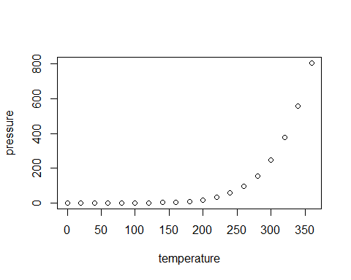

### Heading 3

Note that the echo = FALSE parameter was added to the code chunk to prevent printing of the R code that generated the plot.

Here is a table

|  |  |  |  |  |  |  |  |  |  |  |  |
| --- | --- | --- | --- | --- | --- | --- | --- | --- | --- | --- | --- |
|  | mpg | cyl | disp | hp | drat | wt | qsec | vs | am | gear | carb |
| Mazda RX4 | 21.0 | 6 | 160 | 110 | 3.90 | 2.620 | 16.46 | 0 | 1 | 4 | 4 |
| Mazda RX4 Wag | 21.0 | 6 | 160 | 110 | 3.90 | 2.875 | 17.02 | 0 | 1 | 4 | 4 |
| Datsun 710 | 22.8 | 4 | 108 | 93 | 3.85 | 2.320 | 18.61 | 1 | 1 | 4 | 1 |
| Hornet 4 Drive | 21.4 | 6 | 258 | 110 | 3.08 | 3.215 | 19.44 | 1 | 0 | 3 | 1 |
| Hornet Sportabout | 18.7 | 8 | 360 | 175 | 3.15 | 3.440 | 17.02 | 0 | 0 | 3 | 2 |
| Valiant | 18.1 | 6 | 225 | 105 | 2.76 | 3.460 | 20.22 | 1 | 0 | 3 | 1 |

#### Heading 4

Now knit this doc, and edit the styles in the resulting docx file. Then rename as 'template' and use this in the yml:

output:  
 word_document:  
 reference_docx: templates/template.docx

Don't forget line numbers for JAS! Headings are bold, underline, nothing. And Arial Narrow 10pt for tables.

See here for more information: <http://rmarkdown.rstudio.com/articles_docx.html>