Mobilization or Intimidation?

The Effect of Police Shootings on Voter Turnout

Andrew Kazal

Middlebury College Department of Economics

April 24, 2019

Advised by John Maluccio

**Abstract**

This paper examines the impact of police shootings on voter turnout. Specifically, I ask whether police shootings in the United States during the period leading up to the midterm 2014 and 2018 elections as well as the 2016 presidential election has a relationship with voter turnout at the county level. Thus far, other turnout literature examines factors such as demographics, the political environment, and economic influences. However, only one notable study examines the impact of a specific policing policy (Stop, Question, and Frisk) on voter turnout in the state of New York. To this point, no studies have directly examined the relationship between police shootings and voter turnout. I test this link using a county and year fixed-effects model, controlling for severable variables thought to impact voter turnout. I find that, while there is spurious evidence of a strong correlation in one direction, an increase of one shooting per 100 thousand citizens in a county in the 10-month period leading up to the election is associated with approximately a 0.07 percentage point decrease in voter turnout ( $p$ < 0.25). Due to the imprecision of this estimate, I conclude that there is the possibility of either no effect or multiple mechanisms pushing results in opposite directions, both of which are possible and indistinguishable in my study.

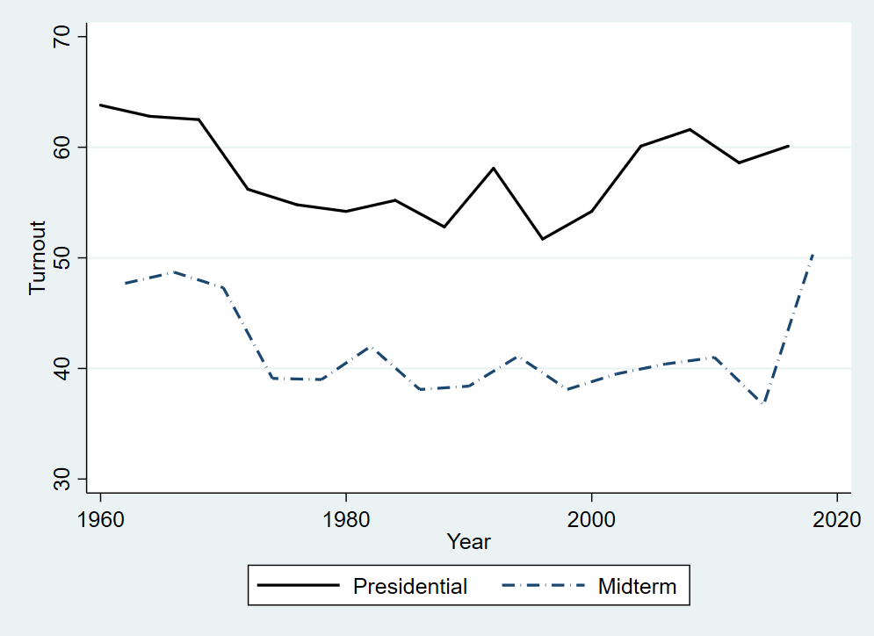**I. Introduction**

Figure . United States Voter Turnout 1960-2018

The United States has an irregularly low voter turnout rate compared to other developed countries. According to an analysis by the Pew Research Center, just under 56 percent of the voting age population participated in the 2016 election. This places United States beside Estonia and Luxembourg in OECD rankings. For comparison, Belgium ranked first with a participation rate for the voting age population of approximately 87% in 2014, although voting is mandatory. However, Denmark does not have mandatory voting laws and still saw a turnout of approximately 80% in 2015 (Desilver 2018). Is voter turnout a problem? First, consider Figure 1, the turnout for the voting eligible population in the United States since 1960 for midterm and presidential elections.[1] Although there have been certain years where turnout has increased from the previous cycle, voter turnout, on the whole, appears to be trending downwards since 1960. Second, consider that in the United States, the population of voters is not necessarily representative of the whole population (Leighley and Nagler 2017). Thus, for the democracy to fully serve all citizens, more participation is preferred. Some academic research proposes solutions to the issue. For example, as mentioned earlier, other countries have compulsory voting laws. Hill proposes the implementation of compulsory voting in the United States and makes a case for its benefits (Hill 2006). The largest opposition to successful use of compulsory voting is likely cultural and political conventions. In either case, part of the solution to this participation dilemma lies in understanding what currently causes individuals to vote. Television (Gentzkow 2006), demographics (Leighley and Nagler 2017), crime victimization (Bateson 2012), and trust in the government (Hooghe and Marien 2013) are all thought to influence whether an individual decides to vote. Can any of these factors be leveraged to improve turnout? Are there certain contributors that have not been examined fully?

The United States has particularly high rates of police shootings, especially compared to other OECD countries (*The Economist* 2014, Lopez 2018). This is an issue that has gained significant media coverage in the past decade. However, there is little research on whether police violence and police shootings can affect voting behavior. Most related studies come from other countries or analyze specific events. In my article, I attempt to provide a more comprehensive review by looking at country-wide voter turnout. Specifically, I ask the question: Is there a relationship between police shootings and voter turnout by county in the United States in the past 3 election cycles? In my study, I demonstrate that there may be no effect or the mixed effect of two mechanisms working against each other. The most significant result is that, compared to the 2014 and 2018 elections, shootings in the period leading up to the 2016 election may have had a very small but negative effect on voter turnout as a percentage of the county population; however, this result is imprecise (p < 0.25) and thus uncertain.

**II. Literature Review**

What determines an individual’s propensity to vote in any given election? This decision is influenced by a variety of factors, whether contextual, circumstantial, or demographic. Understanding these factors may help in understanding the low level of political participation in the United States. For example, the introduction of the television accounts for as much as half and one fourth of the reduction in participation in midterm and presidential elections, respectively, since the mid-20th century (Gentzkow 2006). The reduction in midterm participation is proposed to have been the result of a competition for press space between lower-level, local political press and national news sources and other television content.

Demographic and other variables can have both a positive effect or a negative, and some may have a mixed effect that is represented as a net-zero effect. One example is that different demographic characteristics play different roles at different stages of political participation (Timpone 1998). In the book, *Who Votes Now?* Leighley and Nagler (2017) further outline the other subtle demographic considerations important to voter turnout. The authors examine how voting behavior has evolved since 1972, citing and engaging with literature and conventions about turnout. In particular, Leighley and Nagler mention Anthony Downs’ conceptualization of voting as a typical economic decision. According to Downs, individuals act rationally by considering the costs and benefits of voting. John Aldrich further develops this idea by claiming that voting is a low-stakes activity, and therefore small changes in the costs or benefits result in substantial impacts on decisions. Leighly and Nagler internalize this theoretical framework to their analysis of differences in decisions by different demographic groups as the result of “differential abilities to subsume costs and benefits from voting.” The authors investigate education, income, race, age, gender, and marital status. The theoretical backing for the impact of education on voting behavior comes from the notion that education makes it easier to navigate and understand an election. There exists a positive and significant relationship between educational achievement and voter turnout. For income, the relationship is smaller but still positive. The effect of income is largest at the lower end of the income bracket, pointing to the fact that very poor individuals cannot afford to sacrifice effort and time more necessarily devoted to subsistence. In terms of race, blacks have had higher rates of turnout than whites, with the difference increasing since 1972. Additionally, non-Hispanic whites have consistently had higher rates of turnout than Hispanics. Age has a positive effect on voter participation. Finally, women are more likely to vote than men, and married individuals are more likely to vote than single individuals (Leighley and Nagler 2017). This general overview of demographic influences gives a structure which more specific studies build upon.

Other studies have examined the more niche components of voter turnout theory. Voting seems to conform to the rules of habit; voters who have participated in a previous election are more likely to participate in future elections (Gerber, Green, and Shachar 2003). Crime victimization (Bateson 2012), proximity of contact with the justice system (Walker 2014), and trust in the government (Hooghe and Marien 2013) are all linked to political participation. Using survey data from across the world, Bateson (2012) demonstrates no matter the level of crime, recent victimization results in higher participation. This suggests that, if citizens consider police violence a crime, victims of police violence may be more likely to participate politically. However, this is specifically only the case for instances of lower use of force where the victim survives. Walker (2014) outlines a more explicit explanation of how the criminal justice system can influence political participation by contrasting personal contact and proximal contact. Personal contact is defined as any spontaneous interaction where an individual encounters the criminal justice system, whereas proximal contact is considered knowing someone who has experienced personal contact as defined above. Personal contact is generally linked to demobilization (Weaver and Lerman 2010), and Walker shows that proximal contact does not have an effect on voting but a mobilizing effect on other political activities instead. The author hypothesizes that the positive effect will be on political participation specifically related to the criminal justice system instead of broader participation, yet she gives no evidence of this mechanism. Additionally, this study examines an expansive possibility of contact with the criminal justice system and is not focused on police violence. There is an obvious connection to trust in the government in both Walker’s study of the criminal justice system and Bateson’s study of victimization. The more trust a citizen has in their government, the more likely they are to engage in institutionalized participation (Hooghe and Marien 2013). Thus, police violence may erode a citizen’s trust and therefore reduce their likelihood of voting. Other studies represent more exact investigations of the effect of police activity on voting.

In the specific context New York City, a study examined the impact of the Stop, Question, and Frisk (SQF) program on voter participation (Laniyonu 2018). Using panel data on voter turnout at the voter tabulation district level for the 2006, 2008, and 2010 elections and the 2013 presidential primary elections, Laniyonu uses a binomial regression to show that the relationship between the number of stops and the turnout depends on the election year. Namely, in the 2006 and 2010 election cycles the relationship was negative. In the 2008 election and the 2013 democratic primary, the relationship was positive. The author attributes the difference in results to the facets of the political environments such as Obama’s campaign in 2008 and the presence of platforms cautionary against SQF. In another study in the state of New York, authors examine the results of a statewide survey measuring the effect of Eric Garner’s death on state-level voting decisions (Rahman et al. 2017). The proportion of respondents that supported the indictment of the officers involved in the case increased by almost 15% after viewing the “I can’t breathe” video; however, the authors note that many individuals will have already seen this video. Additionally, the survey results show that governor Cuomo’s proposition for a “special prosecutor” in cases where an officer kills a citizen garnered the approval of most of New York voters. While this study does not focus on voter turnout, it does examine how police violence can influence citizen’s political preferences. Incorporating this exposure to the event in the form of a video affected citizens and this dynamic of media coverage would be a valuable extension of my study but is not included here.

Finally, while less directly related to the implications of police violence in the United States, studies from other countries help to fill in the overall picture of state violence and voter turnout. The Catalonian referendum in 2017 is an example of police violence in a similarly developed country. Spanish police intervened during the voting process, and this provided an opportunity to examine the role of police in voting behavior. Rodon and Guinjoan (2018) ask if police use of force and deterrence against citizens during the Catalonian referendum impacted the behavior of voters both in and around municipalities that experienced violence. Using cross-sectional data and a survey of individuals who voted in the election, the authors show that the effect is negative in municipalities that directly experienced the violence, but a positive effect in surrounding communities. This case is removed from my study in that it occurs in a different country with a different political climate and there is a particular event in question. However, the study suggests another dynamic, the spillover effect, which may manifest in the effect of police shootings in the United States. If one county or community experiences a police shooting, perhaps this event not only impacts the community itself but also other neighboring populations.

In underdeveloped countries, democracy tends to be less stable and there are more overt uses of violence. In the case of sub-Saharan Africa and Kenya, electoral violence will reduce participation in particular political settings, especially if that reduction is the intended outcome of electoral violence; however, it does not generally result in lower turnout (Bekoe and Burchard 2017). In Colombia, two political parties, FARC and the paramilitaries, chose to suppress and mobilize voters, respectively, to achieve political success. Gallego (2018) shows, using panel data from the period of 1988 to 2009, that each party used violence for suppression when they lacked control. Further, FARC used alliances with current parties to influence voters positively but turned to violence when they lost control. In a theoretical article, Dunning (2011) examines when fighting and voting are considered complements and when are they considered substitutes. Two bodies of literature tend to explain violence and elections independently, but this article explains the choice between the two. Elections and violence can be considered substitutes even in a democracy such as the United States. For example, legislature might represent elections, and protests or riots might represent violence. In the substitute framework, violence can be dependent on the balance of power and considered direct or indirect. Indirect violence is used as a way of suppression whereas direct violence is used as a way to upset the norm. In the complement framework, the question is not whether there is a choice between violence and election but instead how the choice is made and why. That is to say, violence and elections can be used together in differing levels by examining the geographic distribution of voting and then exploiting violence in vulnerable locations to benefit political actors. In this case, in contrast to my study, political actors use and often impost elections as a tool to achieve other political endeavors. If police shootings can be exploited and used as electoral violence, this may be worth considering in my study.

My paper will add to the current literature by examining the distinct case of police shootings, a subset of police violence, and whether it influences voter turnout at the county level in the three most recent election cycles: the 2014 and 2018 midterms and the 2016 presidential election.

**III. Data Description**

I combine county-level data on voter turnout, police shootings, other measures of police violence, and demographic controls from several sources. For the independent variable, I use the Mapping Police Violence data set on police shootings across the United States. Mapping Police Violence compiles incidents reported by the crowdsourced websites KilledbyPolice.net, Fatalencounters.org, and the U.S. Police Shootings Database covering 2013-present. An incident is considered a police shooting if “a person dies as a result of being chased, beaten, arrested, restrained, shot, pepper sprayed, tasered, or otherwise harmed by police officers, whether on-duty or off-duty, intentional or accidental.”[2] The summary statistics for this dataset are presented in Table 2 of Appendix A.

For the dependent variable, voter turnout, I use Dave Leip’s Atlas of Presidential Elections for the 2014 and 2018 midterms and the 2016 presidential election. These datasets contain the total number of ballots cast in each county for the previously listed election cycles.

Controls at the county level include total population, population density, age, racial composition, educational attainment, foreign-born population, median household income in the past 12 months, and crime. These controls are modeled after those used by Madestam et al. (2013). All controls except unemployment, crime, and population density come from the American Community Survey (ACS). I accessed this survey data through the IPUMS NHGIS data finder. In order to exploit all counties, I use the 5-year averages ending in the election cycle year. For example, in the 2014 midterm cycle, I use the 5-year average of 2009-2014. I source violent crime and property crime from the Uniform Crime Reporting (UCR) Program, unemployment from the Bureau of Labor Statistics’ Local Area Unemployment Statistics, and population density from the United States Census Bureau’s American Fact Finder. Summary statistics for these control variables are presented in Table 1 of Appendix A.

Additionally, I compile various datasets from the Police Data Initiative as an attempt to understand whether other levels of use of force are correlated with police killings. These datasets are taken from 24 self-reporting city departments, with some cities reporting incidents across multiple years and others only across a single year.

**IV. Methodology**

For this analysis, I use two types of models: an ordinary least squares model specified for each of the three election cycles, and a fixed effects model specified using only the 2014 and 2018 midterm election cycles. Additionally, for all models, I examine a 3-month and a 10-month period of police shootings, both periods ending on the election day for each year. For example, the 2014 3-month period begins on August 4th, 2014 and ends on November 4th, 2014. This allows me to examine whether the immediacy of the shooting is important to the effect on turnout. Additionally, for each of the OLS models without fixed effects, I look at three regression specifications: a naïve estimate with no controls, an estimate with all controls, and an intermediate estimate with the sample limited to the observations included in the full-controls regression. In summary, I have eight different models.

I start with a simple model explaining voter turnout using the number of shootings per 100,000 residents in that county.

${Vote}_{i,t}= β_{0}+ β_{1}{Shootings}_{i, t-3}+ε_{i, t}$ (1)

${Vote}_{i,t}= β_{0}+ β_{1}{Shootings}_{i, t-10}+ε_{i, t}$ (2)

The turnout as a percentage of the total population in county *i* in election cycle *t* is explained by the number of police shootings per 100,000 residents in county *i* in election cycle *t*. Models 1 and 2 include shootings in the 3-month and 10-month window preceding the election, respectively. In my next two models, I specify the same regression but limit my sample to the counties for which I have all control variables. This allows me to understand whether there are any systematic differences in the missing observations when I move from my naïve estimate to the estimate including all controls. Next, I add the full set of controls.

${Vote}_{i, t}= β_{0}+ β_{1}{Shootings}_{i, t-3}+ λ_{e}+λ_{d}+ε_{i, t}$ (3)

${Vote}_{i, t}= β_{0}+ β_{1}{Shootings}_{i, t-10}+ λ_{e}+λ_{d}+ε_{i, t}$ (4)

These models have the same independent and dependent variables, but I now control for demographic ($λ_{d}$) and economic ($λ_{e}$) variables. I model my control variables after those used by (Madestam et al. 2013). Controls for race include percent non-Hispanic black, non-Hispanic White, percent Hispanic, and percent of other races. I split education into four categories: less than high school, a high school diploma or equivalent, some college, and bachelor’s degree or higher, all as percentages. I also include foreign-born population (%), logged median household income, total population, logged population density, violent crime (per capita), property crime (per capita), and the unemployment rate (%). I move from an ordinary least squares regression to adding county fixed effects.

${Vote}_{i, t}= β_{0}+ β_{1}{Shootings}_{i, t-3}+γ_{c}+{ γ}_{y}++ε_{i, t}$ (5)

${Vote}_{i, t}= β_{0}+ β_{1}{Shootings}_{i, t-10}+γ_{c}+{ γ}_{y}++ε_{i, t}$ (6)

In models 5 and 6, I specify the fixed effects without any additional controls. This model absorbs any time-varying or county-varying trends in the shooting and voting data. To further support this analysis, I add the full set of controls to the fixed-effect analysis.

${Vote}_{i, t}= β_{0}+ β_{1}{Shootings}_{i, t-3}+ λ_{e}+λ_{d}+γ_{c}+{ γ}_{y}++ε_{i, t}$ (7)

${Vote}_{i, t}= β_{0}+ β_{1}{Shootings}_{i, t-10}+ λ_{e}+λ_{d}+γ_{c}+{ γ}_{y}++ε_{i, t}$ (8)

Thus, models 7 and 8 are the most comprehensive and robust estimates of the effect of police shootings on voter turnout.

Additionally, I use data from the Police Data Initiative to examine the correlation between lower levels of use of force and police killings. I look at whether departments with a high frequency of lower levels of use of force are also associated with a higher frequency of police killings. If police killings themselves have an effect of voter turnout, it is possible that lower levels of use of force may follow the same trend.

**V. Results**

The findings from each of the models are presented in Tables 3-10 in Appendix A. The most significant finding is that, according to my most robust specification of the model including a 3-month window of police shootings presented in Table 9, there exists a positive relationship between the number of shootings per 100,000 residents and voter turnout by county. Namely, an increase of 1 shooting per 100,000 residents results in a 0.00616 increase percent increase in voter turnout. This represents approximately a __ percent increase compared to the mean turnout. Although this effect is statistically significant, it is quite small, especially considering the mean number of shootings per 100,000 residents of a county is 0.095 and 0.067 for 2014 and 2018, respectively (Table 2). Thus, a significant increase in the number of shootings per 100,000 residents has a small impact on voter turnout.

Examining Tables 3-8, the analysis of each election cycle individually, results are varied. The most consistent finding is that once all controls are included in the model, the effect is positive. Additionally, there is a larger effect of police shootings in the period closer to the election. In 2014, the effect is small but positive and statistically significant (Tables 3 and 4). While the effect is still larger in the 3-month window than the 10-month window, the two coefficients are similar. In the 10-month window, the effect appears to be small and negative, but the sign changes and the magnitude grows with the addition of the full set of control variables. In the 2016 presidential election, there is a consistently positive effect across all model specifications (Tables 5 and 6). However, this effect is only statistically significant at the 5 percent-level in the model for the 3-month window including all controls. In the 2018 midterm, the effect is predominantly negative at first glance. However, with the inclusion of the full set of control variables, the effect shrinks and becomes statistically insignificant.

The fixed effects analysis focuses on only the 2014 and 2018 midterm election cycles. This analysis shows that the effect of police shootings is positive and statistically significant, although economically small. The marginal effect of other variables such as education and household income are much more sizeable in explaining voter turnout (Leighley and Nagler 2017).

Although this analysis takes into account many variables and uses a fixed effects analysis to mitigate some of the issues with the scope of analysis, the findings are still nuanced. For example, the findings in each individual case of election cycle (Tables 3-8) might not be entirely comparable due to other factors. There may be a differential effect of police shootings on voter turnout during midterm elections as compared to presidential elections. Additionally, police violence has received more and more news coverage and therefore there may be changes in attitudes between the years of my study. Finally, there are different candidates and different political platforms and agendas set forth in each election, which is not accounted for in Tables 3-8. The fixed-effects analysis may absorb some of these time trends and geographic differences, but there is still reason for caution. The effect of police violence could still be mixed with a positive effect in some cases and a negative effect in others. This is still possible when considering my results as there may be a negative effect that is outweighed by the positive effect.

**VI. Conclusion**

The more trust a citizen has in their government, the more likely they are to engage in institutionalized participation (Hooghe and Marien 2013). Thus, police violence may erode a citizen’s trust and therefore reduce their likelihood of voting. Other studies represent more exact investigations of the effect of police activity on voting.

It is imperative to understand the determinants of voter participation in the United States to ensure the success of the democracy. My study sets out to examine the relationship between police shootings and voter turnout in the United States. I leveraged a nascent dataset on police shootings from Mapping Police Violence in combination with county-level voting data to create simple OLS analyses as well as fixed-effects analyses. While I found a positive effect of the number of shootings per 100,000 residents in a county, the effect was small, especially compared to other determinants of voting behavior. Mapping Police Violence, although an overseen, crowdsourced dataset, will continue to grow in the coming years. As the data quality on police violence in general as well as police shootings develops, this will allow for more exploration, better model specifications, and this analysis will become more comprehensive. Further analysis could also investigate the relationship between other variables in the Mapping Police Violence dataset such as whether the victim was armed, whether the victim was fleeing, and so on.

**References**

Bateson, Regina. 2012. “Crime Victimization and Political Participation.” *The American Political Science Review* 106 (3): 570–87.

Bekoe, Dorina A., and Stephanie M. Burchard. 2017. “The Contradictions of Pre-Election Violence: The Effects of Violence on Voter Turnout in Sub-Saharan Africa.” *African Studies Review* 60 (2): 73–92.

Desilver, Drew. 2018. “U.S. Trails Most Developed Countries in Voter Turnout.” *Pew Research Center*, May 21, 2018. https://www.pewresearch.org/fact-tank/2018/05/21/u-s-voter-turnout-trails-most-developed-countries/.

Dunning, Thad. 2011. “Fighting and Voting: Violent Conflict and Electoral Politics.” *The Journal of Conflict Resolution* 55 (3): 327–39.

Gallego, Jorge. 2018. “Civil Conflict and Voting Behavior: Evidence from Colombia.” 35 (6): 601–21.

Gentzkow, Matthew. 2006. “Television and Voter Turnout*.” *The Quarterly Journal of Economics* 121 (3): 931–72. https://doi.org/10.1162/qjec.121.3.931.

Gerber, A.S., D.P. Green, and R. Shachar. 2003. “Voting May Be Habit-Forming: Evidence from a Randomized Field Experiment.” *American Journal of Political Science* 47 (3): 540–50. https://doi.org/10.1111/1540-5907.00038.

Hooghe, M., and S. Marien. 2013. “A Comparative Analysis of the Relation Between Political Trust and Forms of Political Participation in Europe.” *European Societies* 15 (1): 131–52. https://doi.org/10.1080/14616696.2012.692807.

Laniyonu, Ayobami. 2018. “The Political Consequences of Policing: Evidence from New York City.” *Political Behavior*, May. https://doi.org/10.1007/s11109-018-9461-9.

Leighley, Jan E, and Jonathan Nagler. 2017. *Who Votes Now?: Demographics, Issues, Inequality and Turnout in the United States*. http://dx.doi.org/10.23943/princeton/9780691159348.001.0001.

Lopez, German. 2016. “There’s No Good Official Data on How Many People Police Kill Each Year.” Vox. August 13, 2016. https://www.vox.com/identities/2016/8/13/17938206/police-shooting-killing-data.

Madestam, Andreas, Daniel Shoag, David Yanagizawa-Drott, and Stan Veuger. 2013. “Do Political Protests Matter? Evidence from the Tea Party Movement*.” *The Quarterly Journal of Economics* 128 (4): 1633–85. https://doi.org/10.1093/qje/qjt021.

Rahman, Saeed, Jamie K. Hamilton, Hana T. Hamdi, Anjoli Anand, Anna Andel, Laurene Barlet, Juliana L. Bennington, et al. 2017. “The Eric Garner Case: Statewide Survey of New York Voters’ Response to Proposed Police Accountability Legislation AU - Snyder, Sara A.” *Journal of Social Service Research* 43 (1): 1–17. https://doi.org/10.1080/01488376.2016.1239598.

Rodon, Toni, and Marc Guinjoan. 2018. “Beaten Ballots: Turnout Dynamics Amidst Police Violence.” SSRN Scholarly Paper ID 3228430. Rochester, NY: Social Science Research Network. https://papers.ssrn.com/abstract=3228430.

*The Economist*. 2014. “Don’t Shoot,” December 11, 2014. https://www.economist.com/united-states/2014/12/11/dont-shoot.

Timpone, Richard J. 1998. “Structure, Behavior, and Voter Turnout in the United States.” *The American Political Science Review* 92 (1): 145–58. https://doi.org/10.2307/2585934.

Walker, Hannah L. 2014. “Extending the Effects of the Carceral State: Proximal Contact, Political Participation, and Race.” *Political Research Quarterly* 67 (4): 809–22.

Weaver, Vesla, and Amy Lerman. 2010. “Political Consequences of the Carceral State.” *The*

*American Political Science Review* 104 (4): 817–33.

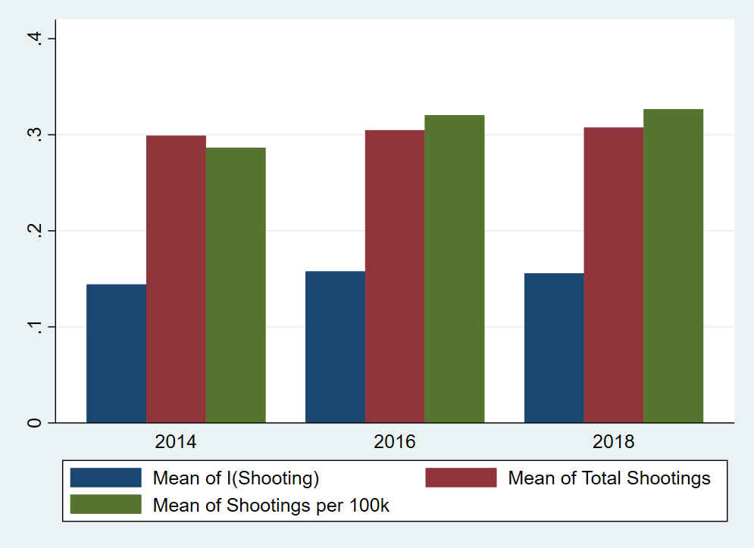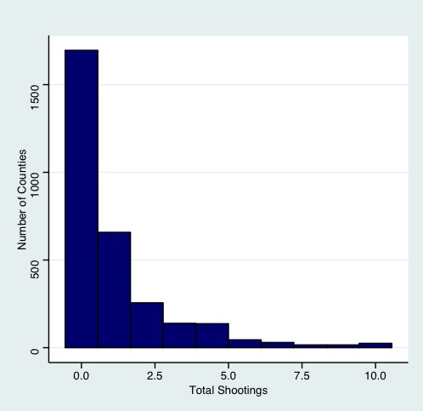**Appendix A: Additional Table and Figures**

Figure . Shooting Statistics Over Time

Figure . Total Shootings per County from 2013-2018

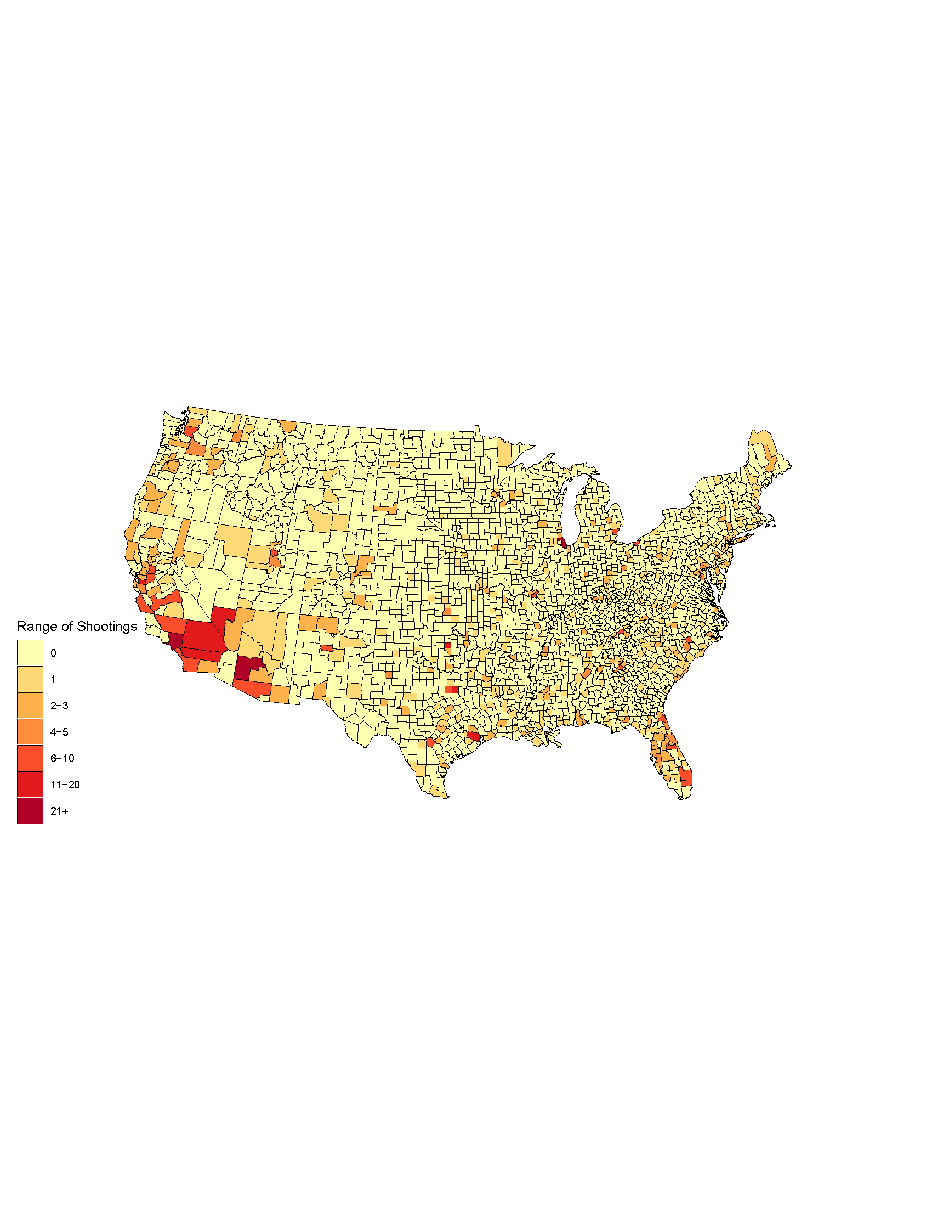

Figure . Total Police Shootings Choropleth by County, 2014

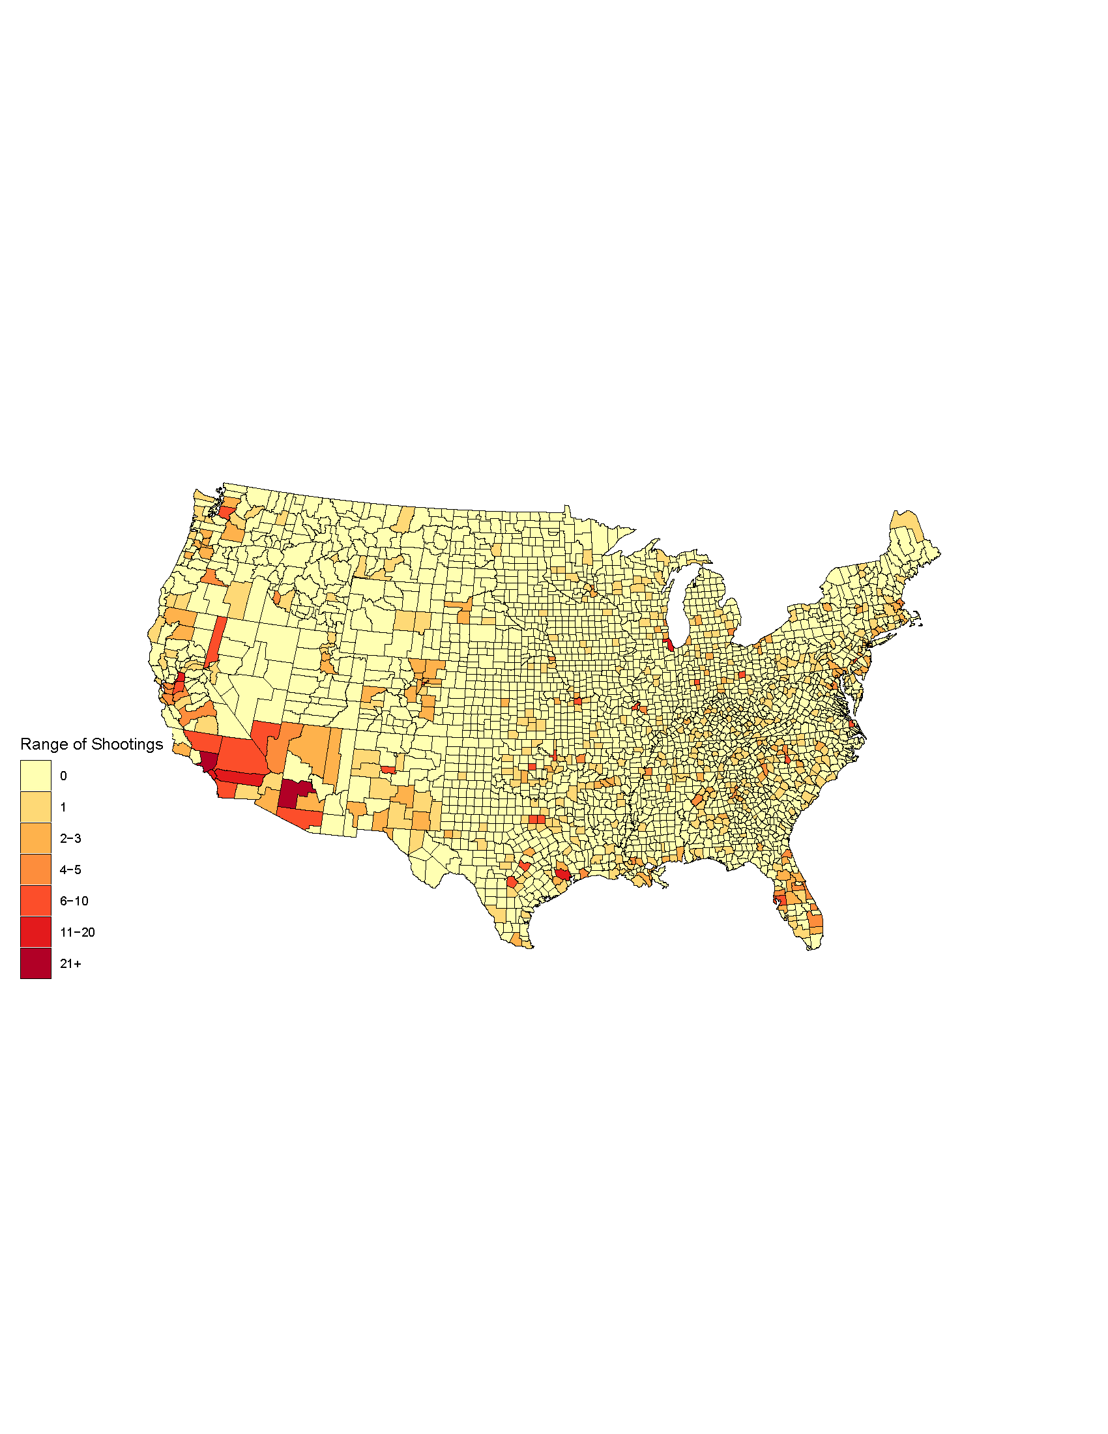

Figure . Total Police Shootings Choropleth by County, 2016

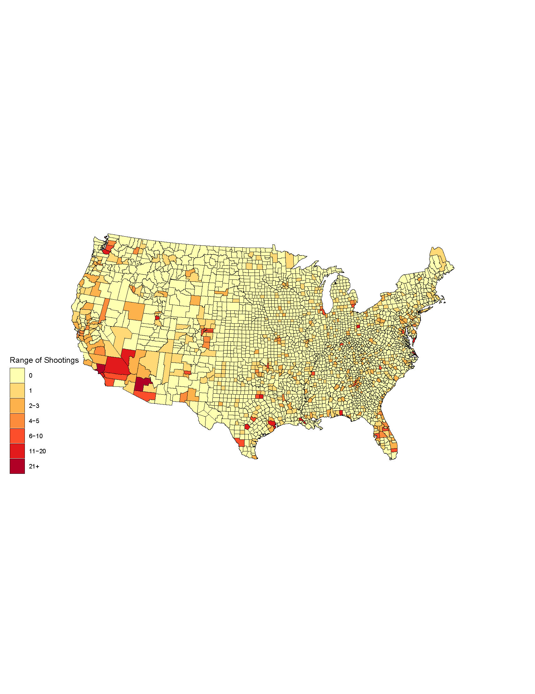

Figure . Total Police Shootings Choropleth by County, 2018

|  |  |  |  |  |  |  |  |  |  |  |  |  |  |  |  |  |  |
| --- | --- | --- | --- | --- | --- | --- | --- | --- | --- | --- | --- | --- | --- | --- | --- | --- | --- |
| Table X: | | | | | | | | | | | | | | | | | |
|  | 2014 | | | | |  | 2016 | | | | |  | 2018 | | | | |
|  | Mean | SD | n | Min | Max |  | Mean | SD | n | Min | Max |  | Mean | SD | n | Min | Max |
| Under 18 (%) | 0.231 | 0.034 | 3107 | 0.060 | 0.404 |  | 0.227 | 0.034 | 3107 | 0.051 | 0.403 |  | 0.225 | 0.034 | 3106 | 0.074 | 0.401 |
| 18-21 (%) | 0.054 | 0.027 | 3107 | 0 | 0.455 |  | 0.054 | 0.027 | 3107 | 0 | 0.488 |  | 0.052 | 0.026 | 3106 | 0 | 0.469 |
| 22-24 (%) | 0.036 | 0.013 | 3107 | 0 | 0.154 |  | 0.037 | 0.012 | 3107 | 0 | 0.151 |  | 0.037 | 0.012 | 3106 | 0 | 0.158 |
| 25-34 (%) | 0.115 | 0.022 | 3107 | 0.040 | 0.279 |  | 0.116 | 0.022 | 3107 | 0.038 | 0.276 |  | 0.117 | 0.023 | 3106 | 0 | 0.266 |
| 35-44 (%) | 0.120 | 0.017 | 3107 | 0.022 | 0.203 |  | 0.117 | 0.016 | 3107 | 0.019 | 0.217 |  | 0.116 | 0.015 | 3106 | 0.028 | 0.208 |
| 45-54 (%) | 0.145 | 0.016 | 3107 | 0.041 | 0.265 |  | 0.139 | 0.015 | 3107 | 0.042 | 0.210 |  | 0.132 | 0.015 | 3106 | 0.041 | 0.206 |
| 55-64 (%) | 0.135 | 0.022 | 3107 | 0.042 | 0.295 |  | 0.138 | 0.022 | 3107 | 0.038 | 0.338 |  | 0.141 | 0.022 | 3106 | 0.040 | 0.419 |
| 65+ (%) | 0.164 | 0.043 | 3107 | 0.033 | 0.467 |  | 0.172 | 0.044 | 3107 | 0.033 | 0.509 |  | 0.180 | 0.045 | 3106 | 0.037 | 0.542 |
| NH White (%) | 0.782 | 0.195 | 3107 | 0.013 | 1 |  | 0.776 | 0.196 | 3107 | 0.009 | 0.998 |  | 0.771 | 0.197 | 3106 | 0.006 | 1 |
| NH Black (%) | 0.089 | 0.145 | 3107 | 0 | 0.862 |  | 0.090 | 0.144 | 3107 | 0 | 0.859 |  | 0.090 | 0.145 | 3106 | 0 | 0.869 |
| Hispanic (%) | 0.085 | 0.134 | 3107 | 0 | 0.984 |  | 0.089 | 0.136 | 3107 | 0 | 0.987 |  | 0.092 | 0.138 | 3106 | 0 | 0.992 |
| Less than HS (%) | 0.105 | 0.046 | 3107 | 0.007 | 0.308 |  | 0.099 | 0.044 | 3107 | 0.009 | 0.327 |  | 0.095 | 0.043 | 3106 | 0.008 | 0.355 |
| HS (%) | 0.238 | 0.054 | 3107 | 0.063 | 0.563 |  | 0.238 | 0.055 | 3107 | 0.051 | 0.470 |  | 0.237 | 0.055 | 3106 | 0.050 | 0.451 |
| Some College (%) | 0.203 | 0.039 | 3107 | 0.055 | 0.352 |  | 0.206 | 0.039 | 3107 | 0.058 | 0.366 |  | 0.210 | 0.039 | 3106 | 0.053 | 0.369 |
| Bachelor or Higher (%) | 0.133 | 0.059 | 3107 | 0.021 | 0.538 |  | 0.139 | 0.061 | 3107 | 0.017 | 0.548 |  | 0.145 | 0.063 | 3106 | 0.036 | 0.555 |
| ln(Median Household Inc) | 10.701 | 0.240 | 3107 | 9.903 | 11.714 |  | 10.720 | 0.244 | 3106 | 9.869 | 11.724 |  | 10.779 | 0.249 | 3106 | 9.866 | 11.772 |
| Foreign Born (%) | 0.045 | 0.055 | 3107 | 0 | 0.513 |  | 0.046 | 0.056 | 3107 | 0 | 0.517 |  | 0.047 | 0.056 | 3106 | 0 | 0.529 |
| ln(Population Density) | 3.811 | 1.722 | 3107 | -2.040 | 11.161 |  | 3.815 | 1.730 | 3107 | -1.744 | 11.176 |  | 3.813 | 1.735 | 3106 | -2.202 | 11.191 |
| Violent Crime (per 100k) | 97.691 | 128.146 | 2524 | 0 | 3448.276 |  | 102.737 | 138.042 | 2568 | 0 | 4162.037 |  | 108.219 | 147.483 | 2417 | 0 | 4444.444 |
| Property Crime (per 100k) | 772.761 | 660.787 | 2524 | 0 | 8045.977 |  | 704.603 | 1334.022 | 2565 | 0 | 61678.489 |  | 670.287 | 1295.383 | 2491 | 0 | 59054.283 |
| Unemployment Rate (%) | 7.351 | 2.621 | 3106 | 1.2 | 25.5 |  | 5.502 | 1.940 | 3107 | 1.8 | 24.1 |  | 4.575 | 1.564 | 3106 | 1.6 | 19.1 |

|  |  |  |  |  |  |  |  |  |  |  |  |  |  |  |  |  |  |  |
| --- | --- | --- | --- | --- | --- | --- | --- | --- | --- | --- | --- | --- | --- | --- | --- | --- | --- | --- |
| Table X: | | | | | | | | | | | | | | | | | | |
|  |  | Any Shooting | | | | |  | Shootings per 100k | | | | |  | Total Shootings | | | | |
|  |  | Mean | SD | n | Min | Max |  | Mean | SD | n | Min | Max |  | Mean | SD | n | Min | Max |
|  |  |  |  |  |  |  |  |  |  |  |  |  |  |  |  |  |  |  |
|  |  | 3 Month Window | | | | | | | | | | | | | | | | |
|  |  |  |  |  |  |  |  |  |  |  |  |  |  |  |  |  |  |  |
| 2014 |  | 0.064 | 0.245 | 3107 | 0 | 1 |  | 0.095 | 1.170 | 3107 | 0 | 56.402 |  | 0.097 | 0.503 | 3107 | 0 | 13 |
| 2016 |  | 0.065 | 0.247 | 3107 | 0 | 1 |  | 0.113 | 1.086 | 3107 | 0 | 43.554 |  | 0.094 | 0.500 | 3107 | 0 | 16 |
| 2018 |  | 0.061 | 0.239 | 3106 | 0 | 1 |  | 0.067 | 0.468 | 3106 | 0 | 8.624 |  | 0.088 | 0.455 | 3106 | 0 | 9 |
|  |  |  |  |  |  |  |  |  |  |  |  |  |  |  |  |  |  |  |
|  |  | 10 Month Window | | | | | | | | | | | | | | | | |
|  |  |  |  |  |  |  |  |  |  |  |  |  |  |  |  |  |  |  |
| 2014 |  | 0.144 | 0.351 | 3107 | 0 | 1 |  | 0.287 | 1.604 | 3107 | 0 | 56.402 |  | 0.299 | 1.310 | 3107 | 0 | 35 |
| 2016 |  | 0.158 | 0.365 | 3107 | 0 | 1 |  | 0.320 | 1.535 | 3107 | 0 | 43.554 |  | 0.305 | 1.306 | 3107 | 0 | 45 |
| 2018 |  | 0.156 | 0.363 | 3106 | 0 | 1 |  | 0.327 | 1.672 | 3106 | 0 | 49.603 |  | 0.307 | 1.313 | 3106 | 0 | 38 |

|  |  |  |  |  |  |
| --- | --- | --- | --- | --- | --- |
| Table X: Turnout (%) | | | | | |
| Year | Mean | SD | n | Min | Max |
| 2014 | 29.005 | 8.566 | 3107 | 0 | 77.135 |
| 2016 | 44.673 | 7.994 | 3107 | 11.667 | 93.274 |
| 2018 | 37.323 | 8.158 | 3106 | 9.796 | 86.813 |

|  |  |  |  |  |  |  |  |  |  |
| --- | --- | --- | --- | --- | --- | --- | --- | --- | --- |
| Table X: | | | | | | | | | |
|  | 3 Month Window | | | |  | 10 Month Window | | | |
|  | (1) | (2) | (3) | (4) |  | (1) | (2) | (3) | (4) |
|  | Turnout | Turnout | Turnout | Turnout |  | Turnout | Turnout | Turnout | Turnout |
|  |  |  |  |  |  |  |  |  |  |
| Shootings per 100k | -0.201*** | -0.0384 | -0.142* | -0.0407 |  | 0.0581 | -0.00480 | -0.0190 | -0.0240 |
|  | (0.0656) | (0.0586) | (0.0837) | (0.0701) |  | (0.0812) | (0.0485) | (0.0715) | (0.0418) |
|  |  |  | (3.849) | (3.690) |  |  |  | (3.851) | (3.689) |
| Violent Crimes Per 100k |  |  | 0.00215 | 0.000501 |  |  |  | 0.00210 | 0.000401 |
|  |  |  | (0.00134) | (0.00122) |  |  |  | (0.00133) | (0.00122) |
| Property Crimes Per 100k |  |  | -0.00136*** | -0.000915*** |  |  |  | -0.00137*** | -0.000920*** |
|  |  |  | (0.000402) | (0.000345) |  |  |  | (0.000401) | (0.000346) |
|  |  |  | (0.0651) | (0.0618) |  |  |  | (0.0647) | (0.0615) |
|  |  |  |  |  |  |  |  |  |  |
| County FE | Y | Y | Y | Y |  | Y | Y | Y | Y |
| Time FE | N | Y | N | Y |  | N | Y | N | Y |
| Demographic Controls | N | N | Y | Y |  | N | N | Y | Y |
| Economic Controls | N | N | Y | Y |  | N | N | Y | Y |
|  |  |  |  |  |  |  |  |  |  |
| Constant | 33.17*** | 29.01*** | 25.58 | 25.05 |  | 33.15*** | 29.01*** | 31.09 | 30.80 |
|  | (0.00527) | (0.0454) | (29.01) | (27.03) |  | (0.0249) | (0.0470) | (29.05) | (26.98) |
|  |  |  |  |  |  |  |  |  |  |
| Observations | 6,180 | 6,180 | 4,905 | 4,905 |  | 6,213 | 6,213 | 4,930 | 4,930 |
| R-squared | 0.001 | 0.733 | 0.748 | 0.773 |  | 0.000 | 0.733 | 0.749 | 0.773 |
| Number of FIPS | 3,107 | 3,107 | 2,747 | 2,747 |  | 3,107 | 3,107 | 2,748 | 2,748 |
| Robust standard errors in parentheses | | |  |  |  |  |  |  |  |
| *** p<0.01, ** p<0.05, * p<0.1 | |  |  |  |  |  |  |  |  |

|  |  |  |  |  |  |  |  |  |  |  |  |
| --- | --- | --- | --- | --- | --- | --- | --- | --- | --- | --- | --- |
| Table X: | | | | | | | | | | | |
|  | 3 Month Window | | | | |  | 10 Month Window | | | | |
|  | (1) | (2) | (3) | (4) | (5) |  | (1) | (2) | (3) | (4) | (5) |
|  | Turnout | Turnout | Turnout | Turnout | Turnout |  | Turnout | Turnout | Turnout | Turnout | Turnout |
|  |  |  |  |  |  |  |  |  |  |  |  |
| Shootings per 100k | 0.0324 | -0.0394 | -0.0746* | -0.0412 | -0.00741 |  | 0.0577 | 0.00487 | 0.00783 | -0.0130 | 0.00596 |
|  | (0.146) | (0.0332) | (0.0396) | (0.0341) | (0.0478) |  | (0.0677) | (0.0273) | (0.0490) | (0.0265) | (0.0332) |
| 2016 X Shootings per 100k |  |  |  |  | -0.0772 |  |  |  |  |  | -0.0618 |
|  |  |  |  |  | (0.0658) |  |  |  |  |  | (0.0491) |
| Violent Crimes per 100k |  |  | 0.00112 | -0.000217 | -0.000220 |  |  |  | 0.00111 | -0.000230 | -0.000213 |
|  |  |  | (0.00123) | (0.000992) | (0.000991) |  |  |  | (0.00123) | (0.000992) | (0.000992) |
| Property Crimes per 100k |  |  | -0.00141*** | -0.000865*** | -0.000871*** |  |  |  | -0.00142*** | -0.000861*** | -0.000875*** |
|  |  |  | (0.000310) | (0.000250) | (0.000251) |  |  |  | (0.000309) | (0.000250) | (0.000251) |
|  |  |  |  |  |  |  |  |  |  |  |  |
| County FE | Y | Y | Y | Y | Y |  | Y | Y | Y | Y | Y |
| Time FE | N | Y | N | Y | Y |  | N | Y | N | Y | Y |
| Demographic Controls | N | N | Y | Y | Y |  | N | N | Y | Y | Y |
| Economic Controls | N | N | Y | Y | Y |  | N | N | Y | Y | Y |
|  |  |  |  |  |  |  |  |  |  |  |  |
| Constant | 37.00*** | 29.01*** | 142.1*** | 120.2*** | 119.7*** |  | 36.98*** | 29.01*** | 141.4*** | 120.2*** | 120.0*** |
|  | (0.0134) | (0.0570) | (29.25) | (25.80) | (25.86) |  | (0.0211) | (0.0574) | (29.40) | (25.86) | (25.88) |
|  |  |  |  |  |  |  |  |  |  |  |  |
| Observations | 9,320 | 9,320 | 7,494 | 7,494 | 7,494 |  | 9,320 | 9,320 | 7,494 | 7,494 | 7,494 |
| R-squared | 0.000 | 0.851 | 0.871 | 0.896 | 0.896 |  | 0.000 | 0.851 | 0.871 | 0.896 | 0.896 |
| Number of FIPS | 3,108 | 3,108 | 2,806 | 2,806 | 2,806 |  | 3,108 | 3,108 | 2,806 | 2,806 | 2,806 |
| Robust standard errors in parentheses | | |  |  |  |  |  |  |  |  |  |
| *** p<0.01, ** p<0.05, * p<0.1 | |  |  |  |  |  |  |  |  |  |  |

**Appendix B: Variable Definitions**

Any Shooting – an indicator for whether the county had any shooting in the given window.

Shootings (per 100k) – the number of shootings in the county per 100,000 residents

Total Shootings – the total number of shootings in the county

Turnout (%) – the proportion of the total county population that cast a vote in the election year

Under 18 (%) – the proportion of the total county population under the age of 18

18-21 (%) – the proportion of the total county population between the age of 18 and 21

22-24 (%) – the proportion of the total county population between the age of 22 and 24

25-34 (%) – the proportion of the total county population between the age of 25 and 34

35-44 (%) – the proportion of the total county population between the age of 35 and 44

45-54 (%) – the proportion of the total county population between the age of 45 and 54

55-64 (%) – the proportion of the total county population between the age of 55 and 64

65+ (%) – the proportion of the county total population above the age of 65

NH White (%) – the proportion of the county population that is non-Hispanic white

NH Black (%) – the proportion of the total county population that is non-Hispanic black

Hispanic (%) – the proportion of the total county population that is Hispanic

Less than HS (%) – the proportion of the total county population with less than a high school diploma or equivalent

HS (%) – the proportion of the total county population with a high school diploma or equivalent

Some College (%) – the proportion of the total county population with some college but either no degree or an Associate’s degree

Bachelor or Higher (%) – the proportion of the total county population with a Bachelor’s Degree Master's degree, professional school degree, or a Doctorate degree

ln(Median Household Inc) – the logarithm of the median household income in the county

Foreign Born (%) – the proportion of the total population that was not born a citizen of the United States

ln(Population Density) – the logarithm of the population density of the county. The population density is calculated as the total county population divided by the total land area of the county

Violent Crime (per 100k) [3] – the number of instances of “murder and nonnegligent manslaughter, rape (legacy & revised), robbery, and aggravated assault” in the county per 100,000 residents

Property Crime (per 100k) 2 – the number of instances of “burglary, larceny-theft, and motor vehicle theft” in the county per 100,000 residents

Unemployment Rate (%) – the proportion of the labor force in the county that is unemployed

1. Data sourced from the United States Election Project (http://www.electproject.org/)
2. From https://mappingpoliceviolence.org/aboutthedata; accessed on March 25, 2019.
3. Formal definitions sourced from https://ucr.fbi.gov/crime-in-the-u.s/2017/crime-in-the-u.s.-2017/topic-pages/property-crime on April 23, 2019