**Preface**

This book is intended to address the earlier part of the process in developing a research strategy. The challenge is to transform the personal, private deliberations leading to critical and creative thinking to a more transparent process. If that can be made more public by using computer algorithms, the innovative paths can be better understood. The concepts involved are comparable to the proof of theorems. The innovator develops a theorem and its proof. Students learn to duplicate the process leading to the desired result and are introduced to the process of critical and creative thinking in that way.

Typically, the research process is presented beginning with the recognition of a problem to be addressed. The process leading to that recognition is hidden. There are different ways to select a problem. It could be recognized after a review of the existing literature. It could be determined by observation during daily activities. It could be determined after discussion with colleagues. The particular path leading to the recognition may be hidden from the individual so that when queried, the best response is – the problem is important ***because…***

**Idea Analysis:** Making the critical and creative thinking process transparent begins with an important mechanical task – the identification, extraction, and organization of the authors’ ideas from scholarly publications. That task can be performed by software. The result is a separation of the mechanical and intellectual components of building and using a resource. The essential data consist of authors’ ideas. These intellectual building blocks can be used to develop descriptions of the topic and to identify gaps or inconsistencies that could lead to new research strategies.

**Algorithmic Approach**: The use of ideas can be made transparent by application of computer algorithms. The advantage is a discernible path of tasks describing the critical or creative act. This separation of mechanical acts performed using algorithms and intellectual acts defining order of and intent of tasks has advantages. Among which is a shortened time and a shift in energy expenditure from the mechanical/clerical to the intellectual. The emphasis is on the higher cognitive functions – synthesis, comparison, evaluation, judgment, and application. The focus is on the development of ***measures*** associated with each cognitive function, the establishment of ***criteria*** to determine how to use those measures, and the recognition of ***decision-rules*** describing the resulting actions associated with the measures and criteria. These deliberations are examples of critical thinking and intellectual function.

**Caries and Anti-cancer Treatment:** To illustrate the process, occurrence of caries following anti-cancer treatment was chosen. Three possible scenarios were presented in the literature. The predominant one was protection against localized damage using various fluoride preparations. The second and third approaches involved inclusion of antioxidants and probiotics to respectively, enhance the immune system and change the bacterial population in the oral cavity. These ideas, however, were presented as results of either observational studies or procedure-lacking literature reviews. As such, the necessary evidence to substantiate changes in practice were apparently insufficient as corrective treatments continued as the methods of choice. These ideas, if prevention of caries is an important objective, require a formalized program of research ranging from case studies, observational studies and conclusive randomized trials.

**Idea Identification, Extraction, and Organization**: Exhibit 1 shows the result of the identification, extraction, and organization process. The informative terms within the first sentence are highlighted in red. These terms are arranged as pairs and entered into a data file. The idea records show these pairs (ideas) together with their location in the document. The document identification number was assigned by PubMed and provides a portal for rapid retrieval. This identification and extraction process is effective in capturing the ideas expressed by the authors and facilitates use of those in building descriptions of existing knowledge (higher frequency and consistently expressed ideas) as well as strategies for development of new research.

**Exhibit 1. Example of Sentence Containing Ideas and the Ensuing Data Records Included in the Idea Repository – Identification Number 19151554.**

**Source:** [**Silva AR**](http://www.ncbi.nlm.nih.gov/pubmed?term=Silva%20AR%5BAuthor%5D&cauthor=true&cauthor_uid=19151554)**1,** [**Alves FA**](http://www.ncbi.nlm.nih.gov/pubmed?term=Alves%20FA%5BAuthor%5D&cauthor=true&cauthor_uid=19151554)**,** [**Antunes A**](http://www.ncbi.nlm.nih.gov/pubmed?term=Antunes%20A%5BAuthor%5D&cauthor=true&cauthor_uid=19151554)**,** [**Goes MF**](http://www.ncbi.nlm.nih.gov/pubmed?term=Goes%20MF%5BAuthor%5D&cauthor=true&cauthor_uid=19151554)**,** [**Lopes MA**](http://www.ncbi.nlm.nih.gov/pubmed?term=Lopes%20MA%5BAuthor%5D&cauthor=true&cauthor_uid=19151554)**. Patterns of demineralization and dentin reactions in radiation-related caries.** [**Caries Res.**](http://www.ncbi.nlm.nih.gov/pubmed/?term=19151554) **2009;43(1):43-9. doi: 10.1159/000192799. Epub 2009 Jan 19. PMID: 19151554.**

**Sentence 1:** ***Radiation-related caries is a unique form of rampant decay and is a complication of head and neck radiotherapy that frequently causes generalized dental destruction and impairs quality of life in cancer patients.***

**Idea Records:**

|  |  |  |  |  |
| --- | --- | --- | --- | --- |
| **Primary** | **Related** | **Year** | **Ident** | **Sentence** |
| **cancer** | **Caries** | **2009** | **19151554** | **1** |
| **cancer** | **Cause** | **2009** | **19151554** | **1** |
| **cancer** | **Dental** | **2009** | **19151554** | **1** |
| **cancer** | **Life** | **2009** | **19151554** | **1** |
| **cancer** | **Radiation** | **2009** | **19151554** | **1** |
| **cancer** | **radiotherapy** | **2009** | **19151554** | **1** |

**Cancer and Caries:** Figure 1 shows the terms linked with the central idea – cancer & caries – for the period 1990-2013. Those terms have been classified into dimensions representing components of the topic. Each term, ,when linked with the central idea, forms a triadic (combination of three terms) idea. As more terms are combined by the authors in their sentences, the result more closely approximates a concept. By definition, a concept is a composite of terms and/or ideas to form a more complete representation of a characteristic. The disease dimension included systemic diseases (e.g., heart, hypertension, infection) and other sites of cancer (e.g., breast and colon). The treatment dimension included treatments for the cancers (e.g., chemotherapy and radiation treatment) as well as those for dental issues (e.g., hygiene, fluoride, and implant). The triadic idea – cancer & caries & nutrition – was used 5 times in documents entered into PubMed between 2000 and 2004. The triadic idea – cancer & caries & prevent – was used 22 times. This idea was considered by authors from 1990 through 2012.

**Preventing Caries in Oral Cancer Patients:** In 1975**,** Wescott reported caries experience following radiotherapy and a post-radiation regimen including stannous fluoride gel. The patients divided themselves into two groups – those who complied with the treatment and those who did not. They found that caries occurrence was considerably lower in the group who complied with daily fluoride treatment.

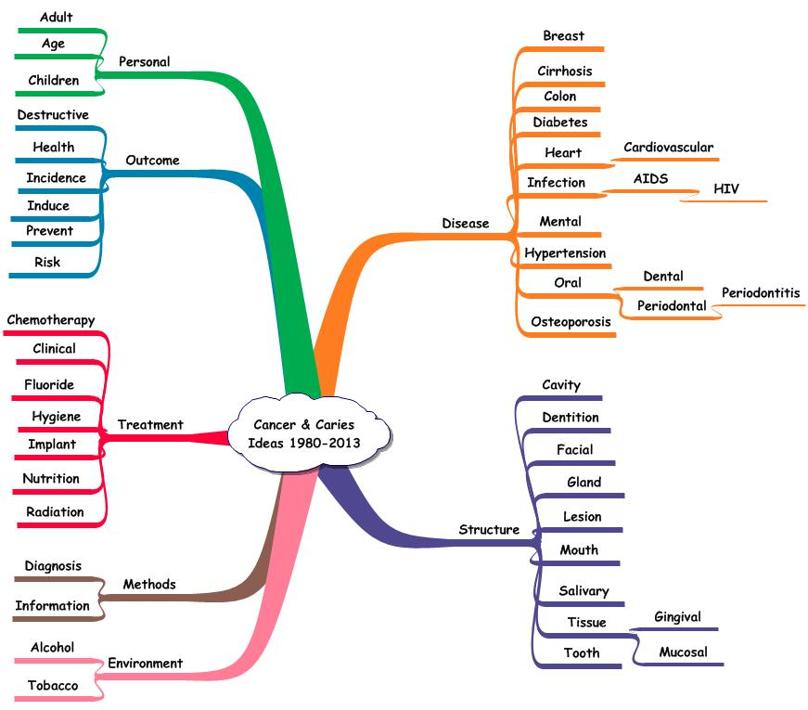**Figure 1. Terms Linked with the Central Idea – Cancer & Caries – 1990-2013.**

Horiot et al reported the results of a randomized study involving sodium fluoride gel vs. high content fluoride toothpaste. At follow-up, the authors found that the gel group had a lower occurrence of caries. The authors indicated that patients who complied with their assigned treatment were free of caries irrespective of the fluoride treatment.

An additional 15 reports describing observational studies or peer-reviewer accepted opinion-based literature reviews were entered into PubMed during the period 1970 and 1989. Observational studies are comparable to case studies but involve groups rather than individual patients. Opinion-based reviews present findings without the details of analysis specified by Cochrane in systematic literature reviews. These reports recognized the benefits of fluoride treatment in preventing caries given radiation treatment or chemotherapy for cancers.

**Challenges:** The application of text mining software to scholarly publications is not without challenges. As an example, the study of dental-related diseases involves contributions from epidemiology, clinical, and laboratory science. As such, the text mining software must deal with different writing styles and vocabularies. In addition to the variation in specific topics considered and ways of describing them, there are numerous sources contributing bibliographic data to PubMed. This bibliographic resource contains over 24 million documents making the assessment of accuracy a monumental task. The resource is continuously changing making retrieval results an estimate rather than a fact. Given these conditions, the search engine identified 18,602 documents (1990-2013) or 74% of the documents containing the phrase – dental AND disease – in their list of subject headings. This capture resulted in more than 1.2 million ideas.

**Idea Databases:** In addition to the eBook describing the earlier part of research development, a comprehensive idea database providing ideas from 1990 – 2013 is included. These ideas are organized as excel files and may be downloaded for detailed processing. In searching for new problems to study or the development of new descriptions of existing knowledge, it is useful to begin with the most recent ideas (2010-2013). When specific ones are identified, their occurrence in earlier years can be determined and a temporal description of the ideas developed. This approach is useful in identifying new ideas versus ones that have been considered for longer periods of time.

The advantage of an idea database using Excel is that the use of the software is widely known. The primary functions are:

1. Selection of record subsets.
2. Sorting of records.
3. Copying of records.
4. Counting of records.

By combining these functions, existing and new arrangements of ideas can be rapidly developed. As a result, the emphasis is on measures, criteria, and decision-rules associated with comparing the various syntheses.

John M. Weiner, Dr.P.H.

[weiner.john@tutorghost.com](mailto:weiner.john@tutorghost.com)

William McAfoos,BCE

[wmcafoos@btbuffalo.com](mailto:wmcafoos@btbuffalo.com)