**Chapter 7 – Research, Idea Database, and Disaster Science**

**Introduction**

Research is a process of self-learning and discovery. The objective considered in this chapter is the relationship between the selection and use of essential data; transparent, quality-controlled procedures; and an emphasis on higher cognitive functions. The data were the ideas from disaster science.

The involved tasks in a research process are shown in Figure 1 as an information network. The major components are literature review, development of a protocol (behaviors and procedures) for the formalized study of the identified problem, the selection of a study design, and the choice of study methods.

**Figure 1. Components of Self-Discovery, Information Processing and Research.**

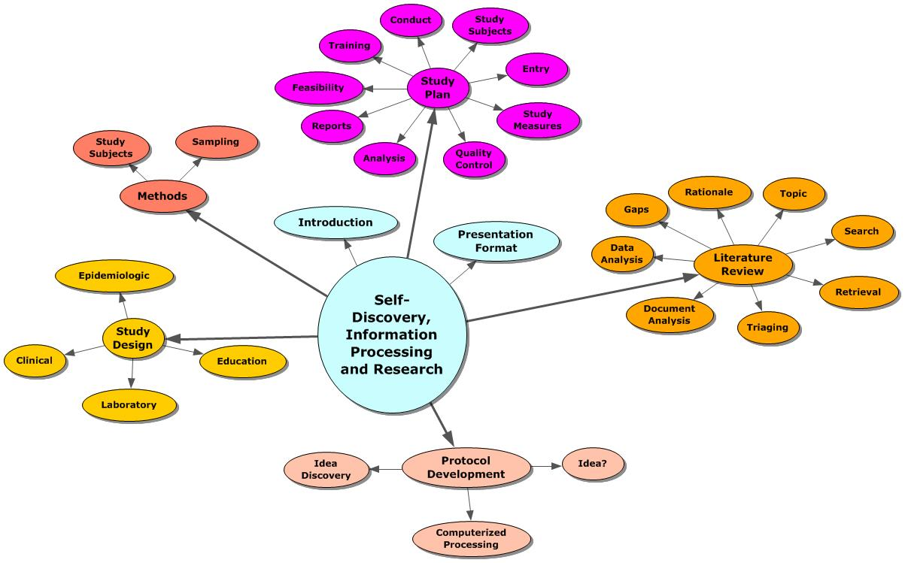

The tasks involved include: selection of a topic, search, triage of retrieved documents, and identification, extraction, and organization of pertinent information. Based on the analysis of the literature set, gaps in the knowledge base could be identified. Those gaps would be assessed for impact on the body of knowledge and a rationale for the proposed study would be developed. However pleasing that approach, a few adventurous individuals elected to postpone the process until they completed their explorations. They used the literature review to justify their findings.

One important reason for avoiding the formal literature review process is seen by examination of the tasks. Most of the steps describe clerical tasks. Those that would be considered as intellectual are based on the assumption that the individual thoroughly knows the body of knowledge. If that assumption is correct, why is there a need for the review? Thorough knowledge would imply that specific documents would be identified and used to satisfy the requirements in building a study plan.

**Ideas and Research as a System:** The methodology underlying the use of authors’ ideas in knowledge utilization has been under investigation since the late 1970s and has been found to be effective in developing new descriptions of topics and in developing new research strategies. This success is not surprising since it follows the ‘***natural***’ investigative process:

1. Determine the existence of a problem (***Discovery of an Idea***).
2. Develop a detailed description of that problem (**Problem Description**).
3. Develop an appropriate intervention to correct or eliminate the problem (**Interventions)**.
4. Conduct a detailed, quality-controlled process to bring the intervention and the problem together (**Protocol Development**).
5. Capture the findings of this interaction (**Study Conduct**).
6. Analyze the findings against the original description of the problem (**Analyses**).
7. Develop and disseminate the results of the process with emphasis on the modifications necessary to existing knowledge (**Report Preparation**).
8. Ensure that others can benefit by making the development process transparent (**Data Curation**).

**Idea Database and Disaster Relationships:**  A new resource containing disaster related ideas was constructed using the Idea Analysis approach. The following example highlights ideas involving the combination Tornado, Recovery, and/or Response. Table 1 shows the terms and the frequency of each idea. Each term, shown as a row, was linked with each of the terms shown as column headings. For example, community was linked with recovery 27 times, with response 115 times, and with tornado, 1 time.

**Table 1. Terms Forming Ideas with the Combination – Tornado, Recovery, and Response – PubMed 1990-2011.**

|  |  |  |  |  |
| --- | --- | --- | --- | --- |
| **Terms** | **Recovery** | **Response** | **Tornado** | **Dimensions** |
| community | 27 | 115 | 1 | environment |
| government | 3 | 49 | 3 | environment |
| inform | 9 | 8 | 1 | intervention |
| police | 5 | 6 | 2 | intervention |
| agent | 1 | 49 | 3 | intervention |
| analysis | 15 | 65 | 1 | method |
| research | 20 | 58 | 1 | method |
| recovery | 3834 | 48 | 1 | outcome |
| response | 48 | 15500 | 1 | outcome |
| person | 23 | 129 | 2 | personal |
| citizen | 3 | 7 | 4 | personal |
| mental | 63 | 163 | 1 | subject |
| danger | 3 | 12 | 3 | subject |
| disaster | 139 | 538 | 3 | subject |
| tornado | 1 | 4 | 63 | subject |

This series of relationships suggests that an author ***could connect the four terms (column headings plus a row term) in a single sentence***, even if that hasn’t been done yet. The idea – ***tornado 🡪 community*** ***🡪 response 🡪 recovery***– could appear in a sentence and represent an evolving premise. This composite idea is made up of selections from the 12 idea pairs:

***Community with Recovery, Response Tornado***

***Recovery with Community, Response, Tornado***

***Response with Community, Recovery, Tornado***

***Tornado with Community, Recovery, Response***.

Those pairs selected are highlighted in red. The first pair involves tornado with community. The next ideas would be community with recovery and response. The last idea would be response with recovery. While these pairs would be emphasized, the fact that each of the pairs was considered by authors makes the combination of the four ideas plausible.

Figure 2 shows the ideas arranged in an interventional design. The major intervention is designated by the term inform. It was linked with recovery 9 times, with response 8 times and with tornado, once. The other two possible interventions shown were agent and police. Those ideas had a lower frequency of occurrence except for agent with response. That idea was observed 49 times. (See Table 1)

**Figure 2. Ideas involving the central combination of Tornado, Recovery and Response – PubMed 1990-2011.**

|  |  |  |  |  |  |  |  |  |
| --- | --- | --- | --- | --- | --- | --- | --- | --- |
| **Personal** |  |  |  |  |  |  |  |  |
| Person |  |  |  |  |  |  |  |  |
| Citizen |  | **Subject** |  |  | **Intervention** | |  | **Outcome** |
|  |  | danger |  |  | agent |  |  | **recovery** |
|  |  | disaster |  |  | **inform** |  |  | **response** |
| **Environment** |  | mental |  |  | police |  |  |  |
| community |  | **tornado** |  |  |  |  |  |  |
| government |  |  |  |  |  |  |  |  |
| agent |  |  | **Methods** |  |  |  |  |  |
| Police |  |  | analysis |  |  |  |  |  |
|  |  |  | research |  |  |  |  |  |

The personal, environmental, and outcome factors are of possible importance. The relationship between a tornado and the individual’s perception of danger or disaster would be important in understanding the behavior patterns associated with a warning system of any type. Similarly, the individual’s perception of the mental effects – stress, depression, anxiety – anticipated with a tornado would be of value to explore in predicting behavior patterns in response to warnings. Previously, these mental effects have been studied as a consequence of a disaster-event. In this study, the effects would be triggers to determine behavioral responses to warning systems. In a comparable fashion, emergency management agency personnel, police, firefighters, and emergency medical personnel could be queried to determine their perceptions of these effects.

The individual’s perception of the response process and the recovery operations also might help in determining likely behaviors given warnings.

The different warning systems could be considered in terms of their influence on the individual. These could be portrayed using a Likert scale with a question dealing with the likelihood of immediate reaction to the different approaches – siren, text message, TV message, phone call. The reaction to messages indicating preparation for the tornado season and how protective actions could be included.

This design involves citizens and agency/police personnel. The relationships of interest to consider in questions could involve:

Tornado 🡪 danger 🡪 response 🡪 recovery

Tornado 🡪 disaster 🡪 response 🡪 recovery

Tornado 🡪 mental effects 🡺 response 🡪 recovery

Tornado 🡪 type of information 🡪 Danger

Tornado 🡪 type of information 🡪 Disaster

Tornado 🡺 type of information 🡪 Mental effects

Tornado 🡪 type of information 🡪 Response

Tornado 🡺 type of information 🡪 Recovery

Tornado 🡺 type of information 🡺 EM agency

Tornado 🡪 type of information 🡪 Police/Other EM units

Tornado 🡺 type of information 🡪 how delivered

Tornado 🡪 type of information 🡪 when delivered/repetitions

Ways of obtaining the necessary response data could be tested – e.g., online survey, paper survey, phone survey, in-person survey. The cost and operational feasibility of these different approaches needs to be weighed against the potential size of the respondent group.

The analysis shown uses the literature findings in what might be considered to be a different way. Traditionally, questions are formed based on previous results and the questionnaire was justified by citing references to previous work. The approach shown above looks at the possibility of a specific idea structure being in place. If that structure did exist, the questions generated would reflect that arrangement.

Given the uncertainty, the data capture process differs by taking small random samples to determine likely responses to the questions. The text of the questions is modified as necessary during this exploratory phase. When the questions are refined to the point of capturing the desired data, a larger sample of respondents can be sought to provide the findings needed for display and interpretation. This experimental process is well established in numerous scientific fields. The so-called pilot or preliminary studies are accepted as learning devices for enhancing the quality of the final instrument. The validating study is accepted as such.

The use of different interventions with different groups also is possible with this design. The example cited above would compare emergency workers with the respondents from the population. In a comparable fashion, different survey methods could be used in samples from the population to determine the one(s) most successful in capturing the required data as well as being feasible.

The frequency of occurrence of ideas in this analysis is a potential concern. The low frequency ideas could be random couplets with no indication of their importance as perceived by the subject specialists. The high frequency ideas could be established but obsolete. Interpretation of the important ideas must necessarily depend on the ways in which these ideas (high frequency or low) are used.

The consistency criterion was used in a different way to identify the terms that might be associated with the more important ideas. In this analysis, consistency involves the same term being linked with the different central terms chosen – i.e., recovery, response, and tornado. The ideas continue to be defined as a pair of informative terms provided by the author within a sentence. The requirement that all four terms – recovery, response, tornado, related term – occur in the same sentence is relaxed. Any combination of the four terms is considered evidence of consistency as long as each of the column terms is linked with each of the row terms (see Table 1).

**Table 2. Consistency Criterion For Disaster Events – Ideas in the Environmental Dimension – PubMed 1990-2011.**

|  |  |  |  |  |  |  |  |
| --- | --- | --- | --- | --- | --- | --- | --- |
| **Terms** | **Recovery** | **Response** | **Earthquake** | **Flood** | **Hurricane** | **Tornado** | **Disaster** |
| coastal | 2 | 5 | 8 | 31 | 4 | 2 | 7 |
| communities | 10 | 36 | 6 | 35 | 7 | 2 | 43 |
| community | 27 | 115 | 15 | 46 | 6 | 3 | 168 |
| demographic | 3 | 2 | 11 | 4 | 2 | 3 | 35 |
| families | 8 | 12 | 2 | 8 | 3 | 4 | 29 |
| global | 5 | 29 | 3 | 1 | 3 | 1 | 29 |
| hospital | 15 | 130 | 51 | 2 | 2 | 4 | 227 |
| household | 5 | 2 | 4 | 11 | 2 | 2 | 9 |
| metropolitan | 1 | 13 | 2 | 25 | 6 | 2 | 4 |
| parent | 9 | 24 | 11 | 13 | 4 | 3 | 49 |
| people | 18 | 31 | 65 | 1 | 11 | 12 | 134 |
| population | 8 | 35 | 21 | 16 | 13 | 1 | 88 |
| public | 20 | 278 | 17 | 1 | 23 | 2 | 211 |
| school | 3 | 6 | 6 | 1 | 3 | 2 | 33 |
| shelter | 5 | 14 | 13 | 2 | 14 | 5 | 21 |
| social | 34 | 38 | 21 | 1 | 18 | 6 | 172 |
| socio-economic | 3 | 2 | 2 | 9 | 1 | 1 | 5 |

Table 2 shows the ideas involving each of the disaster-events as well as the outcome variables – recovery and response -- in the environmental group. These terms include physical, social, and political attributes. The term, hospital, is an example of one that could be classified in environment, intervention, or subject dimensions depending on how the analyst interpreted the relationship between the disaster event and hospital. The consistency criterion was satisfied as each disaster event was linked with each term. The number of times a particular idea was used by the author-specialists ranged from 1 (flood 🡪 people) to 278 (response 🡪 public). Demographic, household, and socio-economic are terms illustrating low frequency of use across the disaster events. For the most part, the ideas involving the general descriptor, disaster, had many of the higher frequency ideas, although, response had the highest frequency idea (with public).

Figure 3 shows the idea map for tornado ideas from documents stored in PubMed. The terms shown as category labels represent the Boolean – tornado 🡪 related term – where the terms occur in one or more sentences within a document. The category terms are chosen based on frequency of occurrence. The labels shown in black were actual ideas. The environment label in blue was not reported by the authors and was arbitrarily used for consistency across different idea maps. Dividing the topic into groupings offers convenience. Each of the terms within a category was linked with the central term, tornado. These terms were entered in a category based on meaning and/or function. In addition, they are examples of the numerous organizations possible depending on the analyst’s interests. This variation is an important advantage to the idea approach. Each idea is an independent entity and can be linked with other ideas to build a new description.

**Figure 3. Tornado Related Ideas, PubMed 1990-2011.**

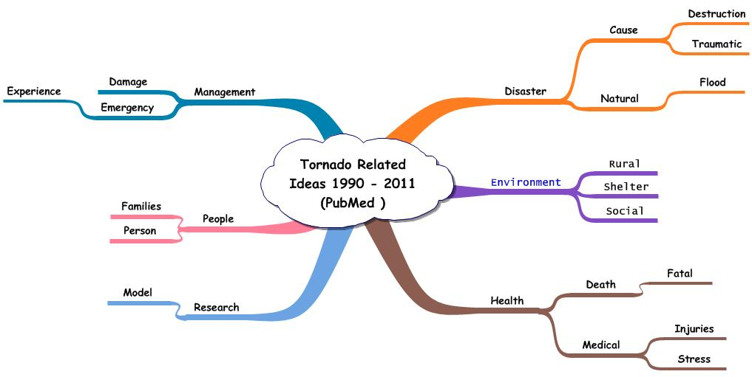

Table 3 shows an excerpt of the terms identified by the Idea Analysis software. The terms are arranged in two ways, alphabetically and by frequency of occurrence. Each of these terms was linked with the central term, tornado. The frequency for each describes the number of times the idea – tornado 🡪 related term – was found in the disaster literature.

Table 4 shows an excerpt of the alphabetically arranged idea records representing tornado relationships. The first entry shows the idea – ***tornado 🡪 accident***. That idea was entered into PubMed in 2002 in the document identified by 12235421. The idea was part of the information in sentence 5.

**Table 3. Excerpt from the Vocabulary used in Authors’ Ideas from Documents in PubMed, 1990-2011.**

|  |  |  |  |  |  |  |
| --- | --- | --- | --- | --- | --- | --- |
| **PUBMED** | |  |  |  | **PUBMED** | |
| **Tornado Related Ideas** | | | **1990 - 2011** | | **Tornado Related Ideas** | |
| **Frequency of Use** | |  |  |  | **Alphabetic Arrangement** | |
|  |  |  |  |  |  |  |
| **Term** | **Freq** |  |  |  | **Term** | **Freq** |
| **tornado** | **615** |  |  |  | **accident** | **1** |
| **flood** | **23** |  |  |  | **action** | **2** |
| **cause** | **22** |  |  |  | **activities** | **1** |
| **death** | **20** |  |  |  | **activity** | **1** |
| **emergency** | **17** |  |  |  | **address** | **2** |
| **injuries** | **15** |  |  |  | **adherence** | **1** |
| **person** | **14** |  |  |  | **admission** | **2** |
| **people** | **12** |  |  |  | **adolescent** | **3** |
| **disaster** | **11** |  |  |  | **alcohol** | **1** |

**Table 4. Excerpt of the Alphabetically Arranged Ideas Involving Tornado 🡪 Related Term, PubMed 1990-2011.**

|  |  |  |  |  |
| --- | --- | --- | --- | --- |
| **PUBMED** | |  |  |  |
| **Tornado Related Ideas** | |  |  |  |
| **Alphabetical Arrangement of Related Terms** | | | |  |
|  |  |  |  |  |
| **Tornado** | **Related** | **Year** | **Ident** | **Sentence** |
| **tornado** | **accident** | **2002** | **12235421** | **5** |
| **tornado** | **action** | **1995** | **10144032** | **1** |
| **tornado** | **action** | **2000** | **10718015** | **7** |
| **tornado** | **activities** | **2006** | **17162693** | **1** |
| **tornado** | **activity** | **2000** | **10718015** | **7** |
| **tornado** | **address** | **2003** | **12711529** | **3** |
| **tornado** | **address** | **2008** | **18380856** | **2** |
| **tornado** | **adherence** | **1990** | **2083989** | **6** |

**Exhibit 3. Abstract Containing Sentence and Idea – tornado 🡪 accident.**

Many states require long-term care facilities to develop mandatory training sessions on several safety, infection, and biohazard-related topics. The challenge for most facilities is how to make learning exciting and new. Many training sessions are mandatory, so the challenge for educators is how to take the boredom out of going to inservice programs. This article outlines an inservice program developed at Attic Angel Place in Madison, WI. **Using the popular television show Wheel of Fortune as a model, the facility developed a similar game-like training program dealing with accident prevention, fire and tornado safety, and biohazardous materials.** Of the facility's 175 full- and part-time employees, 75 attended the "Wheel of Disaster." [***Peterson R***](http://www.ncbi.nlm.nih.gov/pubmed?term=%22Peterson%20R%22%5BAuthor%5D)***. W-H-E-E-L of Disaster.*** [***J Nurses Staff Dev.***](http://www.ncbi.nlm.nih.gov/pubmed?term=12235421) ***2002 Jul-Aug;18(4):210-2. PMID: 12235421***

Exhibit 3 shows the abstract identified as containing the idea – tornado 🡪 accident – in sentence 5. The sentence is highlighted in green with the informative terms in red. The pair in question was included in this sentence. The pair is contextually relevant as anticipated because the author included the idea in the sentence. Larger combinations of the informative terms would include the ones of interest to the author. Namely, tornado 🡪 accident 🡪 training is one presented by the author.

**Table 5. Excerpt of the Within Document Arranged Ideas Involving Tornado 🡪 Related Term, PubMed 1990-2011.**

|  |  |  |  |  |
| --- | --- | --- | --- | --- |
|  | **PUBMED** | |  |  |
|  | **Tornado Related Ideas** | | |  |
|  | **Within Document Arrangement** | | |  |
|  |  |  |  |  |
| **Tornado** | **Related** | **Year** | **Ident** | **Sentence** |
| **tornado** | **accident** | **2002** | **12235421** | **5** |
| **tornado** | **facility** | **2002** | **12235421** | **5** |
| **tornado** | **hazard** | **2002** | **12235421** | **5** |
| **tornado** | **model** | **2002** | **12235421** | **5** |
| **tornado** | **program** | **2002** | **12235421** | **5** |
| **tornado** | **training** | **2002** | **12235421** | **5** |

Table 5 shows the idea records organized within the document. The terms linked with tornado are shown and agree with those in the sentence. The idea emphasis uses the authors’ assigned relationships to select the words entered into the vocabulary. This three-stage process includes: 1. Use of suffixes to identify potential informative terms; 2. Consistency of use across different situations; and 3. Frequency of occurrence of ideas involving the word of interest. Words infrequently linked or inconsistently used tend to be eliminated from the vocabulary. The result is a statement of fact indicating that the author presented the combination of terms together with the associated identifying data assigned to the document. No interpretation of importance is implied. These factual statements are prepared as data records and stored in the database. The focus on a sentence ensures that the author intended to combine the terms to form a communication of some type. By using the authors’ Boolean combinations, ‘false hits’ associated with spurious combinations of the search terms are eliminated. The software, identifying that combination of terms, within the sentence, provides the fact that the combination was present.

**Summary**

Research is a process of self-learning and discovery. In a real sense, it is the epitome of the intellectual process. With traditional information processing methods, most of this intellectual effort would be hidden in the individual’s subconscious with impressions and implications mysteriously transferred to the conscious brain.

The use of modern computer-supported methods changes much of this. The concept of a centralized resource of essential data representing the topics in a subject also introduces a physical, mental, and resulting, behavioral change in attitude and process. With those available, the analyst can more readily separate the tasks involved in a formal learning process. The focus can be on the higher cognitive functions and the transformation of those into measures, criteria, and decision-rules. The emphasis on those components results in a more transparent, quality-controlled process that can more readily be understood by peers and students. That acquisition of new knowledge and the understanding of existing form the motivation for research.