**Chapter 5 -- Merging Ideas from Disparate Topics to Enhance Both**

**Introduction**

Formal analysis using ideas to consider the merging of the multiple topics has been minimally explored. One example dealt with the merging of ideas using the ideas from the critical thinking and information literacy literatures. These topics dealt with common meanings and both relied on Bloom’s Taxonomy of Learning as a theoretical basis. That commonality suggested that the two phrases and operations might be more similar than different. The success of that analysis suggested that this idea-oriented approach might be effective in exploring the integration of the two topics – ***complex adaptive systems*** and ***disaster management***. The disaster-related ideas from the scientific literature numbered over 1,838,000 for the period 1990 – 2013. Complex adaptive systems are composed of a large number of interacting agents behaving in an apparent random fashion while actually following local inputs and rules. Examples of complex systems include health care administration, disaster management, and homeland security issues.

**Figure 1. Highest Frequency Terms Linked with the Idea – Complex Adaptive – to Form Triadic Ideas.**

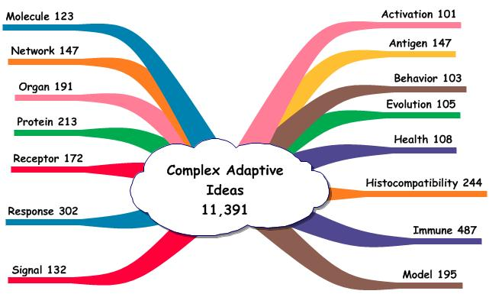

The ideas dealing with the complex adaptive systems were identified and organized. There were 2,368 articles entered into PubMed dealing with this topic. These articles contained 348,556 ideas of which 11,391 contained the central idea – complex & adaptive. The complex adaptive and disaster idea databases were used to determine the consequences of merging the two topics.

Figure 1 shows the higher frequency terms linked with the central idea – complex & adaptive. The terms were color coded to represent different categories or dimensions of the topic. The number of times each triad (e.g., complex 🡪 adaptive 🡪 peripheral term) was used by authors in sentences is shown. These higher frequency ideas represent a form of consensus by the world’s authors.

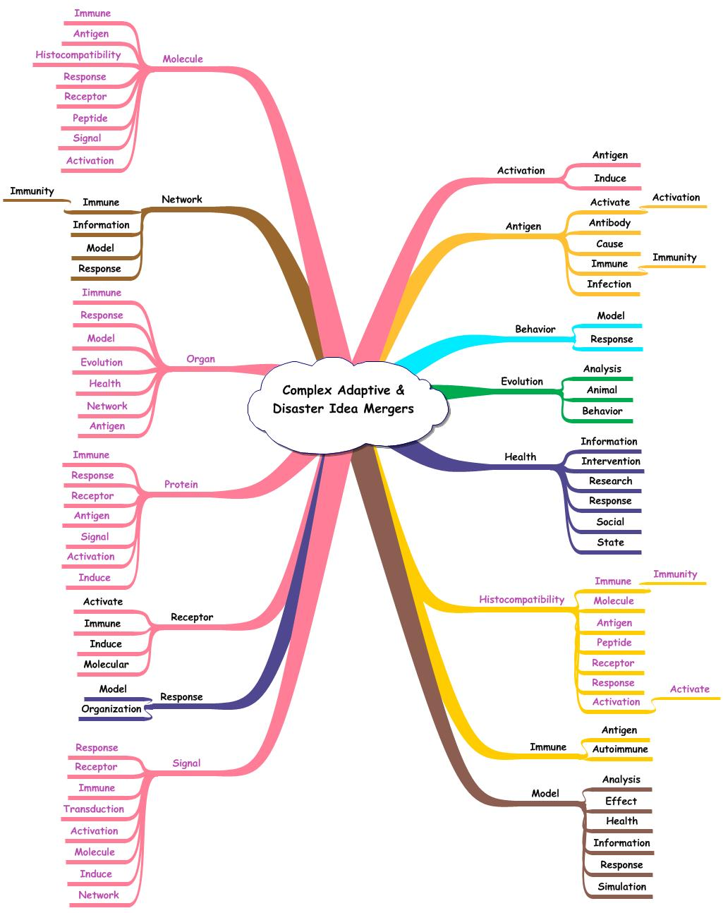**Figure 2. Ideas Common to Both – Complex Adaptive Systems and Disaster Research – Against the Background of the Complex Adaptive Systems Idea Map. Legend: Black = complex adaptive and disaster management, Violet = complex adaptive system only.**

**Complex Adaptive System Background:** Figure 2 shows the effect of merging the two topics by highlighting the ideas common to both using the ***complex adaptive system map as the background***. The common ideas are shown in black while those restricted to only complex adaptive systems in violet. The complex adaptive system and disaster management ideas included ideas describing: ***activation, antigen, behavior, evaluation, health, model, network, receptor***, and ***response***. The complex adaptive system ideas included: ***histocompatibility, molecule, organ, protein***, and ***signal***. The idea swarms illustrate the complexity associated with both topics.

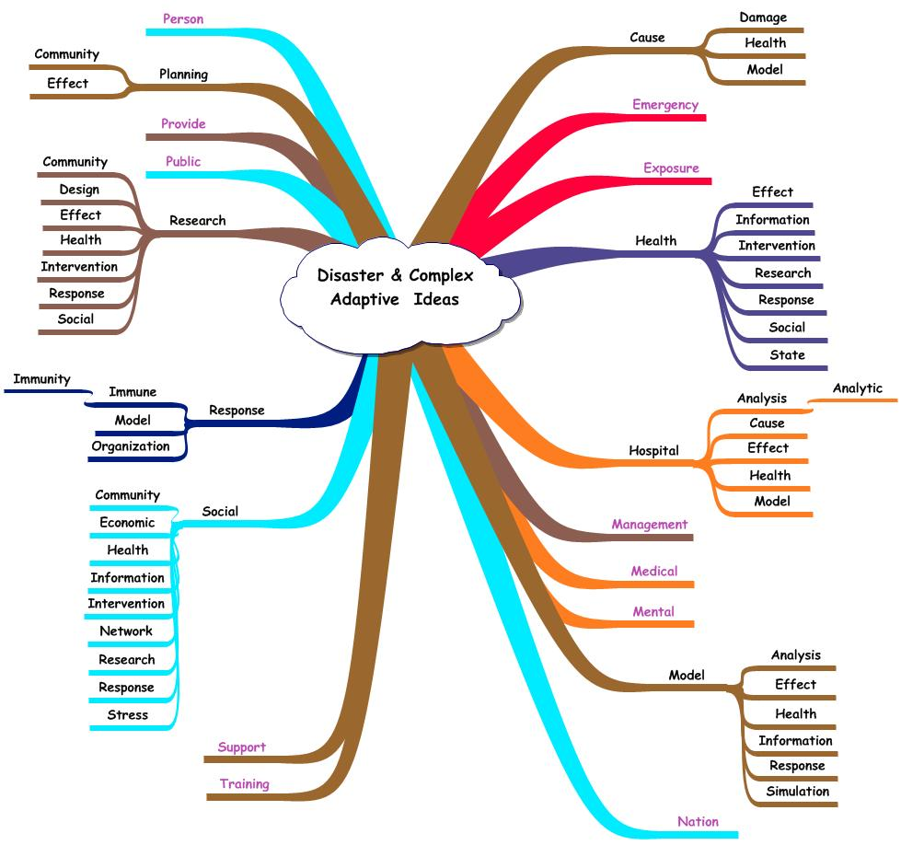**Figure 3. Terms Matching the Two Topics Against a Background of High Frequency Disaster Related Ideas. Legend: Black = Disaster and Complex Adaptive System Ideas; Violet = Disaster Only.**

**Disaster Ideas Background:** Figure 3 shows the ideas from the two topics that match when the background is the higher frequency ideas from the ***disaster idea map***. The terms linked only with disaster are shown in violet while those that match both are in black. Forty-two percent of the terms linked with disaster also were linked with complex adaptive systems. The predominant matching ideas were linked with health, hospital, model, research, and social. The ideas in common were: ***cause, health, hospital, model, planning, research, response***, and ***social***.

**Combining the Idea Sets**: This study was designed to explore the possible connection between ideas from each were compared using the idea analysis approach.

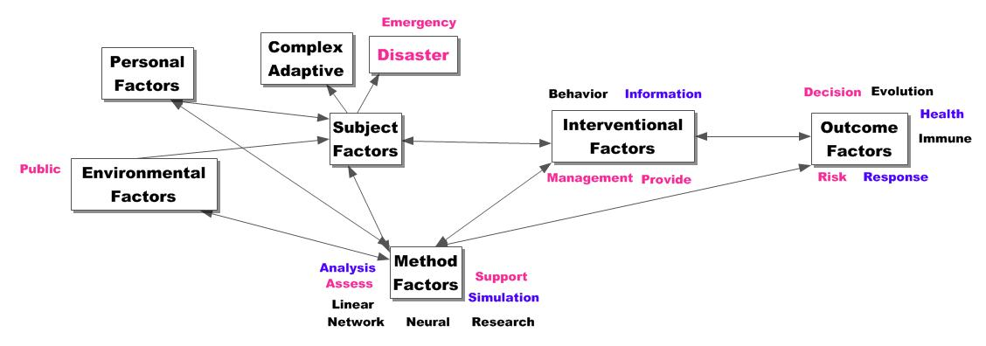**Figure 4. Higher Frequency Ideas in Complex Adaptive Systems and/or Disaster Management Arranged in an Interactive System. Legend: Black = Complex Adaptive; Red = Disaster; Purple = Both.**

Figure 4 summarizes the integrative effects and shows the higher frequency ideas involving complex adaptive systems and/or disaster management. The ideas associated with complex adaptive systems are in black. The ones involving disaster are in red. The ideas common to both are in purple. Each term is linked by authors to either complex adaptive or disaster or both. The map also shows the dimensions assigned to both topics to help better understand the issues involved. As anticipated, the dimensions and the representative ideas are interactive.

The two idea sets, when merged, form a clearer and more comprehensive description of the system. The complex adaptive system predominates in supplying ideas to the methods (6/8) and outcome factors (4/6). The interventional factors are more general than the ones from the disaster set. In addition, the disaster ideas contribute to the outcome factors by supplying important outcomes – decision, health, response, and risk.

**New Research:** Figure 4 also shows the areas where new research could be helpful. The omission of ideas describing the different sub-populations and personal factors is evident. Whether these should be considered as separate systems or as agents in a larger system also are questions to be resolved. Subject factors are absent although structures describing sub-systems are evident in each of the different examples used to describe complex adaptive systems. The interventions could be more specific in describing the behavior, information, and management procedures. As an example, what information is required to motivate population groups to protect against natural disasters?

As a method, is the complex adaptive system approach sufficient in providing the insights needed in studying and correcting emergencies, security, and health care issues? The method emphasizes the importance of the interactive, non-linear process and these features are important. However, without the details provided by idea analysis in determining the essence of each subject, the result would be a focus on key terms or phrases. Those fail in providing the contextual meaning essential to understanding and solving complex problems.

This analysis explored the possible merger of ideas representing complex adaptive systems and disaster management in order to determine the potential use of the former in dealing with the situations presented by the latter. A number of organizations have declared that the merger is possible and fruitful. This declaration was examined by identifying the ideas from each topic and then investigating the use of the same ideas in both. The basis for this is the simple law – If A = B and B = C, then A = C.

Since an essential feature of the complex adaptive system is the interaction of the agents yielding outcomes that appear to be patterned even though the operation is believed to be random, the research approach must necessarily be detailed yet cognizant of the interactive rather than simple linear effects. A focus on ideas fits this requirement.

The author-specialist generates these combinations of informative terms within a sentence in order to convey a certain message. When the resulting idea is extracted from the sentence, the contextual relationship remains unchanged. This facilitates consideration of the idea in different situations and arrangements. The resulting patterns could yield ideas that are considered essential (i.e., specific to the underlying meaning) or inconsequential (i.e., arbitrary combinations that do not assist in understanding the inherent meaning). Essential ideas tend to be used frequently by specialists, thus, forming a coherent description of the topic.

The findings suggested that the idea description of the complex adaptive system involved an emphasis on the methods factors and less so on other dimensions. The idea analysis approach described the disaster research by emphasizing intervention and outcome factors. The combination of the two methods was more informative than either alone. The integrated idea map also showed some of the gaps in knowledge that new research could supply.