**Chapter 3 – Creative and Critical Thinking Using the Idea Database**

**Introduction**

The claim has been made that the idea database served as an important resource in developing an operational path to creative and critical thinking. A suggested process is explored to determine the veracity of that statement. The rationale for the idea database and its associated operational behaviors is due to the available time and energy saved by developing a more effective data identification, capture, and organizational approach. That mechanical energy can be transformed into cognitive functions enabling a more intense consideration of the three important elements in critical and creative thinking. Those are ***measures*** used to describe attributes of characteristics, ***criteria*** used to evaluate the measures and interrelationships, and ***decision-rules*** defining behaviors based on the measures and criteria.

**Using the Research Template:** The template is helpful in organizing ideas into possible research strategies. Each strategy can be compared with the others to determine the ones most interesting and feasible. As an example of the use of the template, consider the ideas presented in document PMID 24686032. The source data and pertinent sentences are given in Exhibit 1.

**Exhibit 1. Ideas Presented in Document 24686032. Arranged using the Research Design Template.**

***Source:*** [**Mahmoudvand H**](http://www.ncbi.nlm.nih.gov/pubmed/?term=Mahmoudvand%20H%5BAuthor%5D&cauthor=true&cauthor_uid=24686032)**1,** [**Fasihi Harandi M**](http://www.ncbi.nlm.nih.gov/pubmed/?term=Fasihi%20Harandi%20M%5BAuthor%5D&cauthor=true&cauthor_uid=24686032)**2,** [**Shakibaie M**](http://www.ncbi.nlm.nih.gov/pubmed/?term=Shakibaie%20M%5BAuthor%5D&cauthor=true&cauthor_uid=24686032)**3,** [**Aflatoonian MR**](http://www.ncbi.nlm.nih.gov/pubmed/?term=Aflatoonian%20MR%5BAuthor%5D&cauthor=true&cauthor_uid=24686032)**4,** [**ZiaAli N**](http://www.ncbi.nlm.nih.gov/pubmed/?term=ZiaAli%20N%5BAuthor%5D&cauthor=true&cauthor_uid=24686032)**5,** [**Makki MS**](http://www.ncbi.nlm.nih.gov/pubmed/?term=Makki%20MS%5BAuthor%5D&cauthor=true&cauthor_uid=24686032)**6,** [**Jahanbakhsh S**](http://www.ncbi.nlm.nih.gov/pubmed/?term=Jahanbakhsh%20S%5BAuthor%5D&cauthor=true&cauthor_uid=24686032)**1. Scolicidal effects of biogenic selenium nanoparticles against protoscolices of hydatid cysts.** [**Int J Surg.**](http://www.ncbi.nlm.nih.gov/pubmed/?term=24686032) **2014;12(5):399-403. doi: 10.1016/j.ijsu.2014.03.017. Epub 2014 Mar 28. PMID 24686032**

**Sentence: Cystic echinococcosis (hydatid cyst, CE) as a zoonotic parasitic infection caused by the larval stage of the dog tapeworm Echinococcus granulosus is still an important economic and public health concern in the world.**

**Sentence: One of the treatment options for CE is surgical removal of the cysts combined with chemotherapy using albendazole and/or mebendazole before and after surgery.**

**Sentence: The present study was aimed to investigate the in vitro scolicidal effect of selenium nanoparticles biosynthesized by a newly isolated marine bacterial strain Bacillus sp. MSh-1 against protoscoleces of E. granulosus.**

**Sentence: Protoscolices were aseptically aspirated from sheep livers having hydatid cysts.**

**Figure 1. Example of Use of Research Design Template using Ideas from PMID 24686032.**

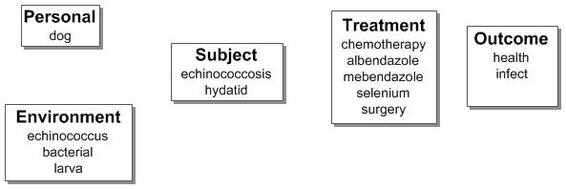

The ideas from the sentences were used to populate the research design template. The arrangement in Figure 1 reflects the thoughts expressed by the authors. There are different possible designs included. Figure 2 shows some of these possibilities.

**Figure 2. Possible Research Designs using the Ideas from Document 24686032.**

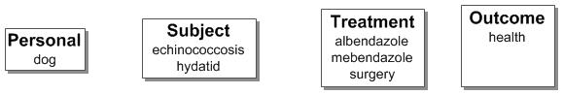

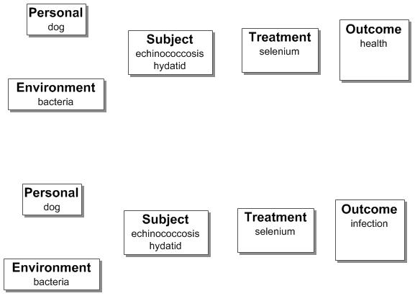

The first design in Figure 2 depicts the previous treatment approach used in managing echinococcosis. The second design represents the approach suggested by the authors as an alternative with emphasis on the relationship between selenium and health. The third design represents the same relationship with emphasis on selenium produced by bacteria and reducing infection. The distinction between the second and third templates involves the source of the selenium and the determination of suitable outcome variable.

**Using an Algorithmic Approach to Assist in Creative and Critical Thinking:** Traditionally, creative and critical thinking have been regarded as behaviors restricted to the capabilities of the individual. A common assumption has been that the individual possessed inheritable characteristics that made these intellectual activities possible and effective. If those perceptions were true, the delays in dealing with complex problems could be explained in terms of waiting for the genius interested in the problem and willing to solve it.

If however, critical and creative thinking is a learned behavior, then the number of individuals performing such behavior could markedly increase. The focus on ideas and their innate ability to be combined in a variety of ways, suggest that algorithms could be developed to assist the individual in producing the varied arrangements of ideas and in choosing the arrangement offering maximal success.

Bloom’s Taxonomy of Learning and Weiner’s modification of it suggest that the cognitive functions making up the learning process can be considered separately. Each function could be divided into three components – development of measures describing attributes of characteristics involved in the function; development of criteria for dealing with the results of those measures; and development of decision-rules for instituting specific reactions or behaviors. These possibilities plus the independence of ideas give justification for attempting to construct operational translations of the cognitive functions.

The current process employing algorithms to assist in developing critical and creative thinking is under development and assessment. It involves the following steps:

1. Select terms representing the different situations to be considered.
2. Create a matrix showing the terms involved in each type of disaster using ***Excel***. Enter the frequency of occurrence of each of the column (type of disaster) & row (related terms) ideas.
3. Determine the frequency of use of each row term in the column ideas. Use the formula -- ***=sum(n1:n2).*** Copy the contents of the first cell in the sum column and highlight subsequent cells in the column by running the cursor down. The empty cells will be changed to the number indicating frequency of use of ideas involving the row term.
4. Determine the consistency score for each row idea set. Use the formula -- ***=countif(n1:n2, “>0”)*** The variables, n1 and n2, refer to beginning and ending cells in the first data row. Copy the contents of the first cell in the consistency column and highlight subsequent cells in that column by running the cursor down. The empty cells will be changed to the number indicating consistency for that row.
5. Group the ideas for each row by dimension – personal, environmental, subject, intervention, outcome, and method.
6. Sort the row ideas within each dimension by consistency score and frequency of use from largest to smallest.

Those tasks enable construction of descriptions based on frequency of ideas and/or consistency of ideas for terms having a direct relationship with each of the column variables. The criterion used for selection of terms depends on the analyst.

The complexity of relationships among terms suggests that there are strong indirect relationships. The selection of specific terms in this secondary category requires additional tasks. Those tasks would be:

1. Identify the terms from the above matrix that have higher consistency scores irrespective of frequency of occurrence. Expand the lower frequency/higher consistency terms to form new idea arrays.
2. Construct a new matrix with the central terms as columns and the idea array terms as rows. Enter the frequency of occurrence of each of the column & row ideas.
3. Determine the consistency score for each row idea set.
4. Group the ideas for each row by dimension.
5. Sort the row ideas within each dimension by consistency score – largest to smallest.
6. Consider the high consistency terms as additions to the ideas identified from the direct relationship (first) high frequency/high consistency set.

With the terms and ideas identified, construct a series of research templates by populating the basic design. Develop measures, criteria, and decision rules using Bloom’s cognitive functions as modified by Weiner. Those functions are: comparison, evaluation, judgment, and application. This final step is the crucial one in revealing the individual’s intellectual accomplishment. It is the culmination of the individual’s inherent capabilities, the academic preparation, the learning accomplished, and the ability to develop new descriptions, study procedures, and solutions to recognized problems.

The results are a set of possible studies, instead of the traditional one study. Each has benefits and deficits. The selection of a particular study to execute would depend on the interests of the individual and the evaluation process employed. The array of possible studies has value in conducting cooperative research. The opportunity to pick a favored study out of the set will result in different investigators simultaneously pursuing studies. The result will be a formalized acceleration of information production. In addition, the organization of the ideas as an idea structure will facilitate transformation of the new information into new knowledge.

**Summary**

This chapter showed the value of the ideas in developing research strategies. The critical differences from traditional information processing included:

1. The formal process used in selection of vocabulary.
2. The reliance on the power of ideas (i.e., combinations of informative terms within the domain of a sentence).
3. The independence of ideas enabling them to be used in a variety of ways.
4. The acceleration of creative action by eliminating the mechanical waste in traditional information processing.
5. The assumption that creative and critical thinking is a learned behavior.

The exponentially increasing volume of scholarly literature in virtually every subject requires new information processing methods. The focus on the ideas and the algorithmic approach to recognizing relevant vocabulary significantly reduce the time and energy involved in organizing the data. With those methods in place, the individual can spend essentially fulltime on the real intellectual challenges of developing new descriptions of topics and in forming new research strategies, comparing them, and choosing the most effective for translation to a working protocol.

The distinction between a single design and modern information processing is the constellation of possible research strategies that could contribute information. The challenge to find the most informative from the set ignores the contributions possible from different designs. Building the array of possible designs and encouraging selection by cooperating scientists translates the existing ***investigator initiated research process*** into a formalized, coordinated effort. Like the human genome project, such coordination should yield more information more rapidly.

The algorithmic approach described does not impinge on the individual’s intellectual capabilities. This is not an extreme version of artificial intelligence. Instead, it is an orderly, computer-supported process designed to enhance intellectual activities by eliminating the mechanical and fatiguing aspects of information processing. If ideas are the essential data in information utilization, an approach such as the one described should provide significant benefits.