**Chapter 4 – Ideas in Recognizing Unanswered Questions**

**Introduction**

The analysis that follows looked at the authors’ ideas linking earthquake, flood, hurricane and tornado to related terms. In each situation, the ideas linking the central term, disaster, with communication were explored. Relationships between the individual events, disaster, and communication were determined.

**Earthquake Related Ideas:** Figure 1 shows the ideas involving earthquakes. The ideas are arranged within dimensions and the organization implies a possible study design. Earthquake is assumed to be the major intervention leading to traumas, health issues, and survival. The role of the hospital as a care facility is assumed to act as a secondary intervention modifying the outcomes. The terms in blue indicate linkage with both earthquake and disaster. Those in red were restricted to disaster. The environmental dimension includes ideas linking global, rural, and community to the central terms, earthquake and disaster. The idea, disaster 🡪 pandemic, also was included. The terms, crisis and emergency, were added to the subject dimension and protection to the outcome dimension. The methods dimension consists of two subgroups – communication and detection. The communication subgroup includes 6 additional ideas. The term, network, was linked with both earthquake and disaster. The remaining terms were linked with only disaster.

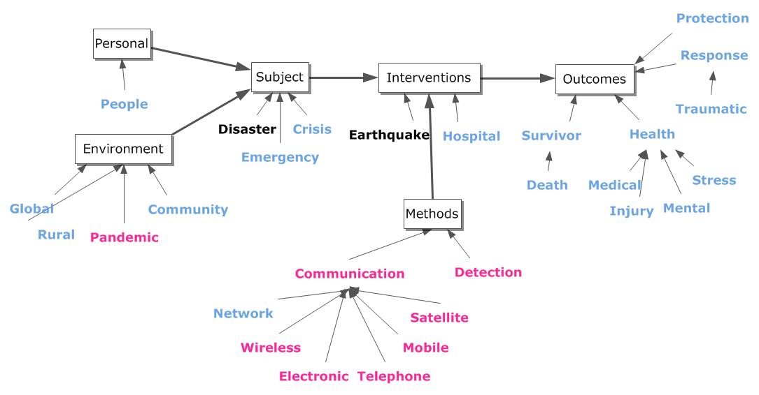**Figure 1. Earthquake and Disaster Ideas.**

**Network Ideas:** The ideas involving network with the specific disaster events were identified and the sentences containing those ideas retrieved.(See Exhibit 1) These sentences are used to show the emphasis placed on the idea – earthquake & network -- by the involved authors. As seen, the article by Rahim (2010) considered the term, network, in the context of communication. None of these reports emphasized the idea – communication & network – in earthquake disasters as a possible intervention. As such, this idea points to an unrecognized problem.

**Exhibit 1. Sentences containing the Idea – Earthquake and Network.**

[***Stein RS***](http://www.ncbi.nlm.nih.gov/pubmed?term=Stein%20RS%5BAuthor%5D&cauthor=true&cauthor_uid=16844644)***,*** [***Toda S***](http://www.ncbi.nlm.nih.gov/pubmed?term=Toda%20S%5BAuthor%5D&cauthor=true&cauthor_uid=16844644)***,*** [***Parsons T***](http://www.ncbi.nlm.nih.gov/pubmed?term=Parsons%20T%5BAuthor%5D&cauthor=true&cauthor_uid=16844644)***,*** [***Grunewald E***](http://www.ncbi.nlm.nih.gov/pubmed?term=Grunewald%20E%5BAuthor%5D&cauthor=true&cauthor_uid=16844644)***. A new probabilistic seismic hazard assessment for greater Tokyo.*** [***Philos Transact A Math Phys Eng Sci.***](http://www.ncbi.nlm.nih.gov/pubmed?term=16844644) ***2006 Aug 15;364(1845):1965-88.* We used the prehistoric record of great earthquakes preserved by uplifted marine terraces and tsunami deposits (17 M approximately 8 shocks in the past 7000 years), a newly digitized dataset of historical shaking (10000 observations in the past 400 years), the dense modern seismic network (300,000 earthquakes in the past 30 years), and Japan's GeoNet array (150 GPS vectors in the past 10 years) to reinterpret the tectonic structure, identify active faults and their slip rates and estimate their earthquake frequency.**

[***Wang LY***](http://www.ncbi.nlm.nih.gov/pubmed?term=Wang%20LY%5BAuthor%5D&cauthor=true&cauthor_uid=21137323)***,*** [***Wu WP***](http://www.ncbi.nlm.nih.gov/pubmed?term=Wu%20WP%5BAuthor%5D&cauthor=true&cauthor_uid=21137323)***,*** [***Li SZ***](http://www.ncbi.nlm.nih.gov/pubmed?term=Li%20SZ%5BAuthor%5D&cauthor=true&cauthor_uid=21137323)***,*** [***Fu Q***](http://www.ncbi.nlm.nih.gov/pubmed?term=Fu%20Q%5BAuthor%5D&cauthor=true&cauthor_uid=21137323)***,*** [***Wang Q***](http://www.ncbi.nlm.nih.gov/pubmed?term=Wang%20Q%5BAuthor%5D&cauthor=true&cauthor_uid=21137323)***,*** [***Tian T***](http://www.ncbi.nlm.nih.gov/pubmed?term=Tian%20T%5BAuthor%5D&cauthor=true&cauthor_uid=21137323)***,*** [***Yang SJ***](http://www.ncbi.nlm.nih.gov/pubmed?term=Yang%20SJ%5BAuthor%5D&cauthor=true&cauthor_uid=21137323)***. [The risk evaluation and response to the spread of hydatid disease after Yushu earthquake in Qinghai Province].*** [***Zhongguo Ji Sheng Chong Xue Yu Ji Sheng Chong Bing Za Zhi.***](http://www.ncbi.nlm.nih.gov/pubmed?term=21137323) ***2010 Aug;28(4):315-7.* Reviewing the previous data on the prevalence of the disease and the information from the communicable disease surveillance network during 2004 to April 15, 2010, possible impact of the Yushu earthquake was evaluated.**

[***Rahim M***](http://www.ncbi.nlm.nih.gov/pubmed?term=Rahim%20M%5BAuthor%5D&cauthor=true&cauthor_uid=21495597)***,*** [***Kazi BM***](http://www.ncbi.nlm.nih.gov/pubmed?term=Kazi%20BM%5BAuthor%5D&cauthor=true&cauthor_uid=21495597)***,*** [***Bile KM***](http://www.ncbi.nlm.nih.gov/pubmed?term=Bile%20KM%5BAuthor%5D&cauthor=true&cauthor_uid=21495597)***,*** [***Munir M***](http://www.ncbi.nlm.nih.gov/pubmed?term=Munir%20M%5BAuthor%5D&cauthor=true&cauthor_uid=21495597)***,*** [***Khan AR***](http://www.ncbi.nlm.nih.gov/pubmed?term=Khan%20AR%5BAuthor%5D&cauthor=true&cauthor_uid=21495597)***. The impact of the disease early warning system (DEWS)in responding to natural disasters and conflict crises in Pakistan.*** [***East Mediterr Health J.***](http://www.ncbi.nlm.nih.gov/pubmed?term=21495597) ***2010;16 Suppl:S114-21.* The DEWS network was replicated successfully during subsequent flood and earthquake disasters as well as during the 2008-09 internally displaced persons' crisis.**

.

**Flood or Hurricane Related Ideas:** The ideas involving flood as the central term were examined. The higher frequency ideas were organized as a study plan and are shown in Figure 2. The terms linked with flood and disaster are shown in blue. Those linked with disaster alone are shown in red. Communication and wireless were linked only with disaster. The other communication terms were linked with both central terms.

Figure 3 shows the terms linked with hurricane and disaster in blue and those linked with only disaster are shown in red. As with the other specific events, research using communication issues appears to have been low on investigators’ priority.

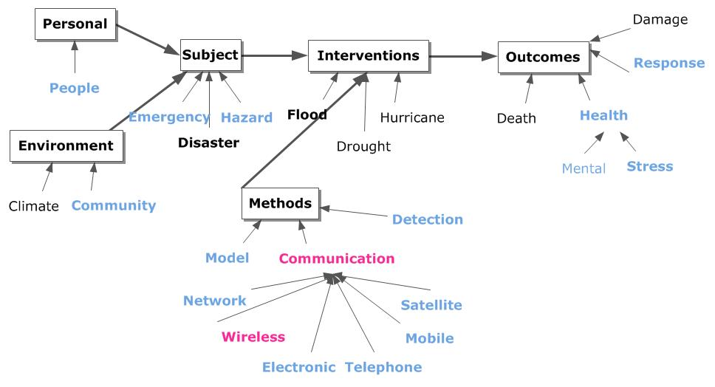**Figure 2. Flood and Disaster Ideas**

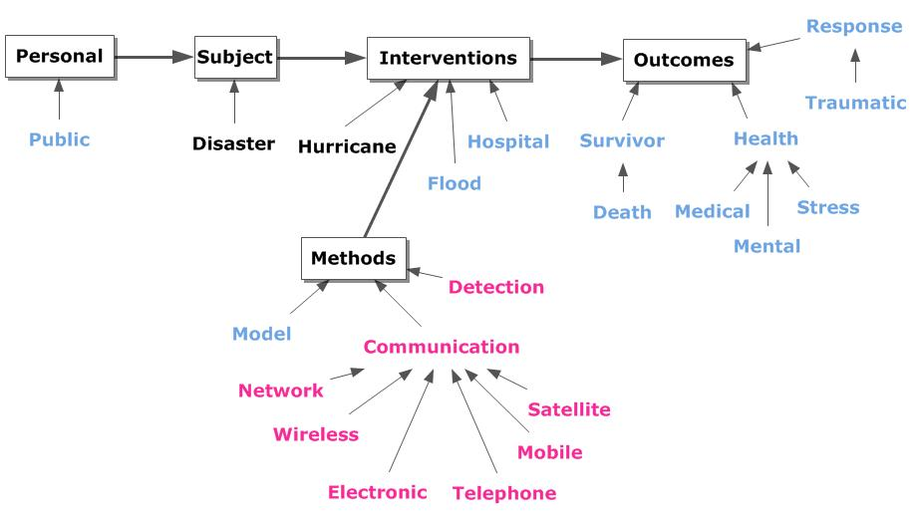**Figure 3. Hurricane and Disaster Ideas**

**Tornado Ideas:** The tornado related literature for 1990 through 2011 from PubMed was analyzed. There were 615 ideas involving the term, tornado. Figure 4 shows the terms linked with tornado and occurring with increased frequency. For convenience, the terms are presented in alphabetical order in clockwise order. The solid lines depict the links between the terms. That is, the pairs identified by the solid lines occurred in authors’ sentences. These ideas might be considered important if frequency of occurrence is the criterion. The dashed lines indicate ideas that have not yet been reported by specialists. The graph shows that these terms and their interrelationships form an informational structure describing issues associated with tornados.

**Figure 4. Tornado Idea Network – Higher Frequency Ideas.**

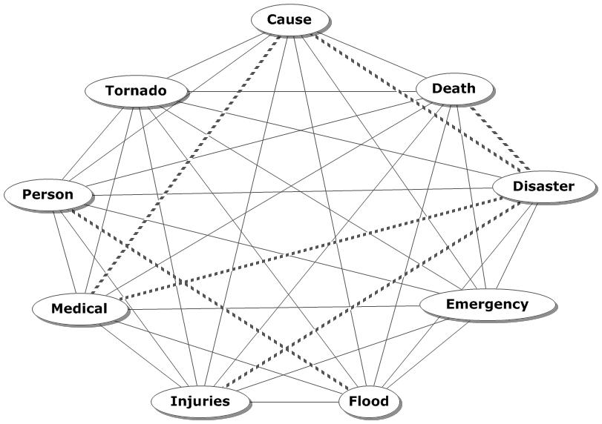

**Building New Descriptions:** All of these terms were linked with tornado. Those pairs would be:

***Tornado with, respectively, cause, death, disaster, emergency, flood, injuries, medical, and person.***

These building blocks can be used to develop descriptions of various types. Combinations of three (i.e., triadic ideas) would be:

*Tornado & cause & death – observed.*

***Tornado & cause & disaster -- absent***

*Tornado & cause & emergency -- observed*

*Tornado & cause & flood -- observed*

*Tornado & cause & injuries -- observed*

***Tornado & cause & medical – absent***

*Tornado & cause & person – observed*

In this example, the central idea is tornado 🡪 cause. The third term must occur in the same sentence in order to define a triadic idea. Two combinations, highlighted above, show that the linkage was not yet provided by at least one author. ***Tornado as the cause of a disaster*** may be too obvious to declare. ***Tornado as the cause of a medical*** situation also is obvious. In contrast, statements such as ***tornado as the cause of death*** or ***tornado as the cause of an emergency*** were presented. The authors’ selection of ideas is an individual decision. The presumed importance of the idea also is an individual decision.

These examples illustrate the difference between the traditional and modern approach to information processing. In the traditional, each idea is assessed as part of the triaging process. If considered ***important***, it is stored for further use. In the modern, each idea is stored irrespective of presumed importance. The rationale for this is change in perceptions with time. An idea considered important at one point of time may be considered unimportant in another. Similarly, an unimportant idea may gain in importance. Storage of all ideas in an accessible, useable form implies that such deliberations can be made easier and faster. The need to recapture previously ignored data is eliminated.

Combinations can include more terms presented within the same sentence. For example, the ideas describing the central idea – ***tornado & cause & death*** -- linked with a fourth term from the same sentence would include:

*Tornado & cause & death & emergency – observed*

*Tornado & cause & death & flood – observed*

*Tornado & cause & death & injuries – observed*

These ideas are examples of conceptual precursors. A concept can be considered to be a central idea with related attributes that describes a particular characteristic. The conditions relevant in describing the ***tornado as the cause of death*** include: emergency, flood, injuries, medical, and person.

**Figure 5. Relationships Describing Tornado Effects.**

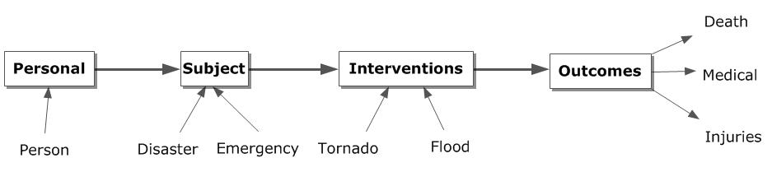

Figure 5 shows the tornado related ideas arranged in dimensions and forming a study plan. The **personal factors** are described by the tornado 🡪 person idea. The **subject factors** are represented by the tornado 🡪 emergency idea. **Interventions** include tornado and flood. The two are linked as well as having relationships with the other terms. The **outcomes** linked with tornado are death and medical injuries.

The idea – tornado 🡪 cause – is not shown in Figure 5. The graph itself, and particularly the relationship involving interventions and outcomes, raises the possibility of causation or association. The tornado may be the cause of the outcome events. It is certainly associated with them.

**Centralized Data Resources:** The use of a centralized data resource was introduced with the advent of numerical databases. In that case, careful capture of data could be accomplished and stored in a usable fashion. With that resource, numerous investigators could select subsets of the data and perform analyses using statistical software. The results represented new interpretations and perspectives reinforcing the concept of human intellectual diversity built on carefully managed data.

The information flow associated with numerical data is:

***Data capture 🡪 Editing 🡪 Storage 🡪 Retrieval 🡪 Analysis 🡪 Interpretation 🡪 Reporting***

The essential characteristic is transparent processing using algorithms and methods that facilitate third-party monitoring of the process. The sole deviation from this public display is in the interpretation phase. Here the individual can express intellectual prowess based on the results of the analysis and his/her intellectual capabilities. The result is enhanced accuracy and reduced delay between initiation of the work and completion ***without sacrificing individual intellectual diversity.***

This approach, using text, has merits. The algorithms are different but can be as transparent. The phases could be the same. The data captured is critical to the success of the adventure. While informative terms are important, they do not tell the same story as the ideas made from combinations of informative terms entered in a sentence by the author. The simplest idea is a pair of informative terms and represents the thought presented in the simple sentence. Complex sentences consist of multiple simple sentences. As such, the ideas in a complex sentence can be identified.

**Using Information to Form Knowledge:** An important difference between traditional and modern processing is the emphasis on **reduction** of the data by the traditional and the **organization** of the data by the modern. That is, by developing a structure that facilitates retrieval of ideas on demand (not documents), different arrangements of the ideas can be considered. Retrieval of documents results in a plethora of ideas provided by the author. While those ideas are inherently valuable, they are not organized for general use, but, rather for use by the author. This is one possible arrangement from many.

Access to specific ideas enhances development of new syntheses or arrangements of these ideas. These syntheses represent a significant improvement by providing the opportunity for developing measures, criteria, and decisions associated with comparison and evaluation of different representations of the topic. Reduction is accomplished as the result of formal comparison rather than as part of a tedious, fatiguing screening. The difference is a detailed, reproducible, transparent path to the creative act versus a mysterious, spontaneous one which may or may not be reproducible. While the latter is dramatic, the ability to instruct and learn is made more difficult because of the unknown process employed in the traditional approach.