**NDVI Instructions**

**GIS STEPS**

1. Download Dataset of NDVI:
   1. 1-year US
      1. <https://daac.ornl.gov/cgi-bin/dsviewer.pl?ds_id=1299>
   2. 1-day World
      1. <https://www.ncei.noaa.gov/data/avhrr-land-normalized-difference-vegetation-index/access/>
2. Upload to VINCI (if using more than 1-day data, must email VINCI to get it uploaded)
3. Make NetCDF dataset into raster layer in ArcMAP
   1. Catalog -> Toolboxes -> System Toolboxes -> Multidimensional Tools -> Make NetCDF Raster

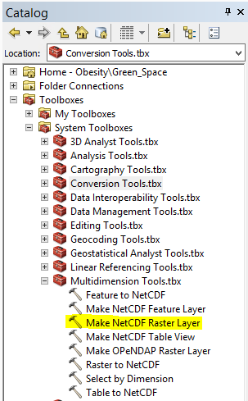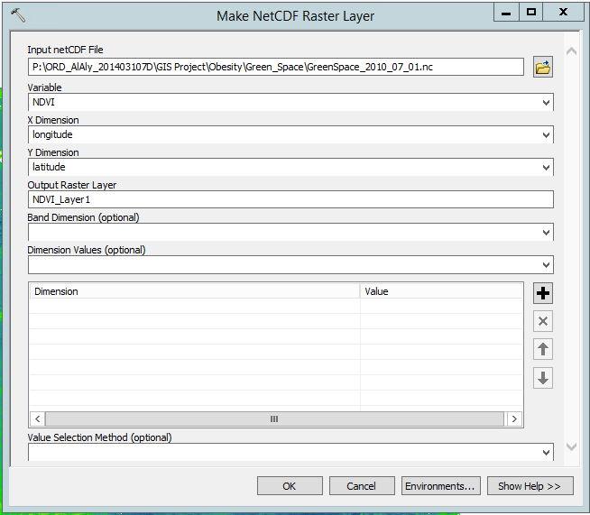

1. Subset data to only include US
   1. Change extent to (left: -128, right: -50, top: 50, bottom: 22)

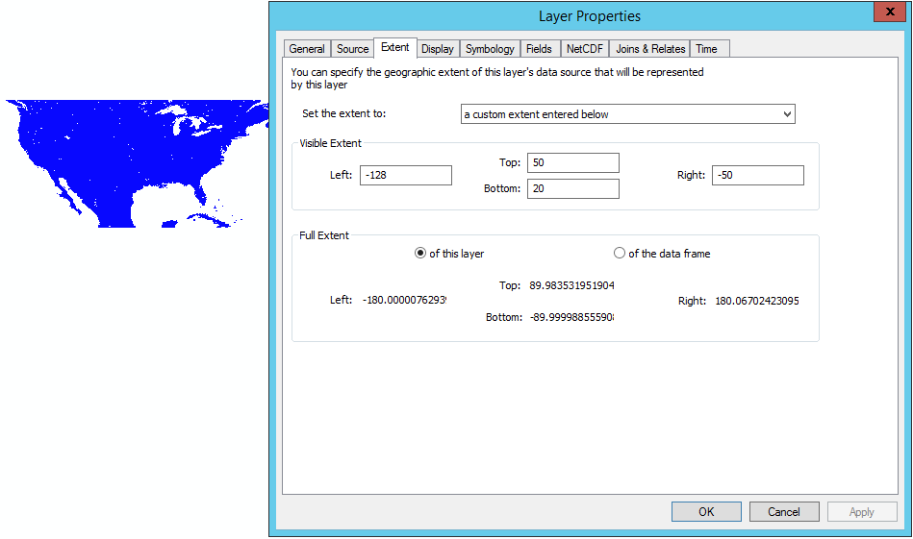

* 1. Zoom to extent (click and drag little magnifying glass around US)

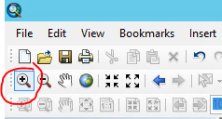

* 1. Export data with following settings

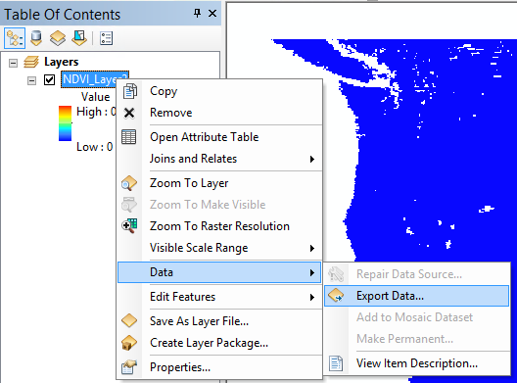

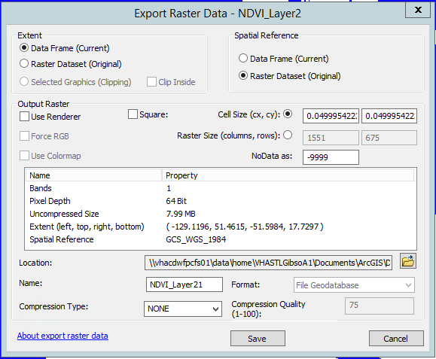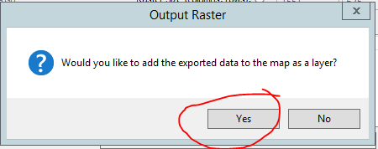

1. Convert raster to point (conversion->from raster-> to point). To note this does the centroid of the pixels.

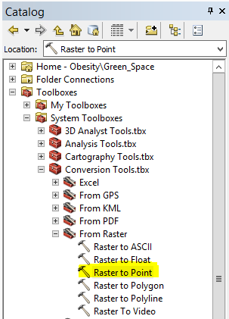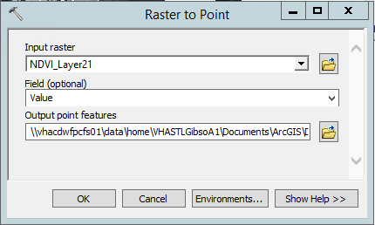

1. Open attribute table

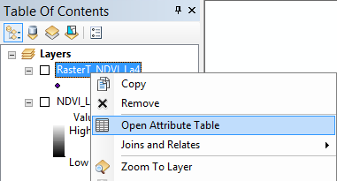

1. Make new columns (lat and long) (float type)

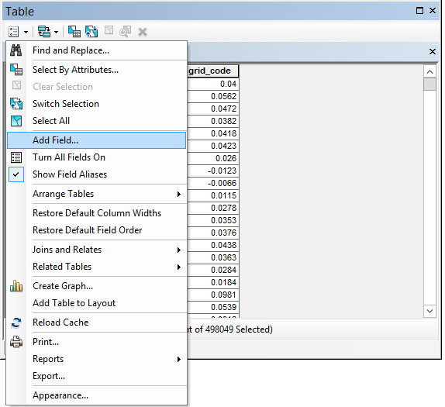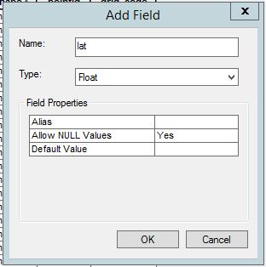

1. Calculate geometry

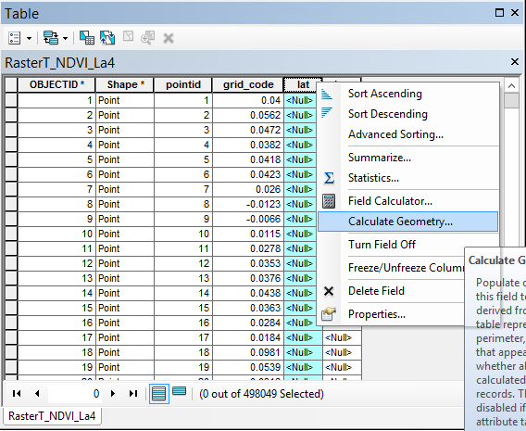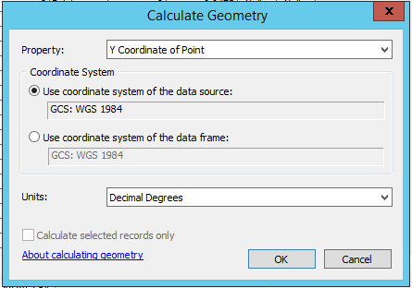

1. Export data table

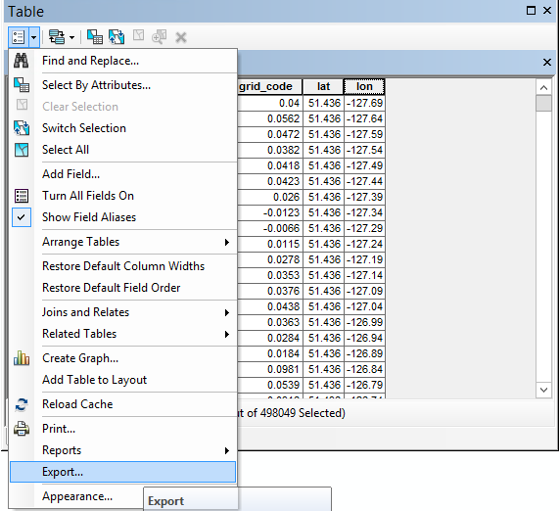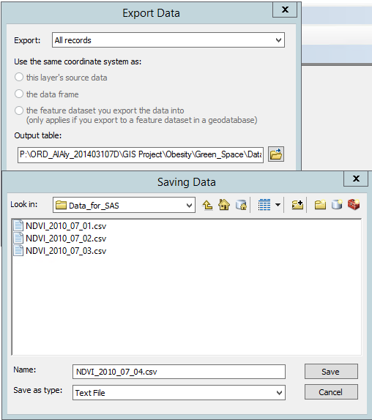

**SAS STEPS**

1. Merge 31 data tables (csv files, 1 for each day of July 2010)
2. Make 1000m buffers
   1. Join table with itself, conditioned on haversine/geodist within 1000m (each buffer will contain the NDVI values from other 30 days of July)

|  |  |  |  |  |  |
| --- | --- | --- | --- | --- | --- |
| A_lat | A_lon | NDVI | A_lat | A_lon | NDVI2 |
| A_lat | A_lon | NDVI | C_lat | C_lon | NDVI2 |
| A_lat | A_lon | NDVI | D_lat | D_lon | NDVI2 |
| B_lat | B_lon | NDVI | B_lat | B_lon | NDVI2 |
| B_lat | B_lon | NDVI | D_lat | D_lon | NDVI2 |

1. For each point, average NDVI2 values of top 5 highest NDVI values within buffer

|  |  |  |
| --- | --- | --- |
| A_lat | A_lon | A_avg_NDVI |
| B_lat | B_lon | B_avg_NDVI |
| C_lat | C_lon | C_avg_NDVI |

1. Assign residential addresses to NDVI of closest lat/lon based on haversine/geodist formula

**SAS STEPS (If have high-enough resolution to make 1000m buffers)**

1. 31 data tables (csv files) for each day of month of July 2010
2. For each table, make 1000m buffers
   1. Join table with itself, conditioned on haversine equation within 1000m (in miles right now, needs to be in meters)

07/01/2010

|  |  |  |  |  |  |
| --- | --- | --- | --- | --- | --- |
| A_lat | A_lon | A_NDVI | A_lat | A_lon | A_NDVI |
| A_lat | A_lon | A_NDVI | C_lat | C_lon | C_NDVI |
| A_lat | A_lon | A_NDVI | D_lat | D_lon | D_NDVI |
| B_lat | B_lon | B_NDVI | B_lat | B_lon | B_NDVI |
| B_lat | B_lon | B_NDVI | D_lat | D_lon | D_NDVI |

* 1. For each point, average NDVI values of every point within buffer

07/01/2010

|  |  |  |
| --- | --- | --- |
| A_lat | A_lon | A_avg_NDVI |
| B_lat | B_lon | B_avg_NDVI |
| C_lat | C_lon | C_avg_NDVI |

1. Merge 31 data tables (one for each day of July 2010)
2. For each set of 31 points (buffers), find largest 5 NDVI values and average them to get maximum average NDVI for each point (buffer)

|  |  |  |  |
| --- | --- | --- | --- |
| 07/01/2010 | A_lat | A_lon | A_avg_NDVI |
| 07/02/2010 | A_lat | A_lon | A_avg_NDVI |
| 07/13/2010 | A_lat | A_lon | A_avg_NDVI |
| 07/11/2010 | A_lat | A_lon | A_avg_NDVI |
| 07/16/2010 | A_lat | A_lon | A_avg_NDVI |
| 07/01/2010 | B_lat | B_lon | B_avg_NDVI |
| 07/02/2010 | B_lat | B_lon | B_avg_NDVI |
| 07/13/2010 | B_lat | B_lon | B_avg_NDVI |
| 07/11/2010 | B_lat | B_lon | B_avg_NDVI |
| 07/16/2010 | B_lat | B_lon | B_avg_NDVI |

->

Maximum 5-day-avg of July

|  |  |  |
| --- | --- | --- |
| A_lat | A_lon | A_avg5_NDVI |
| B_lat | B_lon | B_avg5_NDVI |
| C_lat | C_lon | C_avg5_NDVI |

**Helpful Threads:**

* Changing symbology or getting pixel values for NDVI in ArcMAP
  + <https://community.esri.com/thread/13254>
* Data imports:
  + NDVI into arcmap
    - https://desktop.arcgis.com/en/arcmap/10.3/manage-data/netcdf/reading-netcdf-data-as-a-raster-layer.htm
  + NDVI into R/SAS
    - https://disc.gsfc.nasa.gov/information/howto?keywords=netcdf&title=How%20to%20Read%20Data%20in%20netCDF%20Format%20with%20R