Nmap-Network-Enumeration-Lab
Author: Andrew
Institution: anonymous
Report Type: Professional Cybersecurity Documentation

1. Introduction
This lab demonstrates the fundamentals of network enumeration using Nmap on Kali Linux. The project focuses on identifying active hosts, detecting operating systems, discovering open ports, and analyzing exposed network services in a controlled lab environment.

2. Objectives
- Understand the fundamentals of network enumeration.
- Install and verify Nmap in Kali Linux.
- Identify network interfaces and IP configuration.
- Perform host discovery scans on a local network.
- Detect operating systems and enumerate services.
- Analyze security exposure through open ports.

3. Tools and Environment
Operating System: Kali Linux
Enumeration Tool: Nmap 7.99
Target Environment: Local Virtualized Network (VMware)
Target Machine: Metasploitable-like vulnerable Linux system

4. Nmap Installation Verification
The installation verification confirms that Nmap version 7.99 is successfully installed and available on the Kali Linux system.
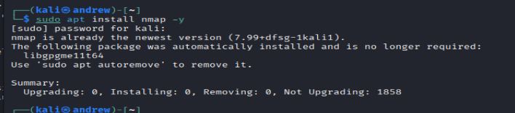

5. Network Interface Identification
The 'ip a' command was used to identify the active network interface and assigned IP address. The interface eth0 was assigned the IP range 192.168.37.x.
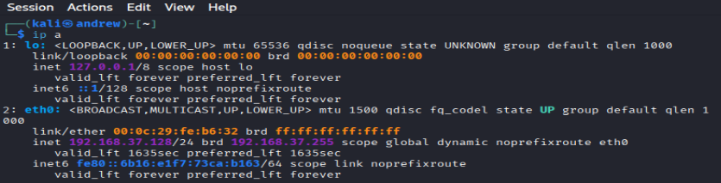

6. Host Discovery Scan
A ping sweep scan using 'nmap -sn 192.168.37.0/24' identified active devices within the subnet. Multiple VMware virtual devices were discovered.
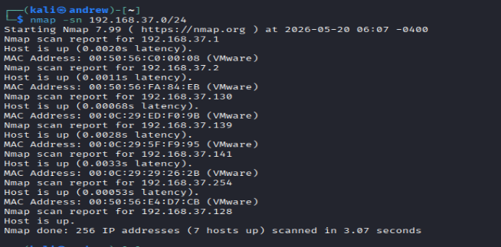

7. Operating System Detection Scan
Operating system detection using 'nmap -O 192.168.37.130' identified the target system as Linux Kernel 2.6.x. The scan also revealed multiple exposed services.
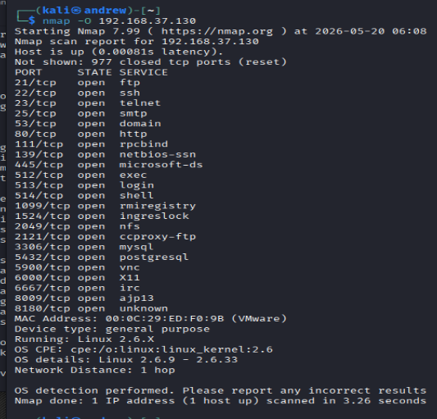

8. Detailed Open Port Enumeration
The enumeration results revealed critical open ports including FTP, SSH, Telnet, SMTP, HTTP, MySQL, PostgreSQL, and VNC services.
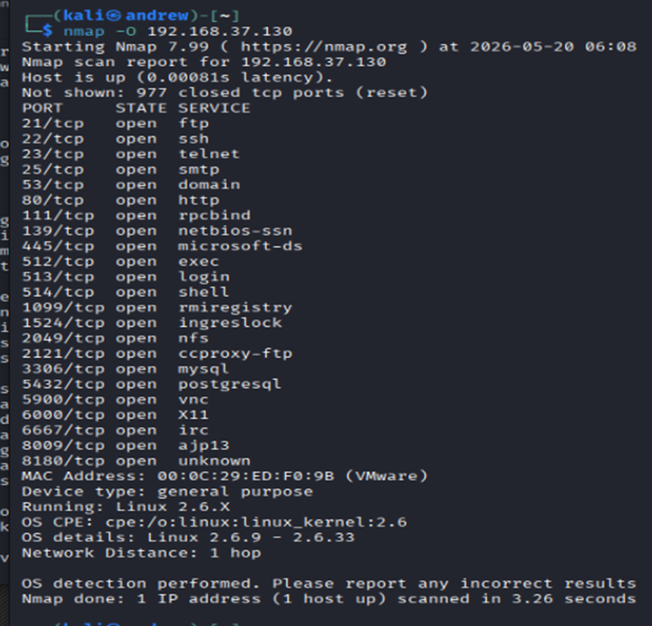

9. Security Analysis
The target system exposes several insecure and legacy services such as Telnet and outdated Linux kernel versions. These findings indicate a vulnerable environment suitable for penetration testing and security research. The enumeration phase demonstrates how attackers and security professionals gather intelligence before further assessment.

10. Conclusion
This project successfully demonstrated the use of Nmap for network discovery and enumeration. The lab provided practical exposure to identifying hosts, enumerating services, and detecting operating systems within a controlled cybersecurity environment. The exercise strengthened understanding of reconnaissance techniques used in real-world penetration testing.

