# **Final Project Deliverable**

League of Legends: Champions database

Andrew Ku

IST 659 Data Admin Concepts & Database Management

08/01/2021

# Lol Logo PNG images, Free Download L.O.L Pictures - Free Transparent PNG Logos

***Image 1: League of Legends Logo (***[***https://na.leagueoflegends.com/en-us/***](https://na.leagueoflegends.com/en-us/)***)***



***Image 2: Map of League of Legends (***[***https://www.riotgames.com/en***](https://www.riotgames.com/en)***)***

## **PART 1**

## 1.Summary

Multiplayer Online Battle Arena (MOBA) game is a strategy video game in which two teams of players play against each other on a predefined map. League of Legends is a MOBA video game developed and published by Riot games. In this game, two teams of five players exist, and each player controls one champion (game character) of their choice. Champions become more stronger by purchasing items with collected gold as well as levelling up by collecting experience points. The objective of this game is to defeat the opponent by destroying the enemy nexus (tower) by pushing through the enemy base.

***Image 3: Map of League of Legends (***[***https://www.esportstalk.com/blog/eli5-league-of-legends-guide-23576/***](https://www.esportstalk.com/blog/eli5-league-of-legends-guide-23576/)***)***

One of the most important rules of this game is playing your specific role in each given lane on the map. There are total of 3 lanes and 1 jungle as shown in **Image 1**. As a result, each champion is usually preferred (by a player) to a lane. Simply, there are top, mid, bot lane champions and jungle champions. Two champions go to bot lane indicated as bottom and support champions.

This game has been one of the most popular games the past seven years; therefore, it has been producing massive amount of data. The company wants to provide overall well-balanced game by analyzing:

* Similar win, play, and ban rate between the champions.

This analysis will be used to find the difference between weaker and stronger champions. Champion is referred to as too strong if their win, play, and ban rate are much higher than others (lower for weaker champions). Therefore, the company has formed a database team to design a database that provides each champion’s win, pick and ban rate.

## 2.Data Questions:

1. What was the play amount of each champion today?
2. What was the win amount of each champion today?
3. Most assigned roles for each champion?

## 3.Stakeholders

The stakeholders included in this project are the company owner, the employees, and the players. From this new database design, the employees will be able to use this database to accurately analyze champion data that changes frequently day to day. Players will be able to see which champion has been affected by each balance patch provided by the company. In turn, this will increase the overall profit of the company due to increase in players’ satisfaction.

## 4. Glossary

1. A **player** is a person who plays the game.
2. A **match** is a in-game data produced buy a player.
3. A **champion** is a in-game character that a player plays in the game.
4. A **role** is an indicator of a lane that a player has been assigned to.

## 5. Business rules

1. Each player plays **0 to many matches**; Each match is played by **1 to many** players. (Must have at least one player for the match to start.)
2. Each champion can have **1 to many roles** (a player must pick a role to play the game); each champion is applied to **0 to many** roles. (Abnormally, a role can be selected by 0 players)
3. Each player can play **0 to many** champions (a player does not need to play every single champion); Each champion is played by 0 to many players. (Abnormally, a champion can be selected by 0 players)

## 6. Conceptual ERD

***Image 4: Conceptual Model.***

## 7. Logical Enhanced ERD

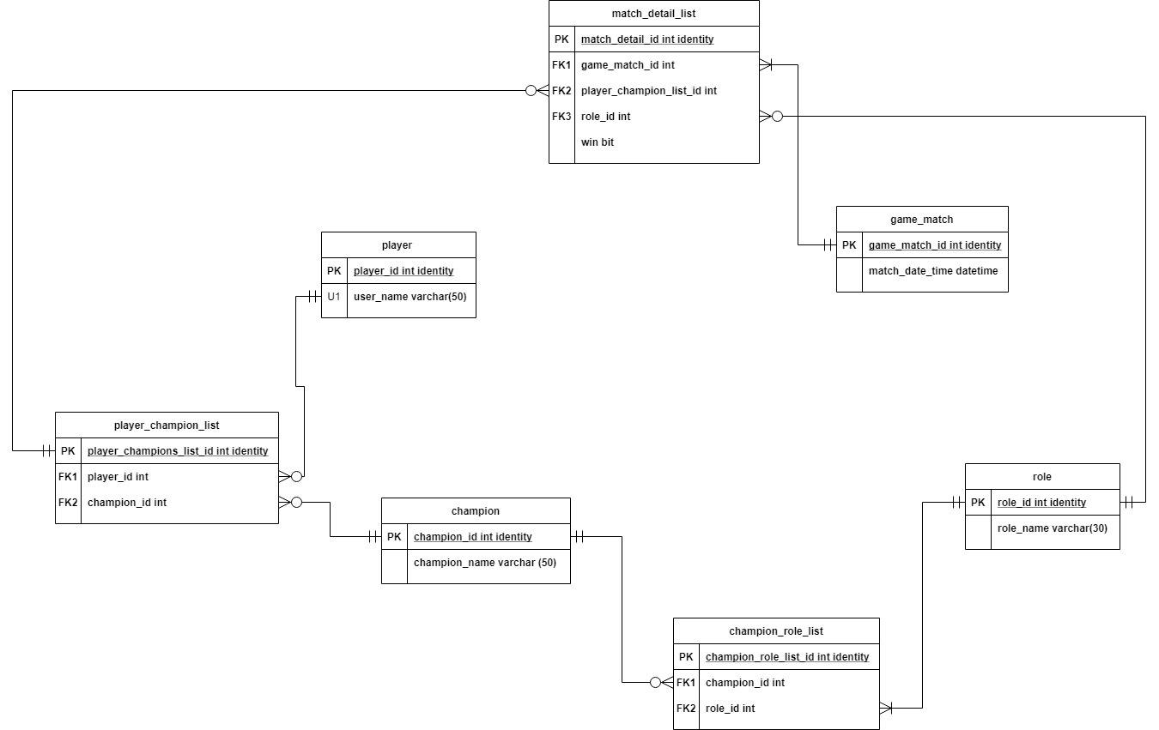

***Image 5: Logical Enhanced ERD.***

## **PART 1**

### Data Definition Language – Creating Tables and Constraints

DROP TABLE IF exists lol_match_detail_list

DROP TABLE IF exists lol_champion_role_list

DROP TABLE IF exists lol_player_champion_list

DROP TABLE IF exists lol_game_match

DROP TABLE IF exists lol_role

DROP TABLE IF exists lol_champion

DROP TABLE IF exists lol_player

--Creating player table

CREATE TABLE lol_player (

lol_player_id int identity primary key,

lol_user_name varchar(30) not null,

CONSTRAINT U1_lol_player UNIQUE (lol_user_name)

)

--Creating champion table

CREATE TABLE lol_champion (

lol_champion_id int identity primary key,

lol_champion_name varchar(30) not null,

CONSTRAINT U1_lol_champion UNIQUE (lol_champion_name)

)

--Creating role table

CREATE TABLE lol_role (

lol_role_id int identity primary key,

lol_role_name varchar(30) not null,

CONSTRAINT U1_lol_role UNIQUE (lol_role_name)

)

--Creating game match table

CREATE TABLE lol_game_match (

lol_game_match_id int identity Primary key,

lol_match_date_time datetime not null default getdate()

)

--Creating player champion list table

CREATE TABLE lol_player_champion_list (

lol_player_champion_list_id int identity Primary key,

lol_player_id int not null FOREIGN KEY REFERENCES lol_player(lol_player_id),

lol_champion_id int not null FOREIGN KEY REFERENCES lol_champion(lol_champion_id)

)

--Creating champion_role_list table

CREATE TABLE lol_champion_role_list (

lol_champion_role_list_id int identity Primary key,

lol_champion_id int not null FOREIGN KEY REFERENCES lol_champion(lol_champion_id),

lol_role_id int not null FOREIGN KEY REFERENCES lol_role(lol_role_id)

)

--Creating match_detail_list table

CREATE TABLE lol_match_detail_list (

lol_match_detail_id int identity primary key,

lol_game_match_id int not null foreign key references lol_game_match(lol_game_match_id),

lol_player_champion_list_id int not null foreign key references lol_player_champion_list(lol_player_champion_list_id),

lol_role_id int not null foreign key references lol_role(lol_role_id),

lol_win bit not null

)

### Data Manipulation Language – Adding Data Using INSERT Statements

INSERT INTO lol_role (lol_role_name)

VALUES ('Top'), ('Jungle'), ('Mid'), ('Bot'), ('Support')

--inserting values into lol_champion

INSERT INTO lol_champion (lol_champion_name)

VALUES ('Fiora'), ('Sett'), ('Tahm Kench'), ('Camille'), ('Irelia'),

('Lee Sin'), ('Jarvan IV'), ('Xin Zhao'), ('Shaco'), ('Taliyah'),

('LeBlanc'), ('Katarina'), ('Talon'), ('Zed'), ('Akshan'),

('Vayne'), ('Ashe'), ('Ezreal'), ('Ziggs'), ('Samira'),

('Blizcrank'), ('Leona'), ('Amumu'), ('Lulu'), ('Thresh')

--inserting values into lol_player

INSERT INTO lol_player(lol_user_name)

VALUES

('Overthrower'), ('Flashpoint'), ('BlueWhale'), ('Tsunami'),

('Parabolo'), ('Possessed'), ('Divinity'), ('Steadfast'), ('Smokescreen')

INSERT INTO lol_player(lol_user_name)

VALUES

('AndyKu')

--inserting values into lol_game_match

INSERT INTO lol_game_match(lol_match_date_time)

VALUES ('3/1/2021 14:00'), ('3/1/2021 14:15'), ('3/1/2021 14:21')

--inserting values into lol_champion_role_list

SELECT * FROM lol_champion_role_list

INSERT INTO lol_champion_role_list(lol_champion_id, lol_role_id)

VALUES

(1,1),(6,2),(11,3),(16,4),(21,5),

(2,1),(7,2),(12,3),(17,4),(22,5),

(3,1),(8,2),(13,3),(18,4),(23,5),

(4,1),(9,2),(14,3),(19,4),(24,5),

(5,1),(10,2),(15,3),(20,4),(25,5)

--inserting values into lol_player_champion_list

SELECT * FROM lol_player_champion_list

INSERT INTO lol_player_champion_list(lol_player_id, lol_champion_id)

VALUES

(1,1),(2,6),(3,11),(4,16),(5,21),

(6,2),(7,7),(8,12),(9,17), (10,22),

(1,2),(2,7),(3,12),(4,17),(5,22),

(6,3),(7,8),(8,13),(9,18), (10,23),

(1,3),(2,8),(3,13),(4,18),(5,23),

(6,4),(7,9),(8,14),(9,19), (10,24)

--inserting values

INSERT INTO lol_match_detail_list(lol_game_match_id,lol_player_champion_list_id,lol_role_id,lol_win)

VALUES

(1,1,1,1), (1,2,2,1), (1,3,3,1), (1,4,4,1), (1,5,5,1),

(1,6,1,0), (1,7,2,0), (1,8,3,0), (1,9,4,0), (1,10,5,0),

(2,11,1,0), (2,12,2,0), (2,13,3,0), (2,14,4,0), (2,15,5,0),

(2,16,1,1), (2,17,2,1), (2,18,3,1), (2,19,4,1), (2,20,5,1),

(3,21,1,1), (3,22,2,1), (3,23,3,1), (3,24,4,1), (3,25,5,1),

(3,26,1,0), (3,27,2,0), (3,28,3,0), (3,29,4,0), (3,30,5,0)

### Answering Data Questions

1. What was the match amount of each champion today?
2. What was the win amount of each champion today?
3. Most assigned roles for each champion?

--Creating Function to calculate total matches per champion

GO

CREATE FUNCTION dbo.lol_championMatchCount (@championID int)

RETURNS int AS

BEGIN

DECLARE @returnValue int

SELECT @returnValue = COUNT(lol_player_id) FROM lol_player_champion_list

WHERE lol_player_champion_list.lol_champion_id = @championID

RETURN @returnValue

END

--CREATING VIEW

GO

CREATE or ALTER VIEW championDetails AS

SELECT

lol_player_champion_list.lol_champion_id

, lol_champion.lol_champion_name

, SUM(CAST(lol_win AS int)) as winAmount

, dbo.lol_championMatchCount(lol_champion.lol_champion_id) AS matchAmount

, lol_role.lol_role_name AS playedRoles

FROM lol_match_detail_list

RIGHT JOIN lol_player_champion_list ON lol_player_champion_list.lol_player_champion_list_id = lol_match_detail_list.lol_player_champion_list_id

JOIN lol_champion ON lol_champion.lol_champion_id = lol_player_champion_list.lol_champion_id

JOIN lol_role ON lol_role.lol_role_id = lol_match_detail_list.lol_role_id

GROUP BY

lol_player_champion_list.lol_champion_id

, lol_champion.lol_champion_name

, dbo.lol_championMatchCount(lol_champion.lol_champion_id)

, lol_role.lol_role_name

SELECT * FROM championDetails

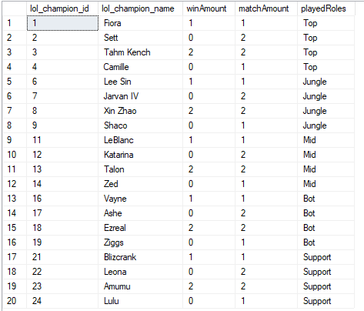

***Result of the championDetails VIEW Table.***

## User Interface

