Undercurrent
CSI Engine
Technical Product Requirements Document
Cultural and social insight engine
Author: Andrew Kuan, Automation and AI Lead, Influencer
Status: Draft for build (v2 rebuild)
Date: 7 July 2026
Repository: andrewkuan/undercurrent (new repository)
This is the build-facing technical specification. A product-register version for wider stakeholders can be derived from the plain-language opening of each section, with the deeper technical subsections trimmed.

Contents
1. Overview and purpose 3
2. Problem and goals 3
Root cause 3
Goals (v2) 3
3. Users and use cases 3
Rollout 4
Core use case 4
4. Functional requirements 4
4.1 Project-first structure 4
4.2 The query, gather, synthesise flow 4
4.3 Report output components 4
4.4 Differentiating principles 4
4.5 Dive-deeper (build on top) 5
4.6 Exports and sharing 5
5. System architecture 5
5.1 Two-stage pipeline 5
5.2 Deployment topology 5
5.3 The stack 6
5.4 The gather agent 6
5.5 Background-work model 8
6. Data model and schema 8
6.1 The evidence ledger 9
6.2 The tables 9
6.3 Design rules that make provenance structural 10
6.4 Two-stage write path 10
6.5 Dive-deeper inheritance 10
7. External integrations 10
8. Authentication and access 11
9. Non-functional requirements 11
9.1 Performance and latency 11
9.2 Cost envelope 11
9.3 Security and privacy 12
9.4 Reliability 12
9.5 Scale 12
10. Waves and Ocean integration (future phase) 12
11. Future phases 12
12. Open questions and risks 13
13. Appendix: schema sketch 14

1. Overview and purpose
Undercurrent is an internal cultural and social insight engine. A strategist asks a natural-language question about a cultural topic, and Undercurrent returns a structured insight report grounded in real, verifiable sources drawn from Reddit, the open web, and uploaded documents.
It began as a prototype built during a MongoDB hackathon and was well received by the cultural insight and creative strategy teams. It is now being rebuilt for production. Two things drive the rebuild. The hackathon stack was temporary and has already partly broken. More importantly, the prototype cannot guarantee trustworthy provenance, which is the one thing every user asked for.
This document specifies the production rebuild. It covers the v2 architecture, data model, integrations, and non-functional requirements, and it lays out the future phases that v2 is deliberately designed to accommodate. Throughout, it is honest about the gap between what the engine can do today and where it is going. Each section distinguishes current capability from planned work.

2. Problem and goals
Across every feedback session, users asked for the same core thing: insight they can trust and trace. The recurring complaints were dead links, statistics that turned out to be third-hand, and citations that could not be verified.

Root cause
In the prototype, citations were stored as bare integer indices into a model-authored references array, while the underlying retrieved content sat in an unstructured blob with no per-source identity and no stable ID. Nothing in the data model guaranteed that a citation pointed at a real, retrieved source, or that the source still existed. This is a data-model problem, not a prompt-tuning problem, which is why the fix is structural rather than a matter of better instructions to the model.

Goals (v2)
- Make provenance structural. Every citation must resolve to a real, stored source with a stable identity and a verified, clickable link.
- Separate gather from synthesise. Evidence is gathered first and persisted, then synthesis may only cite evidence that was actually retrieved.
- Preserve the agentic retrieval loop that makes the engine genuinely useful.
- Ship a coherent, owned production stack aligned with the wider Waves and Ocean ecosystem.

3. Users and use cases
v2 serves internal strategists. Two user shapes recur, and the engine should serve both without forcing a mode choice on them.
- The depth-led strategist works on slow culture over a long horizon and needs evidence they can stand behind.
- The trend-led strategist works fast against live briefs and needs timely, relevant signal.
Both are expert at framing a sharp cultural question, which v2 assumes. That assumption is exactly what the future guided-refinement phase later relaxes (see section 11).

Rollout
Creative operations first, then potentially client services.

Core use case
A strategist creates or opens a project, asks a natural-language question, and receives a structured insight report with verifiable sources. They can dive deeper into any thread, and share the result as a link or a PDF.

4. Functional requirements

4.1 Project-first structure
Work is organised into projects. A project holds its audiences, its topics, the documents uploaded into it, and the questions asked within it. This maps to the projects and uploaded_files tables in section 6.

4.2 The query, gather, synthesise flow
A question triggers a two-stage process. Stage one (gather) runs an agentic retrieval loop across Reddit, web search, and uploaded document chunks, writing every retrieved item into the evidence ledger. Stage two (synthesise) writes the insight report and may only cite sources that already exist in the ledger. The two stages are the mechanism that makes trustworthy citation enforceable rather than hoped for.

4.3 Report output components
The report is composed of six components. Composition follows the feedback synthesis and should be validated against the live brief before output copy is locked.
- Headline reframe, expressed through the obvious, unexpected, and interesting lens.
- Topic breakdown.
- Tensions, framed to provoke rather than to conclude.
- Consumer voice and verbatims, prioritising real consumer language over expert commentary.
- Suggested creator angles, which the engine proposes rather than discovering named creators.
- Sources, every one verified and clickable.

4.4 Differentiating principles
Four principles every output must honour:
- Verified, clickable sources.
- Consumer voice over expert voice.
- Recency control. Each question carries its own recency window.
- Provoke, do not conclude.

4.5 Dive-deeper (build on top)
A follow-up question inherits its parent's evidence from the shared ledger at no extra retrieval cost, and spends new retrieval budget only on what the follow-up specifically asks. Parent and child questions are linked through parent_question_id, so a thread of inquiry accumulates rather than starting fresh each time.

4.6 Exports and sharing
Two outward surfaces only: a shareable link, which is an app route that renders a saved result, and a PDF export. There is no client login in v2.

5. System architecture

5.1 Two-stage pipeline
The engine runs as two stages with the evidence ledger between them: an agentic gather stage writes retrieved evidence to the ledger; a synthesis stage reads the working set and writes the report, citing sources by their ledger ID; the report then renders by resolving each cited ID back to its stored source. Splitting gather from synthesis is what makes the rule cite only real evidence something the system enforces rather than something the model is merely asked to do.

5.2 Deployment topology
Undercurrent deploys to Vercel on the Pro plan, with a managed Neon database alongside it. Only the web app is exposed to the outside world.
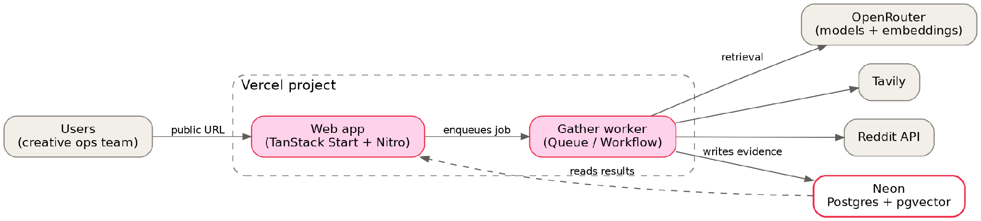
Figure 1. Vercel deployment topology. Only the web app is public; the gather worker, run as a queue or workflow, is the only part that reaches external APIs.
- Web app. Thin. It takes the question, hands the heavy work off, and renders finished results. Public HTTPS URL, deployed through the Nitro Vercel preset.
- Gather worker. The agentic gather loop, run as a Vercel Queue handler or Workflow rather than an always-on process. It writes evidence to the database and is the only part that reaches external APIs.
- Neon (Postgres with pgvector). The evidence ledger, holding both the relational tables and the vectors. Integrates natively with Vercel.
The web app and the gather worker deploy from the same repository, so this is one codebase rather than two. Railway remains a viable container-based fallback if the gather loop ever outgrows the serverless model.

5.3 The stack
Layer | Choice | Why
Framework | TanStack Start + Nitro | Vercel-to-AWS portability via presets; convergence with Waves and Ocean.
Backend | Effect (TypeScript) | Typed errors, retries, telemetry. Well suited to a retrieval engine made mostly of failure cases.
Query layer | @effect/sql-pg or Drizzle | Match what Waves uses for consistency.
Database | Neon (Postgres + pgvector) | Relational ledger and vectors in one store. Integrates natively with Vercel.
Models | OpenRouter (Influencer key) | Sonnet as main agent, Haiku for lightweight tasks.
Embeddings | OpenRouter embeddings | One model and dimension, fixed for the project's life.
Web search | Tavily | Agent-native search and content extraction in one call.
Social | Reddit API | Social retrieval.
Hosting | Vercel (Pro) | Serverless with Fluid Compute; app and gather run as functions, queues, or workflows. Railway is the container fallback.

5.4 The gather agent
Section 5.1 framed the two stages. This section sets out how the gather agent behaves within them, because that behaviour drives both the quality of a report and its cost.
A run begins with a planning step. It takes the question, the recency window, and the project context (its audiences, topics, and uploaded documents) and produces a structured plan: the facets the question needs answered, a concrete set of queries for each channel, and which channels to lean on. The recency window is injected here, so queries are scoped to the timeframe from the outset rather than only filtered afterwards. This step runs on the main model, since it sets the quality of the whole run.
Retrieval then runs in priority order. Documents come first, through a vector search over their chunks: they are internal, highest-trust, and already in scope, so they ground the run in what the team already knows. Reddit and the open web follow together, Reddit for consumer voice and the web for breadth and recent events. Every result, from all three channels, passes a recency filter before it is scored, so anything dated outside the window is dropped early. Internal documents are treated as always in scope, and undated external sources are kept but flagged rather than silently dropped.
Each kept result is scored for relevance and extracted into a source record by the lightweight model, then deduplicated and written to the evidence ledger. After each round the agent decides whether it has enough. Sufficiency is judged by coverage and saturation, not by token count or a raw number of links. Coverage asks whether each planned facet is backed by a minimum number of distinct, relevant, in-window sources. Saturation asks whether the last round added many new relevant sources or almost none; when fresh rounds stop yielding novel sources, the topic is exhausted and the loop ends. A hard cap on rounds and total sources bounds cost regardless.
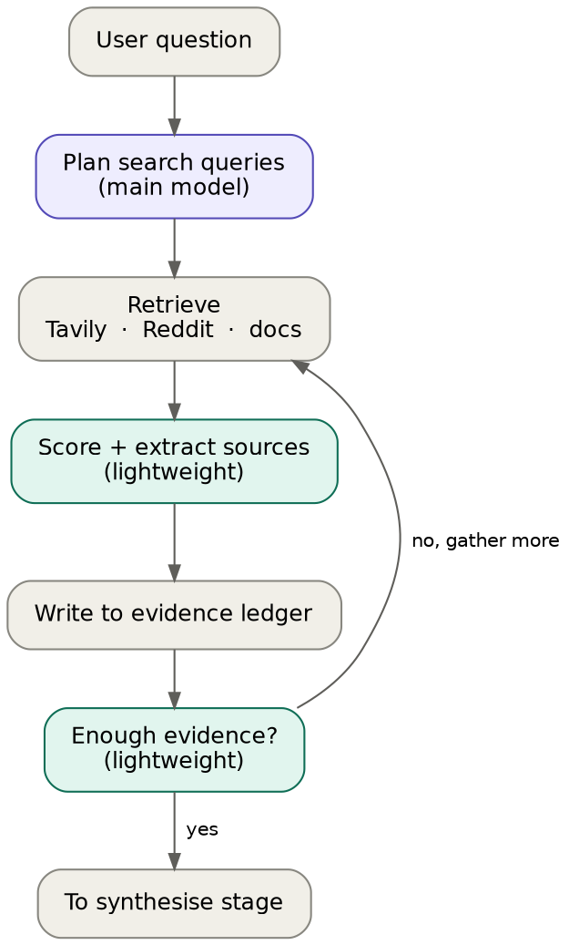
Figure 3. The gather loop. Purple steps use the main model, teal the lightweight model, grey are infrastructure with no model call.
Once gathering ends, the working set is assembled, its members re-verified with a liveness check (not a model call), and the report is written by the main model, which may cite only sources that already exist in the ledger. Citations are then bound to their sources and a snapshot of each is frozen.
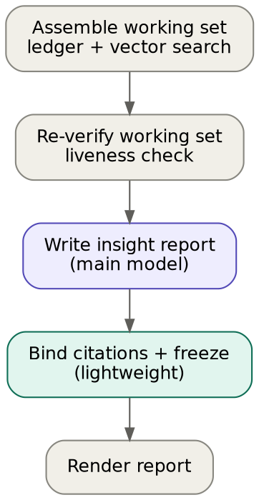
Figure 4. The synthesis stage. One main-model call writes the report; the lightweight model binds and freezes the citations.
The model split follows from this. The main model is used only where reasoning over the whole picture matters: planning and the final synthesis. Everything per-item and high-volume, relevance scoring, extraction, classification, the sufficiency check, and citation binding, runs on the lightweight model, which is where most of the token volume sits. This allocation is the main lever on cost.

5.5 Background-work model
The gather loop never runs inside a web request. The web app records the job and returns immediately; the gather worker runs the loop and updates the question's status as it progresses; the interface polls that status. On Vercel this worker is a Queue handler or a Workflow rather than an always-on process. Fluid Compute suits it well: functions run to a 300-second default and up to thirty minutes when configured, and active-CPU billing pauses while the loop waits on model and API calls, so an I/O-bound agentic run stays cheap. A Workflow, which can pause and resume with durable state, is the pattern for any run that outgrows a single function.

6. Data model and schema
The data model is the heart of the rebuild. It turns provenance from a hope into a guarantee. The redesign is relational at its core, which is why Postgres fits it more naturally than the prototype's document store did.
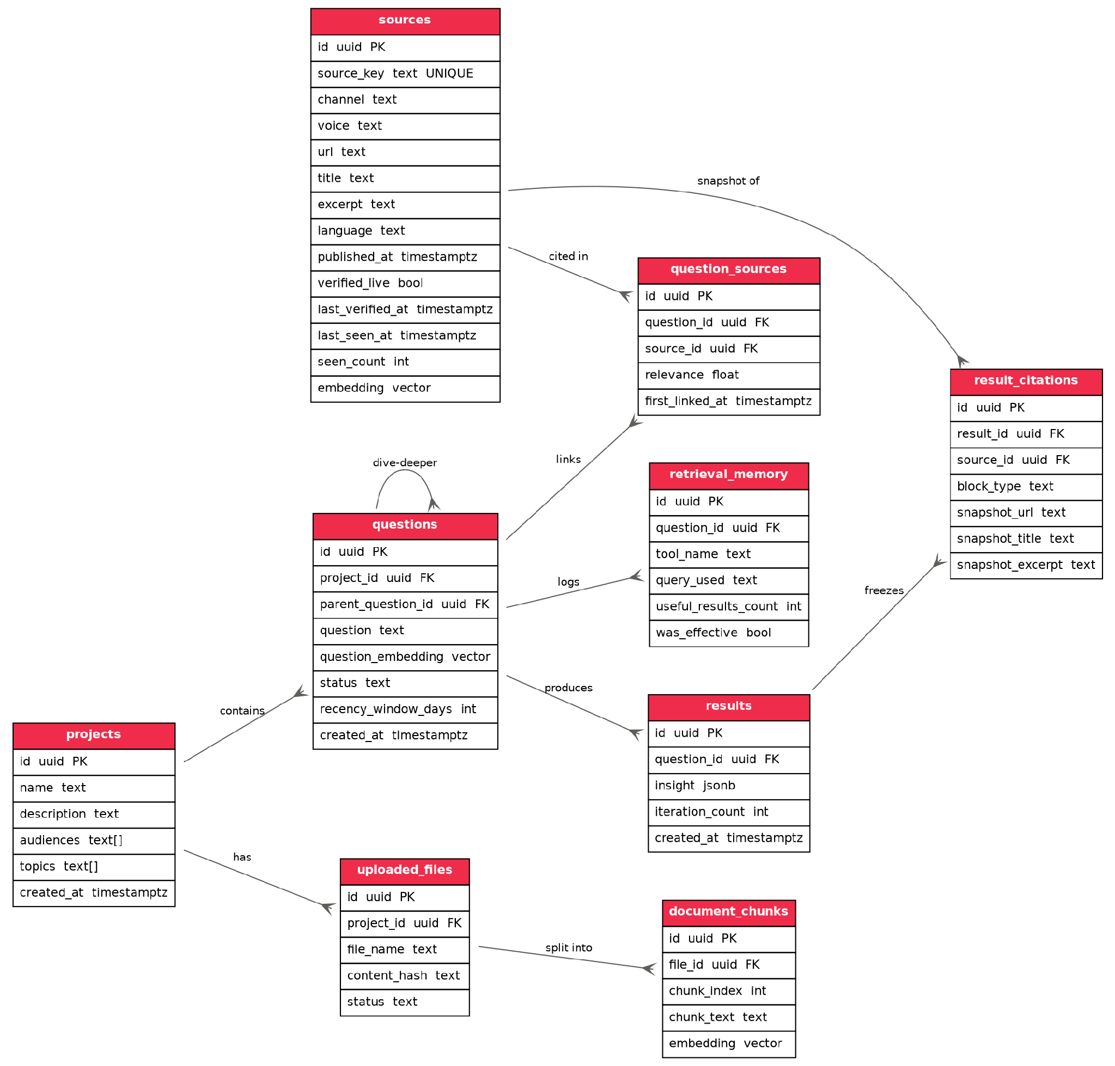
Figure 2. The evidence-ledger schema in Postgres. The sources table is the ledger; result_citations can only reference rows that exist in it.

6.1 The evidence ledger
Every retrieved item becomes a row in sources, with a stable id, a unique source_key for deduplication, verification fields, and an embedding for similarity search. This is the ledger that synthesis is required to cite, and it is the single most important table in the design.

6.2 The tables
- projects. Top-level container: audiences, topics, and the work done inside.
- questions. A first-class record with its own embedding, recency window, status, and an optional parent for dive-deeper threads.
- sources. The evidence ledger. One row per retrieved item, with verification and an embedding.
- question_sources. The join recording which sources a question pulled, with a relevance score.
- results. A produced report. The insight object is held as JSONB.
- result_citations. Each citation in a report, pointing at a real source and freezing a snapshot of it.
- uploaded_files. Documents uploaded to a project.
- document_chunks. Uploaded files split into embedded chunks for retrieval.
- retrieval_memory. A log of every tool call and whether it was effective, so the engine learns which queries pay off.

6.3 Design rules that make provenance structural
- Foreign keys do real work. result_citations.source_id references sources.id, so a citation cannot point at a source that does not exist. The dead-link problem becomes impossible at the storage layer.
- Deduplication by source_key. source_key carries a UNIQUE constraint. A repeat sighting uses INSERT ... ON CONFLICT (source_key) DO UPDATE to bump seen_count and last_seen_at rather than create a duplicate. The key is namespaced: Reddit fullname, canonicalised-URL hash, or file-content-hash plus chunk index.
- Frozen snapshots. result_citations stores snapshot_url, snapshot_title, and snapshot_excerpt captured at synthesis time, so a historical report stays honest even if the live source later changes or disappears.
- Re-verification. Before a source older than seven days by last_verified_at joins a working set, it is re-verified and its verified_live and last_verified_at fields are updated.
- Vectors and indexes. question_embedding, sources.embedding, and document_chunks.embedding are vector columns, each with an HNSW index. Vector similarity and SQL filters (recency, project, voice) run in a single query.
- JSONB where it belongs. results.insight is variable, nested, model-authored output displayed as a unit and rarely filtered, so it lives in a JSONB column. This is the correct use of JSON, the opposite of forcing relational data into a blob.

6.4 Two-stage write path
Gather writes sources, question_sources, and retrieval_memory. Synthesis reads the working set and writes results and result_citations. The two write paths never cross, which keeps the citation guarantee intact.

6.5 Dive-deeper inheritance
A child question, with parent_question_id set, inherits the parent's question_sources and reads its evidence from the shared ledger at no cost, spending external retrieval budget only on what the follow-up newly requires.

7. External integrations
The engine talks to every external service through a single thin internal retrieval service. That boundary means any provider can be swapped without touching the rest of the engine, and it is the same boundary through which Waves data will later flow (section 10).
- OpenRouter (Influencer credentials only). Sonnet as the main agent and Haiku for lightweight work, plus embeddings, all on one key.
- Tavily. Agent-native web search and content extraction in one call, with freshness controls and prompt-injection filtering on retrieved content. Brave and Exa remain drop-in alternatives behind the retrieval boundary.
- Reddit. Social retrieval.
- Embeddings. One model and dimension, fixed for the project's life. Changing it later means re-embedding every vector column, so the choice is made once and recorded.

8. Authentication and access
v2 uses Better Auth, configured to mirror Waves and Ocean. Mirroring matters: the integration plan treats Undercurrent and Waves as peers sharing an auth layer, and speaking the same library makes that a connection rather than a bridge between two different auth worlds.
- Methods. Google login plus a whitelist that auto-provisions any influencer-email user at a baseline permission, which an admin can then raise.
- Roles. A custom-role concept from the start, so permissions can later inherit from Waves roles.
The open question of whether to evolve or replace the existing admin and guest model is recorded in section 12.

9. Non-functional requirements

9.1 Performance and latency
Vector search returns in single-digit milliseconds at this scale. The agentic gather loop is the slow part, taking seconds to a minute or more depending on depth, which is precisely why it runs asynchronously off the web request. Reports render instantly because they read stored results rather than recomputing them.

9.2 Cost envelope
Infrastructure is small and predictable. AI usage is the variable, and the model allocation in section 5.4 is the main lever on it.
Most of the per-report token volume, the relevance scoring, extraction, classification, and citation binding, runs on the lightweight model, which costs roughly a third of the main model. The main model is reserved for query planning and the single synthesis call over the working set. Anchoring on the current v1 build, which runs about £0.15 to £0.20 a report, a v2 report is projected in the region of £0.20 to £0.35 once the added ledger work is included, with prompt caching trimming the input cost further. These are projections, to be confirmed once the new loop is instrumented.
Usage | Reports / month | AI spend | Infra | All-in
Light | about 100 | £20 to £35 | about £20 | £45 to £60
Heavy | about 300 | £60 to £105 | about £25 | £90 to £135
Search adds a small fixed cost. Tavily bills about £0.006 a query (roughly $0.008) and bundles content extraction, with 1,000 free queries a month, which covers light usage and runs to only a few pounds at heavy usage; Reddit is free. The all-in figures include this. Converted at about £0.76 to the US dollar (June 2026); OpenRouter and Tavily bill in US dollars, so figures are indicative. Other levers: routing per-item work to the lightweight model, prompt caching, and the per-question recency window to bound retrieval.

9.3 Security and privacy
- Only the web app is publicly exposed. The database is reached over a secure connection string held in environment variables and is never public.
- Secrets live in environment variables, never in the repository, with the local env file ignored from the first commit.
- Access is limited to influencer-email accounts through the auth whitelist.

9.4 Reliability
Fluid Compute reduces cold starts through instance reuse and pre-warming, though it does not remove them entirely. The database is managed with backups. Portability is the main safeguard: because the app is built on Nitro, it can move off Vercel with a preset change, and section 12 notes this.

9.5 Scale
v2 targets roughly ten users in creative operations. pgvector is comfortable into the low millions of vectors; pgvectorscale is the in-place upgrade if the corpus grows toward tens of millions, and a dedicated vector store only becomes relevant if vector search ever becomes the primary workload rather than one feature of the engine.

10. Waves and Ocean integration (future phase)
Undercurrent is designed to sit alongside Waves and Ocean as a peer application, connected through a shared authentication layer rather than by reaching into each other's databases.
- Shared auth. Better Auth on both sides, so a Waves user's identity and role can carry into Undercurrent.
- Alignment. Undercurrent runs on Vercel, the same platform Waves 2 currently uses, and its TanStack Start and Nitro foundation keeps it portable to Waves' eventual AWS deployment with a preset change, so convergence stays a lift rather than a rewrite.

11. Future phases
Sequencing below is indicative, not committed.
- v2 rebuild. The locked stack and the evidence-ledger architecture, in content-query mode.
- Scaling to client services. Widening the audience beyond expert strategists.
- Guided query refinement. A clarifying-question step, in the style of how Claude probes before answering, that helps a user sharpen a question before research runs. Most valuable as the tool reaches less specialist users. To be scoped further.
- Wider sources. Bringing in the other sources the teams rely on, such as Corq newsletters, as the verified core proves out.
- Deeper extraction. Tavily covers everyday search and extraction, but a tool such as Firecrawl could be added for deep crawling of a specific report or a JavaScript-heavy site. To adopt if it proves clearly worthwhile.
- Audience-query mode. Pending a decision on whether to bring in demographic data such as GWI.
- Waves and Ocean integration. The peer-app phase, sharing authentication, as detailed in section 10.

12. Open questions and risks
- Auth evolution (open decision). Whether to evolve the existing admin and guest session model toward the Waves pattern, or replace it wholesale with Better Auth from the start. Evolving preserves continuity but carries legacy assumptions; replacing is cleaner and more convergent but is more upfront work. A short spike should settle it before the auth layer is built.
- Demographic data source. Audience-query mode depends on a demographic source. Whether to pursue GWI for this is still open.
- Platform reliability. Keep database backups, and treat portability through Nitro presets as a sensible precaution.
- Embedding model choice. The embedding model and dimension are fixed once chosen, so the decision is worth making deliberately. A minor consideration rather than a blocker.

13. Appendix: schema sketch
Indicative DDL for the core tables. Types and constraints are illustrative; the embedding dimension is set to match the chosen model. Vector indexes and the deduplication pattern follow the table definitions.
create extension if not exists vector;

create table projects (
id uuid primary key default gen_random_uuid(),
name text not null,
description text,
audiences text[],
topics text[],
created_at timestamptz not null default now()
);

create table questions (
id uuid primary key default gen_random_uuid(),
project_id uuid not null references projects(id),
parent_question_id uuid references questions(id),
question text not null,
question_embedding vector(1536),
status text not null default 'run_once',
recency_window_days int,
created_at timestamptz not null default now()
);

create table sources (
id uuid primary key default gen_random_uuid(),
source_key text not null unique,
channel text not null, -- reddit | web | doc
voice text, -- consumer | expert
url text,
title text,
excerpt text,
language text,
published_at timestamptz,
verified_live bool not null default false,
last_verified_at timestamptz,
last_seen_at timestamptz,
seen_count int not null default 1,
embedding vector(1536)
);

create table question_sources (
id uuid primary key default gen_random_uuid(),
question_id uuid not null references questions(id),
source_id uuid not null references sources(id),
relevance float,
first_linked_at timestamptz not null default now()
);

create table results (
id uuid primary key default gen_random_uuid(),
question_id uuid not null references questions(id),
insight jsonb not null,
iteration_count int,
created_at timestamptz not null default now()
);

create table result_citations (
id uuid primary key default gen_random_uuid(),
result_id uuid not null references results(id),
source_id uuid not null references sources(id),
block_type text,
snapshot_url text,
snapshot_title text,
snapshot_excerpt text
);

create table uploaded_files (
id uuid primary key default gen_random_uuid(),
project_id uuid not null references projects(id),
file_name text not null,
content_hash text,
status text
);

create table document_chunks (
id uuid primary key default gen_random_uuid(),
file_id uuid not null references uploaded_files(id),
chunk_index int not null,
chunk_text text not null,
embedding vector(1536)
);

create table retrieval_memory (
id uuid primary key default gen_random_uuid(),
question_id uuid not null references questions(id),
tool_name text not null,
query_used text,
useful_results_count int,
was_effective bool
);

-- vector indexes (one per embedding column)
create index on sources using hnsw (embedding vector_cosine_ops);
create index on questions using hnsw (question_embedding vector_cosine_ops);
create index on document_chunks using hnsw (embedding vector_cosine_ops);

-- deduplication on repeat sightings
insert into sources (source_key, channel, url, title, embedding)
values ($1, $2, $3, $4, $5)
on conflict (source_key) do update
set seen_count = sources.seen_count + 1,
last_seen_at = now();

