Activity 1: Flipped Classroom and AI
Chosen topic | The OSI 7-Layer Reference Model (開放系統互連參考模型)
Concept | Layered communication, encapsulation, and mapping OSI to TCP/IP
Level / curriculum | S.5 ICT · Compulsory Part, Module C Internet and its Applications · Networking and Internet Basics
Pre-lesson video | PowerCert Animated Videos — OSI Model Explained (about 8–10 min)
Video URL | https://www.youtube.com/watch?v=vv4y_uOneC0
Reading | Cloudflare — What is the OSI Model? https://www.cloudflare.com/learning/ddos/glossary/open-systems-interconnection-model-osi/
AI tool (teacher) | Gemini — to draft MCQs, a video summary, fill-in items, flashcards and discussion points; then teacher-edited to HKDSE style
Student tool introduced | Cisco Packet Tracer (Simulation mode) — to watch encapsulation layer by layer in class
Purpose of this pack: students meet the seven layer names, PDUs and one worked example at home, so class time can be used for Packet Tracer, a case study and a role-play — not for copying notes.

1. MCQ Generator (before class)
Prompt (paste into Gemini)
Generate five MCQs based on https://www.youtube.com/watch?v=vv4y_uOneC0 for S.5 ICT students. Use HKDSE Paper 1 style. Cover: (1) why we use a layered model; (2) the order of the seven layers; (3) HTTP / TCP / IP and their layers; (4) switch versus router; (5) encapsulation order. Include one combination item with (1)(2)(3)(4). Do not ask CCNA-only detail. Provide an answer key.
Purpose: To equip students with basic knowledge about the OSI 7-layer model before the lesson.
AI-generated output (teacher-edited)

Question 1
The main reason the OSI model is taught in ICT is that it
A. is the protocol suite actually used by every website on the Internet
B. divides network communication into layers so protocols and devices can be discussed systematically
C. replaces TCP/IP in Hong Kong school networks
D. encrypts all data before it leaves a computer

Question 2
Which of the following is the correct order of OSI layers from Layer 1 to Layer 7?
A. Physical → Network → Data Link → Transport → Session → Presentation → Application
B. Physical → Data Link → Network → Transport → Session → Presentation → Application
C. Application → Presentation → Session → Network → Transport → Data Link → Physical
D. Physical → Data Link → Transport → Network → Session → Presentation → Application

Question 3
A student cannot reach a website on the Internet, but can still print to a printer on the same LAN. Which device is most likely at fault, and at which OSI layer does that device mainly operate?
A. The switch — Layer 3
B. The hub — Layer 7
C. The router — Layer 3
D. The web browser — Layer 2

Question 4
HTTP and HTTPS are protocols of the
A. Application layer
B. Transport layer
C. Network layer
D. Data Link layer

Question 5
Which of the following statements about TCP and IP are correct?
(1) TCP works at the Transport layer and can retransmit lost segments.
(2) IP works at the Network layer and is responsible for routing packets to the destination host.
(3) IP guarantees that packets arrive in order.
(4) TCP uses port numbers so the receiving host knows which application should get the data.
A. (1) and (2) only
B. (1), (2) and (4) only
C. (2), (3) and (4) only
D. (1), (2), (3) and (4)
Answer key (do not issue with the student sheet)
1B · 2B · 3C · 4A · 5B
Q3 is a typical HKDSE diagnosis item: the LAN still works (Layer 2 is fine), so the path to another network (the router, Layer 3) is the likely fault. Q5(3) is false because IP is best-effort; TCP, not IP, keeps order.

2. Summary of a video
Prompt
Okay, generate 10 point forms to summarize this video: https://www.youtube.com/watch?v=vv4y_uOneC0 for S.5 ICT students. Use simple English. Include the seven layer names, PDUs, one device or protocol per layer, and how OSI maps to TCP/IP.
Purpose: Students watch the 8-minute animation at home and check their notes against this 10-point summary. Class does not replay the whole video.
- A layered model lets different vendors’ hardware and software work together, because each layer has one job and a standard way of talking to the layer next to it.
- The seven OSI layers, from bottom to top, are Physical, Data Link, Network, Transport, Session, Presentation and Application. Mnemonic: Please Do Not Throw Sausage Pizza Away.
- Layer 1 (Physical) sends bits over a medium — UTP cable, fibre, or Wi-Fi radio. A hub and the signalling part of a NIC work here.
- Layer 2 (Data Link) puts bits into frames and uses MAC addresses. A switch forwards frames on the local network. Ethernet and Wi-Fi sit here.
- Layer 3 (Network) uses logical IP addresses and chooses a path. A router works here. The PDU is a packet.
- Layer 4 (Transport) delivers data end-to-end. TCP is reliable and uses port numbers; UDP is faster but does not retransmit. The PDU is a segment (TCP) or datagram (UDP).
- Layers 5–7 handle the session, the data format/encryption, and the application. HTTP, HTTPS, DNS, SMTP and FTP are Application-layer protocols in HKDSE terms.
- Encapsulation: as data goes down the stack, each layer adds a header (and Layer 2 also adds a trailer). Decapsulation unwraps those headers at the receiver.
- PDU names going down: Data → Segment → Packet → Frame → Bits.
- The Internet actually runs TCP/IP, not OSI. OSI 5–7 map to the TCP/IP Application layer; OSI 4 to Transport; OSI 3 to Internet; OSI 1–2 to Network Access / Link.

3. Fill in the blank (before class to grasp basic knowledge, or after class to consolidate knowledge)
Prompt
Write a 15-blank cloze paragraph about sending a web request through the OSI stack. Use this word bank once each: Application, bits, Data Link, encapsulation, frame, HTTP, IP, Network, packet, Physical, router, segment, switch, TCP, Transport. Provide the answers.
Purpose: Before class, this checks that students can place HTTP, TCP, IP, a switch and a router on the correct layer. After class, the same cloze can be reused without the word bank.
Word bank
Application · bits · Data Link · encapsulation · frame · HTTP · IP · Network · packet · Physical · router · segment · switch · TCP · Transport
When you open a web page, your browser creates an (1) ____________ request at the (2) ____________ layer. That request is passed down to the (3) ____________ layer, where (4) ____________ adds a header with port numbers and, if needed, splits the data into a (5) ____________. The (6) ____________ layer then adds an (7) ____________ header containing the source and destination logical addresses; the data unit is now called a (8) ____________. A (9) ____________ uses this address to choose a path towards another network. On the local network the (10) ____________ layer wraps the packet in a (11) ____________ that uses MAC addresses; a (12) ____________ forwards it using those MAC addresses. Finally the (13) ____________ layer turns everything into (14) ____________ on a cable or radio wave. Adding a header at each layer is called (15) ____________.
Answers
(1) HTTP (2) Application (3) Transport (4) TCP (5) segment (6) Network (7) IP (8) packet (9) router (10) Data Link (11) frame (12) switch (13) Physical (14) bits (15) encapsulation
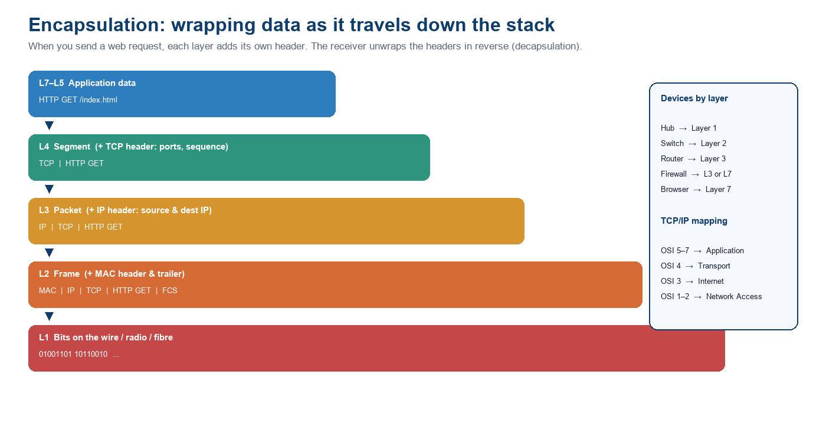
Figure 1. Encapsulation of an HTTP GET — the story behind the cloze.

4. Draw a mind map (before/after class)
Prompt
Create a mind map of the OSI 7-layer model for S.5 ICT. Centre node: OSI 7-Layer Reference Model. Branches: the seven layers (name, PDU, one example, Chinese name), plus Encapsulation, Devices, and TCP/IP mapping.
Purpose: Before class, students complete a blank mind map from the video. After class, they compare it with this version. Weaker students may be given this map as a starter.
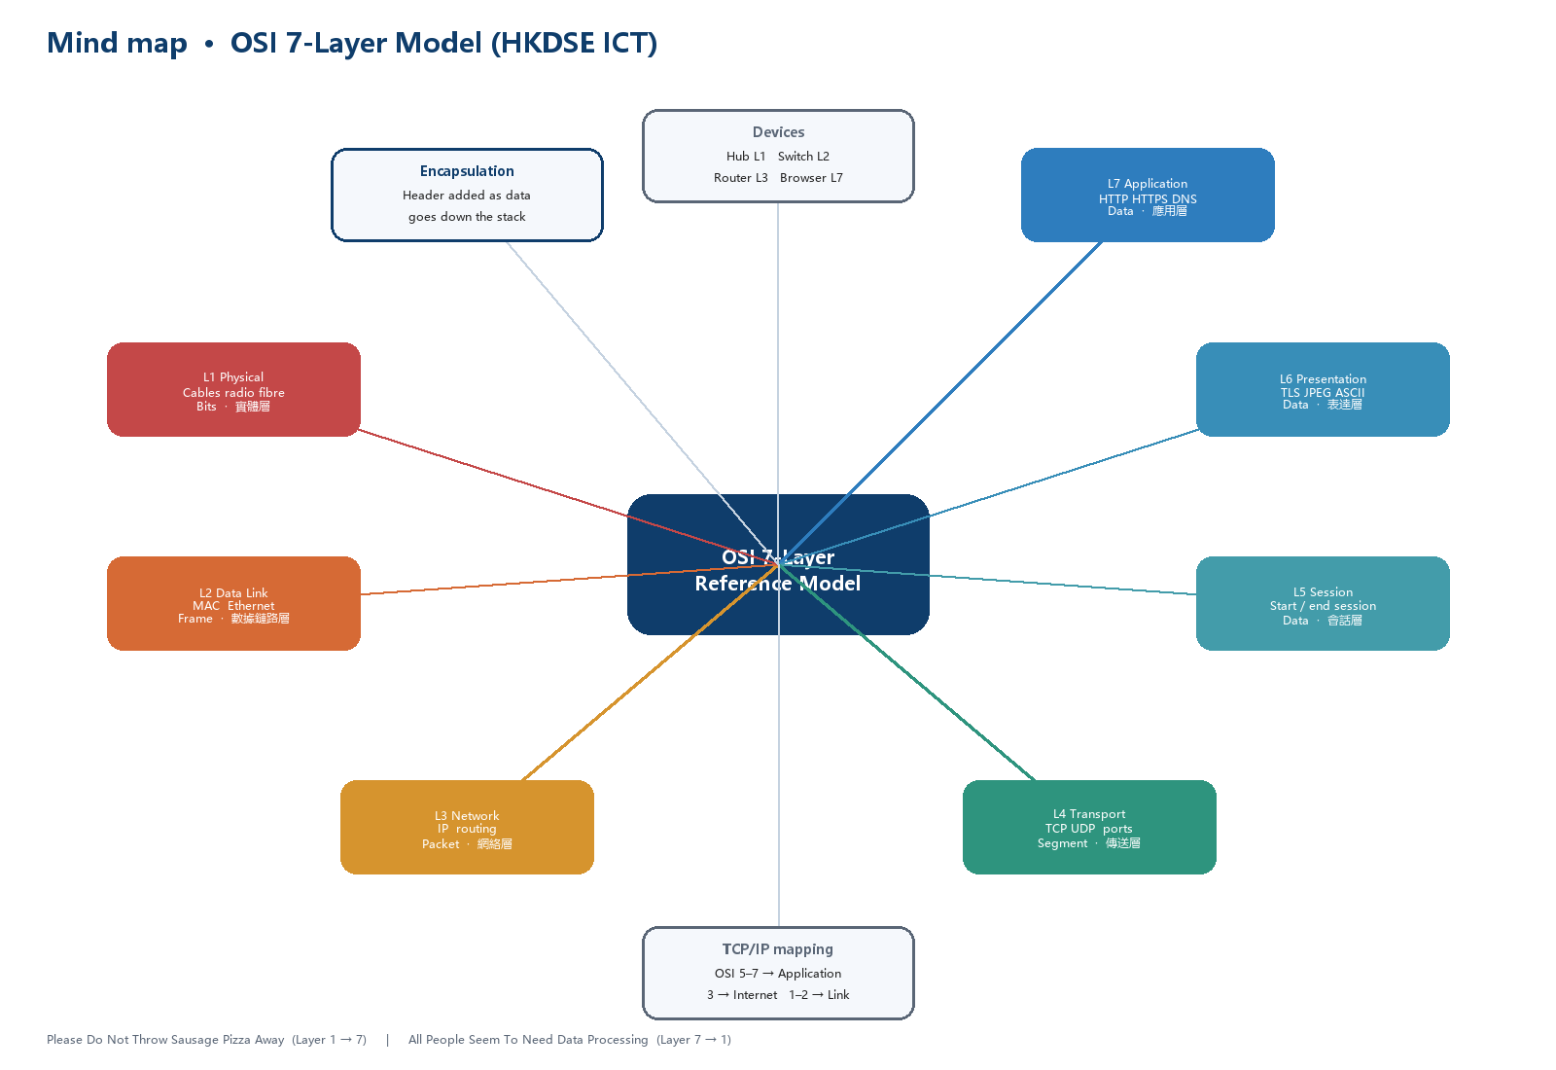
Figure 2. AI-assisted mind map (redrawn for print). Students can rebuild it in MindMeister, Coggle or Gemini.

5. Case Study (compare two devices / models, and when to use them)
Prompt
Write a short school-based case study for S.5 ICT comparing (a) a switch and a router, and (b) the OSI model and the TCP/IP model. Include a ‘when to use which’ table and two HKDSE-style follow-up questions.
Purpose: In class, groups apply the layers to a real school network instead of reciting names.

Case: Ying Wa computer room
The ICT room can print to a shared printer and share files on the school LAN, but this morning nobody can open https://www.hkeaa.edu.hk. The printer still works. Two devices sit in the cabinet: a switch and a router. Students must decide which device, and which OSI layer, is the likely fault — and explain why we still teach OSI when the Internet uses TCP/IP.
 | Switch | Router
Main OSI layer | Layer 2 Data Link | Layer 3 Network
Address used | MAC address | IP address
PDU | Frame | Packet
When to use | Connect PCs, printers and APs inside one LAN / one broadcast domain. | Connect the LAN to another network or the Internet; choose a path.
If it fails | Local sharing and printing break. | Local LAN still works; Internet / other subnets fail.

 | OSI model | TCP/IP model
What it is | A 7-layer reference / teaching model (ISO). | The 4-layer protocol suite that actually runs the Internet.
When to use it | To name a layer, a device or a fault (“this is a Layer 1 cable problem”). | To explain how HTTP, TCP and IP work together on a real network.
HKDSE takeaway | OSI is how we think and troubleshoot. | TCP/IP is what the exam (and the Internet) actually run.

Follow-up questions (in class)
1. Using the table, explain why the printer still works in this case. Name the layer of the likely fault. (2 marks)
2. “We should stop teaching OSI because the Internet uses TCP/IP.” Do you agree? Give one argument for and one against. (4 marks)

6. Role-playing (e.g. user testing a web request)
Prompt
Design a 10-minute role-play for a class of S.5 ICT students to act out encapsulation of an HTTP GET. Include roles, props, steps, and a ‘fault card’ for user-testing what happens when one layer fails.
Purpose: Class time is for doing, not listening. The role-play is the flipped ‘active’ half: students test whether they can locate a fault by layer.
Roles (7 students + 1 sender + 1 receiver):
- Sender (browser) — writes “HTTP GET /index.html” on a card.
- L7 Application, L6 Presentation, L5 Session, L4 Transport, L3 Network, L2 Data Link, L1 Physical — each holds a coloured sticky-note header.
- Receiver — unwraps the headers in reverse and reads the request aloud.
- Rest of the class — observers who must name the layer when a fault card is drawn.
Steps:
- Sender hands the card to L7. Each lower layer adds its sticky note (TCP ports → IP addresses → MAC + FCS → “bits”).
- The card is walked across the room (the “medium”) to the receiver, who peels the notes off from L1 back up to L7.
- Draw a fault card and repeat. Observers name the broken layer.
Fault cards (user testing):
- Unplugged UTP cable → Layer 1.
- Wrong MAC / switch port down → Layer 2.
- Wrong IP / router off → Layer 3.
- Port 443 blocked → Layer 4.
- HTTPS certificate / encoding problem → Layer 6.
- Browser cannot open the page but ping works → Layer 7.

7. Discussion (brainstorming / generating discussion points before class)
Prompt
Generate five pre-class discussion points about the OSI model for S.5 ICT, suitable for a 3-minute Google Classroom post and a 8-minute in-class talk. One point should be about AI: can a chatbot replace learning the layers?
Purpose: Students post a one-sentence answer before class. The teacher opens the lesson from the most common misconception.
- Why bother with seven layers if WhatsApp “just works”? What problem is OSI trying to solve?
- A classmate says “the switch is broken because I cannot open Instagram.” What would you ask them before you agree?
- HTTPS: is it Layer 6 (encryption) or Layer 7 (web application)? Why do HKDSE marking schemes usually treat it as Application?
- OSI versus TCP/IP: which one should you write in a Paper 1 answer about how data is transmitted over the Internet? Why?
- You asked Gemini “which layer is a firewall?” and it said Layer 7. How would you check that answer instead of copying it?

8. Revision flashcards
Prompt
Make 10 revision flashcards for HKDSE ICT on the OSI model. Front: a short question. Back: a one-line answer plus the Chinese term where useful.
Purpose: After class consolidation. Students can also paste the table into Quizlet or Gemini Student Spaces.
# | Front | Back
1 | OSI from Layer 1 to 7? | Physical, Data Link, Network, Transport, Session, Presentation, Application
2 | PDU of Layer 2 / 3 / 4? | Frame / Packet / Segment
3 | HTTP sits at which layer? | Application (L7) · 應用層
4 | TCP sits at which layer? | Transport (L4) · 傳送層
5 | IP sits at which layer? | Network (L3) · 網絡層
6 | Switch vs router? | Switch = L2, MAC, frames. Router = L3, IP, packets.
7 | What is encapsulation? | Each lower layer adds a header as data travels down the stack. 封裝
8 | MAC address is used at which layer? | Data Link (L2) · 數據鏈路層
9 | OSI 5–7 map to which TCP/IP layer? | Application layer of TCP/IP
10 | Bottom-to-top mnemonic? | Please Do Not Throw Sausage Pizza Away

9. Study guide / cheat sheet
Prompt
Make a one-page cheat sheet of the OSI 7 layers for HKDSE ICT: English name, Chinese name, PDU, function, one protocol or device. Add the TCP/IP mapping and the two mnemonics.
Purpose: A single page students may keep on the desk during the role-play, but not during the MCQ.
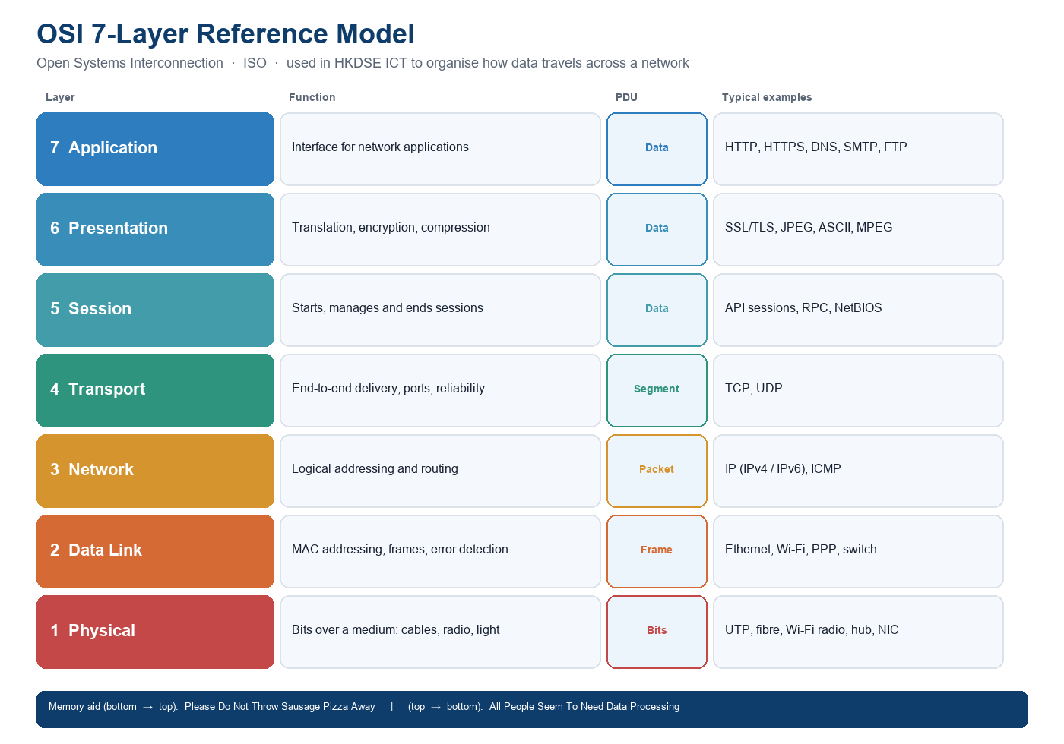
Figure 3. One-page cheat sheet. Chinese names used in papers: 實體層 / 數據鏈路層 / 網絡層 / 傳送層 / 會話層 / 表達層 / 應用層.
TCP/IP mapping (write this on the back of the cheat sheet):
- OSI 5 + 6 + 7 → TCP/IP Application
- OSI 4 → TCP/IP Transport
- OSI 3 → TCP/IP Internet
- OSI 1 + 2 → TCP/IP Network Access / Link

10. Making presentation / videos
Prompt
Outline a 6-slide pre-lesson micro-presentation (max 4 minutes) on the OSI model for S.5 ICT, to be built in Gamma or Canva. Also suggest one optional extension video besides PowerCert.
Purpose: The teacher (or a student helper) posts a short narrated slide deck on Google Classroom the night before. This is the flipped “lecture at home”.
Required video (students watch this): https://www.youtube.com/watch?v=vv4y_uOneC0 — PowerCert, OSI Model Explained.
Optional extension: https://www.youtube.com/watch?v=3kfO61Mensg — NetworkChuck, a real HTTP request through the layers (~17 min).
6-slide outline (Gamma / Canva / PowerPoint Recorder):
- Slide 1 — Hook: “You typed a URL. Name every job the network just did.”
- Slide 2 — Why layers exist (vendor-neutral, divide-and-conquer).
- Slide 3 — The seven layers + mnemonic.
- Slide 4 — Encapsulation of HTTP GET (Figure 1).
- Slide 5 — Switch vs router; OSI vs TCP/IP.
- Slide 6 — Tonight’s task: 5 MCQs + cloze + one sentence for class.
Microsoft PowerPoint Recorder (the module in the Activity 1 brief) can turn these six slides into a narrated video without extra software.
NotebookLM / Gemini Student Spaces can also turn the video URL into flashcards, a quiz, a study guide, a mind map, a cheat sheet and a presentation in one click — the same menu shown in the original Activity 1 screenshots. In this rewrite those outputs are written out in full so the pack can be printed without a live AI tab.

11. Tool introduced: Cisco Packet Tracer
The original Activity 1 sheet uses Gemini to generate learning materials. For this topic we also introduce a student tool that can show the concept, not only talk about it.
Why this tool
Cisco Packet Tracer (free via Cisco Networking Academy) has a Simulation mode. Students send one HTTP request and step through each OSI layer as headers are added and removed. A chatbot cannot show a frame leaving a NIC. Wireshark is too raw for a first OSI lesson. Packet Tracer matches HKDSE devices: switch = Layer 2, router = Layer 3.
How to get it:
- Free course: https://www.netacad.com/courses/getting-started-cisco-packet-tracer
- Install on Windows / macOS / Linux, or use the school machines.
- If there is no install at home, watch this walk-through of “Investigate the TCP/IP and OSI Models in Action”: https://www.youtube.com/watch?v=gQoskICZV2U
- Browser fallback (no install): OpenLabs OSI Model Explorer https://www.openlabs.org.in/computer-science/networking/osi-model
Tiny pre-lesson task with the tool (the class “ticket”):
Open Simulation mode (or the OpenLabs explorer) once. Complete this sentence and bring it:
When a PC sends a web request, I saw the packet pick up a ____________________ header at Layer 4 and an ____________________ header at Layer 3.
Expected: TCP (or UDP) at Layer 4; IP at Layer 3.

How the flipped lesson uses these AI activities
Phase | Activities from this sheet | Time
Before class | Video + reading + MCQs (§1) + cloze (§3) + mind map (§4) + tool ticket (§11) | 20–25 minutes at home
During class | Discussion from §7 → Packet Tracer → Case study §5 → Role-play §6 | 40 minutes
After class | Flashcards §8 and cheat sheet §9; optional NetworkChuck video | 10 minutes

AI literacy note (EDB, 2026)
Gemini drafted the MCQs, cloze, summary, flashcards and discussion points. Every item was then checked against the video and the C&A Guide: distractors were rewritten to look like real HKDSE mistakes (layer swaps, TCP versus IP, switch versus router). Students are told the worksheet was AI-assisted. Classroom rule: an AI explanation of “which layer is HTTPS” is a draft, not a mark scheme. That is the difference between using AI and outsourcing thinking.

References
Cisco Networking Academy. (n.d.). Getting Started with Cisco Packet Tracer. https://www.netacad.com/courses/getting-started-cisco-packet-tracer
Cloudflare. (n.d.). What is the OSI Model? https://www.cloudflare.com/learning/ddos/glossary/open-systems-interconnection-model-osi/
Curriculum Development Council & HKEAA. (2021). Information and Communication Technology Curriculum and Assessment Guide (Secondary 4–6). Education Bureau.
Education Bureau. (2026). AI Literacy Learning Framework for Primary and Secondary Schools.
Microsoft Learn. (n.d.). Flipped instruction with PowerPoint Recorder. https://learn.microsoft.com/en-us/training/modules/flipped-instruction-powerpoint-recorder/
NetworkChuck. (2020). REAL LIFE example!! (TCP/IP and OSI layers) [Video]. YouTube. https://www.youtube.com/watch?v=3kfO61Mensg
PowerCert Animated Videos. (n.d.). OSI Model Explained [Video]. YouTube. https://www.youtube.com/watch?v=vv4y_uOneC0

