THE EDUCATION UNIVERSITY OF HONG KONG
INT2065 Foundations of Information and Communication Technologies
Activity 1 · Flipped Classroom and AI
Pre-lesson Materials for HKDSE ICT
Topic: The OSI 7-Layer Reference Model
Concept: Layered communication, encapsulation, and mapping to TCP/IP

Subject / Level | HKDSE Information and Communication Technology · S.4 / S.5
Curriculum locus | Compulsory Part · Module C Internet and its Applications · Networking and Internet Basics (9 hours)
Pre-lesson time | 20–25 minutes at home (video 8 min + reading 7 min + worksheet 8–10 min)
In-class follow-up | 40-minute lesson: Packet Tracer simulation, DSE-style items, troubleshooting role-play
AI tool used | Gemini (MCQ / fill-in generator) · then teacher-edited to HKDSE style
Student tool introduced | Cisco Packet Tracer (Simulation mode) · free via Cisco Networking Academy

1. Chosen topic and concept
This flipped package prepares S.4/S.5 ICT students for a lesson on how data actually travels from one device to another. Students often can name HTTP or an IP address, but cannot explain why a switch, a router and a web browser are doing different jobs. The OSI model gives them a shared language for that explanation.

1.1 Topic
The OSI 7-Layer Reference Model (Open Systems Interconnection / 開放系統互連參考模型).

1.2 Core concept
Network communication is organised as stacked layers. Each layer has one job, talks only to the layers immediately above and below it, and wraps (or unwraps) a header around the data. This idea — encapsulation — is the concept students must take into class. Once they can place protocols and devices on the correct layer, TCP/IP, HTTP/HTTPS, DNS, switches and routers in the HKDSE syllabus stop being a list of terms and become one story.

1.3 Why this topic for HKDSE ICT
The Education Bureau Curriculum and Assessment Guide (2021) does not require students to recite ISO 7498. It does require them to:
- understand the need for communication software and communication protocols, including simple concepts of TCP/IP;
- describe how data is transmitted over the Internet;
- understand URL, DNS, HTTP and HTTPS;
- explain the functions of network hardware (NIC, switch, router, communication links).
OSI is the teaching model that organises those outcomes. TCP/IP is the protocol suite that actually runs the Internet. Students need both: OSI to think, TCP/IP to sit the exam.

1.4 Prior knowledge assumed
- LAN versus WAN; wired and wireless access.
- What an IP address looks like (IPv4), and that a URL names a resource.
- Names of common devices: NIC, switch, router, modem — but not yet which layer they work at.

1.5 Pre-lesson learning objectives
By the start of the lesson, students should be able to:
- Name the seven OSI layers in order, from Layer 1 to Layer 7, using a mnemonic.
- State the main function and the protocol data unit (PDU) of each layer.
- Match common protocols (HTTP, TCP, IP, Ethernet) and devices (hub, switch, router, NIC) to a layer.
- Describe encapsulation using the everyday example of opening a web page.
- Map the seven OSI layers onto the four TCP/IP layers used in the HKDSE syllabus.

2. Flipped-classroom design
A flipped classroom moves first contact with facts out of the lecture and into homework, so class time can be used for problem-solving (Bergmann & Sams; Microsoft Learn, Flipped instruction). OSI is a poor lecture topic: students copy seven names and forget them. It is a strong activity topic: they can watch a packet being wrapped, then argue about which device failed.
Phase | What students do | Why
Before class (this pack) | Watch 8-min animation; read one short article; complete MCQs and fill-in; glance at Packet Tracer. | Acquire names, order, PDUs and one worked example so class does not start from zero.
During class | Warm-up from the MCQ errors; Packet Tracer Simulation mode; DSE-style items; role-play a broken network. | Apply the model to devices, protocols and troubleshooting — the skills the exam actually marks.
After class | Short exam-style consolidation (fill-in + one long question on HTTP over TCP/IP). | Lock the mapping OSI ↔ TCP/IP before the next topic (DNS, HTTPS, security).

How AI is used in this flipped design (INT2065 Activity 1)
Gemini is used only to draft retrieval items (MCQs and cloze sentences) from the assigned video. The teacher then rewrites stems so they match HKDSE wording, removes trick options, and adds the TCP/IP mapping that the public exam actually tests. Students are told that the worksheet was AI-assisted, and that they must still check every answer against the video and the reading. This models the EDB (2026) AI Literacy expectation: use generative AI as a draft, not as an unchecked authority.

3. Video (before class)

3.1 Required video
PowerCert Animated Videos — “OSI Model Explained | OSI Animation | Open System Interconnection Model | OSI 7 layers”
URL: https://www.youtube.com/watch?v=vv4y_uOneC0
- Length: about 8–10 minutes — short enough for genuine pre-lesson use.
- Why this video: clear animation of all seven layers, PDUs, and a mnemonic; language is accessible to S.4 mixed-ability classes; no CCNA-level extra theory.
- Purpose: equip students with the names, order and everyday function of each layer before they meet Packet Tracer.

3.2 Optional extension (able students / fast finishers)
NetworkChuck — “REAL LIFE example!! (TCP/IP and OSI layers)” (~17 min). Follows one web request through encapsulation and decapsulation.
URL: https://www.youtube.com/watch?v=3kfO61Mensg

3.3 Video viewing questions (write short answers while watching)
- What problem is the OSI model trying to solve? Why not let every vendor invent its own way of sending data?
- Write the seven layer names from Layer 1 (bottom) to Layer 7 (top). Circle the mnemonic used in the video.
- At which layer does a router make a forwarding decision? At which layer does a switch forward a frame?
- When you type a URL, which layer first “sees” that request, and which layer turns it into bits on the cable?

4. Readings (before class)
Students read one core article. The other sources are for the teacher and for students who want a second explanation. None of the readings replace the video.

4.1 Core reading (required, ~7 minutes)
Cloudflare Learning — “What is the OSI Model?”
https://www.cloudflare.com/learning/ddos/glossary/open-systems-interconnection-model-osi/
- Why this one: written for non-specialists; one paragraph per layer; ends with OSI versus TCP/IP, which is exactly the HKDSE link.
- Read with a purpose: complete the layer table in Section 7 while you read, do not copy the whole page.

4.2 Supporting readings (teacher / extension)
- Cisco — “What is the OSI Model?” https://www.cisco.com/c/en/us/solutions/enterprise-networks/what-is-osi-model.html Device-focused examples (hub, switch, router) that match Paper 1 hardware questions.
- MDN — “How does the Internet work?” https://developer.mozilla.org/en-US/docs/Learn_web_development/Howto/Web_mechanics/How_does_the_Internet_work Everyday story of switches (MAC) and routers (IP) without OSI jargon — useful for weaker readers.
- School textbook: HKDSE ICT Compulsory Part, Module C, the chapter on communication protocols / TCP/IP. Students should bring this to class.
- Education Bureau (2021). Information and Communication Technology Curriculum and Assessment Guide (Secondary 4–6). Module C, “Networking and Internet Basics”.

4.3 Guided reading focus
While reading, students only need to collect four facts per layer: English name, Chinese name, one function, one example. They do not need port numbers, CRC polynomials, or the history of ISO.

5. Tool introduced: Cisco Packet Tracer
The pre-lesson is not a Packet Tracer lab. It is an introduction so that, in class, nobody is meeting the software for the first time. Simulation mode is the reason this tool is chosen: students can send one HTTP request and watch each OSI layer add a header.

5.1 What the tool is
- Cisco Packet Tracer is a free network simulator from Cisco Networking Academy. Students drag PCs, switches and routers onto a canvas, cable them, and generate traffic — without any physical hardware.
- Simulation mode (as opposed to Realtime mode) steps through a single packet. A panel lists the OSI layers and shows which header is being added or removed at each hop.
- This is the same idea as the Cisco NetAcad activity “Investigate the TCP/IP and OSI Models in Action”.

5.2 Why this tool, not another
Tool | Decision for this lesson
Cisco Packet Tracer | Chosen. Free for students; Simulation mode visualises encapsulation; devices match HKDSE (switch = L2, router = L3). Many Hong Kong ICT rooms already have it.
Wireshark | Too raw for a first OSI lesson. Excellent later, when students already know what a TCP header is for.
Gemini / ChatGPT | Used by the teacher to draft items. Not the student tool for this concept — a chatbot cannot show a frame leaving a NIC.

5.3 How students get it (before class, 5 minutes)
- Create a free Cisco Networking Academy account and open Getting Started with Cisco Packet Tracer: https://www.netacad.com/courses/getting-started-cisco-packet-tracer.
- Install Packet Tracer for Windows, macOS or Linux. School computers may already have it.
- If installation is not possible at home, watch this 18-minute walk-through of the exact OSI activity so the screen is familiar in class:
https://www.youtube.com/watch?v=gQoskICZV2U ([CCNAv7] Investigate the TCP-IP and OSI Models in Action)
- Browser fallback (no install): OpenLabs OSI Model Explorer https://www.openlabs.org.in/computer-science/networking/osi-model.

5.4 Tiny pre-lesson task with the tool
Do not configure a whole network at home. Do this only:
- Open Packet Tracer (or the OpenLabs explorer).
- Find Simulation mode, or click through the seven-layer animation once.
- Write one sentence: “When a PC sends a web request, I saw the packet pick up a _____ header at Layer 4 and an _____ header at Layer 3.”
That sentence is the entry ticket to the lesson.

6. Visual summary (use while doing the worksheet)
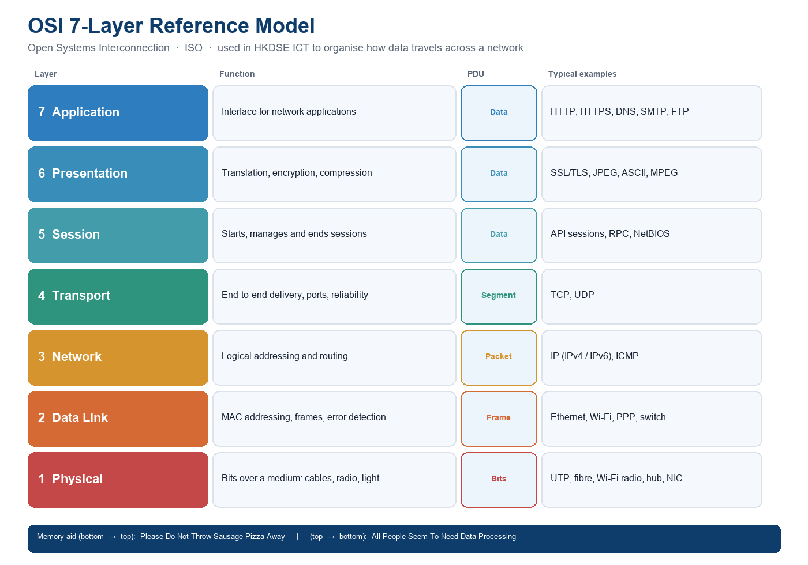
Figure 1. The seven OSI layers, with PDU names and HKDSE-relevant examples.
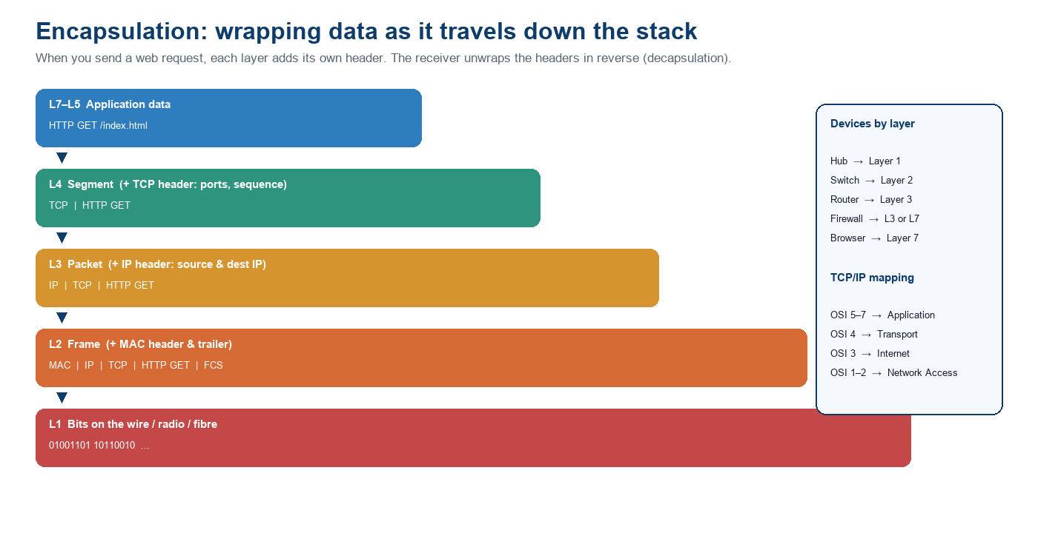
Figure 2. Encapsulation of an HTTP GET request as it travels down the stack.
Chinese names used in HKDSE papers (learn both): 實體層 / 數據鏈路層 / 網絡層 / 傳送層 / 會話層 / 表達層 / 應用層.

7. Student pre-lesson worksheet
Name | ________________________________
Class / class no. | ________________ Date: ______________
Time on task | About 20–25 minutes. Complete Sections A–D before the lesson. Bring this sheet.

Section A · Multiple-choice questions
Answer after watching the PowerCert video. Choose the best answer. These items are written in HKDSE Paper 1 style.

A1.
The main reason the OSI model is taught in ICT is that it
A. is the protocol suite actually used by every website on the Internet
B. divides network communication into layers so protocols and devices can be discussed systematically
C. replaces TCP/IP in Hong Kong school networks
D. encrypts all data before it leaves a computer

A2.
Which of the following is the correct order of OSI layers from Layer 1 to Layer 7?
A. Physical → Network → Data Link → Transport → Session → Presentation → Application
B. Physical → Data Link → Network → Transport → Session → Presentation → Application
C. Application → Presentation → Session → Network → Transport → Data Link → Physical
D. Physical → Data Link → Transport → Network → Session → Presentation → Application

A3.
A student in a computer room cannot reach a website on the Internet, but can print to a printer on the same LAN. Which device is most likely at fault, and at which OSI layer does that device mainly operate?
A. The switch — Layer 3
B. The hub — Layer 7
C. The router — Layer 3
D. The web browser — Layer 2

A4.
HTTP and HTTPS are protocols of the
A. Application layer
B. Transport layer
C. Network layer
D. Data Link layer

A5.
Which of the following statements about TCP and IP are correct?
(1) TCP works at the Transport layer and can retransmit lost segments.
(2) IP works at the Network layer and is responsible for routing packets to the destination host.
(3) IP guarantees that packets arrive in order.
(4) TCP uses port numbers so the receiving host knows which application should get the data.
A. (1) and (2) only
B. (1), (2) and (4) only
C. (2), (3) and (4) only
D. (1), (2), (3) and (4)

A6.
When an HTTP request is encapsulated, the protocol data units appear in which order as the data moves down the stack?
A. Bits → Frame → Packet → Segment → Data
B. Data → Packet → Segment → Frame → Bits
C. Data → Segment → Packet → Frame → Bits
D. Data → Frame → Packet → Segment → Bits

A7.
A MAC address is used at the Data Link layer. A MAC address is best described as
A. a logical address that a DHCP server can change every day
B. a physical address burnt into (or assigned to) a network interface, used to deliver a frame on the local link
C. the same thing as an IPv4 address, written in hexadecimal
D. the port number of a web server, usually 80 or 443

A8.
In the TCP/IP model used on the Internet, the OSI Session, Presentation and Application layers are grouped into the
A. Internet layer
B. Transport layer
C. Network Access / Link layer
D. Application layer

Section B · Fill in the blanks
Use the word bank. Each word is used once.
Word bank
Application · bits · Data Link · encapsulation · frame · HTTP · IP · Network · packet · Physical · router · segment · switch · TCP · Transport

When you open a web page, your browser creates an (1) ____________ request at the (2) ____________ layer. That request is passed down to the (3) ____________ layer, where (4) ____________ adds a header with port numbers and, if needed, splits the data into a (5) ____________. The (6) ____________ layer then adds an (7) ____________ header containing the source and destination logical addresses; the data unit is now called a (8) ____________. A (9) ____________ uses this address to choose a path towards another network. On the local network the (10) ____________ layer wraps the packet in a (11) ____________ that uses MAC addresses; a (12) ____________ forwards it using those MAC addresses. Finally the (13) ____________ layer turns everything into (14) ____________ on a cable or radio wave. Adding a header at each layer is called (15) ____________.

Section C · Layer table (fill in)
Complete the empty cells. The first row is done for you.
L | English name | Chinese name | PDU | One example (protocol / device)
7 | Application | 應用層 | Data | HTTP / HTTPS / DNS
6 |  | 表達層
5 |  |  | Data
4 |  | 傳送層 |  | TCP / UDP
3 | Network
2 |  | 數據鏈路層
1 |  | 實體層 | Bits

Section D · Bring-to-class ticket
Complete this sentence after you have looked at Packet Tracer or the OpenLabs explorer:
When a PC sends a web request, I saw the packet pick up a ____________________ header at Layer 4 and an ____________________ header at Layer 3.
One thing I am still unsure about (we will start the lesson from these sentences):
___________________________________________________________________________
___________________________________________________________________________
___________________________________________________________________________

Before-class checklist (tick)
- I watched the PowerCert OSI video (about 8–10 minutes).
- I read the Cloudflare “What is the OSI Model?” page.
- I completed Sections A, B and C without looking at the answer key.
- I opened Packet Tracer Simulation mode, or the OpenLabs explorer, or watched the walk-through.
- I wrote my “still unsure” sentence so the teacher can use it tomorrow.

How long should this take?
If you finish in under 15 minutes, watch the optional NetworkChuck video (Section 3.2) and add UDP and DNS onto Figure 2 in your own notes. If you need more than 25 minutes, stop after Section B and bring the unfinished table — we will complete it in pairs at the start of the lesson.

8. Teacher notes and answer key (do not issue to students)

8.1 Answer key — Section A (MCQ)
Q | Ans. | Brief reason (use in the lesson warm-up)
A1 | B | OSI is a reference model, not the live Internet stack. TCP/IP is what websites actually use.
A2 | B | Please Do Not Throw Sausage Pizza Away. A swaps Network/Data Link; D swaps Transport/Network.
A3 | C | LAN still works (L2 switch path is fine). Internet needs a L3 router. Classic DSE diagnosis item.
A4 | A | HTTP/HTTPS sit at L7. TLS is often discussed at L6, but the syllabus treats HTTPS as an application protocol.
A5 | B | (3) is false: IP is best-effort and does not keep order. TCP does. Typical HKDSE combination item.
A6 | C | Data → Segment (L4) → Packet (L3) → Frame (L2) → Bits (L1). Down the stack = more wrapping.
A7 | B | MAC = local-link physical address. IP = logical address. Port = L4, not L2.
A8 | D | TCP/IP Application = OSI 5+6+7. Internet = OSI 3. Link/Network Access = OSI 1+2.

8.2 Answer key — Section B (fill in the blanks)
(1) HTTP (2) Application (3) Transport (4) TCP (5) segment (6) Network (7) IP (8) packet (9) router (10) Data Link (11) frame (12) switch (13) Physical (14) bits (15) encapsulation

8.3 Answer key — Section C (layer table)
L | English | Chinese | PDU | Example (accept equivalents)
7 | Application | 應用層 | Data | HTTP, HTTPS, DNS, SMTP, FTP, browser
6 | Presentation | 表達層 | Data | SSL/TLS, JPEG, ASCII, encryption, compression
5 | Session | 會話層 | Data | RPC, NetBIOS, login session
4 | Transport | 傳送層 | Segment | TCP, UDP (UDP PDU is often called a datagram)
3 | Network | 網絡層 | Packet | IP, ICMP, router
2 | Data Link | 數據鏈路層 | Frame | Ethernet, Wi-Fi, PPP, switch, MAC address
1 | Physical | 實體層 | Bits | UTP, fibre, Wi-Fi radio, hub, NIC (physical signalling)
Section D ticket: Layer 4 = TCP (or UDP); Layer 3 = IP. Accept “TCP header” and “IP header”.

8.4 Gemini prompt used to draft the items
This is the prompt that matches INT2065 Activity 1. The output was then rewritten by the teacher so that distractors look like real HKDSE mistakes (layer swaps, TCP versus IP, switch versus router).
Prompt (paste into Gemini)
You are helping a Hong Kong S.5 ICT teacher design a flipped-classroom pre-lesson. Generate FIVE multiple-choice questions and a 12-blank cloze paragraph based on this video: https://www.youtube.com/watch?v=vv4y_uOneC0 (PowerCert, OSI Model Explained). Audience: HKDSE ICT students who already know LAN/WAN and IP addresses but have not yet studied OSI. Constraints: (1) Use HKDSE Paper 1 style, including at least one combination item with (1)(2)(3)(4). (2) Cover layer order, PDUs, HTTP/TCP/IP, and switch vs router. (3) Do not ask about CCNA-only detail (window size, CSMA/CD timing). (4) Provide an answer key with one-line reasons. (5) Include Chinese layer names in a fill-in table.

8.5 Suggested in-class follow-up (40 minutes)
- 0–5 min. Collect the “still unsure” sentences. Build a 10-word word cloud (Mentimeter / Wordwall). Typical gaps: Session vs Presentation; UDP versus TCP; “is HTTPS Layer 6 or 7?”
- 5–15 min. Packet Tracer: two PCs, one switch, one router, one server. Send HTTP in Simulation mode. Students call out the layer as each header appears. Pause on the router hop: “Why did the MAC address change but the IP address did not?”
- 15–28 min. Two DSE-style short questions in pairs: (a) functions of TCP versus IP; (b) a school network diagram — identify the layer of each labelled device.
- 28–38 min. Role-play: four students are Layers 1–4. A “browser” hands a paper HTTP request down the line; each student adds a sticky-note header. Then a “fault card” is drawn (unplugged cable / wrong IP / blocked port 443) and the class names the layer of the fault.
- 38–40 min. Exit ticket: write the TCP/IP four-layer names next to OSI 7, 4, 3 and 1–2.

8.6 Differentiation and access
- Weaker students: allow the mnemonic card and Figure 1 on the desk during Section C; skip A5 if time is short.
- Stronger students: optional NetworkChuck video; ask them to add UDP and DNS to Figure 2.
- Chinese-medium classes: issue the same sheet; the table already carries HKEAA Chinese names.
- No home PC: the OpenLabs explorer and the YouTube Packet Tracer walk-through are the fallback. Do not make installation a barrier to the worksheet.

8.7 AI literacy and ethics (EDB, 2026)
Students should hear, in one sentence, that this worksheet was drafted with Gemini and then checked by the teacher. Two classroom rules follow: (1) an AI explanation of “which layer is HTTPS” is a draft, not a mark scheme; (2) they may use Gemini to quiz themselves, but they must be able to justify the answer with Figure 1. That is the difference between using AI and outsourcing thinking.

9. References
- Cisco. (n.d.). What is the OSI Model? https://www.cisco.com/c/en/us/solutions/enterprise-networks/what-is-osi-model.html
- Cisco Networking Academy. (n.d.). Getting Started with Cisco Packet Tracer. https://www.netacad.com/courses/getting-started-cisco-packet-tracer
- Cloudflare. (n.d.). What is the OSI Model? https://www.cloudflare.com/learning/ddos/glossary/open-systems-interconnection-model-osi/
- Curriculum Development Council & HKEAA. (2021). Information and Communication Technology Curriculum and Assessment Guide (Secondary 4–6). Education Bureau.
- Education Bureau. (2026). AI Literacy Learning Framework for Primary and Secondary Schools. https://www.edb.gov.hk/en/edu-system/primary-secondary/applicable-to-primary-secondary/it-in-edu/debp.html
- Microsoft Learn. (n.d.). Flipped instruction with PowerPoint Recorder. https://learn.microsoft.com/en-us/training/modules/flipped-instruction-powerpoint-recorder/
- Mozilla Developer Network. (n.d.). How does the Internet work? https://developer.mozilla.org/en-US/docs/Learn_web_development/Howto/Web_mechanics/How_does_the_Internet_work
- NetworkChuck. (2020). REAL LIFE example!! (TCP/IP and OSI layers) [Video]. YouTube. https://www.youtube.com/watch?v=3kfO61Mensg
- PowerCert Animated Videos. (n.d.). OSI Model Explained [Video]. YouTube. https://www.youtube.com/watch?v=vv4y_uOneC0

What to submit / print
Print pages of Section 7 (student worksheet) for the class. Keep Section 8 for yourself. The video URL, Cloudflare reading and Packet Tracer install link can be posted on Google Classroom the day before. Collect Section D as the lesson entry ticket.

