Andrew Le

CSPC 386-02

5/12/2017

Comet Crush Project Summary

**Introduction**

Comet crush is a top down shooter game where the player controls a ship trying to shoot and dodge comets flying towards the player. The goal of the game is to score the highest score by destroying the most comets.

**Design**

Rules of the game:

1. Shoot or dodge the comets before they touch you

Sources of uncertainty:

The comets are randomly generated in speed, angle they fall at and starting point

Win State/ Loose state:

The win and loose state of my game are not mutually exclusive as anytime you loose you get to the end state which is a screen that shows your score. The only time you “win” is setting a new high score which means that you get to the end screen with a message saying you got a new high score.

Expected Skills the player must have prior to game:

The concept of attacking the enemies(comets) that are after you.

Controls:

Left Arrow Key- move player(ship) left

Right Arrow Key -move player(ship) right

SPACE - Player shoots a laser from the center of ship

Expected duration of a game:

The expected duration of the game depends on the player’s ability to dodge the comets but generally it will be 1-4 mins of gameplay.

Scoring:

Scoring works by the size of the comet, the smaller the comet the bigger the score.

**Software Architecture Detail**

**Classes:**

Player:

Class loads the ship image for the player and controls moving the player’s ship:

Important Functions:

Shoot function() – spawns a shot class object from the center point of the ship

Shot:

Class loads the image for the laser that shoots from the ship and controls the movement of the shot

Mob:

Class loads the image for the comet and controls the movement of it by randomly generating x and y speeds

Explosion:

Class loads the animation which is multiple images for the explosion. Controls when the animation timing goes off which takes about 2 milliseconds.

**Game Demonstration**

Start Screen

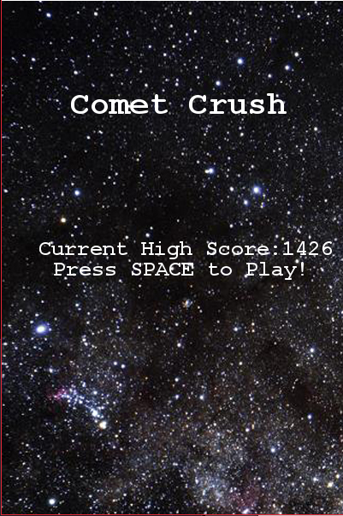

The start screen loads up first with the title and the current High Score, To begin the game Player will need to press SPACE.

Game Loop

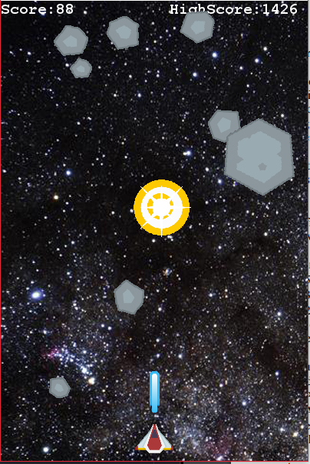

Player ship is at the bottom of the screen, which is controlled by the Player Class. The player can choose to move left or right or shoot with the space bar to shoot incoming comets. The shot is shown coming out of the ship which is using the Shot Function from the player class which uses the class Shot. The comets you see falling are randomly generated size and speed and starting point is controlled by the Mob Class. The top left of the screen shows the current score of the player and the top right of the screen shows the current high score.

End State

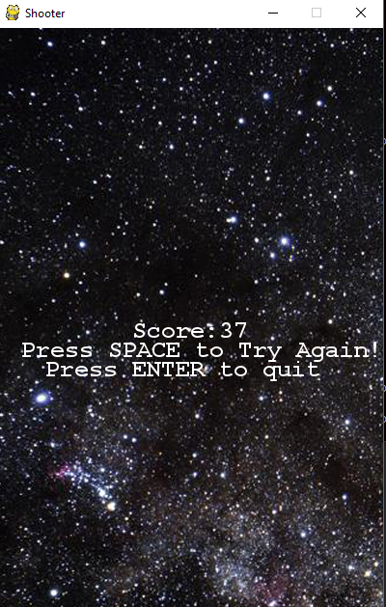

The end state of the game when the player gets hit by a comet. The end state will display the score and a message for the player to try again or quit the game.

Bibliography:

I learned most of pygame from the YouTube channel Game Development with pygame,I also used the book Diving into Python.