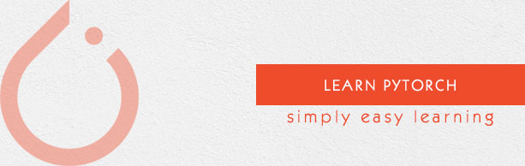

**PyTorch** is an open source machine learning library for Python and is completely based on Torch. It is primarily used for applications such as natural language processing.

Feature :

* Easy Interface : offer easy to use API
* Python Usage : It can leverage all the services by Python Env
* Computational Graph : A user can change them during runtime. This is highly useful when a developer has no idea of how much memory is required for creating a neural network model.

PyTorch is known for having three levels of abstraction as given below :

* Tensor − Imperative n-dimensional array which runs on GPU.
* Variable − Node in computational graph. This stores data and gradient.
* Module − Neural network layer which will store state or learnable weights.

Training a deep learning algorithm involves the following steps:

* Building the data pipeline
* Building the network architecture
* Evaluating the architecture using loss function
* Optimizing the network architecture weights using an optimization algorithm

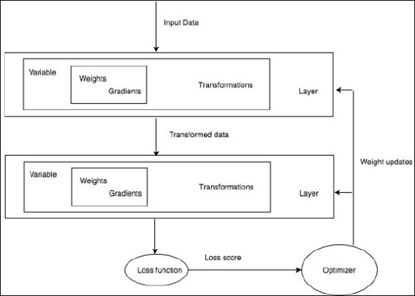

Nếu tensor được lưu trên GPU thì mọi người sẽ không thể chuyển trực tiếp tensor sang Numpy array được, mà mình cần copy nội dung của tensor sang CPU trước rồi mới chuyển sang Numpy array. Do đó 2 biến trên gpu và np không dùng chung vùng nhớ và sửa 1 biến không ảnh hưởng biến còn lại.

