

**NumPy** is a Python package. It stands for **'Numerical Python'**. It is a library consisting of multidimensional array objects and a collection of routines for processing of array.

Operations using NumPy :

* Mathematical and logical operations on arrays.
* Fourier transforms and routines for shape manipulation.
* Operations related to linear algebra. NumPy has in-built functions for linear algebra and random number generation.

NumPy – A ***Replacement*** for MatLab :

NumPy is often used along with packages like SciPy (Scientific Python) and Mat−plotlib (plotting library).

The most important object defined in NumPy is an N-dimensional array type called **ndarray**. It describes the collection of items of the same type.

Every item in an ndarray takes the same size of block in the memory. Each element in ndarray is an object of data-type object (called **dtype**).

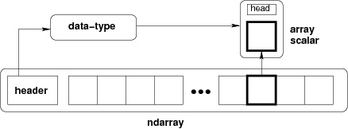

Data Type Objects (**dtype**) : describes interpretation of fixed block of memory corresponding to an array

* Type of data (integer, float or Python object)
* Size of data
* Byte order (little-endian or big-endian)
* In case of structured type, the names of fields, data type of each field and part of the memory block taken by each field.
* If data type is a subarray, its shape and data type.