**Battle Bot Royale**

Game Design Document

Gladiator Games

CS583F2018_Team_14

Revision: 0.0.0

GDD Template Written by: Benjamin “HeadClot” Stanley

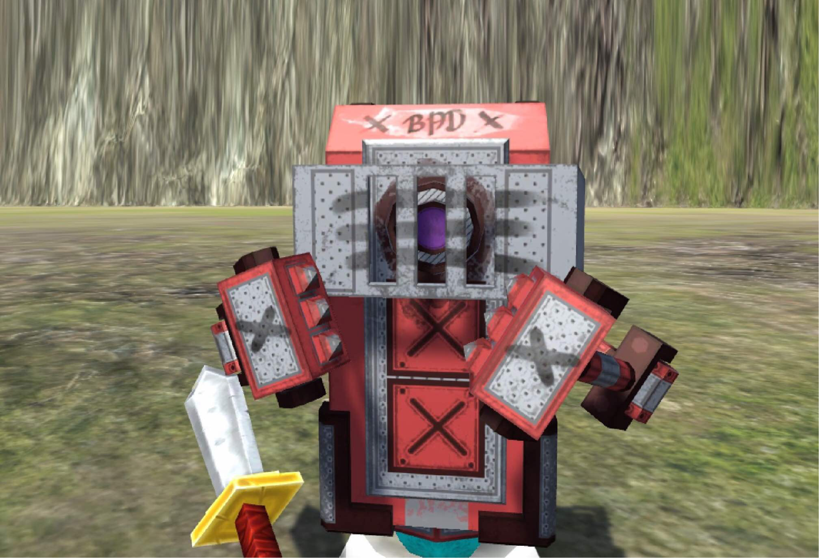

License

If you use this in any of your games. Give credit in the GDD (this document) to Alec Markarian and Benjamin Stanley. We did work so you don’t have to.

Feel free to Modify, redistribute but **not sell** this document.

**Game** **Overview**

## Title

Battle Bot Royale

## Platform

PC Standalone

## Genre

3D level-based survival combat fighter

## Target Audience

Students of CS583 and anyone who wants to play

Battle Bot Royale is a simple yet addictive fighting game, where the player can slash through various enemies, and even a boss or two, with nothing but a sword and their survival skills. Witness what it is like to battle tooth and nail in an arena like prison, with the only goal being to destroy the sinister and lead fisted robots that stand between you and the crown. Keep track of the enemy bots and try your best to win the Battle Bot Royale.

## High Concept

Battle Bot Royale finds the player in an unknown land, plagued by fierce robots and a mighty Robot King. You, as a fighter, must gather your weapons and lay waste to the onslaught of mechanical menaces that stand in the way of you and your victory.

## Unique Selling Points

### - Beautiful graphics and fluid gameplay

### - Easy to master controls

### - Challenging enemies

**- Continuous Playability**

## Synopsis

You want to survive right? Then fight for your life!

## Game Objectives

Fight and defeat all enemies in a level to continue onto the next. At the very last level, fight the final enemy(es) and be victorious.

## Game Rules

The player can move around in the arena like terrain, to try and avoid incoming attackers. To beat a level, the player must defeat all robots on the field. If you die in a later level, you restart at that level, and can keep playing until you win or go to the main menu. Use your sword to inflict damage and mind the healthbars of yourself and the enemy. Other than that, the player must have fun!

# **Game Structure**

The game is entirely level based, with the ability to advance only when all enemies are defeated. Levels can be replayed, and there is a final boss level too.

# **Gameplay**

## Game Controls

‘WASD’ or Arrow Keys for player movement on screen

SPACE to jump

SHIFT to run

Left Mouse Click to attack

Mouse itself controls 1st person viewpoint