Answer sheet

1.branching is the condition when has a value of true or false, and if it was true it can execute the program.it most likely do by step if the condition true ,if not true not work. Branching statements in Python are used to change the normal flow of execution based on some condition. The return branching statement is used to explicitly return from a method. break branching statement is used to break the loop and transfer control to the line immediate outside of loop.

iteration is called when the program has a loop,and most likely use “if”and “wlile”fuction.

2.for=Initialization, condition checking, iteration statement are written at the top of the loop. If the condition is not put up in 'for' loop, then loop iterates infinite times. in 'for' loop the initialization once done is never repeated. In 'for' loop iteration statement is written at top, hence, executes only after all statements in loop are executed.

Since=Only initialization and condition checking is done at the top of the loop. The 'while' loop used only when the number of iteration are not exactly known. If the condition is not put up in 'while' loop, it provides compilation error. In while loop if initialization is done during condition checking, then initialization is done each time the loop iterate.

Answer 3-5 in the jupyter notebook

4

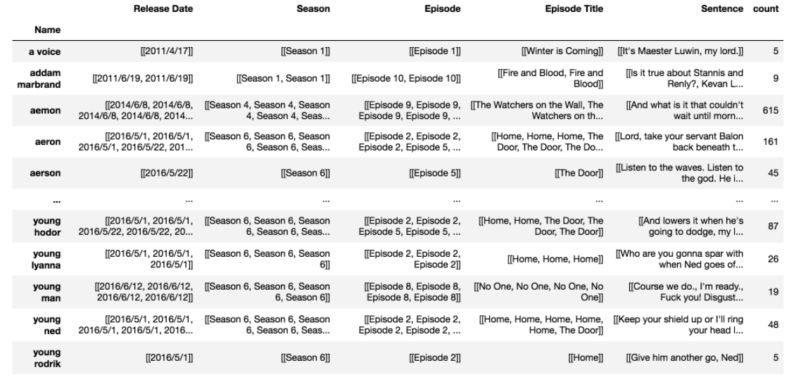

5

