Plotting_Financial_Charts_Using_R

Andrew Meng

November 29, 2016

## Warning: package 'quantmod' was built under R version 3.2.5

## Loading required package: xts

## Warning: package 'xts' was built under R version 3.2.5

## Loading required package: zoo

##   
## Attaching package: 'zoo'

## The following objects are masked from 'package:base':  
##   
## as.Date, as.Date.numeric

## Loading required package: TTR

## Warning: package 'TTR' was built under R version 3.2.5

## Version 0.4-0 included new data defaults. See ?getSymbols.

## As of 0.4-0, 'getSymbols' uses env=parent.frame() and  
## auto.assign=TRUE by default.  
##   
## This behavior will be phased out in 0.5-0 when the call will  
## default to use auto.assign=FALSE. getOption("getSymbols.env") and   
## getOptions("getSymbols.auto.assign") are now checked for alternate defaults  
##   
## This message is shown once per session and may be disabled by setting   
## options("getSymbols.warning4.0"=FALSE). See ?getSymbols for more details.

## Warning in download.file(paste(yahoo.URL, "s=", Symbols.name, "&a=",  
## from.m, : downloaded length 241788 != reported length 200

## [1] "GSPC"

## GSPC.Open GSPC.High GSPC.Low GSPC.Close GSPC.Volume  
## 2015-12-23 2042.20 2064.73 2042.20 2064.29 3484090000  
## 2015-12-24 2063.52 2067.36 2058.73 2060.99 1411860000  
## 2015-12-28 2057.77 2057.77 2044.20 2056.50 2492510000  
## 2015-12-29 2060.54 2081.56 2060.54 2078.36 2542000000  
## 2015-12-30 2077.34 2077.34 2061.97 2063.36 2367430000  
## 2015-12-31 2060.59 2062.54 2043.62 2043.94 2655330000  
## GSPC.Adjusted  
## 2015-12-23 2064.29  
## 2015-12-24 2060.99  
## 2015-12-28 2056.50  
## 2015-12-29 2078.36  
## 2015-12-30 2063.36  
## 2015-12-31 2043.94

## GSPC.Close  
## 2015-12-23 2064.29  
## 2015-12-24 2060.99  
## 2015-12-28 2056.50  
## 2015-12-29 2078.36  
## 2015-12-30 2063.36  
## 2015-12-31 2043.94

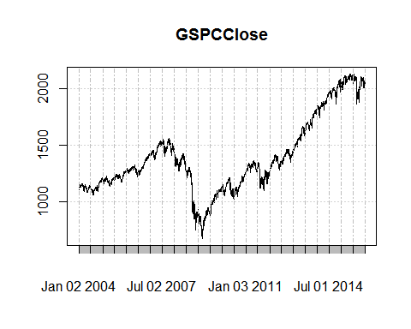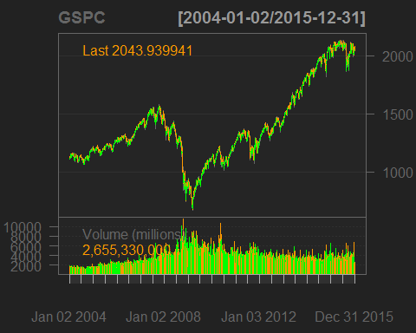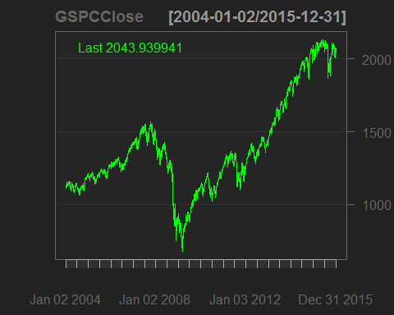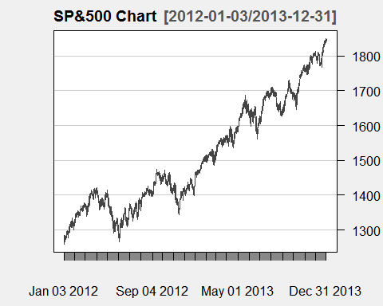

## [1] "fg.col" "bg.col" "grid.col" "border"   
## [5] "minor.tick" "major.tick" "up.col" "dn.col"   
## [9] "dn.up.col" "up.up.col" "dn.dn.col" "up.dn.col"   
## [13] "up.border" "dn.border" "dn.up.border" "up.up.border"  
## [17] "dn.dn.border" "up.dn.border" "main.col" "sub.col"   
## [21] "area" "fill" "Expiry" "theme.name"

