**User Manual**

**Study Better Together**

**A Collaborative Learning Website**

[**http://studybettertogether.com**](http://studybettertogether.com)

**Contents**

Accessing the Website and Logging In 2

Creating a New Account 3

The Home Page 4

Site Navigation 5

Uploading Files 6

Searching and Downloading Public Files 8

Searching and Downloading Your Files 9

Using the Study Forum 11

Using the Chatroom 13

Study Pages 14

Help Pages 14

Admin Use Only – Manage Users 15

Admin Use Only – Manage Classes 16

Admin Use Only – Forum Settings 17

# ****Accessing the Website and Logging In****

**To access the website, open your browser and navigate to** <http://studybettertogether.com>**. You will then see the following page where you have the option to either log in with an existing username and password or else register for a new account. Once logged in you will be redirected to the Home Page.**

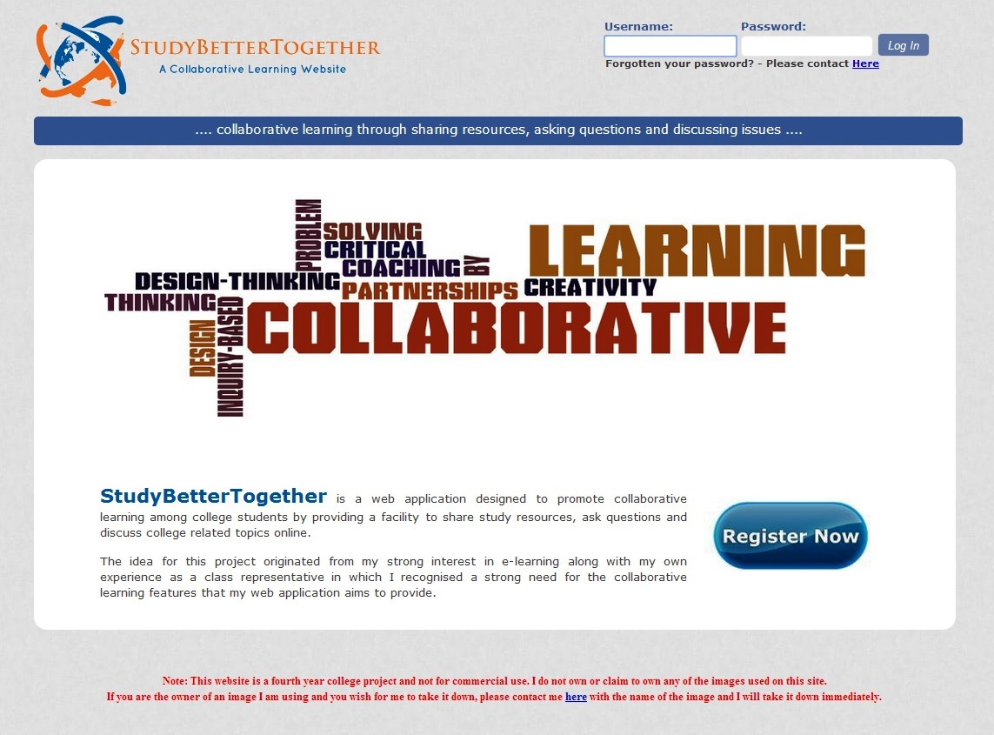

Click here to create a **new account**

Enter your username and password here and click **Log in**

# ****Creating a New Account****

**In order to register for this website you will first need a class name and registration code which will be provided to you by your lecturer. Once you have these details, follow the below steps to create an account.**

1. **Fill in your details in the text boxes provided**
2. **Usernames must be at least 6 characters and can only contain letters and numbers**
3. **Passwords must be at least 6 characters and also must contain one uppercase letter, one lowercase letter and one number, e.g. Password1**
4. **Click the Register button to complete your registration; if successful you will be redirected to the Home Page**
5. **If your registration is not successful and error message will be displayed with further instructions**

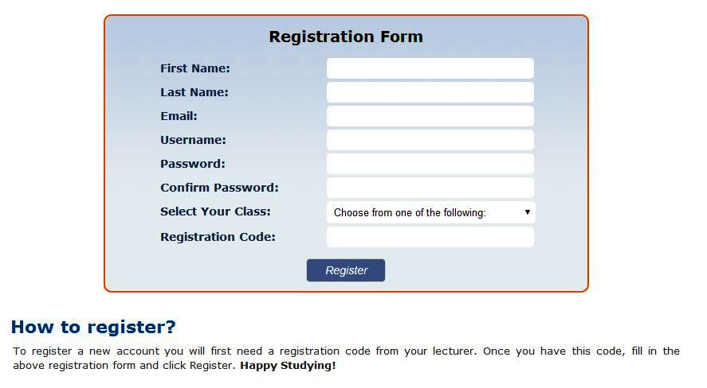

Click the **Register button** to complete your registration; if successful you will be redirected to the **Home Page**

Enter the **Registration Code** provided by your lecturer

Select your **Class** from this dropdown list

# ****The Home Page****

**This is the page you will see when you first log into the website and** contains information and picture links to each of the main website features.

Username of student currently logged in

**Site Logo** –click here from any page to return to the home page

Logout Button

Menu Bar

Picture Links to the main website features

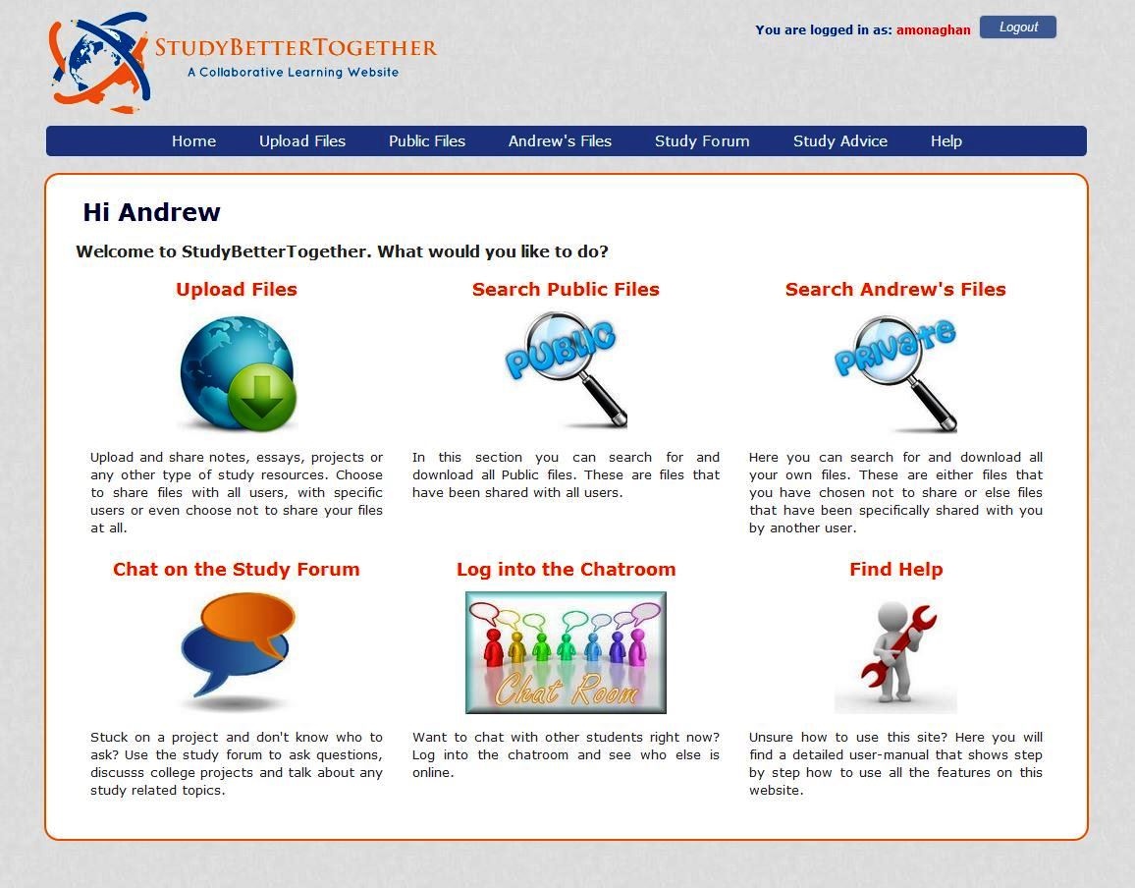

# Site Navigation

There are two ways to navigate around the website. You can click the image links contained on the **Home** **page** or you can use the **menu bar**. Clicking the *StudyBetterTogether* logo (top left of website) from any page will take you back to the Home page.

Menu Bar



The menu bar contains seven links (Level 1 links). When you bring the mouse over some of these links a sub menu may appear underneath (Level 2 links).

Table 1.1 briefly outlines the functionality provided on each of the web pages linked to from the menu bar. A more detailed description including screenshots is contained throughout the remainder of this user manual.

Table 1.1 – Brief description of website pages

|  |  |  |
| --- | --- | --- |
| Level 1 Links | Level 2 Links | Description |
| Home |  | Contains a description and picture link to each of the main website features. |
| Upload Files |  | Upload files and choose to either make them private, public or else share files with specific students. |
|  | **Acceptable Files** | Contains a list of all the file types that are allowed to be uploaded. |
| Public Files |  | Search for (and download) all public files on the website. |
| Andrew’s Files |  | Search for (and download) all of your own files on the website. These are files that either you have uploaded yourself or else files that have been shared with you by another student. |
| Study Forum |  | Create new conversation topics or search through and reply to previously created topics. |
|  | **Chat Room** | Log in and chat with any students who are also logged into the Chatroom |
| Study Advice |  | Read through an excellent study document containing advice and tips on a variety of study related topics |
|  | **Useful Resources** | Contains a list of external links to recommended study resources found online |
| Help |  | Contains this user manual |
|  | **List of users** | View the list of all students registered for this website. This can be used for matching usernames to students for the purpose of specifically sharing files. |
|  | **Change Password** | Change your login password |

# Uploading Files

To upload files simply follow these 6 steps.

1. Click the **Choose File** button and select a file on your computer you want to upload.
2. Enter a **Description** of the file if you wish. This step is optional.
3. Enter a **Subject** for the file if you wish. This step is optional.
4. Choose the desired **Sharing Status** for your file.
   * **Public** – File can be searched for and downloaded by all users
   * **Private** – File can only be searched for and downloaded by yourself
   * **Specific User(s)** – You can select the specific users (students) that you want to be able to search for and download your file
5. Click **Yes** to confirm you agree to the upload terms and conditions which are listed underneath the upload form.
6. Click the **Upload** button

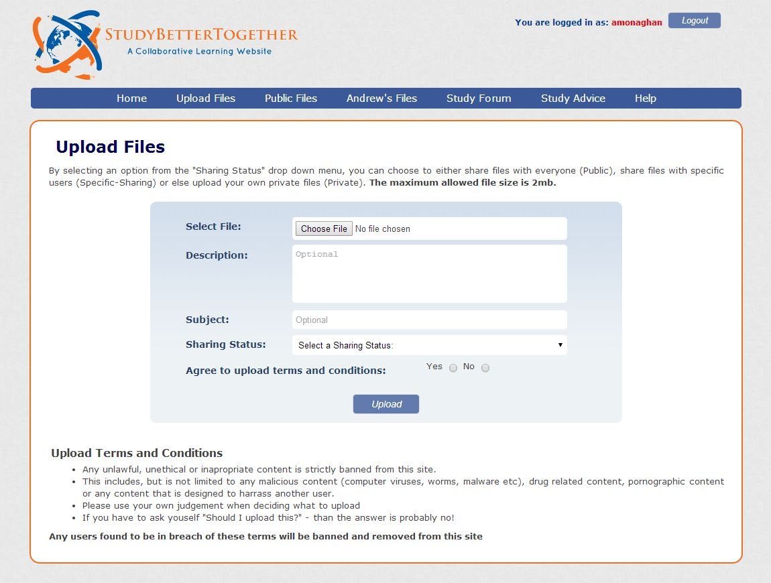

**3.**

**4.**

**2.**

**1.**

**5.**

**6.**

Choosing a Sharing Status

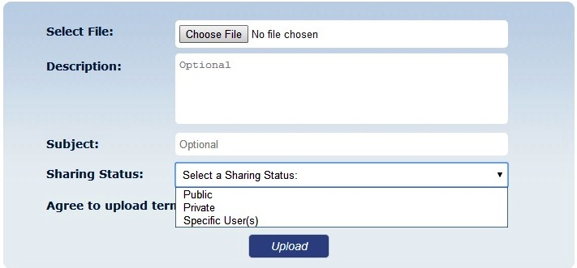

You will need to select a **Sharing Status** for your file

Specific User Sharing

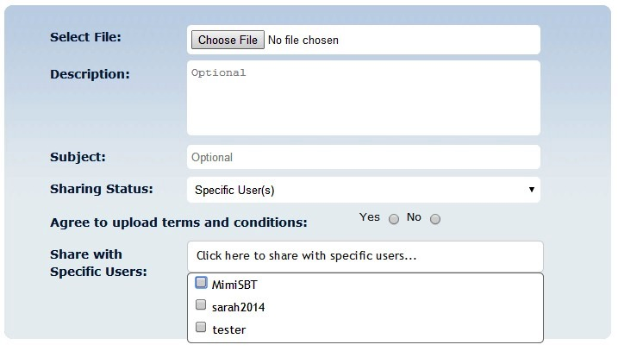

If you choose **Specific User(s)** as your Sharing Status – a new dropdown menu will appear from which you can select the users you want to share your file with.

**Note:** When you move the mouse over the *Upload Files* link in the menu bar, a sub menu link will appear called *Acceptable Files.* This page contains a list of all the file types that are allowed to be uploaded to the website.

Sub Menu – Acceptable Files



# Searching and Downloading Public Files

To search for and download public files simply enter your search criteria in the provided boxes and click search. The results will be displayed below the search form. To display a list of all the public files available, click search without entering any search criteria.

1. Enter in any **search criteria** you wish to search for

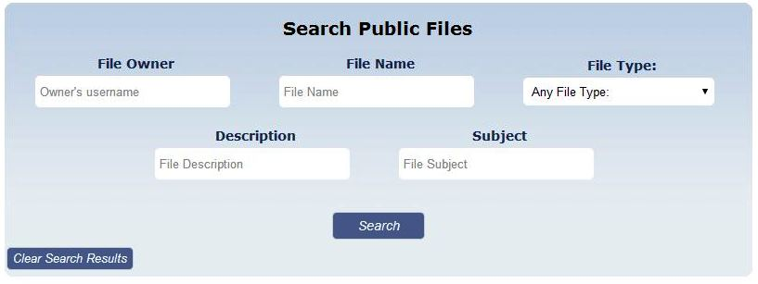

**2)** Click **Search**

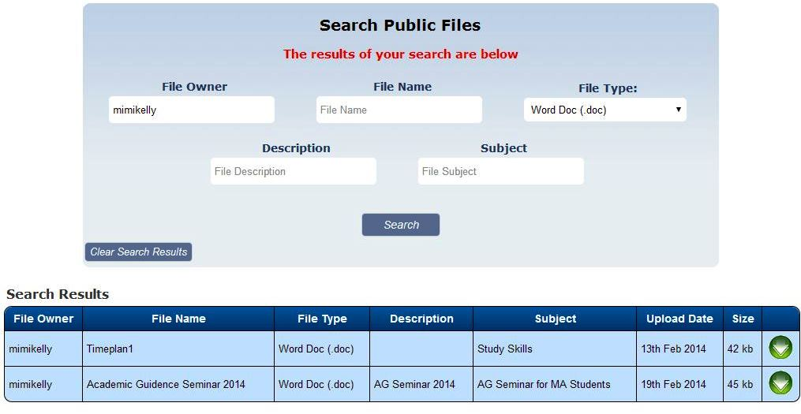

The **results** of your search will appear below the search form

**Search criteria** **entered**

Click this button to **Download** the file

# Searching and Downloading Your Files

Here you can search for and download all of your own files on the website. These are files that either you have uploaded yourself or else files that have been shared with you by another student.

1. Enter in any **search criteria** you wish to search for

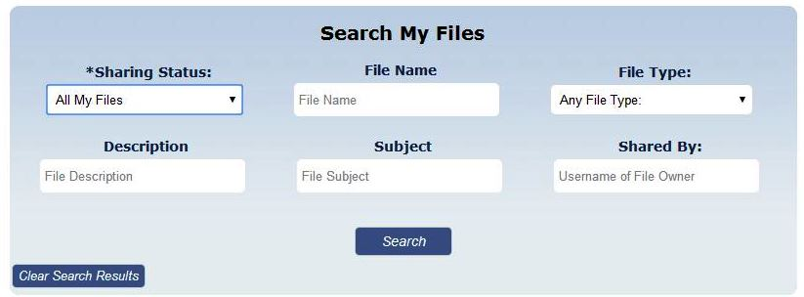

**2)** Click **Search**

Sharing Status - Search Options

You can choose from one of the following five options under the dropdown menu – Sharing Status

1. **All My Files** – This will return all files where you are the file owner (i.e. files you have uploaded).
2. **My Public Files** – This will return all public files you have uploaded.
3. **My Private Files** – This will return all private files you have uploaded.
4. **My Specifically Shared Files** - This will return all specifically shared files that you have uploaded.
5. **Files Shared With Me** – This will return all files that have been specifically shared with you by another user. Since another user is the file owner you will not be given the option to delete these files.

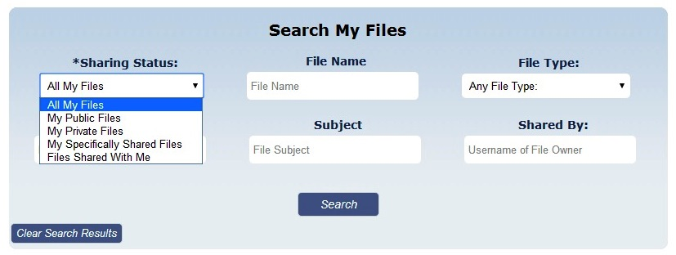

Search Results for “My Files”

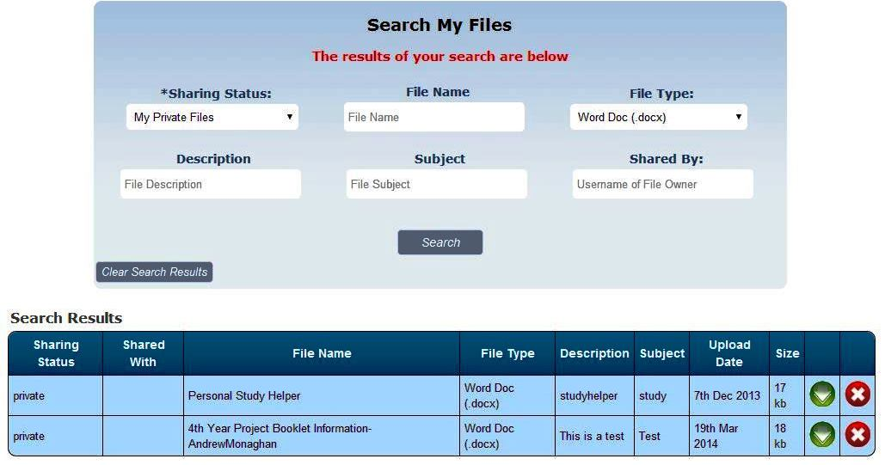

Click this button to **Download** the file

The **results** of your search will appear below the search form

**Search criteria** **entered**

Click this button to **Delete** the file.

Different Results Table for “Files Shared with Me”

When you choose the search status “Files Shared with Me” you will be presented with a slightly different results table. The two main changes are:

1. The username of the file owner is displayed
2. The usernames of whom the file is shared with is displayed
3. There will be no delete button as you are not the owner of the file

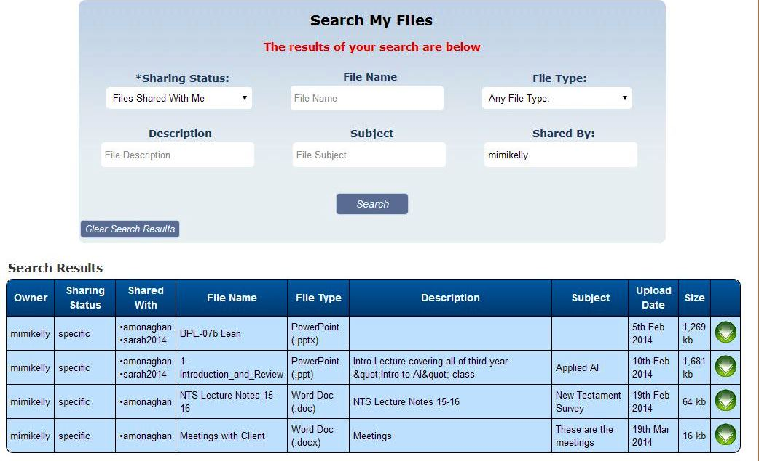

File Owner

Usernames of students whom the files have been shared with

**Note:** No delete button as you are not the file owner

# Using the Study Forum

When using the study forum you have several options depending on what you want to do.

1. **Create a new conversation topic**
2. **Search through previously created topics**
3. **Reply to a previously created topic**
4. **Filter conversation topics by category**

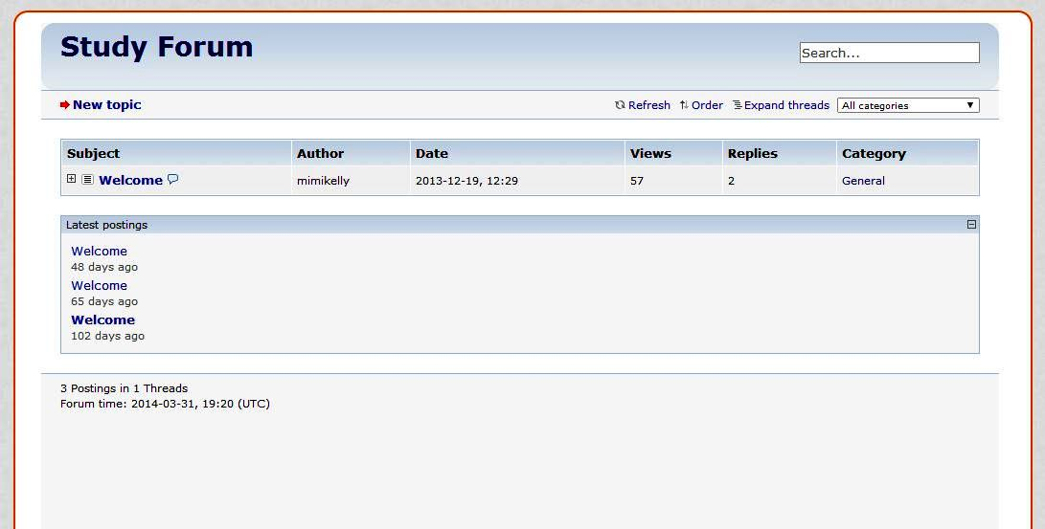

**4.**

**3.**

**1.**

**2.**

Clicking on a topic heading will expand the topic allowing you to

1. View the conversation history
2. Reply to specific posts

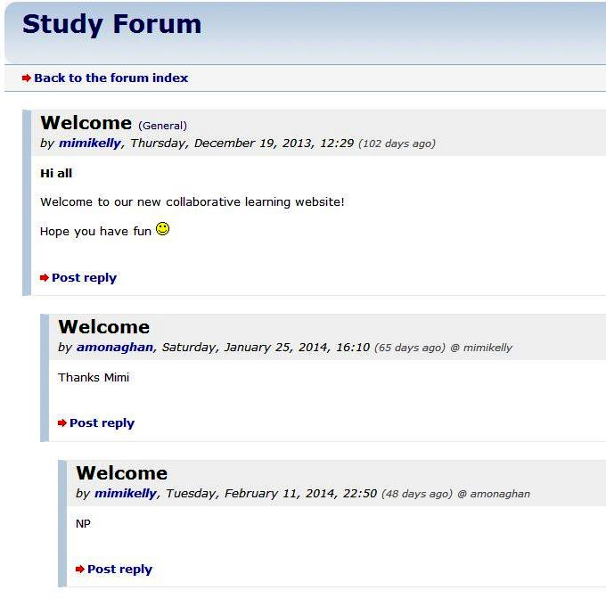

Creating a new Conversation Topic

Clicking the **New Topic** link on the main Study Forum screen will open a new window. To create a New Topic simply follow the below 5 steps.

1. Choose a category from the dropdown list
2. Enter a subject
3. Enter your message
4. Click the button to agree to the terms of use
5. Click the Submit button to complete your new topic post.

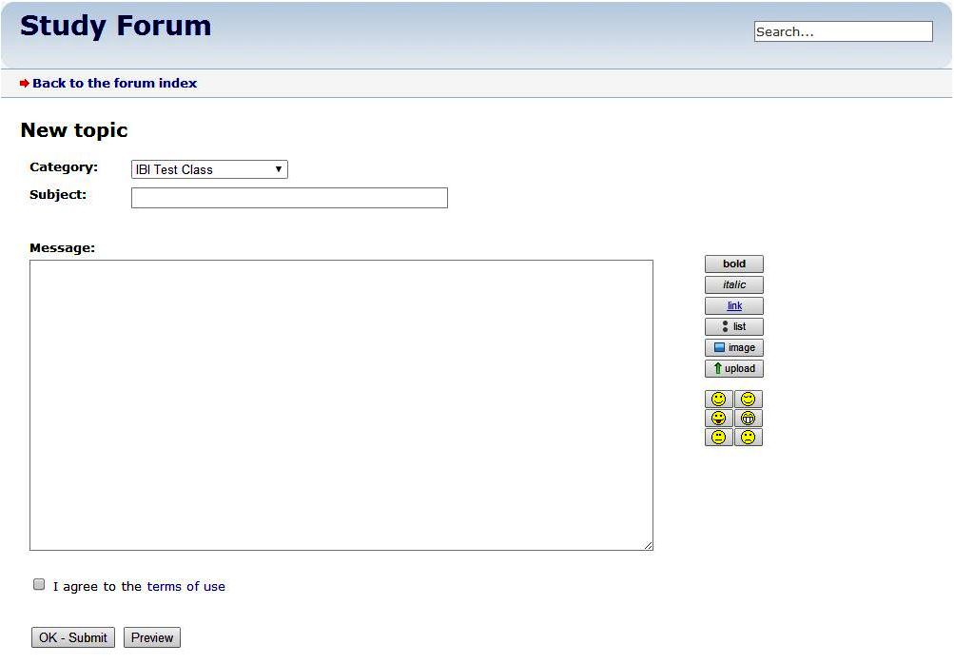

Use these formatting options to enhance the design of your message

**5.**

**4.**

**3.**

**1.**

**2.**

Clicking this **Preview** button will allow you to preview your new topic post before you submit it

# Using the Chatroom

Moving the mouse over the **Study Forum** link in the menu bar will make a sub link appear called **Chat Room**.



Submenu link appearing on mouse hover

1. After clicking this link, the first thing you will need to do is to Log into the Chatroom. To do this, simply click the **Login button**.

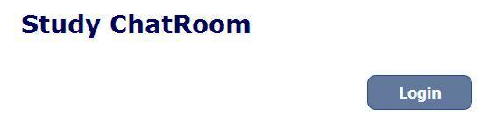

1. Once you are logged in you will see the below screen. Here you can chat with other students who are also logged into the Chatroom.
2. 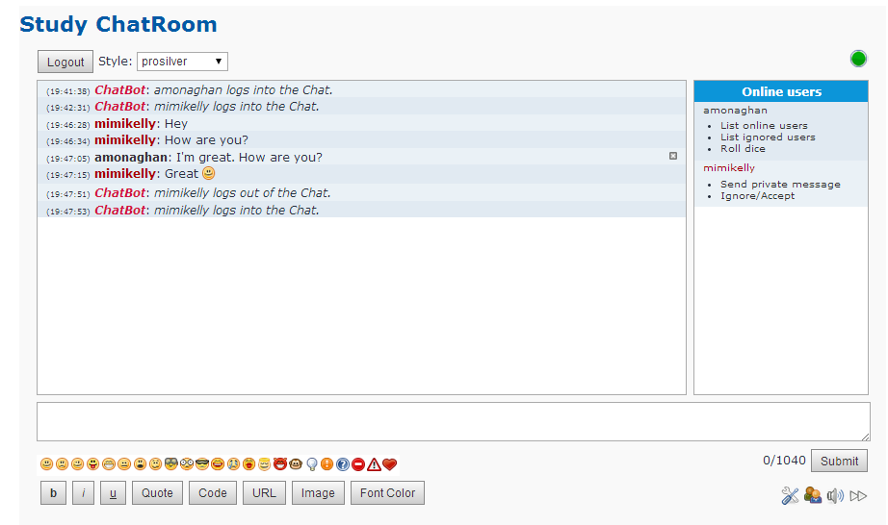If you wish to logout of the Chatroom, simply click the **Logout button**.

Advanced options for sending private messages

You can delete your own messages by clicking this button

Previous messages will appear here

Use these formatting options to enhance the design of your message

List of other users who are also logged in to the Chatroom

Type your Message here and either and click Submit

# Study Pages

When you move the mouse over the **Study Advice** link in the menu bar a sub link will appear called **Useful Resources**. These pages make up the Study Advice section and contain the following information.

* **Study Advice** – On this page you can read through an excellent study document containing advice and tips on a variety of study related topics
* **Useful Resources** – This page contains a list of external links to recommended study resources found online



Submenu link appearing on mouse hover

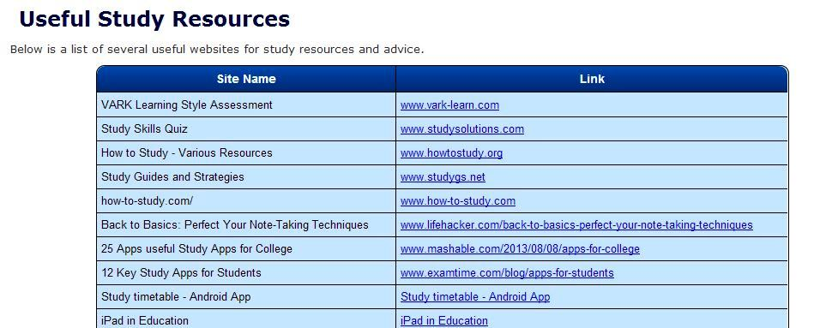

Name and link to various types of study resources

# Help Pages

When you move the mouse over the **Help** link in the menu bar two sub links will appear called **List of Users** and **Change Password**. These pages make up the Help section and contain the following information.

* **Help** – Contains this user manual
* **List of Users** – Here you can view a list of other students registered for this website. This is useful for matching a username to the relevant students name for the purpose of specifically sharing files.
* **Change Password** – Here you can change your login password

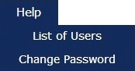

Submenu links appearing on mouse hover

Enter your new password twice and click **Confirm**

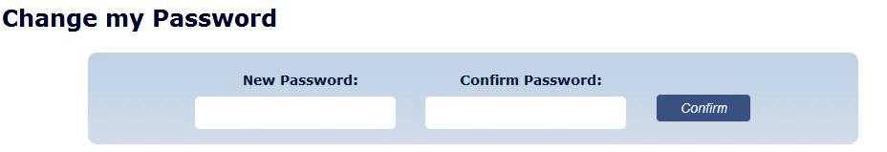

# Admin Use Only – Manage Users

There are a number of features which are only accessible by the administrator of this website. These features include editing student details, creating new classes, creating a class registration code and configuration options for the Study Forum.

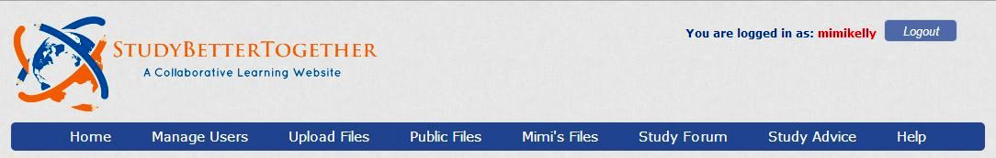

Only visible when the **Administrator** is logged in

Once the administrator logs in, a new option will appear in the Menu bar called **Manage Users**. Clicking this link will bring up a list of all users current registered on the website and provide you with two options:

* **Edit** –allows you to update student details, reset their password or assign them to a new class
* **Delete** –deletes a student and all their files from the website

List of all users currently registered on the website

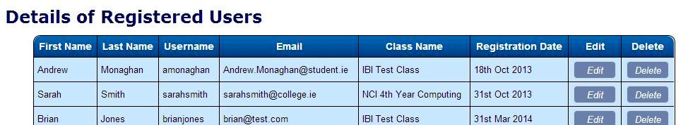

Clicking the **Edit button** beside a Student will open up the **Edit Student Details** page

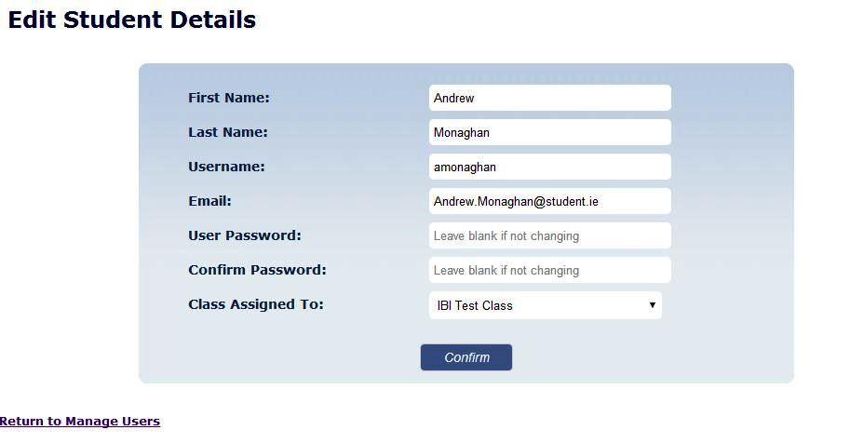

Make any necessary changes to the student’s details and then click **Confirm**

# Admin Use Only – Manage Classes

Assuming the administrator is logged in; moving the mouse over the **Manage Users** link in the menu bar will make a sub link appear called **Manage Classes**.



The Manage Classes page provides the following functionality:

* **Add a New Class** –Enter a class name, class code and registration code and then click confirm. This new class will be shown in the registration page and also as a category in the Study Forum.
* **Delete a Class** –Clicking the delete button beside a class will delete that class. Note: You can only delete a class if no students are currently assigned to that class.
* **Update Class Details** –Clicking the edit button beside a class will bring up the Edit Class Details page where you can change the class name, class code and registration code.

Add a **New Class** by entering in the Class details and clicking Confirm

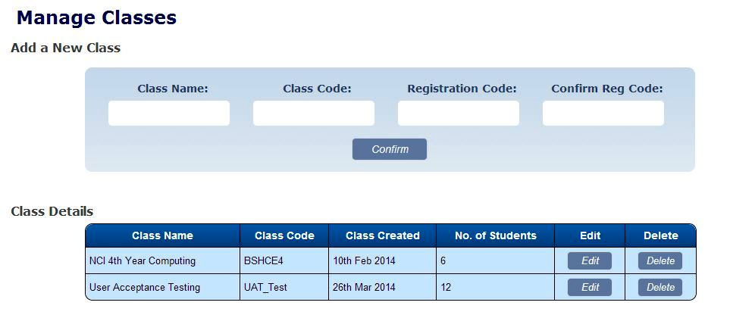

Clicking the **Edit button** beside a Class will open up the **Edit Class Details** page

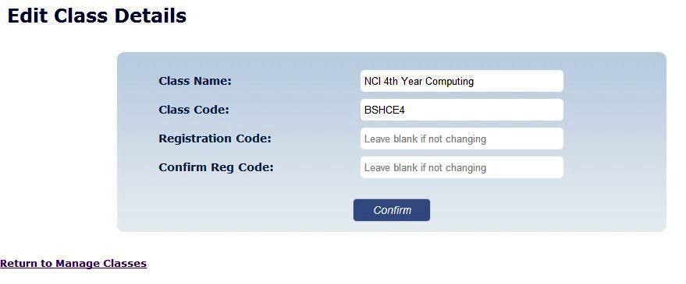

If you don’t want to change the **Registration code,** simply leave these boxes blank

Here you can change the Class Name, Class Code or create a new Registration Code

# Admin Use Only – Forum Settings

There is one other menu link that is only available if the administrator is logged in and that is the **Forum Admin** page. This is a submenu under the main Study Forum link in the menu bar as per the screenshot below.

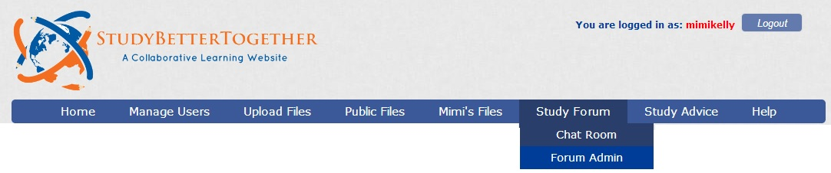

Only visible when the **Administrator** is logged in

The Forum Admin page contains various settings for configuring the Study Form including:

* **Forum Settings** – this is the main forum configuration page and contains options for changing many aspects of the forums functionality and appearance.
* **User Administration** – this page allows you to view the forum activity of each user and also lock the account of users.
* **Category Administration** – this page allows you to view and edit all categories.
* **Smilies** – this folder allows you to edit and delete smilies used by forum users when writing posts.

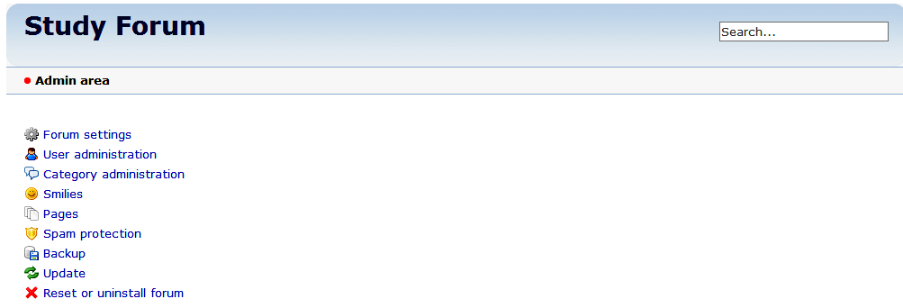

Multiple **administration options** for configuring the Study Forum