**User Manual**

**Study Better Together**

**A Collaborative Learning Website**

**Contents**

The Home Page 2

Site Navigation 3

Uploading Files 4

Searching and Downloading Public Files 6

Searching and Downloading Your Files 7

Using the Study Forum 9

Using the Chatroom 11

Study Pages 12

Help Pages 12

# ****The Home Page****

**This is the page you will see when you first log into the website and** contains information and picture links to each of the main website features.

Picture Links to the main website features

Logout Button

Username currently logged in

**Site Logo** –click here from any page to return to the home page

Menu Bar

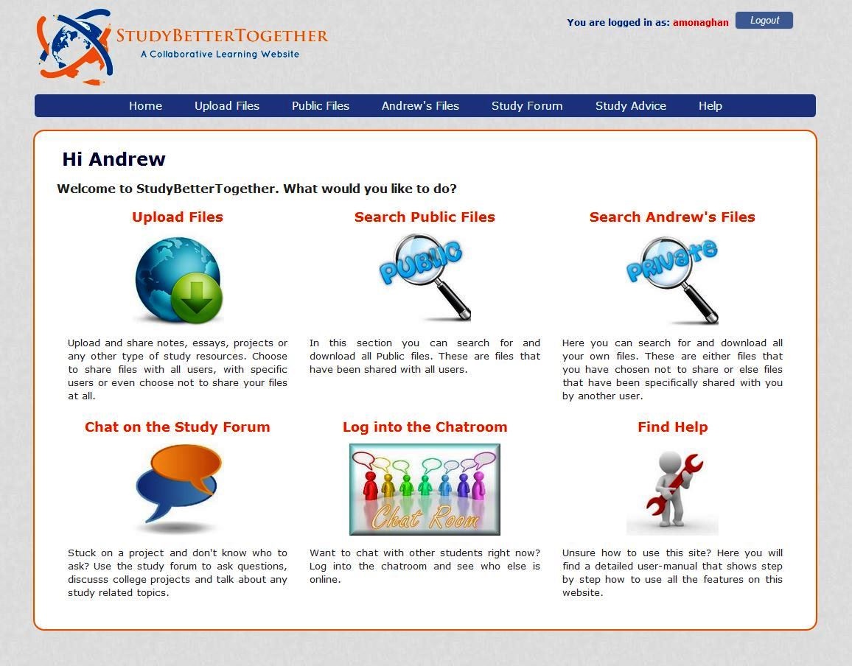

# Site Navigation

There are two ways to navigate around the website. You can click the image links contained on the **Home** page or you can use the menu bar. Clicking the *StudyBetterTogether* logo (top right of website) from any page will take you back to the Home page.

Menu Bar



The menu bar contains seven links (Level 1 links). When you bring the mouse over some of these links a sub menu may appear underneath (Level 2 links).

Table 1.1 briefly outlines the functionality provided on each of the web pages linked to from the menu bar. A more detailed description including screenshots is contained throughout the remainder of this user manual.

Table 1.1 – Brief description of website pages

|  |  |  |
| --- | --- | --- |
| Level 1 Links | Level 2 links | Description |
| Home |  | Contains information and picture links to each of the main website features. |
| Upload Files |  | Upload files and choose to either make them private, public or else share files with specific students. |
|  | **Acceptable Files** | Contains a list of all the file types that are allowed to be uploaded. |
| Public Files |  | Search for (and download) all public files on the website. |
| Andrew’s Files |  | Search for (and download) all of your own files on the website. These are files that either you have uploaded yourself or else files that have been shared with you by another student. |
| Study Forum |  | Create new conversation topics or search through and reply to previously created topics. |
|  | **Chat Room** | Log in and chat with any students who are also logged into the Chatroom |
| Study Advice |  | Read through an excellent study document containing advice and tips on a variety of study related topics |
|  | **Useful Resources** | Contains a list of external links to recommended study resources found online |
| Help |  | Contains this user manual |
|  | **List of users** | View a list of other students registered for this website. This is useful for matching a username to the relevant students name for the purpose of specifically sharing files. |
|  | **Change Password** | Change your login password |

# Uploading Files

To upload files simply follow these 6 steps.

1. Click the **Choose File** button and select a file on your computer you want to upload.
2. Enter a **Description** of the file if you wish. This step is optional.
3. Enter a **Subject** for the file if you wish. This step is optional.
4. Choose the desired **Sharing Status** for your file.
   * **Public** – File can be searched for and downloaded by all users
   * **Private** – File can only be searched for and downloaded by yourself
   * **Specific User(s)** – You can select the specific users that you want to be able to search for and download your file
5. Click **Yes** to confirm you agree to the upload terms and conditions which are listed below the upload form.
6. Click the **Upload** button

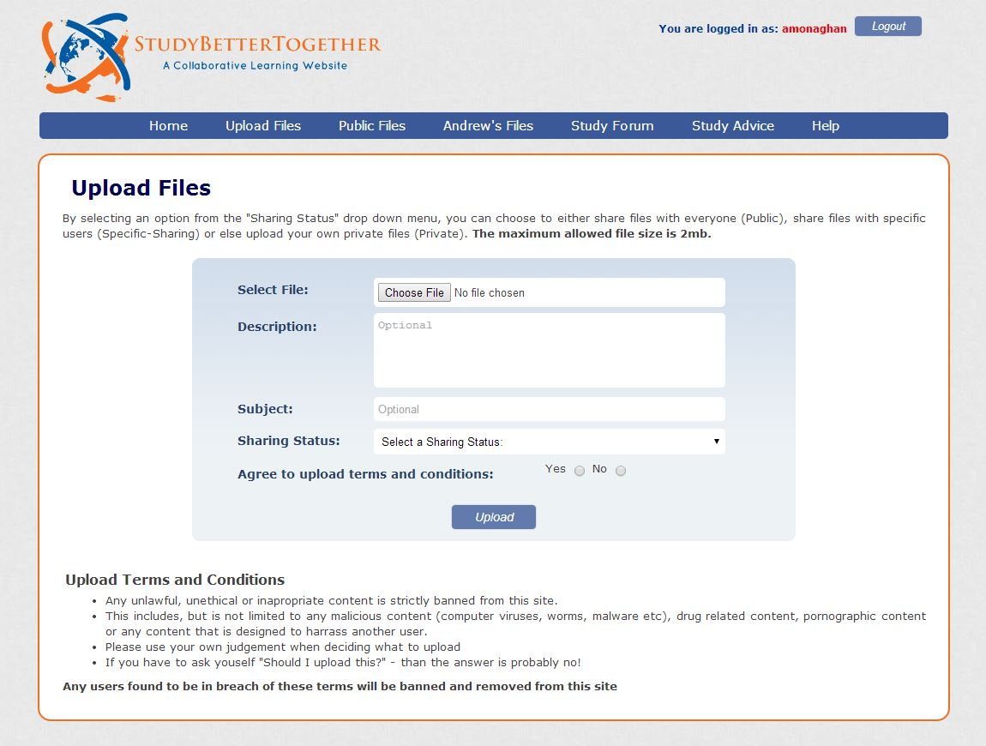

**3.**

**4.**

**2.**

**1.**

**5.**

**6.**

Choosing a Sharing Status

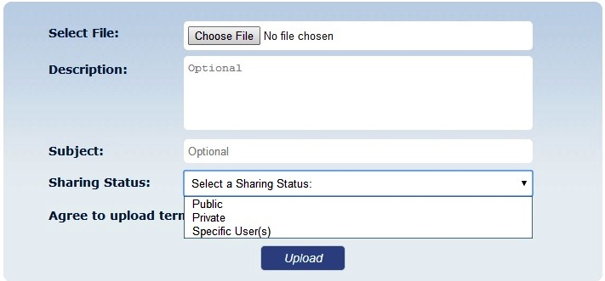

You will need to select a **Sharing Status** for your file

Specific User Sharing

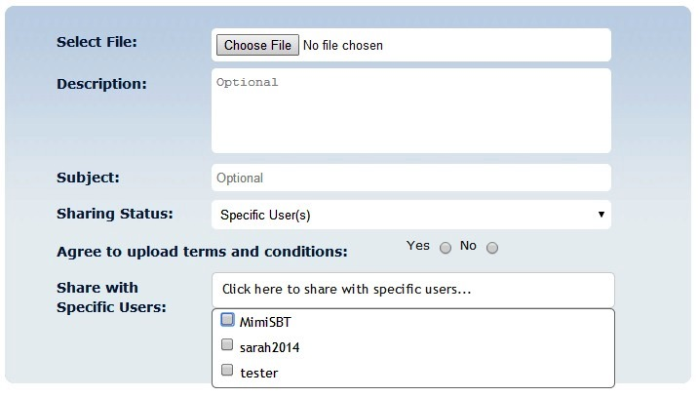

If you choose **Specific User(s)** as your Sharing Status – a new dropdown menu will appear from which you can select the users you want to share your file with.

**Note:** When you move the mouse over the *Upload Files* link in the menu bar, a sub menu link will appear called *Acceptable Files* which contains a list of all the file types that are allowed to be uploaded to the website.

Sub Menu – Acceptable Files



# Searching and Downloading Public Files

To search for and download public files simply enter in your search criteria in the provided boxes and click search. The results will be displayed below the search form. To display a list of all the public files available, simply click search without entering any search criteria.

1. Enter in any **search criteria** you wish to search for

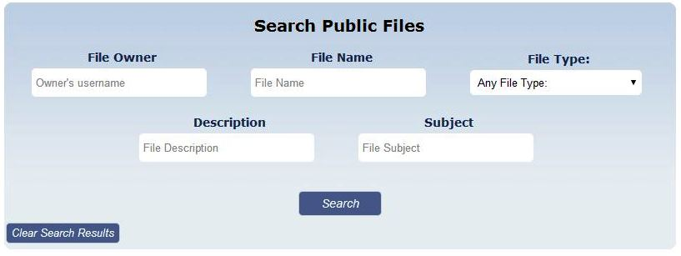

**2)** Click **Search**

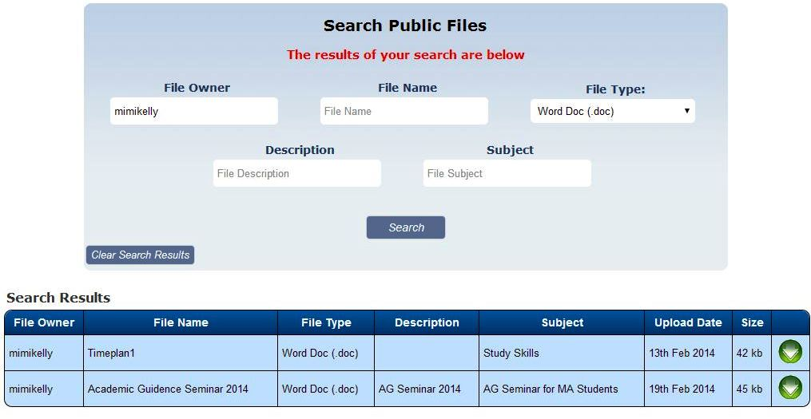

The **results** of your search will appear below the search form

**Search criteria** **entered**

Click this button to **Download** the file

# Searching and Downloading Your Files

To search for and download public files simply enter in your search criteria in the provided boxes and click search. The results will be displayed below the search form. To display a list of all the public files available, simply click search without entering any search criteria.

1. Enter in any **search criteria** you wish to search for

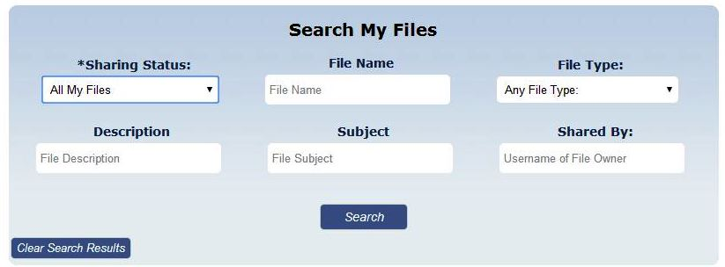

**2)** Click **Search**

Sharing Status - Search Options

You can choose from one of the following five options under the dropdown menu – Sharing Status

1. **All My Files** – This will return all files where you are the file owner (i.e. files you have uploaded).
2. **My Public Files** – This will return all public files you have uploaded.
3. **My Private Files** – This will return all private files you have uploaded.
4. **My Specifically Shared Files** - This will return all specifically shared files that you have uploaded.
5. **Files Shared With Me** – This will return all files that have been specifically shared with you by another user. Since another user is the file owner you will not be given the option to delete these files.

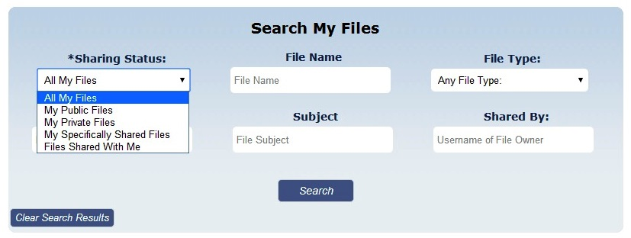

Search Results for “My Files”

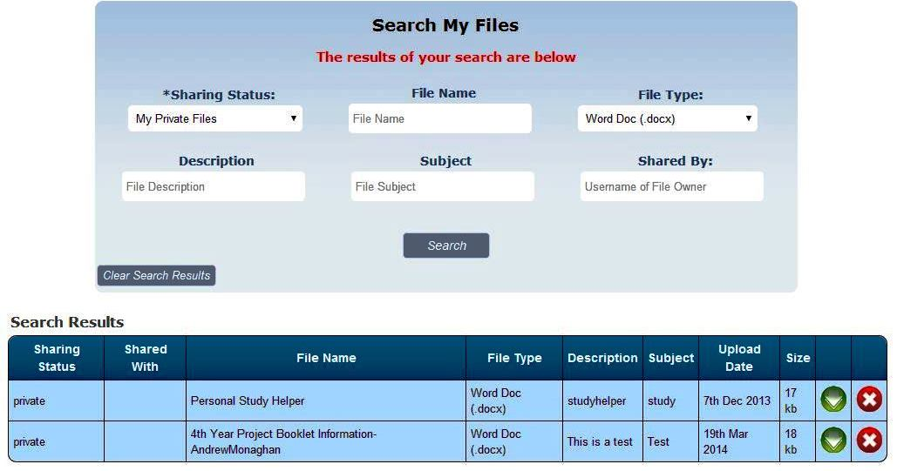

Click this button to **Download** the file

The **results** of your search will appear below the search form

**Search criteria** **entered**

Click this button to **Delete** the file.

Different Results Table for “Files Shared with Me”

When you choose the search status “Files Shared with Me” you will be presented with a slightly different results table. The two main changes are:

1. The username of the file owner is displayed
2. The usernames of whom the file is shared with is displayed
3. There will be no delete button as you are not the owner of the file

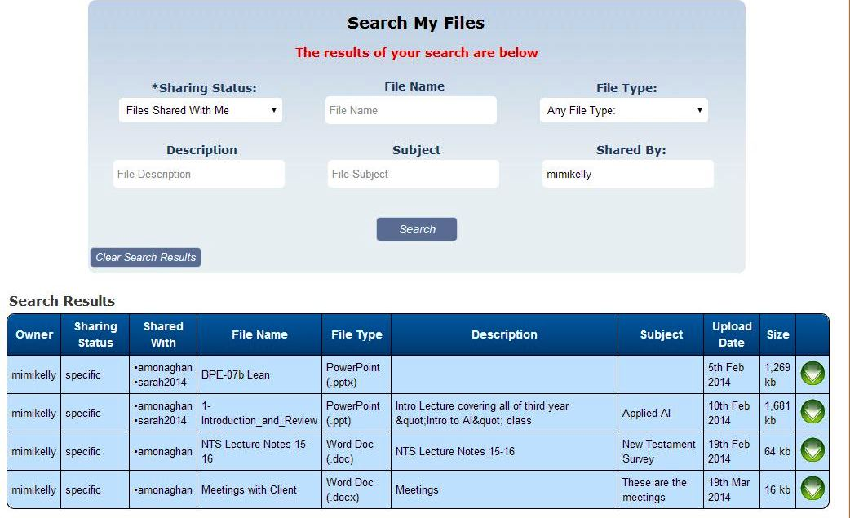

File Owner

Usernames of students whom the files have been shared with

**Note:** No delete button as you are not the file owner

# Using the Study Forum

When using the study forum you have several options depending on what you want to do.

1. **Create a new conversation topic**
2. **Search through previously created topics**
3. **Reply to a previously created topic**
4. **Filter conversation topics by category**

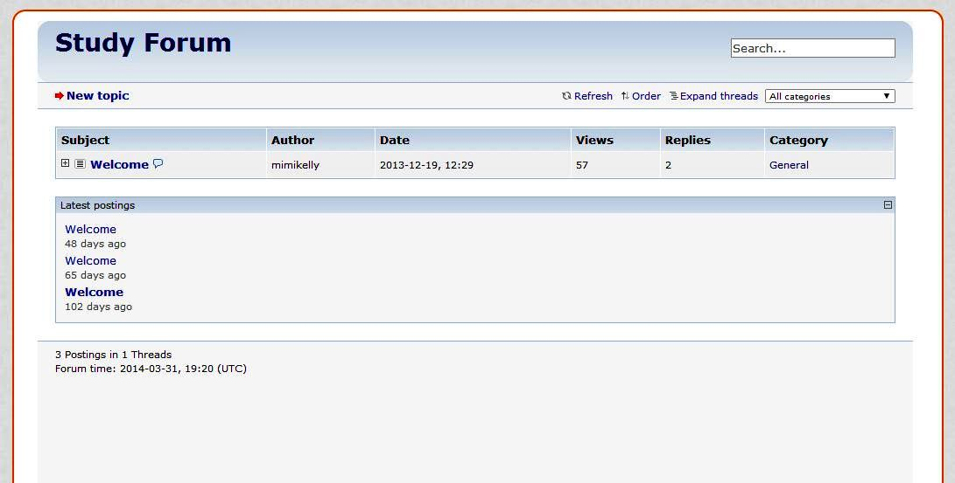

**4.**

**3.**

**1.**

**2.**

Clicking on a topic heading will expand the topic allowing you to

1. View the conversation history
2. Reply to specific posts

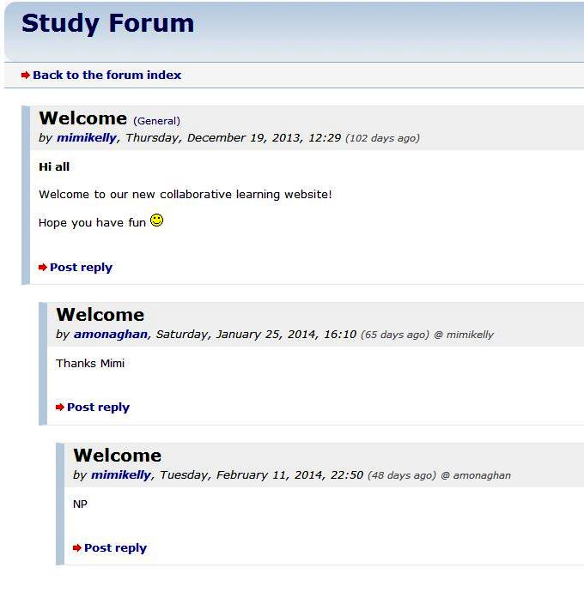

Creating a new Conversation Topic

Clicking the **New Topic** link on the main study form screen will open a new window. To create a New Topic simply follow the below 5 steps.

1. Choose a category from the dropdown list
2. Enter a subject
3. Enter your message
4. Click to agree to the terms of use
5. Click the Submit button to complete your new topic post.

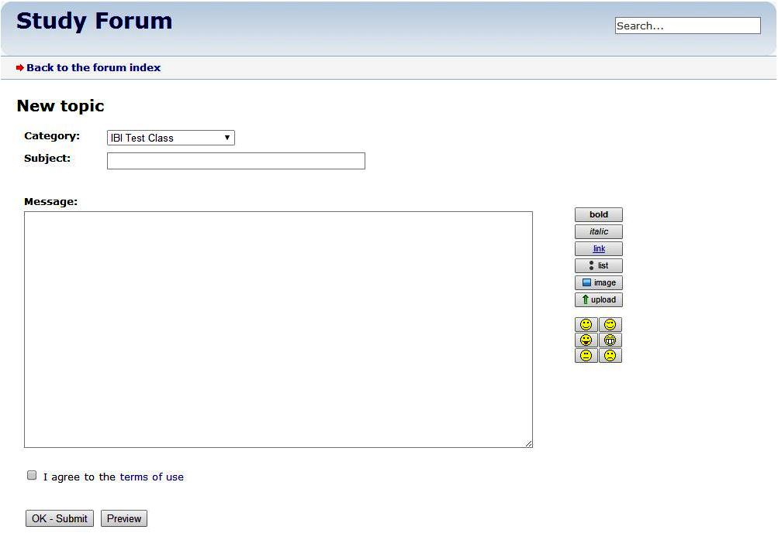

Use these formatting options to enhance the design of your message

**5.**

**4.**

**3.**

**1.**

**2.**

Clicking this **Preview** button will allow you to preview your new topic post before you submit it

# Using the Chatroom



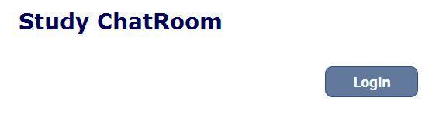

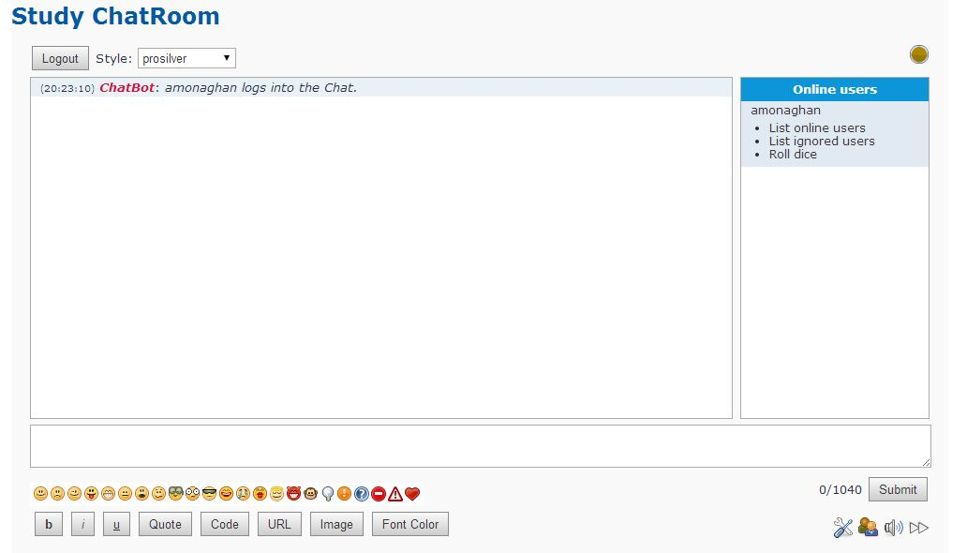

# Study Pages

When you move the mouse over the **Study Advice** link in the menu bar a sub link will appear called **Useful Resources**. These two pages make up the Study Advice section and contain the following information.

* **Study Advice** – On this page you can read through an excellent study document containing advice and tips on a variety of study related topics
* **Useful Resources** – This page contains a list of external links to recommended study resources found online



Submenu link appearing on mouse hover

# Help Pages

When you move the mouse over the **Help** link in the menu bar two sub links will appear called **List of Users** and **Change Password**. These pages make up the Help section and contain the following information.

* **Help** – This page contains this user manual
* **List of Users –** Here you can view a list of other students registered for this website. This is useful for matching a username to the relevant students name for the purpose of specifically sharing files.
* **Change Password** – Here you can change your login password

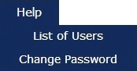

Submenu links appearing on mouse hover