Project Proposal

**Study Better Together**

***‘A collaborative file-sharing, quiz-making mobile study platform’***

Andrew Monaghan

09102825

andrew.monaghan@student.ncirl.ie

BSc (Hons) in Business Information Systems

06/10/2013

# Objectives

The scope of this project is to create a website and mobile web app that will facilitate collaborative learning among students by allowing them share notes, ask questions and create and share MCQ quizzes which can be easily accessed on mobile devices.

My client is Mimi - a lecturer in a third level Theology College in Dublin who delivers both undergraduate and postgraduate modules in History, Sociology and Study Support. She will use this website to communicate with her students through their mobile phones and also facilitate collaborative learning among her students.

One of the key features of this project is that the web application can be both accessible and user friendly to all students regardless of the device they are using. To achieve this, two versions of this web application will be created, a standard website and a mobile web app.

I envision *(see Note below)* this project providing the following functionality:

* The lecturer can post study related content to the site which can be accessed by the students
* The lecturer can create MCQ quizzes for her students and likewise the students can create MCQ quizzes for themselves. These quizzes can be easily accessible on any device.
* Students can post questions on the study forum. Both the lecturer and other students can reply to these questions meaning that when the lecturer is busy a student can still receive replies to their queries.
* Students can upload and share study notes, projects, essays and any other information with each other. These files can be easily accessible on any device.

**Note**: As this project is still in the initial planning phase, client requirements are still being elicited and analysed, thus the project scope and the project functionality is subject to change.

# Background

The idea for this project came about from my experiences as a part-time student and also my strong interest in e-learning and mobile learning. It is my belief that students study best when working as a team, sharing their notes and studying together. The functionality to enable students create their own quizzes to test their knowledge and then share these quizzes with each other would provide a fun, interactive method of collaborative learning. The ability to access these features easily on mobile devices helps take learning out of the classroom and literally puts it in the hand of the student.

When I had the initial idea for my project, I approached Mimi to see if she was also interested in the idea and if it might be something she might want to use. Mimi thought the idea was very interesting and that a user friendly system that enabled her to communicate with her students through their mobile phones and also facilitated collaborative learning among her students would be a very useful application.

One of the questions I’ve been asked when discussing my idea with colleagues is what is the difference between my project and other Learning Management Systems such as Moodle? While my project does share some similar features with Moodle, I see the main difference being that Moodle is primarily used for colleges to interact with their students and has limitations in its abilities for students to interact with each other. For example Moodle does not easily allow a student upload files and share them with other students or create a quiz and share this quiz with other students. Another difference between my project and Moodle is accessibility. Moodle is predominantly used on laptops and PC’s. While reaching the mobile environment is something that Moodle are currently looking into, there still remain limitations in terms of usability and functionality when accessing Moodle on mobile devices. This project does not aim to replace Moodle but to be used by a college alongside Moodle to provide a mobile platform for students to study together through sharing notes, asking questions and quiz based revision.

# Technical Approach

**Implementation**

This project will consist of two main parts, a website which will provide the main elements of functionality and a mobile web app that will contain most, if not all the functionality provided in the main website.

**Software Development Model**

The development approach will largely follow a sequential development model (aka Waterfall Model) which will consist of five main phases - requirement elicitation, system design, development, testing and finally maintenance. Each phase will follow the previous phase in a sequential manner. That said I will also be adapting elements of an iterative and incremental model to allow for changes in client’s requirements throughout the course of the project lifecycle.

I believe a combination of both these models will enable this project to be both structured and well documented while also being client driven and flexible to any changes in the client’s needs.

**Requirements Elicitation**

The primary form of requirement elicitation will be through several meetings with the client. This process has already begun with a first meeting to discuss the proposed features and functionality. The secondary form of requirement elicitation will be through the use of a questionnaire which will be distributed to a random sample of students. All requirements and their technical implementation will be recorded in the requirement specification document. Project functionality will be subject to change in order to adapt to any changes in the clients requirements.

# Special resources required

To implement this project I will first need to learn a number of different technologies. As I have never used PHP or JQuery before it will be a real challenge to learn these technologies to implement the required functionality within the allotted time. To do this, I will need access to a number of books, video tutorials and technical support platforms.

The following list is a collection of the resources that I am planning to use:

**Books**:

* Learning PHP, MySQL, JavaScript, and CSS, 2nd Edition - Robin Nixon 2012
* PHP Application Development with NetBeans - M A Hossain Tonu - 2012
* Sams Teach Yourself PHP, MySQL and Apache All in One - Julie C. Melon- - 2012
* jQuery Mobile: Up and Running - Maximiliano Firtman – 2012

**Videos – Lynda.com**:

* Installing Apache, MySQL, and PHP with David Gassner, 2013
* PHP with MySQL Essential Training with Kevin Skoglund, 2013
* MVC Frameworks for Building PHP Web Applications with Drew Falkman, 2012
* jQuery Essential Training with Joe Marini, 2009
* jQuery Mobile Web Applications with Ray Villalobos, 2012
* jQuery Mobile Essential Training with Joe Marini, 2011

# Project Plan

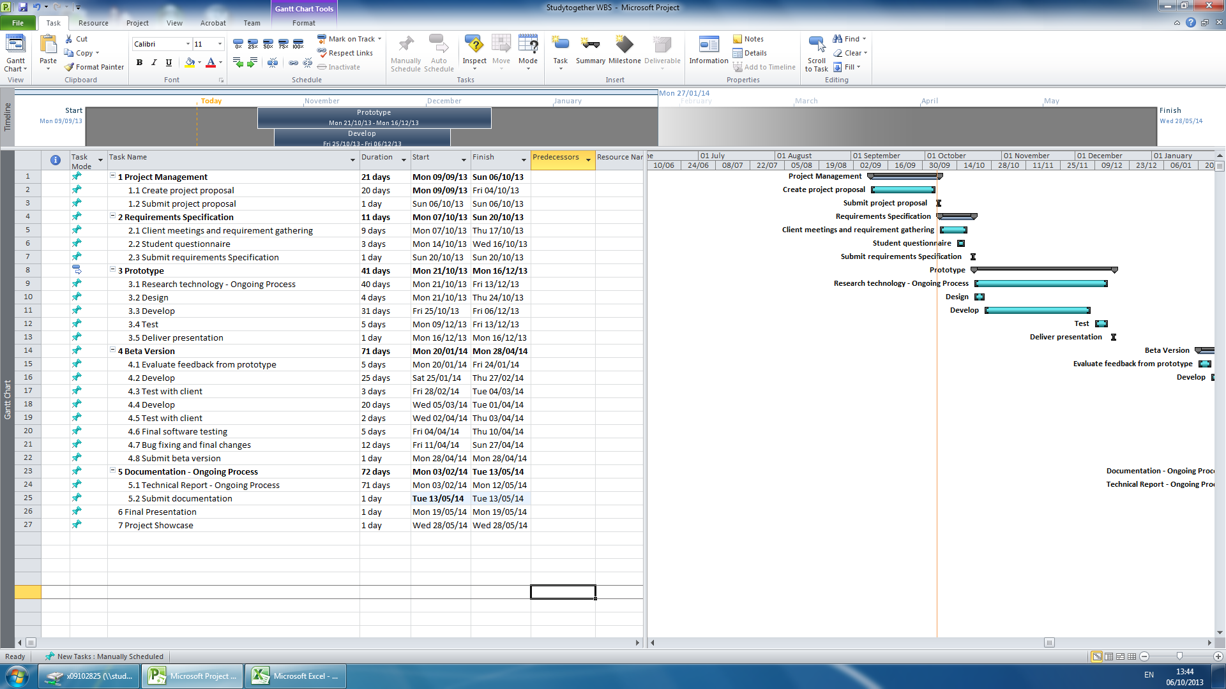

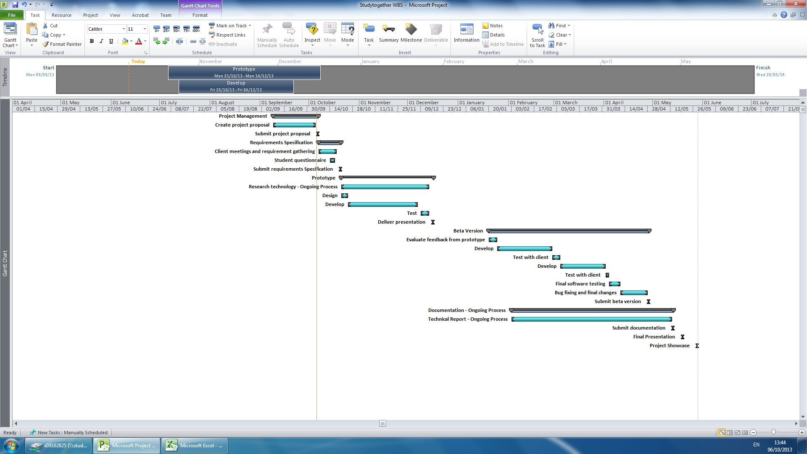

# Technical Details

**Website Application**

The website frontend will be built using HTML5 and CSS3 to create the site structure and design. JavaScript will be used for client side validation and client side interactive features such as the quiz builder.

The website backend will be built using PHP as the server side language and MYSQL as the relational database. This combination of PHP and MYSQL will be used to create the user account management system, all server side validation, the quiz builder (along with JavaScript), the study forum and the ability for the lecturer to post news items and study tips.

**Mobile Website Application**

The mobile version of the website will be created using a combination of the above technologies alongside the JQuery Mobile Framework.

# Evaluation

**Software Testing**

This website and web app will be evaluated using the following testing methods:

* **Unit Testing**: This will test the various individual components of the project.
* **Integration Testing**: This will test how the individual components integrate with each other.
* **System Testing**: This will test the completely integrated system and verify that it meets the requirements as defined in the requirement specification document.
* **Compatibility Testing**: This will test that the software is compatible with other application software or if accessed through other software. For example the website will be tested to ensure it is still functional when accessed through different browsers.
* **Performance Testing**: This will test how the software handles under stress. For example will the database still function if accessed my multiple users.
* **Usability Testing**: This will test the user interface of the software and how easy it is to use and understand.

I will also be evaluating this project through continuous end user testing. This will be undertaken through regular communication (both electronic and personal meetings) with the client to ensure they are happy with the progress and that any changes or suggestions they have can be implemented in good time. Upon completion of a first prototype, a test group will be formed from a panel of the clients choosing who can use the prototype in a test environment. This will provide further end user testing to evaluate the project.

# Consultation with Project Specialisation Coordinator

**Paul Hayes**

Paul liked my idea and thought I should focus more on the quiz making functionality. He stated that it could be very useful for a lecturer to create quizzes that can be easily accessed on a student’s mobile phone.

# Consultation with Academic Staff (1)

**Jonathan McCarthy**

Jonathan thought the idea of a quiz maker website sounded really interesting and could prove a really useful idea. From my initial conversation with Jonathan, he encouraged me to find a real life client for my project as it was vital to receive real life input in the design stage and also having someone who can evaluate the project would be important. Based on this advice I found a client who was interested in my idea and wanted me to build it for her.

# Consultation with Academic Staff (2)

**Frances Sheridan**

I talked to Frances about my initial idea for this project which was a mobile Study Smart app containing mainly static content such as study tips and quizzes. Frances said she liked the idea and thought it could be quite useful for students. However she encouraged me to expand on the idea as static content and MCQ in an app is fairly straightforward and would not meet the required functionality for this project. On reflection of this feedback I changed my project slightly to include both a website and mobile website that would offer more interactive functionality such as a web forum, file sharing and quiz builder.

# Proposed Supervisor

I would like the college to choose a supervisor for me who can work with me and provide technical advice for my project.

_____________________

Andrew Monaghan

6th October 2013