Project Proposal

**StudyTogther.com**

***‘A collaborative file-sharing, quiz-making study platform’***

Andrew Monaghan

09102825

andrew.monaghan@student.ncirl.ie

BSc (Hons) in Business Information Systems

06/10/2013

# Objectives

The scope of this project is to create a website and a mobile web app that will facilitate collaborative learning among Irish students by allowing them share notes, ask questions and create study quizzes.

My long term vision for this website is it could be used by all learners regardless of the college they attend or even if they attend college at all. This would create a community of leaners who are sharing their knowledge and using the interactive feature of quiz based learning to help each other learn. However for the purpose of this project I will be reducing the scope of this vision and creating the website for my client, a third level college lecturer who will use the website to facilitate collaborative learning among her students. My client - Mimi lectures in a third level Theology College in Dublin and delivers both undergraduate and postgraduate modules in History, Sociology and Study Support. The benefit of creating this website for a lecturer who teaches study skills is that I will have key input from a professional educator throughout the project, particularly in the design and evaluation stages.

One of the key features of this project is that the web application can be accessible and user friendly to all students regardless of the device they are using. To achieve this, two versions of this web application will be created, a standard website and a mobile web app.

I envision *(see Note below)* this project providing the following functionality:

* A lecturer can share study tips (or any college related information) and any files with students who can then access this information via any device (static or mobile)
* A lecturer can create MCQ for their student which the students can receive and attempt on their phones.
* Likewise, students can either create MCQ for themselves or use other students MCQ and use these quizzes on their phones.
* Students can post questions on a topic they may be struggling with on the study forum. Both the lecturer and other students can reply to these questions meaning that even when the lecturer is busy, a student can still receive replies to their queries.
* Students can share their study notes, projects, essays and any other information with each other. These files can be easily accessed on any device.

**Note**: As this project is still in the initial planning phase, client requirements are still being collected and analysed, thus the project scope and the project functionality is subject to change.

# Background

The idea for this project came about from my experiences as a part-time student and also my interest in e-learning and mobile learning. From my own experience, students study best when working as a team, sharing their notes and studying together. The functionality to enable students create their own quizzes to test their knowledge and then share these quizzes with each other would provide a fun, interactive method of collaborative learning. The ability to access these features easily on mobile devices would enable a student to attempt either their own quiz or a friend’s quiz wherever they are. This helps take learning out of the classroom and literally puts it in the hand of the student.

When I had the initial idea for my project, I approached Mimi to see if she was also interested in the idea and if it might be something she might want to use. Mimi thought the idea was very interesting and that a user friendly system that enabled students study together was something that could prove very beneficial to her students. The additional feature of optimising the site so it can be easily used on mobile devices was of particular interest to Mimi as she was previously looking for ways to incorporate mobile based learning into her teaching methods.

One of the questions I’ve been asked when discussing my idea with colleagues is what is the difference between my project and other Learning Management Systems such as Moodle? While my project does share some similar features with Moodle, I see the main difference being Moodle is primarily used for colleges to interact with their students and has limitations in its abilities for students to interact with each other. For example Moodle does not easily allow a student upload files and share them with other students or create a quiz and share this quiz with other students. Another difference between my project and Moodle is accessibility. Moodle is predominantly used on laptops and PC’s. While reaching the mobile environment is something that Moodle are currently looking into, there still remain limitations in terms of usability and functionality when accessing Moodle on mobile devices. My project does not aim to replace Moodle but to be used by a college alongside Moodle to provide a mobile platform for students to study together through sharing notes, asking questions and quiz based revision.

# Technical Approach

**Implementation**

I will be creating two main parts of this project, a website which will provide the main elements of functionality and a mobile web app that will contain most, if not all the functionality provided in the main website.

**Software Development Model**

For this project I will primarily be using a sequential development model (aka Waterfall Model) which will consist of five main phases - requirement elicitation, system design, development, testing and finally maintenance. Each phase will follow the previous phase in a sequential manner. That said I will also be adapting elements of an iterative and incremental model to allow for changes in client’s requirements throughout the course of the project lifecycle.

I think a combination of both these models will enable this project to be both structured and well documented while be client driven and flexible to any changes in the client’s needs.

**Requirements Elicitation**

The primary form of requirement elicitation will be through several meetings with the client. This process has already begun with a first meeting to discuss the proposed features and functionality. Further meetings are scheduled for the next few weeks. The secondary form of requirement elicitation will be through the use of a questionnaire which I will distribute to a random sample of students. All requirements and their technical implementation will be recorded in the requirement specification document. Project functionality will be subject to change to adapt to any changes in the clients requirements.

# Special resources required

To implement this project I will first need to learn a number of different technologies. As I have never used PHP or JQuery before it will be a real challenge to learn these technologies to implement the required functionality within the allotted time. To do this, I will need access to a number of books, video tutorials and technical support platforms.

The following list is a collection of the resources that I am planning to use:

**Books**:

* Learning PHP, MySQL, JavaScript, and CSS, 2nd Edition - Robin Nixon 2012
* PHP Application Development with NetBeans - M A Hossain Tonu - 2012
* Sams Teach Yourself PHP, MySQL and Apache All in One - Julie C. Melon- - 2012
* jQuery Mobile: Up and Running - Maximiliano Firtman – 2012

**Videos – Lynda.com**:

* Installing Apache, MySQL, and PHP with David Gassner, 2013
* PHP with MySQL Essential Training with Kevin Skoglund, 2013
* MVC Frameworks for Building PHP Web Applications with Drew Falkman, 2012
* jQuery Essential Training with Joe Marini, 2009
* jQuery Mobile Web Applications with Ray Villalobos, 2012
* jQuery Mobile Essential Training with Joe Marini, 2011

# Project Plan

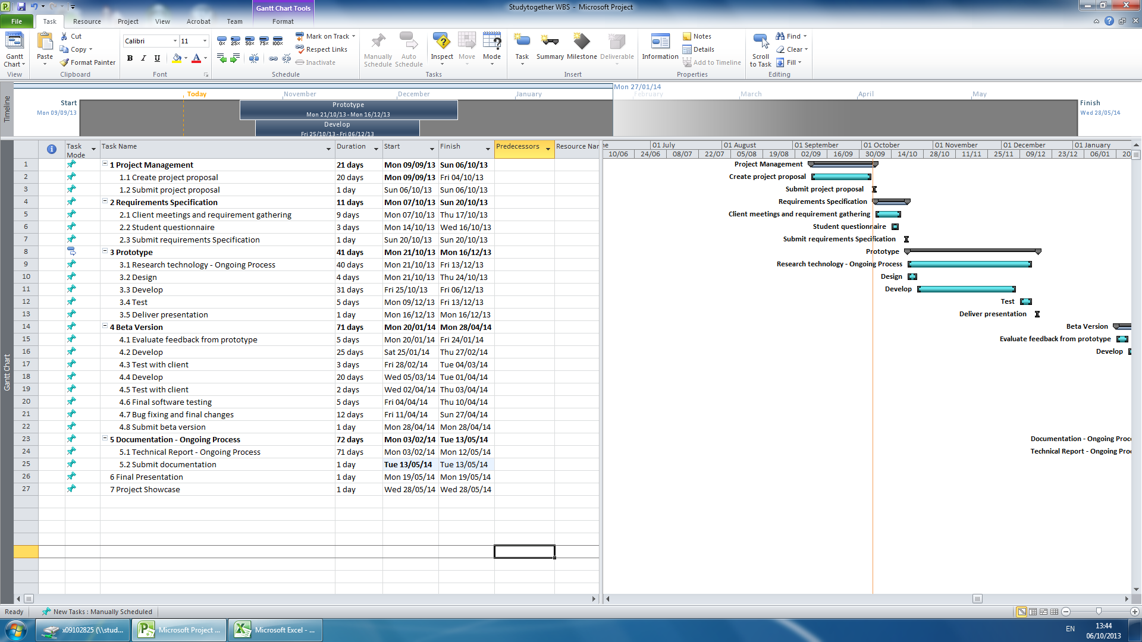

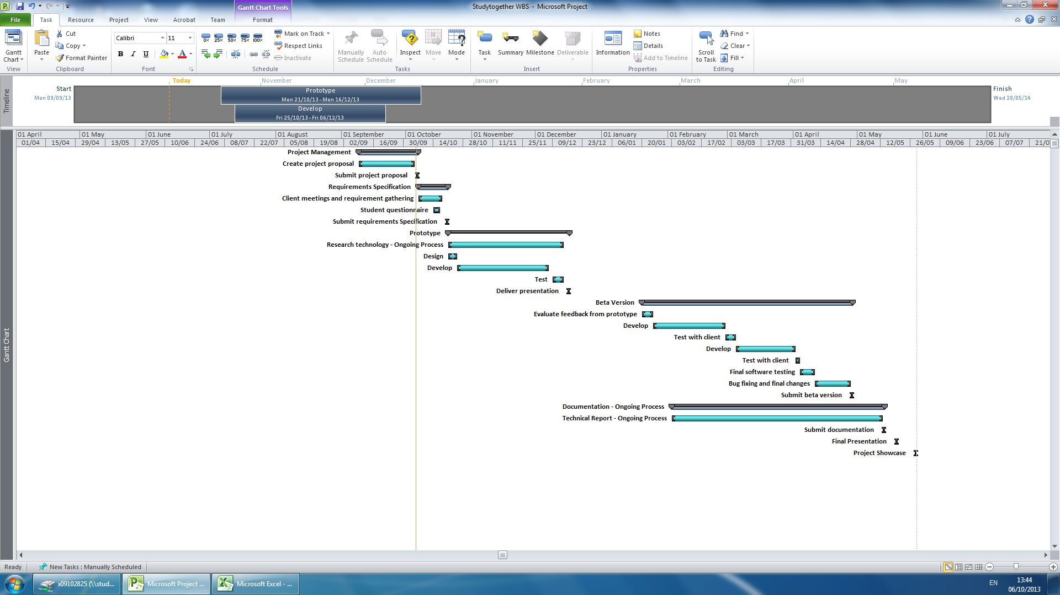

# Technical Details

**Website Application**

The website frontend will be built using HTML5 and CSS3 to create the site structure and design. I will use JavaScript as my client side scripting language which will be used for client side validation and client side interactive features such as the quiz builder.

The website backend will be built using PHP as my server side language and MYSQL as my relational database. The combination of PHP and MYSQL will be used to create the user account management system, all server side validation, the quiz builder (along with JavaScript), the study forum and the ability for the lecturer to post news items and study tips.

**Mobile Website Application**

The mobile version of the website will be created using a combination of the above technologies alongside the JQuery Mobile Framework.

# Evaluation

**Software Testing**

This website and web app will be evaluated using the following testing methods:

* **Unit Testing**: This will test the various individual components of the project.
* **Integration Testing**: This will test how the individual components integrate with each other.
* **System Testing**: This will test the completely integrated system and verify that it meets the requirements as defined in the requirement specification document.
* **Compatibility Testing**: This will test that the software is compatible with other application software or if accessed through other software. For example the website will be tested to ensure it is still functional when accessed through different browsers.
* **Performance Testing**: This will test how the software handles under stress. For example will the database still function if accessed my multiple users.
* **Usability Testing**: This will test the user interface of the software and how easy it is to use and understand.

I will also be evaluating this project through continuous end user testing. This will be undertaken through regular communication (both electronic and personal meetings) with the client to ensure they are happy with the progress and that any changes or suggestions they have can be implemented in good time. Upon completion of a first prototype, a test group will be formed from a panel of the clients choosing who can use the prototype in a test environment. This will provide further end user testing to evaluate the project.

# Consultation with Project Specialisation Coordinator

**Paul Hayes**

Paul liked my idea and thought I should focus more on the quiz making functionality. He stated that it could be very useful for a lecturer to create quizzes that can be easily accessed on a student’s mobile phone.

# Consultation with Academic Staff (1)

**Jonathan McCarthy**

Jonathan thought my initial idea of a quiz maker website sounded really interesting and could prove a really useful idea. From my initial conversations with Jonathan, he encouraged me to find a real life client for my project as it was vital to receive real life input in the design stage and also having someone who can evaluate the project would be important. Based on this advice I found a client who was interested in my idea and wanted me to build it for her.

# Consultation with Academic Staff (2)

**Frances Sheridan**

I talked to Frances about my initial idea for this project which was a mobile Study Smart app containing mainly static content such as study tips and quizzes. Francis said she liked the idea and thought it could be quite useful for students. However she encouraged me to expand on the idea as static content and MCQ in an app is fairly straightforward and would not meet the required functionality for this project. On reflection of this feedback I changed my project slightly to include both a website and mobile website that would offer more interactive functionality.

# Proposed Supervisor

I would like the college to choose a supervisor for me who can work with me and provide technical advice for my project.

_____________________

Andrew Monaghan

6th October 2013