Project Proposal

**StudySmart**

***‘A web based collaborative study platform’***

Andrew Monaghan

09102825

andrew.monaghan@student.ncirl.ie

BSc (Hons) in Business Information Systems

05/10/2013

# Objectives

The scope of this project is to create a user friendly and functional web based solution that enables students study smarter and study together by providing the following functionality:

* View informative and up-to-date study tips and exam information as posted by the lecturer
* Upload study notes, projects, essays or any necessary files and then share these files with other students
* Post questions in a study forum which can be viewed and answered by other students and/or the lecturer
* Create MCQ tests which can be used as a very useful self-study tool
* Share these MCQ tests with other students

Optional functionality which can be included, depending on the implementation of the above features would include:

* A score leader board that charts the students quiz results, thus creating an element of social competitiveness which can spur students on to try harder at the quizzes
* An instant messaging feature to enable the lecturer and students to chat while logged into the application

This project is being built for Mimi – a lecturer who delivers both undergraduate and postgraduate modules in History, Sociology and Study Support in a third level Theology College in Dublin. One of the key success metrics as specified by the client in our initial meeting is that this study smart web application should be both accessible and user friendly to all students regardless of the device they are using. To achieve this, two versions of this web application will be created, a web application optimised for access on tablets, laptops and desktop computers and a mobile web application optimised for access on all sizes of mobile screens.

Below is an overview of the main proposed use cases as discussed at the initial client meeting. These are subject to change and will be confirmed later in the requirement specification document but for now are useful to provide a visual overview of the projects proposed functionality.

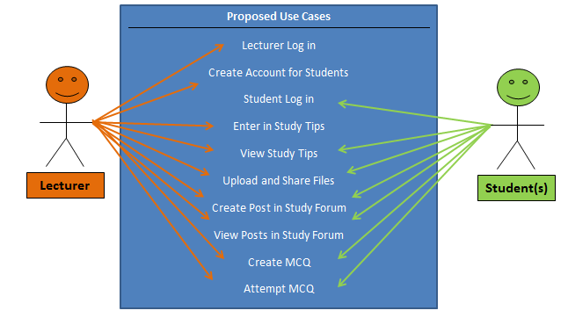

# Background

This project came about from my interest in e-learning and how this can be expanded to mobile learning. I believe one of the main industries to benefit from the rise of internet technology has been the education industry. I think both learners and educators have now more than ever a wealth of technology at their disposal that they can use to aid in their learning. From my experience as a student however, I still find that despite the increase in the popularity of mobile devices, they are still not being fully utilised by learning establishments.

Based on this I wanted to create a project that could aid students in their learning by collaborative study platform that could be accessed through mobile devices. I approached Mimi to see if she was interested in this idea and if it might be something she would want to use. Mimi thought the idea was very interesting and something that she would find useful so we agreed I would create the project for her. She thought a user friendly system that both enabled her communicate more efficiently with her students and enabled her students to study together was something that could prove very beneficial to her students. The additional feature of optimising the site so it can be easily used on mobile devices was of particular interest to Mimi as she was previously looking for ways to incorporate mobile based learning into her teaching methods.

# Technical Approach / Details

**Requirements Elicitation**

The primary form of requirement elicitation will be through several meetings with the client. This process has already begun with a first meeting to discuss the proposed features and functionality. Further meetings are scheduled for the next few weeks. During these meetings, I will examine the specific requirements of the client through the use of use cases and scenarios. The secondary form of requirement elicitation will be through the use of questionnaires which I will distribute to a random sample of students.

All requirements and their technical implementation will be recorded in the requirement specification document.

**Website Application**

The website frontend will be built using HTML5 and CSS3 to create the site structure and design. I will use JavaScript as my client side scripting language which will be used for client side validation and client side interactive features such as the quiz builder.

The website backend will be built using PHP as my server side language and MYSQL as my relational database. The combination of PHP and MYSQL will be used to create the user account management system, all server side validation, the quiz builder (along with JavaScript) and the ability to post news items and study tips.

**Mobile Website Application**

This will be created using JQuery Mobile

# Special resources required

To implement this project I will first need to learn a number of different technologies. As I have never used PHP or JQuery before it will be a real challenge to learn these technologies in order to implement the required functionality within the allotted time. To do this, I will need access to a number of books and technical support platforms. The following list is a collection of the resources that I am planning to use:

# Project Plan

# Evaluation

**Software Testing**

This website and app will be evaluated using the following testing methods:

* **Unit Testing**: This will test the various individual components of the project.
* **Integration Testing**: This will test how the individual components integrate with each other.
* **System Testing**: This will test the completely integrated system and verify that it meets the requirements as defined in the requirement specification document.
* **Compatibility Testing**: This will test that the software is compatible with other application software or if accessed through other software. For example the website will be tested to ensure it is still functional when accessed through different browsers.
* **Performance Testing**: This will test how the software handles under stress. For example will the database still function if accessed my multiple users.
* **Usability Testing**: This will test the user interface of the software and how easy it is to use and understand.

**Client Driven Testing**

As this is a client driven project, the main type of evaluation I will be using is personal client testing. I believe client focused testing to be a critical part of the evaluation process as it ensures the project is developed to meet the exact requirements of the client. This will be undertaken through regular communication (both electronic and personal meetings) with the client to ensure that they are happy with the progress and that any changes or suggestions they have can be implemented in good time. Upon completion of a first prototype, a test group will be formed from a panel of the clients choosing who can use the prototype in a test environment. This will provide further end user testing to evaluate the project.

While software testing does play a key role in any software project to ensure that the software is functional and bug-free, I think a lot of software developers fail to recognise the importance of keeping the client happy. It is pointless to develop a fully functioning, bug-free software application if the client is not satisfied. As a BIS student I see one of my responsibilities, and an area I will pay strong attention to in this project, is to ensure that this project is client driven and that any client changes or requests are dealt with promptly and efficiently.

# Consultation with Project Specialisation Coordinator

**Paul Hayes**

Paul liked my idea and thought I should focus more on the quiz making functionality. He stated that it could be very useful for a lecturer to create quizzes that can be accessed on a student’s mobile phone.

# Consultation with Academic Staff (1)

**Jonathan McCarthy**

Jonathan thought my initial idea of a quiz maker website sounded really interesting and could prove a really useful idea. From my initial conversations with Jonathan, he encouraged me to find a real life client for my project as it was vital to receive real life input in the design stage and also having someone who can evaluate the project would be important. Based on this advice I found a client who was interested in my idea and wanted me to build it for her.

# Consultation with Academic Staff (2)

**Frances Sheridan**

I talked to Frances about my initial idea for this project which consisted of just a mobile app containing mainly static content such as study tips quizzes. Francis said she liked the idea and thought it could be quite useful for students. However she encouraged me to expand on the idea as static content and MCQ in an app is fairly straightforward and would not meet the required functionality for this project. On reflection of this feedback I changed my project slightly to include a website and mobile website that would offer more interactive functionality.

# Proposed Supervisor

I would like the college to choose a supervisor for who can work with me and provide technical advice for my project.

_____________________

Andrew Monaghan

5th October 2013