Preliminary setup

* Create a directory named “deloitte_hackathon”

$ mkdir deloitte_hackathon

* Place the given source zip file (deloitte_hackathon.zip) in the newly created directory.

* Change directory to the deloitte_hackathon and unzip the source zip file.

$ cd deloitte_hackathon

$ unzip deloitte_hackathon.zip

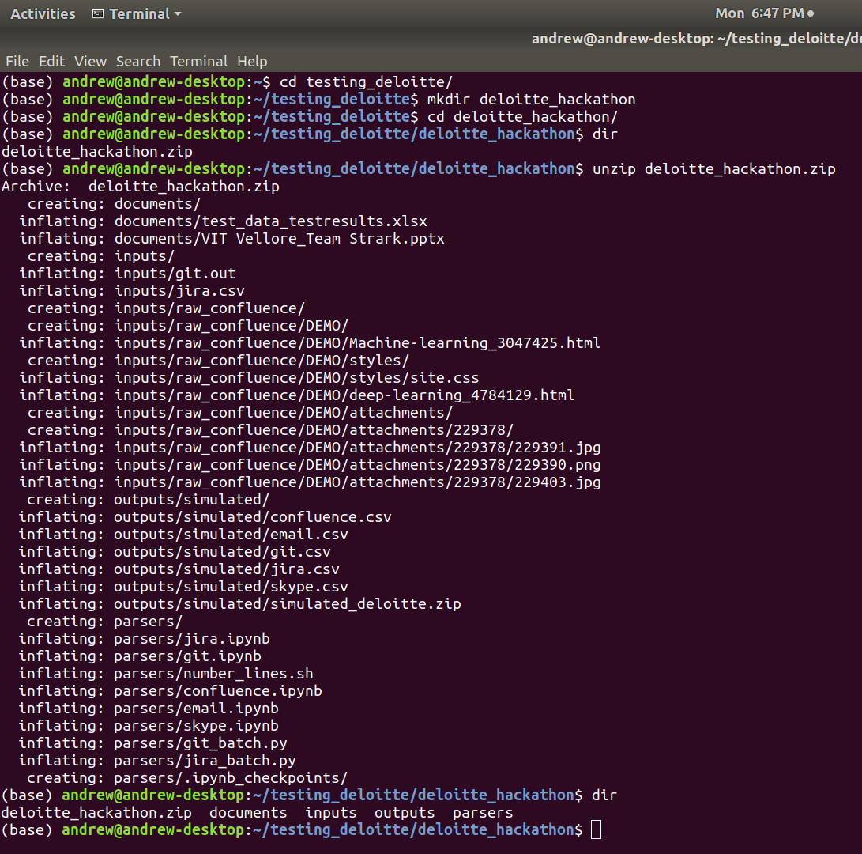

Common Prerequisites:

1. Python3

2. Pandas

3. Jupyter notebook

1. To collect information from a git repository

Prerequisite: Git tool

* Copy and place the shell script (parsers/**number_lines.sh**) in any git repository. E.g. <https://github.com/arzzen/git-quick-stats.git> (clone it locally using ‘git’).

* Execute the shell script from the git repository’s root directory.

e.g.

$ cd git-quick-stats

$ ./number_lines.sh > *output_file_name.out*

e.g. : $ ./number_lines.sh > git.out

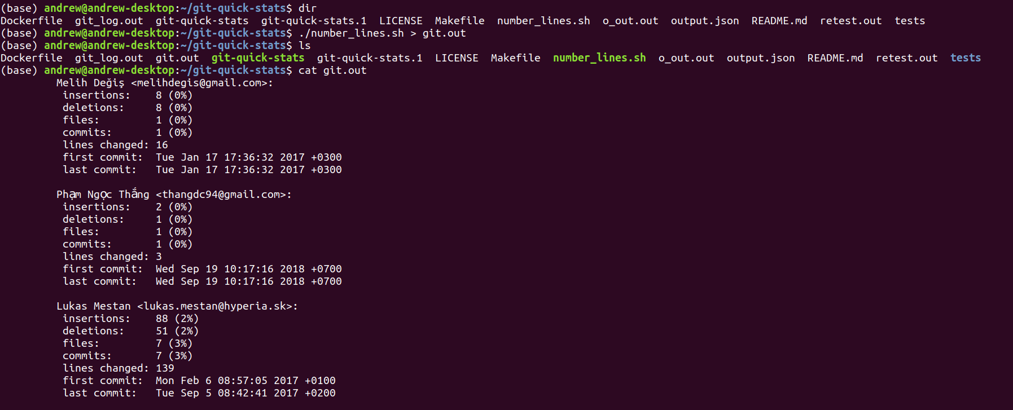

* The unparsed raw information would be stored in the output file in the root directory of the repository.

* Copy and place the newly generated file in (deloitte_hackathon/inputs/.)

* Execute the (parsers/git_batch.py) with first first argument as the newly generated file (git.out).

$ cd parsers

$ python git_batch.py ../inputs/git.out

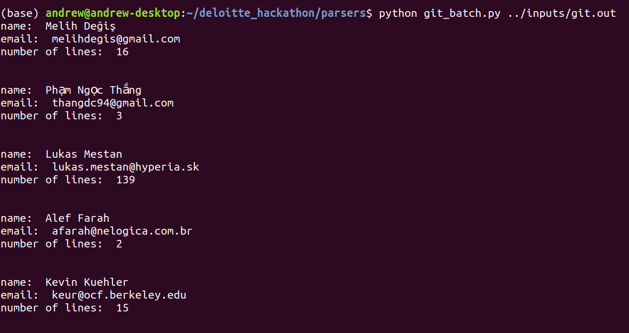

* The output of this script will be stored in (deloitte_hackatohn/outputs/git.csv). This will be the final output of the parser. It contains how many lines were modified by each and every contributor of that given repository.

2. To collect information from a jira project

Prerequisite: Jira project

* Export the Jira tickets of a project in csv file and place it in (deloitte_hackathon/inputs/.). E.g. file is present under the name (inputs/**jira.csv**).

* Execute the (parsers/jira_batch.py) with first argument as the jira raw exported file.

$ cd parsers

$ python jira_batch.py ../inputs/jira.csv

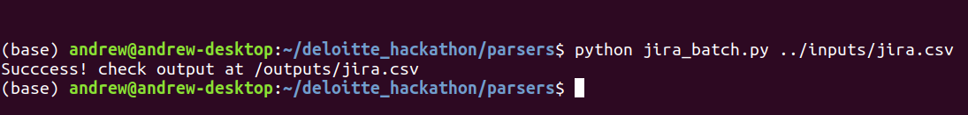

* The output will be stored at *deloitte_hackathon/outputs/jira.csv*. It contains the aggregated sum of tickets resolved by individual authors.

3. To collect information from skype call

Prerequisite: Skype meetings

* Export the skype call log from <https://secure.skype.com/en/data-export> and the file will get downloaded with .json extension. Then open the .json file in Microsoft Excel and there we can see all the call logs. Then place the raw xlsx file in (deloitte_hackathon/inputs/skype/.) Note: Sample files are given at the same directory

* Execute the jupyternotebook (parsers/skype.ipynb) from the same directory.

* The parsed output will be stored at *deloitte_hackathon/outputs/skype.csv.* It contains the aggregated sum of meetings attended by individual participants.

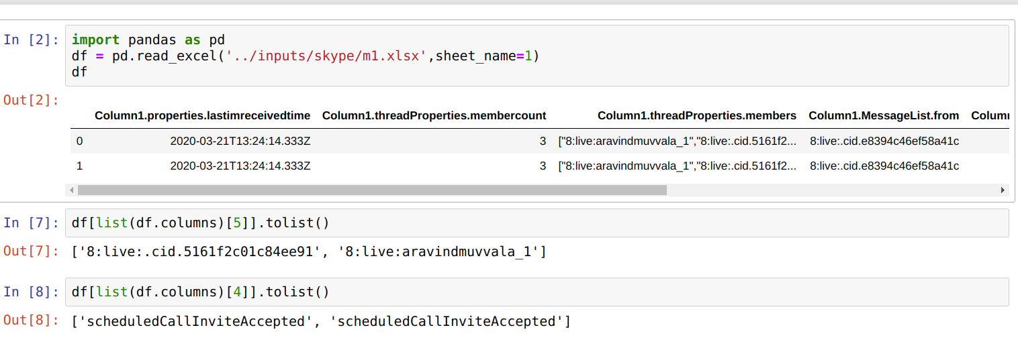

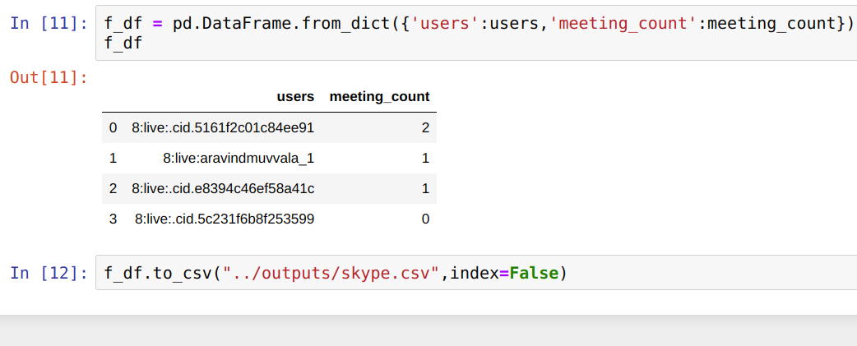

4. To collect information from confluence

Prerequisite: Confluence project

* Export the confluence project from project settings. Export in HTML format. And place the files in (deloitte_hackathon/inputs/raw_confluence/.) Note: Sample files are given at the same directory.

* Execute the jupyternotebook (parsers/confluence.ipynb) from the same directory.

* The parsed output will be stored at *deloitte_hackathon/outputs/confluence.csv* It contains the aggregate sum of character count contributions by individual authors.

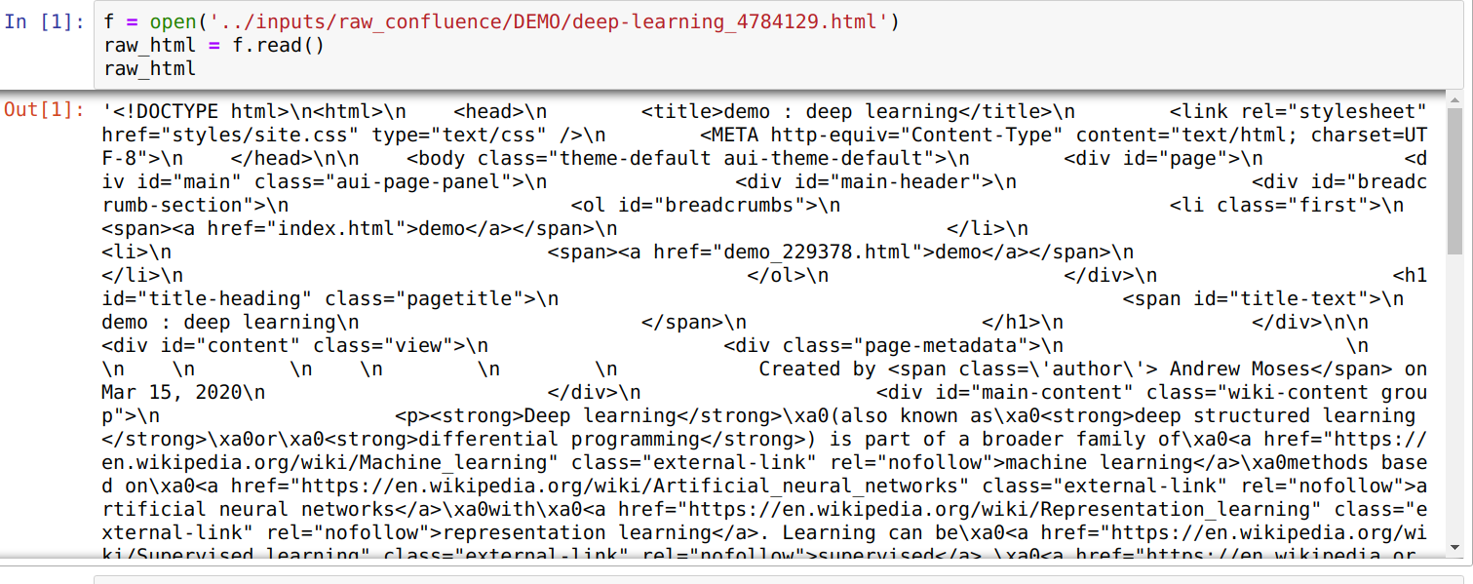

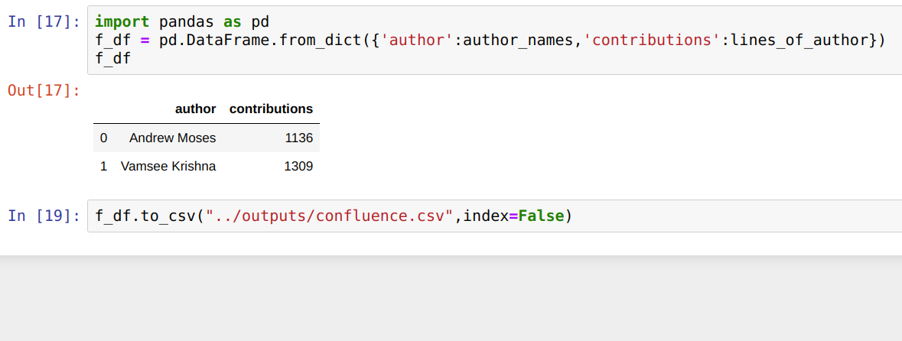

5. To collect unstructured email insights

* For this use case, a subset of open Enron email dataset was utilized. The input file is given at deloitte_hackathon/inputs/email_1k.csv It holds 1000 records (subset) of original emails collected from Enron company (opensourced). <https://www.cs.cmu.edu/~enron/>

* Execute the jupyternotebook (parsers/email.ipynb) from the same directory.

* Unsupervised learning was followed and emails were clustered. Associates who’s emails belong to a region of interest (ROI) cluster will be awarded bonus points.

* The parsed output will be stroed at *deloitte_hackathon/outputs/email.csv* It contains the bonus points awarded to individual email ids.

