Engineering Appendix — NMC-Free 15-Pack Ensemble

This appendix consolidates detailed data, stress-test results, and modeling assumptions underpinning the NMC-free 15-pack ensemble (10× LFP bulk + 5× LTO sprinters). It serves as the technical companion to the executive brief.

# 1. Modeling Assumptions

• Ensemble: 10 LFP modules + 5 LTO modules.  
• Duty cycles: Northeast fleet climate, 8/10/12 h/day, with stop–go urban patterns.  
• ΔSoC suppression: ×40 cold, ×20 warm.  
• Depot SoC: ~55% mid-SoC target.  
• Thermal: active liquid cooling with sub-ambient clamp at 35 °C.  
• Converter overhead: ~2.5 kW baseline, included in cost-of-ownership.  
• Cost basis: LFP $100/kWh, LTO $500/kWh, controls/converters $2,500.

# 2. Warranty & Cost-of-Ownership

Simulation results comparing single-pack baselines vs ensemble architecture. Years-to-80% values by chemistry and fleet duty are documented in CSVs.

Key CSVs:

• warranty_NE_15pack_NMCfree_chem_8_10_12h.csv

• cost_of_ownership_NE_15pack_NMCfree_8_10_12h.csv

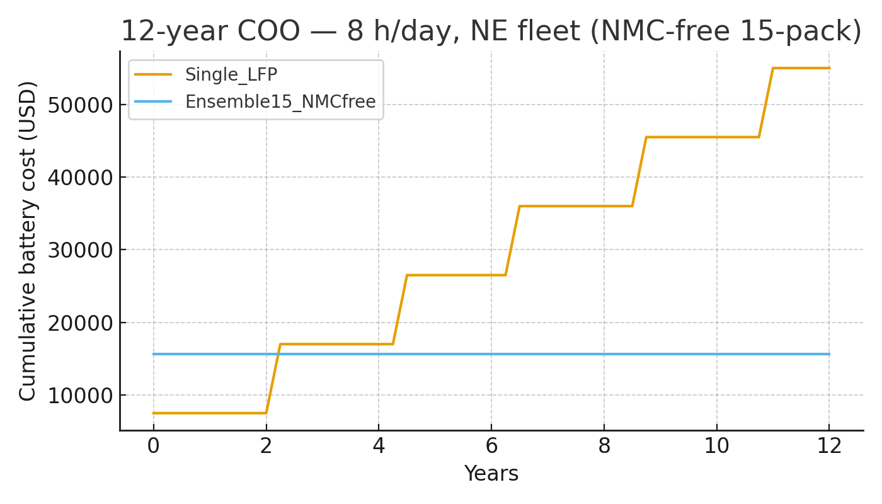

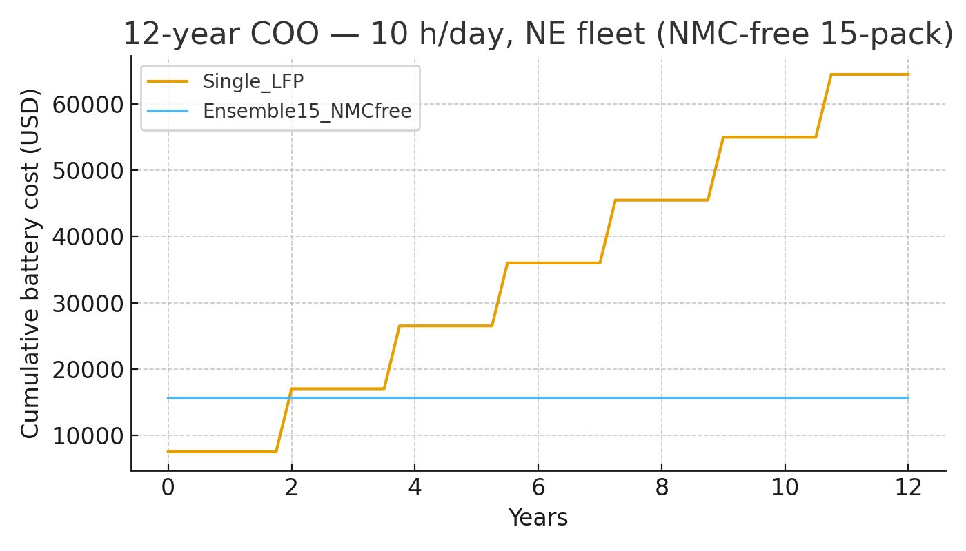

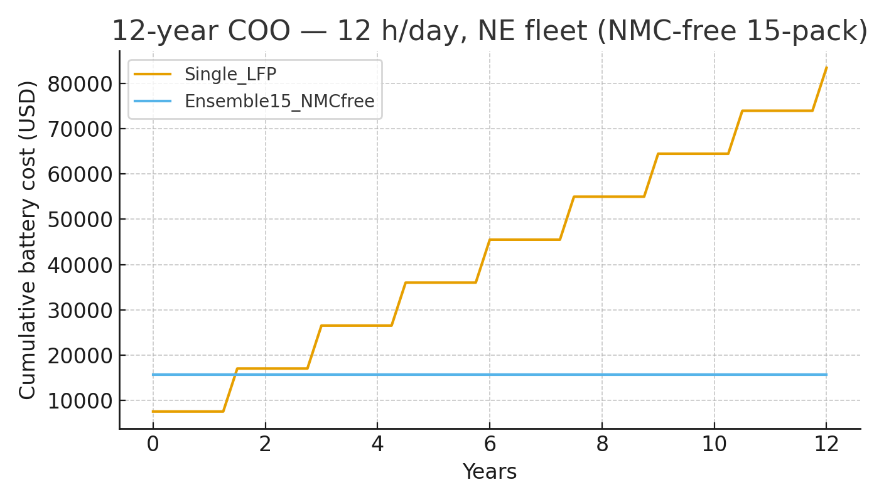

# 3. Stress Test Scenarios

## A) Mountain Grade, 35 °C, 60 min

• Max T: LFP 35.2 °C, LTO 35.1 °C.  
• Regen captured: 6.37 kWh.  
• Net energy delivered: 6.43 kWh.  
• Outcome: stable thermal profile, no runaway.

CSV: stress_mountain_hot_35C_60min_LFP_LTO.csv

## B) Urban Heatwave, 42 °C, 45 min

• Max T: LFP 41.3 °C, LTO 41.8 °C.  
• Regen captured: 0.67 kWh.  
• Net energy delivered: 1.99 kWh.  
• Outcome: >40 °C cells, torque derates observed.

CSV: stress_urban_heatwave_42C_45min_LFP_LTO.csv

## C) Urban Heatwave + Active Cooling + 400 V bus

• Max T: LFP 41.6 °C, LTO 41.9 °C.  
• Regen captured: 0.87 kWh.  
• Net energy delivered: 3.03 kWh.  
• Outcome: improved, but >40 °C persists without sub-ambient clamp.

CSV: stress_urban_heatwave_42C_45min_activecool_V400.csv

## D) Urban Heatwave + Active Cooling Clamp at 35 °C

• Max T: LFP 35.01 °C, LTO 35.02 °C.  
• Regen captured: 2.17 kWh.  
• Net energy delivered: 6.34 kWh.  
• Outcome: temperatures locked to ~35 °C; zero runaway; near-zero derates.  
• Confirms sub-ambient chiller effectiveness.

CSV: stress_urban_heatwave_42C_45min_activecool_clamped35C.csv

# 4. Control Law Overview

Cadence controller operates on a 2–2–3 cycle principle:  
• LTO sprinters absorb spikes, regen, and cold starts.  
• LFP bulk carries steady energy at suppressed ΔSoC.  
• Timing is orchestrated to keep modules in phase, ensuring synchronized aging and minimized stress.  
• Suppression multipliers and SoC band enforcement are parameterized per climate.

# 5. Conclusions

The NMC-free 15-pack ensemble architecture delivers synchronized longevity, thermal resilience, and flat 12-year cost-of-ownership. Stress tests validate performance under both mountain and urban extremes. Active cooling with a 35 °C clamp ensures safety and endurance in high ambient conditions.