# Full experimental stimuli

## Study 1

In Study 1, subjects evaluate the following four gender-matched scenarios in a random order:

A) Drugs Scenario (female names: Brianna, Samantha, and Maria):

Imagine that you are an athlete on a track team. Recently, your coach has become concerned that members of the team are using an illegal performance-enhancing drug called Vitronil. Vitronil use threatens your team’s eligibility to compete, and gives individual athletes unfair advantages.

[No information conditions: Two of your teammates are named **Brian** and **Sam**. You know nothing about if **Brain**uses Vitronil. You also know nothing about if **Sam**uses Vitronil.]

*VS*

[Good information conditions: Two of your teammates are named **Brian** and **Sam**. You overheard another member of the track team saying that **Brian** did not use Vitronil at his last track competition. In contrast, you know nothing about if **Sam**uses Vitronil.]

[Condemnation conditions: One day, you are having a conversation with **Brian**. You tell them a story about a mutual acquaintance, **Mark**, who is a competitive swimmer. After you finish your story, **Brian** mentions that he heard that **Mark** got caught using Vitronil right before an important swim meet. In telling his story, **Brian** expresses strong disapproval of Vitronil use.

*VS*

[No condemnation conditions: One day, you are having a conversation with **Sam**. You tell them a story about a mutual acquaintance, **Mark**, who is a competitive swimmer. After you finish your story, **Sam** mentions that he heard that **Mark** got caught using Vitronil right before an important swim meet. In telling his story, **Sam** expresses strong disapproval of Vitronil use.]

Comprehension questions (always presented in this fixed order):

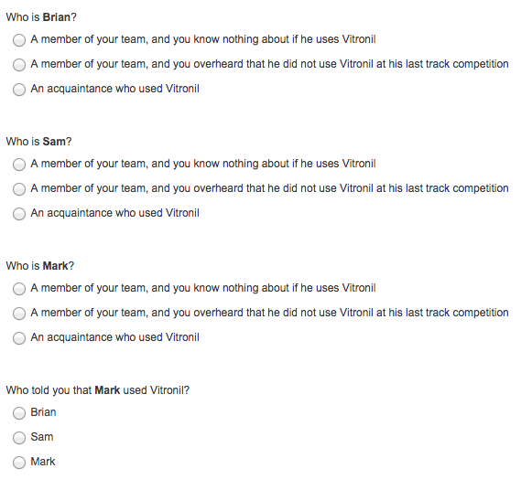

Dependent variables (presented in a random order):

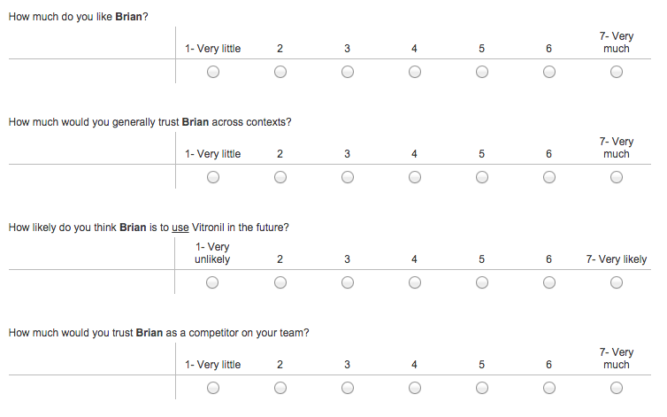

B) Work scenario (female names: Tina, Rachel, and Danielle):

Imagine that you are an employee at an organization. At your organization, you have to work closely with partners on important projects. Individuals are evaluated on the basis of the joint work they produce with their partners.

[No information conditions: Two of your co-workers are named **Thomas** and **Rick**. You know nothing about what **Thomas** is like to work with as a partner. You also know nothing about what **Rick** is like to work with as a partner.]

*VS*

[Good information conditions: Two of your co-workers are named **Thomas** and **Rick**. You overheard another member of the organization saying that **Thomas** was a reliable partner in his last project at work. In contrast, you know nothing about what **Rick** is like to work with as a partner.]

[Condemnation conditions: One day, you are having a conversation with **Thomas**. You tell them a story about a mutual acquaintance, **Daniel**, who is an employee at a similar organization and also works with a partner. After you finish your story, **Thomas** mentions that he heard that **Daniel** failed to meet a critical deadline, causing him and his partner to perform poorly at an important presentation. In telling his story, **Thomas** expresses strong disapproval of unreliable partners.]

*VS*

[No condemnation conditions: One day, you are having a conversation with **Rick**. You tell them a story about a mutual acquaintance, **Daniel**, who is an employee at a similar organization and also works with a partner. After you finish your story, **Rick** mentions that he heard that **Daniel** failed to meet a critical deadline, causing him and his partner to perform poorly at an important presentation. In telling his story, **Rick** expresses strong disapproval of unreliable partners.]

[Subjects then answer comprehension questions and rate Thomas, using measures as in scenario (A)]

C) Academic scenario (female names: Katie, Becca, and Gabrielle):

Imagine that you are a student in a chemistry course. The chemistry course involves difficult take-home exams. The exams are taken at home, but it is against the rules to use the Internet or discuss the exam with other members of the course. Recently, your instructor has become concerned that students are cheating on the exams.  
   
[No information conditions: Two other members of the course are named **Kyle** and **Ben**. You know nothing about if **Kyle**cheats on his exams. You also know nothing about if **Ben**cheats on his exams.]

*VS*

[Good information conditions: Two other members of the course are named **Kyle** and **Ben**. You overheard another member of the course saying that **Kyle**did not cheat on his last exam. In contrast, you know nothing about if **Ben**cheats on his exams.]

[Condemnation conditions: One day, you are having a conversation with **Kyle.**You tell them a story about a mutual acquaintance, **Gabriel**, who is a law student. After you finish your story, **Kyle** mentions that he heard that **Gabriel** has been cheating in his law courses. In telling his story, **Kyle** expresses strong disapproval of academic cheating.]

*VS*

[No condemnation conditions: One day, you are having a conversation with **Ben.**You tell them a story about a mutual acquaintance, **Gabriel**, who is a law student. After you finish your story, **Ben** mentions that he heard that **Gabriel** has been cheating in his law courses. In telling his story, **Ben** expresses strong disapproval of academic cheating.]

[Subjects then answer comprehension questions and rate Kyle, using measures as in scenario (A)]

D) Romantic scenario (female names: Sarah, Jenny and Anna):

Imagine that you are a member of a hiking club. The hiking club is a great way to meet new people, including romantic partners, as new members join regularly and get to know each other on hikes.

[No information conditions: Two other members of the club are named **Steven** and **Josh**. You know nothing about what **Steven** is like as a romantic partner. You also know nothing about what **Josh** is like as a romantic partner.]

*VS*

[Good information conditions: Two other members of the club are named **Steven** and **Josh**. You overheard another member of the club saying that **Steven** was faithful in his last relationship.In contrast, you know nothing about what **Josh** is like as a romantic partner.]

[Condemnation conditions: One day, you are having a conversation with **Steven.**You tell them a story about a mutual acquaintance, **Adam**, who is in a serious relationship. After you finish your story, **Steven** mentions that he heard that **Adam** has been regularly cheating in his relationship. In telling his story, **Steven** expresses strong disapproval of romantic cheating.]

*VS*

[No condemnation conditions: One day, you are having a conversation with **Josh.**You tell them a story about a mutual acquaintance, **Adam**, who is in a serious relationship. After you finish your story, **Josh** mentions that he heard that **Adam** has been regularly cheating in his relationship. In telling his story, **Josh** expresses strong disapproval of romantic cheating.]

[Subjects then answer comprehension questions and rate Steven, using measures as in scenario (A)]

## Study 2

In Study 2, subjects evaluate the following four gender-matched scenarios in a random order:

A) Drugs Scenario (female names: Brianna and Samantha):

Imagine that you are an athlete on a track team. Recently, your coach has become concerned that members of the team are using an illegal performance-enhancing drug called Vitronil. Vitronil use threatens your team’s eligibility to compete, and gives individual athletes unfair advantages.

Two of your teammates are named **Brian** and **Sam**. You know nothing about if either of them use Vitronil.

[Signaling / condemnation condition: One day, you are having a conversation with **Brian**. The two of you are discussing how different members of your team compete at meets. Specifically, you are talking about who stays clean, and who takes Vitronil. In your discussion, **Brian**emphasizes that he disapproves of taking Vitronil.]

*VS*

[Control / condemnation condition: One day, you are having a conversation with **Sam**. The two of you are discussing how different members of your team compete at meets. Specifically, you are talking about who stays clean, and who takes Vitronil. In your discussion, **Sam** emphasizes that he disapproves of taking Vitronil.]

*VS*

[Signaling / direct statements condition: One day, you are having a conversation with **Brian**. The two of you are discussing how different members of your team compete at meets. Specifically, you are talking about who stays clean, and who takes Vitronil. In your discussion, **Brian**emphasizes that he does not take Vitronil.]

*VS*

[Control / direct statements condition: One day, you are having a conversation with **Sam**. The two of you are discussing how different members of your team compete at meets. Specifically, you are talking about who stays clean, and who takes Vitronil. In your discussion, **Sam**emphasizes that he does not take Vitronil.]

Comprehension question:

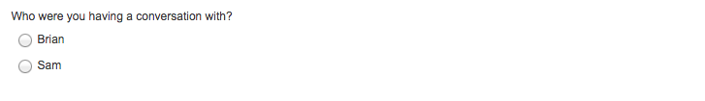

[Subjects then rate Brian, using the same measures as in Study 1.]

B) Work scenario (female names: Tina and Rachel):

Imagine that you are an employee at an organization. At your organization, you have to work closely with partners on important projects. Individuals are evaluated on the basis of the joint work they produce with their partners.

Two of your co-workers are named **Thomas** and **Rick**. You know nothing about what either of them are like to work with as partners.

[Signaling / condemnation condition: One day, you are having a conversation with **Thomas**. The two of you are discussing how different co-workers perform as partners. Specifically, you are talking about who is reliable and meets deadlines, and who is unreliable and fails to meet deadlines. In your discussion, **Thomas** emphasizes that he disapproves of unreliable partners.]

*VS*

[Control / condemnation condition: One day, you are having a conversation with **Rick**. The two of you are discussing how different co-workers perform as partners. Specifically, you are talking about who is reliable and meets deadlines, and who is unreliable and fails to meet deadlines. In your discussion, **Rick** emphasizes that he disapproves of unreliable partners.]

*VS*

[Signaling / direct statements condition: One day, you are having a conversation with **Thomas**. The two of you are discussing how different co-workers perform as partners. Specifically, you are talking about who is reliable and meets deadlines, and who is unreliable and fails to meet deadlines. In your discussion, **Thomas** emphasizes that he is not an unreliable partner.]

*VS*

[Control / direct statements condition: One day, you are having a conversation with **Rick**. The two of you are discussing how different co-workers perform as partners. Specifically, you are talking about who is reliable and meets deadlines, and who is unreliable and fails to meet deadlines. In your discussion, **Rick** emphasizes that he is not an unreliable partner.]

[Subjects then answer comprehension question and rate Thomas, using measures as in scenario (A)]

C) Academic scenario (female names: Katie and Becca):

Imagine that you are a student in a chemistry course. The chemistry course involves difficult take-home exams. The exams are taken at home, but it is against the rules to use the Internet or discuss the exam with other members of the course. Recently, your instructor has become concerned that students are cheating on the exams.

Two other members of the course are named **Kyle** and **Ben**. You know nothing about if either of them cheat on their exams.

[Signaling / condemnation condition: One day, you are having a conversation with **Kyle.**The two of you are discussing how different students in your course complete their exams. Specifically, you are talking about who is honest and works alone, and who cheats by collaborating with others and using the Internet. In your discussion, **Kyle**emphasizes that he disapproves of cheating on exams.]

*VS*

[Control / condemnation condition: One day, you are having a conversation with **Ben.**The two of you are discussing how different students in your course complete their exams. Specifically, you are talking about who is honest and works alone, and who cheats by collaborating with others and using the Internet. In your discussion, **Ben**emphasizes that he disapproves of cheating on exams.]

*VS*

[Signaling / direct statements condition: One day, you are having a conversation with **Kyle.**The two of you are discussing how different students in your course complete their exams. Specifically, you are talking about who is honest and works alone, and who cheats by collaborating with others and using the Internet. In your discussion, **Kyle**emphasizes that he does not cheat on his exams.]

*VS*

[Control / direct statements condition: One day, you are having a conversation with **Ben.**The two of you are discussing how different students in your course complete their exams. Specifically, you are talking about who is honest and works alone, and who cheats by collaborating with others and using the Internet. In your discussion, **Ben**emphasizes that he does not cheat on his exams.]

[Subjects then answer comprehension question and rate Kyle, using measures as in scenario (A)]

D) Romantic scenario (female names: Sarah and Jenny):

Imagine that you are a member of a hiking club. The hiking club is a great way to meet new people, including romantic partners, as new members join regularly and get to know each other on hikes.

Two other members of the club are named **Steven** and **Josh**. You know nothing about what either of them are as in romantic relationships.

[Signaling / condemnation condition: One day, you are having a conversation with **Steven.**The two of you are discussing what different members of your club are as in romantic relationships. Specifically, you are talking about who is trustworthy and stays faithful, and who is not trustworthy and cheats on their partners. In your discussion, **Steven** emphasizes that he disapproves of cheating in relationships.]

*VS*

[Control / condemnation condition: One day, you are having a conversation with **Josh.**The two of you are discussing what different members of your club are as in romantic relationships. Specifically, you are talking about who is trustworthy and stays faithful, and who is not trustworthy and cheats on their partners. In your discussion, **Josh** emphasizes that he disapproves of cheating in relationships.]

*VS*

[Signaling / direct statements condition: One day, you are having a conversation with **Steven.**The two of you are discussing what different members of your club are as in romantic relationships. Specifically, you are talking about who is trustworthy and stays faithful, and who is not trustworthy and cheats on their partners. In your discussion, **Steven** emphasizes that he does not cheat in relationships.]

*VS*

[Control / direct statements condition: One day, you are having a conversation with **Josh.**The two of you are discussing what different members of your club are as in romantic relationships. Specifically, you are talking about who is trustworthy and stays faithful, and who is not trustworthy and cheats on their partners. In your discussion, **Josh** emphasizes that he does not cheat in relationships.]

[Subjects then answer comprehension question and rate Steven, using measures as in scenario (A)]

## Study 3

In Study 3, subjects evaluate the following four scenarios in a random order:

A) Music Scenario

Becky and her friend Amanda are discussing a mutual acquaintance. Amanda mentions that the acquaintance often downloads music illegally from the Internet.

[Hypocrisy condition: Becky says that she thinks it is morally wrong to download music illegally from the Internet.]

*VS*

[Liar condition: Becky says that she doesn't download music illegally from the Internet.]

*VS*

[No sentence presented in the control transgressor condition.]

Shortly after their conversation, Becky goes online, and downloads music illegally.

Dependent variables (presented in random order):

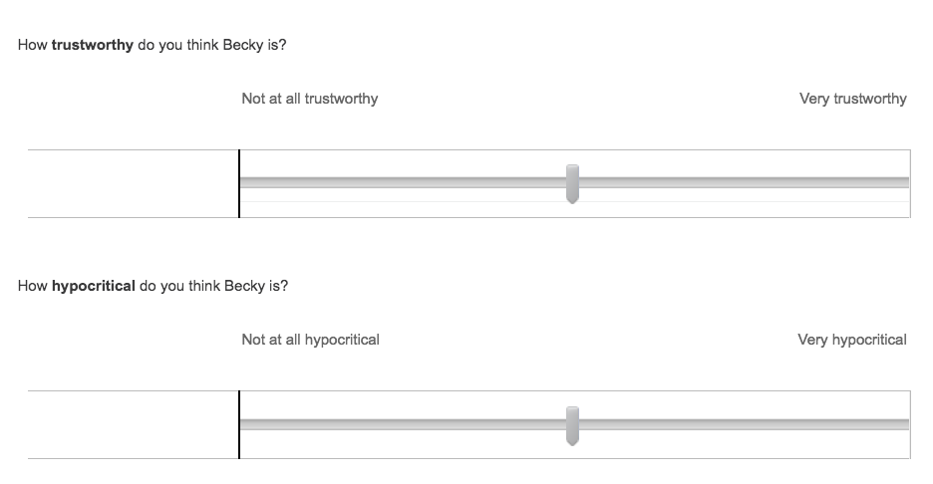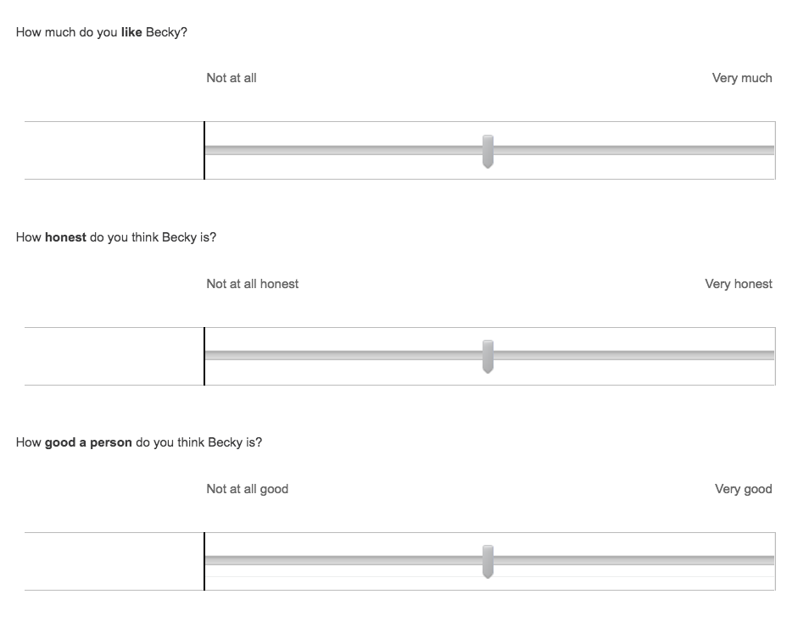

B) Jury Scenario

Jennifer and her friend Rose are discussing a mutual acquaintance. Rose mentions that the acquaintance recently tried to get out of jury duty.

[Hypocrisy condition: Jennifer says that she thinks it is morally wrong to try to get out of jury duty.]

*VS*

[Liar condition: Jennifer says that she doesn't try to get out of jury duty.]

*VS*

[No sentence presented in the control transgressor condition.]

Shortly after their conversation, Jennifer gets called for jury duty, and tries to get out of it.

[Subjects then rate Jennifer, using measures as in scenario (A)]

C) Phone Call Scenario

Bruce and his friend are Zach are discussing a mutual acquaintance. Zach mentions that the acquaintance often ignores his mother's phone calls.

[Hypocrisy condition: Bruce says that he thinks it is morally wrong to ignore your mother's phone calls.]

*VS*

[Liar condition: Bruce says that he doesn't ignore his mother's phone calls.]

*VS*

[No sentence presented in the control transgressor condition.]

Shortly after their conversation, Bruce notices that his mother is calling, and ignores the call.

[Subjects then rate Bruce, using measures as in scenario (A)]

D) Printing Scenario

Kevin and his friend Jack are discussing a mutual acquaintance. Jack mentions that the acquaintance often uses a lot of paper by printing documents single-sided.

[Hypocrisy condition: Kevin says that he thinks it is morally wrong to use a lot of paper by printing documents single-sided.]

*VS*

[Liar condition: Kevin says that he doesn’t use a lot of paper by printing documents single-sided.]

*VS*

[No sentence presented in the control transgressor condition.]

Shortly after their conversation, Kevin has a large document to print, and uses a lot of paper by printing it single-sided.

[Subjects then rate Kevin, using measures as in scenario (A)]

## Study 4

Study 4 is identical to Study 3, except that the “liar” condition is replaced with an “honest hypocrisy” condition (described below), and for clarity we consequently rename the “hypocrisy” condition the “traditional hypocrisy” condition. The Music Scenario of Study 4 looks as follows:

Becky and her friend Amanda are discussing a mutual acquaintance. Amanda mentions that the acquaintance often downloads music illegally from the Internet.

[Traditional hypocrisy condition: Becky says that she thinks it is morally wrong to download music illegally from the Internet.]

*VS*

[Honest hypocrisy condition: Becky says that she thinks it is morally wrong to download music illegally from the Internet, but that she sometimes does it anyway.]

*VS*

[No sentence presented in the control transgressor condition.]

Shortly after their conversation, Becky goes online, and downloads music illegally.

Dependent variables are also the same as in Study 3; and other scenarios are also the same as in Study 3, with analogous changes as in the Music Scenario shown above.

## Study 5

In Study 5, subjects evaluate the “Music and Phone Call” and “Jury and Printing” scenarios in random order, and then evaluate the targets using the same dependent variables as in Studies 3-4. These scenarios involve counterbalancing (which we collapse over in our analyses), as follows:

When presented with the “Music and Phone Call” scenario, we randomly assign subjects to either see the “Condemn Music” or “Condemn Phone Call” version. Furthermore, and orthogonally, we also randomly assign them to see the “Music First” or “Phone Call First” version.

Likewise, when presented with the “Jury and Printing” scenario, we randomly assign subjects to either see the “Condemn Jury” or “Condemn Printing” version. Furthermore, and orthogonally, we also randomly assign them to see the “Jury First” or “Printing First” version.

A) Music and Phone Call Scenario

*Condemn Music, Music First Version*

Becky and her friend Amanda are discussing issues in their lives, like downloading music and answering their parents' phone calls.

[Traditional hypocrisy condition: Becky tells Amanda that she thinks it is morally wrong when people download music illegally from the Internet.]

*VS*

[Disclosure hypocrisy condition: Becky tells Amanda that she thinks it is morally wrong when people download music illegally from the Internet, but that she sometimes ignores her mother's phone calls.]

*VS*

[Honest hypocrisy condition: Becky tells Amanda that she thinks it is morally wrong when people download music illegally from the Internet, but that she sometimes does it anyway.]

*VS*

[No sentence presented in the control transgressor condition.]

Shortly after their conversation, Becky goes online, and downloads music illegally. She also notices that her mother is calling, and ignores the call.

*Condemn Music, Phone Call First Version*

Becky and her friend Amanda are discussing issues in their lives, like answering their parents' phone calls and downloading music.

[Traditional hypocrisy condition: Becky tells Amanda that she thinks it is morally wrong when people download music illegally from the Internet.]

*VS*

[Disclosure hypocrisy condition: Becky tells Amanda that she thinks it is morally wrong when people download music illegally from the Internet, but that she sometimes ignores her mother's phone calls.]

*VS*

[Honest hypocrisy condition: Becky tells Amanda that she thinks it is morally wrong when people download music illegally from the Internet, but that she sometimes does it anyway.]

*VS*

[No sentence presented in the control transgressor condition.]

Shortly after their conversation, Becky notices that her mother is calling, and ignores the call. She also goes online, and downloads music illegally.

*Condemn Phone Call, Music First Version*

Becky and her friend Amanda are discussing issues in their lives, like downloading music and answering their parents' phone calls.

[Traditional hypocrisy condition: Becky tells Amanda that she thinks it is morally wrong when people ignore their mothers' phone calls.]

*VS*

[Disclosure hypocrisy condition: Becky tells Amanda that she thinks it is morally wrong when people ignore their mothers' phone calls, but that she sometimes downloads music illegally from the Internet.]

*VS*

[Honest hypocrisy condition: Becky tells Amanda that she thinks it is morally wrong when people ignore their mothers' phone calls, but that she sometimes does it anyway.]

*VS*

[No sentence presented in the control transgressor condition.]

Shortly after their conversation, Becky goes online, and downloads music illegally. She also notices that her mother is calling, and ignores the call.

*Condemn Phone Call, Phone Call First Version*

Becky and her friend Amanda are discussing issues in their lives, like answering their parents' phone calls and downloading music.

[Traditional hypocrisy condition: Becky tells Amanda that she thinks it is morally wrong when people ignore their mothers' phone calls.]

*VS*

[Disclosure hypocrisy condition: Becky tells Amanda that she thinks it is morally wrong when people ignore their mothers' phone calls, but that she sometimes downloads music illegally from the Internet.]

*VS*

[Honest hypocrisy condition: Becky tells Amanda that she thinks it is morally wrong when people ignore their mothers' phone calls, but that she sometimes does it anyway.]

*VS*

[No sentence presented in the control transgressor condition.]

Shortly after their conversation, Becky notices that her mother is calling, and ignores the call. She also goes online, and downloads music illegally.

B) Jury and Printing Scenario

*Condemn Jury, Jury First Version*

Kevin and his friend Jack are discussing issues in their lives, like attending jury duty and printing documents.

[Traditional hypocrisy condition: Kevin tells Jack that he thinks it is morally wrong when people try to get out of jury duty.]

*VS*

[Disclosure hypocrisy condition: Kevin tells Jack that he thinks it is morally wrong when people try to get out of jury duty, but that he sometimes uses a lot of paper by printing documents single-sided.]

*VS*

[Honest hypocrisy condition: Kevin tells Jack that he thinks it is morally wrong when people try to get out of jury duty, but that he sometimes does it anyway.]

*VS*

[No sentence presented in the control transgressor condition.]

Shortly after their conversation, Kevin gets called for jury duty, and tries to get out of it. He also has a large document to print, and uses a lot of paper by printing it single-sided.

*Condemn Jury, Printing First Version*

Kevin and his friend Jack are discussing issues in their lives, like printing documents and attending jury duty.

[Traditional hypocrisy condition: Kevin tells Jack that he thinks it is morally wrong when people try to get out of jury duty.]

*VS*

[Disclosure hypocrisy condition: Kevin tells Jack that he thinks it is morally wrong when people try to get out of jury duty, but that he sometimes uses a lot of paper by printing documents single-sided.]

*VS*

[Honest hypocrisy condition: Kevin tells Jack that he thinks it is morally wrong when people try to get out of jury duty, but that he sometimes does it anyway.]

*VS*

[No sentence presented in the control transgressor condition.]

Shortly after their conversation, Kevin has a large document to print, and uses a lot of paper by printing it single-sided. He also gets called for jury duty, and tries to get out of it.

*Condemn Printing, Jury First Version*

Kevin and his friend Jack are discussing issues in their lives, like attending jury duty and printing documents.

[Traditional hypocrisy condition: Kevin tells Jack that he thinks it is morally wrong when people use a lot of paper by printing documents single-sided.]

*VS*

[Disclosure hypocrisy condition: Kevin tells Jack that he thinks it is morally wrong when people use a lot of paper by printing documents single-sided, but that he sometimes tries to get out of jury duty.]

*VS*

[Honest hypocrisy condition: Kevin tells Jack that he thinks it is morally wrong when people use a lot of paper by printing documents single-sided, but that he sometimes does it anyway.]

*VS*

[No sentence presented in the control transgressor condition.]

Shortly after their conversation, Kevin gets called for jury duty, and tries to get out of it. He also has a large document to print, and uses a lot of paper by printing it single-sided.

*Condemn Printing, Printing First Version*

Kevin and his friend Jack are discussing issues in their lives, like printing documents and attending jury duty.

[Traditional hypocrisy condition: Kevin tells Jack that he thinks it is morally wrong when people use a lot of paper by printing documents single-sided.]

*VS*

[Disclosure hypocrisy condition: Kevin tells Jack that he thinks it is morally wrong when people use a lot of paper by printing documents single-sided, but that he sometimes tries to get out of jury duty.]

*VS*

[Honest hypocrisy condition: Kevin tells Jack that he thinks it is morally wrong when people use a lot of paper by printing documents single-sided, but that he sometimes does it anyway.]

*VS*

[No sentence presented in the control transgressor condition.]

Shortly after their conversation, Kevin has a large document to print, and uses a lot of paper by printing it single-sided. He also gets called for jury duty, and tries to get out of it.