# <http://www.tuicool.com/articles/RVVfui3>

# 【已解决】ReactNative中实现实现ListView的数据源是多维数组

时间 2017-03-16 18:35:47 [在路上](http://www.tuicool.com/sites/vim6fe)

*原文*  [http://www.crifan.com/react_native_listview_datasource_multiple_dimension_array/](http://www.crifan.com/react_native_listview_datasource_multiple_dimension_array/?utm_source=tuicool&utm_medium=referral)

主题 [ListView](http://www.tuicool.com/topics/11020193) [React Native](http://www.tuicool.com/topics/11120078)

ReactNative iOS中，之前已经用：

class AwesomeProject extends Component {

// Initialize the hardcoded data

constructor(props) {

super(props);

const ds = new ListView.DataSource({rowHasChanged: (r1, r2) => r1 !== r2});

this.state = {

dataSource: ds.cloneWithRows([

‘王小丫’, ‘王芳’, ‘秦小刚’, ‘李小燕’, ‘郑钧’, ‘Lucia Xie’, ‘周明明’, ‘张曲’

])

};

}

render() {

return (

<View style={{flex: 1, paddingTop: 20}}>

<View style={styles.customerList}>

<ListView

dataSource={this.state.dataSource}

renderRow={(rowData) =>

<View style={styles.customerRow}>

<Text style={styles.intentionLevel}>H</Text>

<Text style={styles.customerName}>{rowData}</Text>

<Text style={styles.intentionCar}>奥迪TTS</Text>

<Text style={styles.updateTime}>2017/03/15</Text>

</View>

}

/>

</View>

</View>

);

}

}

const styles = StyleSheet.create({

navigation:{

flex: 1,

paddingTop:10,

height:10,

backgroundColor:’#458cd3′,

},

customerList:{

flex: 1,

paddingTop: 30,

},

customerRow:{

flex: 1,

flexDirection: ‘row’,

height: 30,

},

intentionLevel: {

paddingLeft: 10,

width: 20,

color: ‘red’,

},

customerName: {

paddingLeft: 10,

width: 100,

color: ‘black’,

},

intentionCar: {

paddingLeft: 10,

width: 120,

color: ‘gray’,

},

updateTime:{

paddingLeft: 10,

width: 120,

paddingRight: 10,

color: ‘#c1c4c9’,

},

});

AppRegistry.registerComponent(‘AwesomeProject’, () => AwesomeProject);

实现了效果：

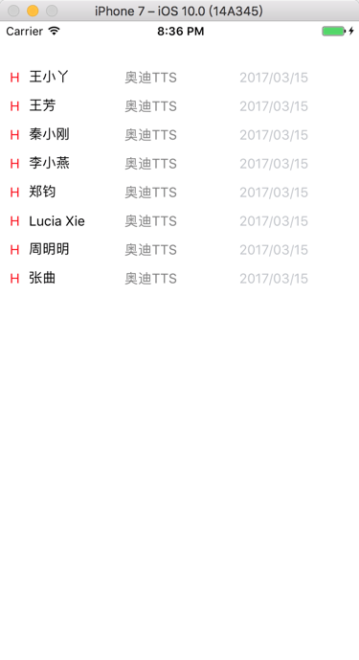

现在想要对于listView的数据源，从一维数组：

[

‘王小丫’, ‘王芳’, ‘秦小刚’, ‘李小燕’, ‘郑钧’, ‘Lucia Xie’, ‘周明明’, ‘张曲’

]

改为多位数组，

以便于每个row的数据都可以从对应的字段获取。

rn ListView DataSource cloneWithRows

rn listview datasource clonewithrows several dimensions

[[ReactNative] ListView.DataSource doesn’t work with ObservableArrays · Issue #476 · mobxjs/mobx · GitHub](https://github.com/mobxjs/mobx/issues/476)

然后最把字符串的列表，改为字典的列表，就可以了：

class AwesomeProject extends Component {

// Initialize the hardcoded data

constructor(props) {

super(props);

const ds = new ListView.DataSource({rowHasChanged: (r1, r2) => r1 !== r2});

this.state = {

dataSource: ds.cloneWithRows([

{

intentionLevel : "H",

customerName : "王小丫",

intentionCar : "奥迪A3进口",

updateTime : "2016/12/28"

},

{

intentionLevel : "A",

customerName : "王芳",

intentionCar : "奥迪S7",

updateTime : "1/1"

},

{

intentionLevel : "C",

customerName : "秦小刚",

intentionCar : "奥迪Q7",

updateTime : "2/5"

},

{

intentionLevel : "B",

customerName : "李小燕",

intentionCar : "奥迪TTS",

updateTime : "周三"

},

{

intentionLevel : "H",

customerName : "郑钧",

intentionCar : "奥迪Q5(进口)",

updateTime : "9:15"

},

{

intentionLevel : "H",

customerName : "Lucia Xie",

intentionCar : "奥迪Q5(进口)",

updateTime : "2016/12/20"

},

{

intentionLevel : "C",

customerName : "司马相如",

intentionCar : "奥迪Q5(进口)",

updateTime : "2/20"

},

{

intentionLevel : "C",

customerName : "张曲",

intentionCar : "奥迪Q5(进口)",

updateTime : "2017/2/15"

},

{

intentionLevel : "O",

customerName : "赵平",

intentionCar : "奥迪Q5(进口)",

updateTime : "昨天"

},

])

};

}

render() {

return (

<View style={{flex: 1, paddingTop: 20}}>

<View style={styles.customerList}>

<ListView

dataSource={this.state.dataSource}

renderRow={(rowData) =>

<View style={styles.customerRow}>

<Text style={styles.intentionLevel}>{rowData.intentionLevel}</Text>

<Text style={styles.customerName}>{rowData.customerName}</Text>

<Text style={styles.intentionCar}>{rowData.intentionCar}</Text>

<Text style={styles.updateTime}>{rowData.updateTime}</Text>

</View>

}

/>

</View>

</View>

);

}

}

const styles = StyleSheet.create({

navigation:{

flex: 1,

paddingTop:10,

height:10,

backgroundColor:’#458cd3′,

},

customerList:{

flex: 1,

paddingTop: 30,

},

customerRow:{

flex: 1,

flexDirection: ‘row’,

height: 30,

},

intentionLevel: {

paddingLeft: 10,

width: 20,

color: ‘red’,

},

customerName: {

paddingLeft: 10,

width: 100,

color: ‘black’,

},

intentionCar: {

paddingLeft: 10,

width: 120,

color: ‘gray’,

},

updateTime:{

paddingLeft: 10,

width: 120,

paddingRight: 10,

color: ‘#c1c4c9’,

},

});

AppRegistry.registerComponent(‘AwesomeProject’, () => AwesomeProject);

效果：

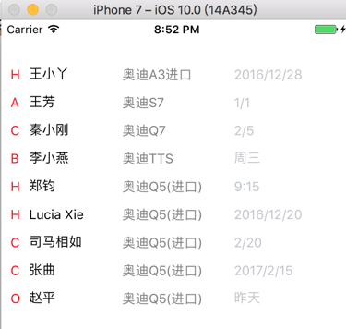

【总结】

ReactNative中，之前是一维数组是：

this.state = {

dataSource: ds.cloneWithRows([

‘王小丫’, ‘王芳’, ‘秦小刚’, ‘李小燕’, ‘郑钧’, ‘Lucia Xie’, ‘周明明’, ‘张曲’

])

};

}

render() {

return (

<View style={{flex: 1, paddingTop: 20}}>

<View style={styles.customerList}>

<ListView

dataSource={this.state.dataSource}

renderRow={(rowData) =>

<View style={styles.customerRow}>

<Text style={styles.intentionLevel}>H</Text>

<Text style={styles.customerName}>{rowData}</Text>

<Text style={styles.intentionCar}>奥迪TTS</Text>

<Text style={styles.updateTime}>2017/03/15</Text>

</View>

}

/>

</View>

想要改为多维数组，直接用字典的列表，即可：

const ds = new ListView.DataSource({rowHasChanged: (r1, r2) => r1 !== r2});

this.state = {

dataSource: ds.cloneWithRows([

{

intentionLevel : "H",

customerName : "王小丫",

intentionCar : "奥迪A3进口",

updateTime : "2016/12/28"

},

{

intentionLevel : "A",

customerName : "王芳",

intentionCar : "奥迪S7",

updateTime : "1/1"

},

。。。

{

intentionLevel : "O",

customerName : "赵平",

intentionCar : "奥迪Q5(进口)",

updateTime : "昨天"

},

])

};

}

render() {

return (

<View style={{flex: 1, paddingTop: 20}}>

<View style={styles.customerList}>

<ListView

dataSource={this.state.dataSource}

renderRow={(rowData) =>

<View style={styles.customerRow}>

<Text style={styles.intentionLevel}>{rowData.intentionLevel}</Text>

<Text style={styles.customerName}>{rowData.customerName}</Text>

<Text style={styles.intentionCar}>{rowData.intentionCar}</Text>

<Text style={styles.updateTime}>{rowData.updateTime}</Text>

</View>

}

/>

</View>

</View>

);

}

即可。