Project Sunflower
ESP32 Based Rhythm Game
Overview: This project implements a reaction-based rhythm game using a microcontroller. Audio playback is synchronized with LED matrix animations. The system processes user inputs via GPIO interrupts and evaluates the timing accuracy to generate scores based on performance.
Purpose: To design an interactive system that integrates real-time input processing, audio output, and visual feedback to create an engaging and enjoyable experience for the user
Requirements:
- Handle button inputs using interrupts for real-time response
- Display incoming notes using an LED matrix
- Provide music playback and level selection
- Generate sound output through a speaker module
- Calculate and display player score
- Support multiple difficulty levels
- Able to store and read MP3 or Wav files
- Ensure system is portable and self-contained
Architecture: The system is divided into the following modules:
- Game Logic Module:
  - A central timing engine
  - Controls timing, note generation, visual and audio synchronization, scoring system, and difficulty levels
  - Microcontroller handles game logic
- Input handler:
  - Processes button presses and joystick input.
  - Uses GPIO interrupt handling
- LED Controller:
  - Drives the 64x32 RGB LED matrix to display scrolling notes
  - Uses SPI high speed data transfer
- Audio Output Module:
  - Generates music signals and outputs through the speaker
  - Uses PWM-based audio output
- Display Module:
  - Displays menus, score display, and game status
  - Uses I2C
- Feedback System:
  - Provides visual or audio feedback based on player performance
Diagram:
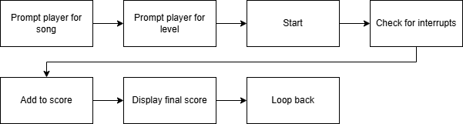

Hardware design:
- Main controller: ESP32C6 Microcontroller
- Main game display: SMD2121 64x32 Pixel RGB LED Matrix
- Audio output: 8Ω 3W Mini Speaker
- Player input: Tactile Push Buttons
- UI display: SSD1306 OLED Display
- UI navigation: Analog Joystick
- Storage: Memory Card Adapter & Micro SD Card
Key Challenges:
- Timing synchronization between audio and LED animation
- Driving the large LED matrix on limited resources
- Managing tasks using a real-time scheduling approach
- Limited pins on the ESP32C6
Future Enhancements:
- Battery-powered system with 2–3 hours runtime
- Wireless updates via WiFi (OTA or server sync for new songs)
- Optional Bluetooth audio output for improved sound quality

