**AGENTS: TORONTO Jessica Martins VANCOUVER Jessica Brown**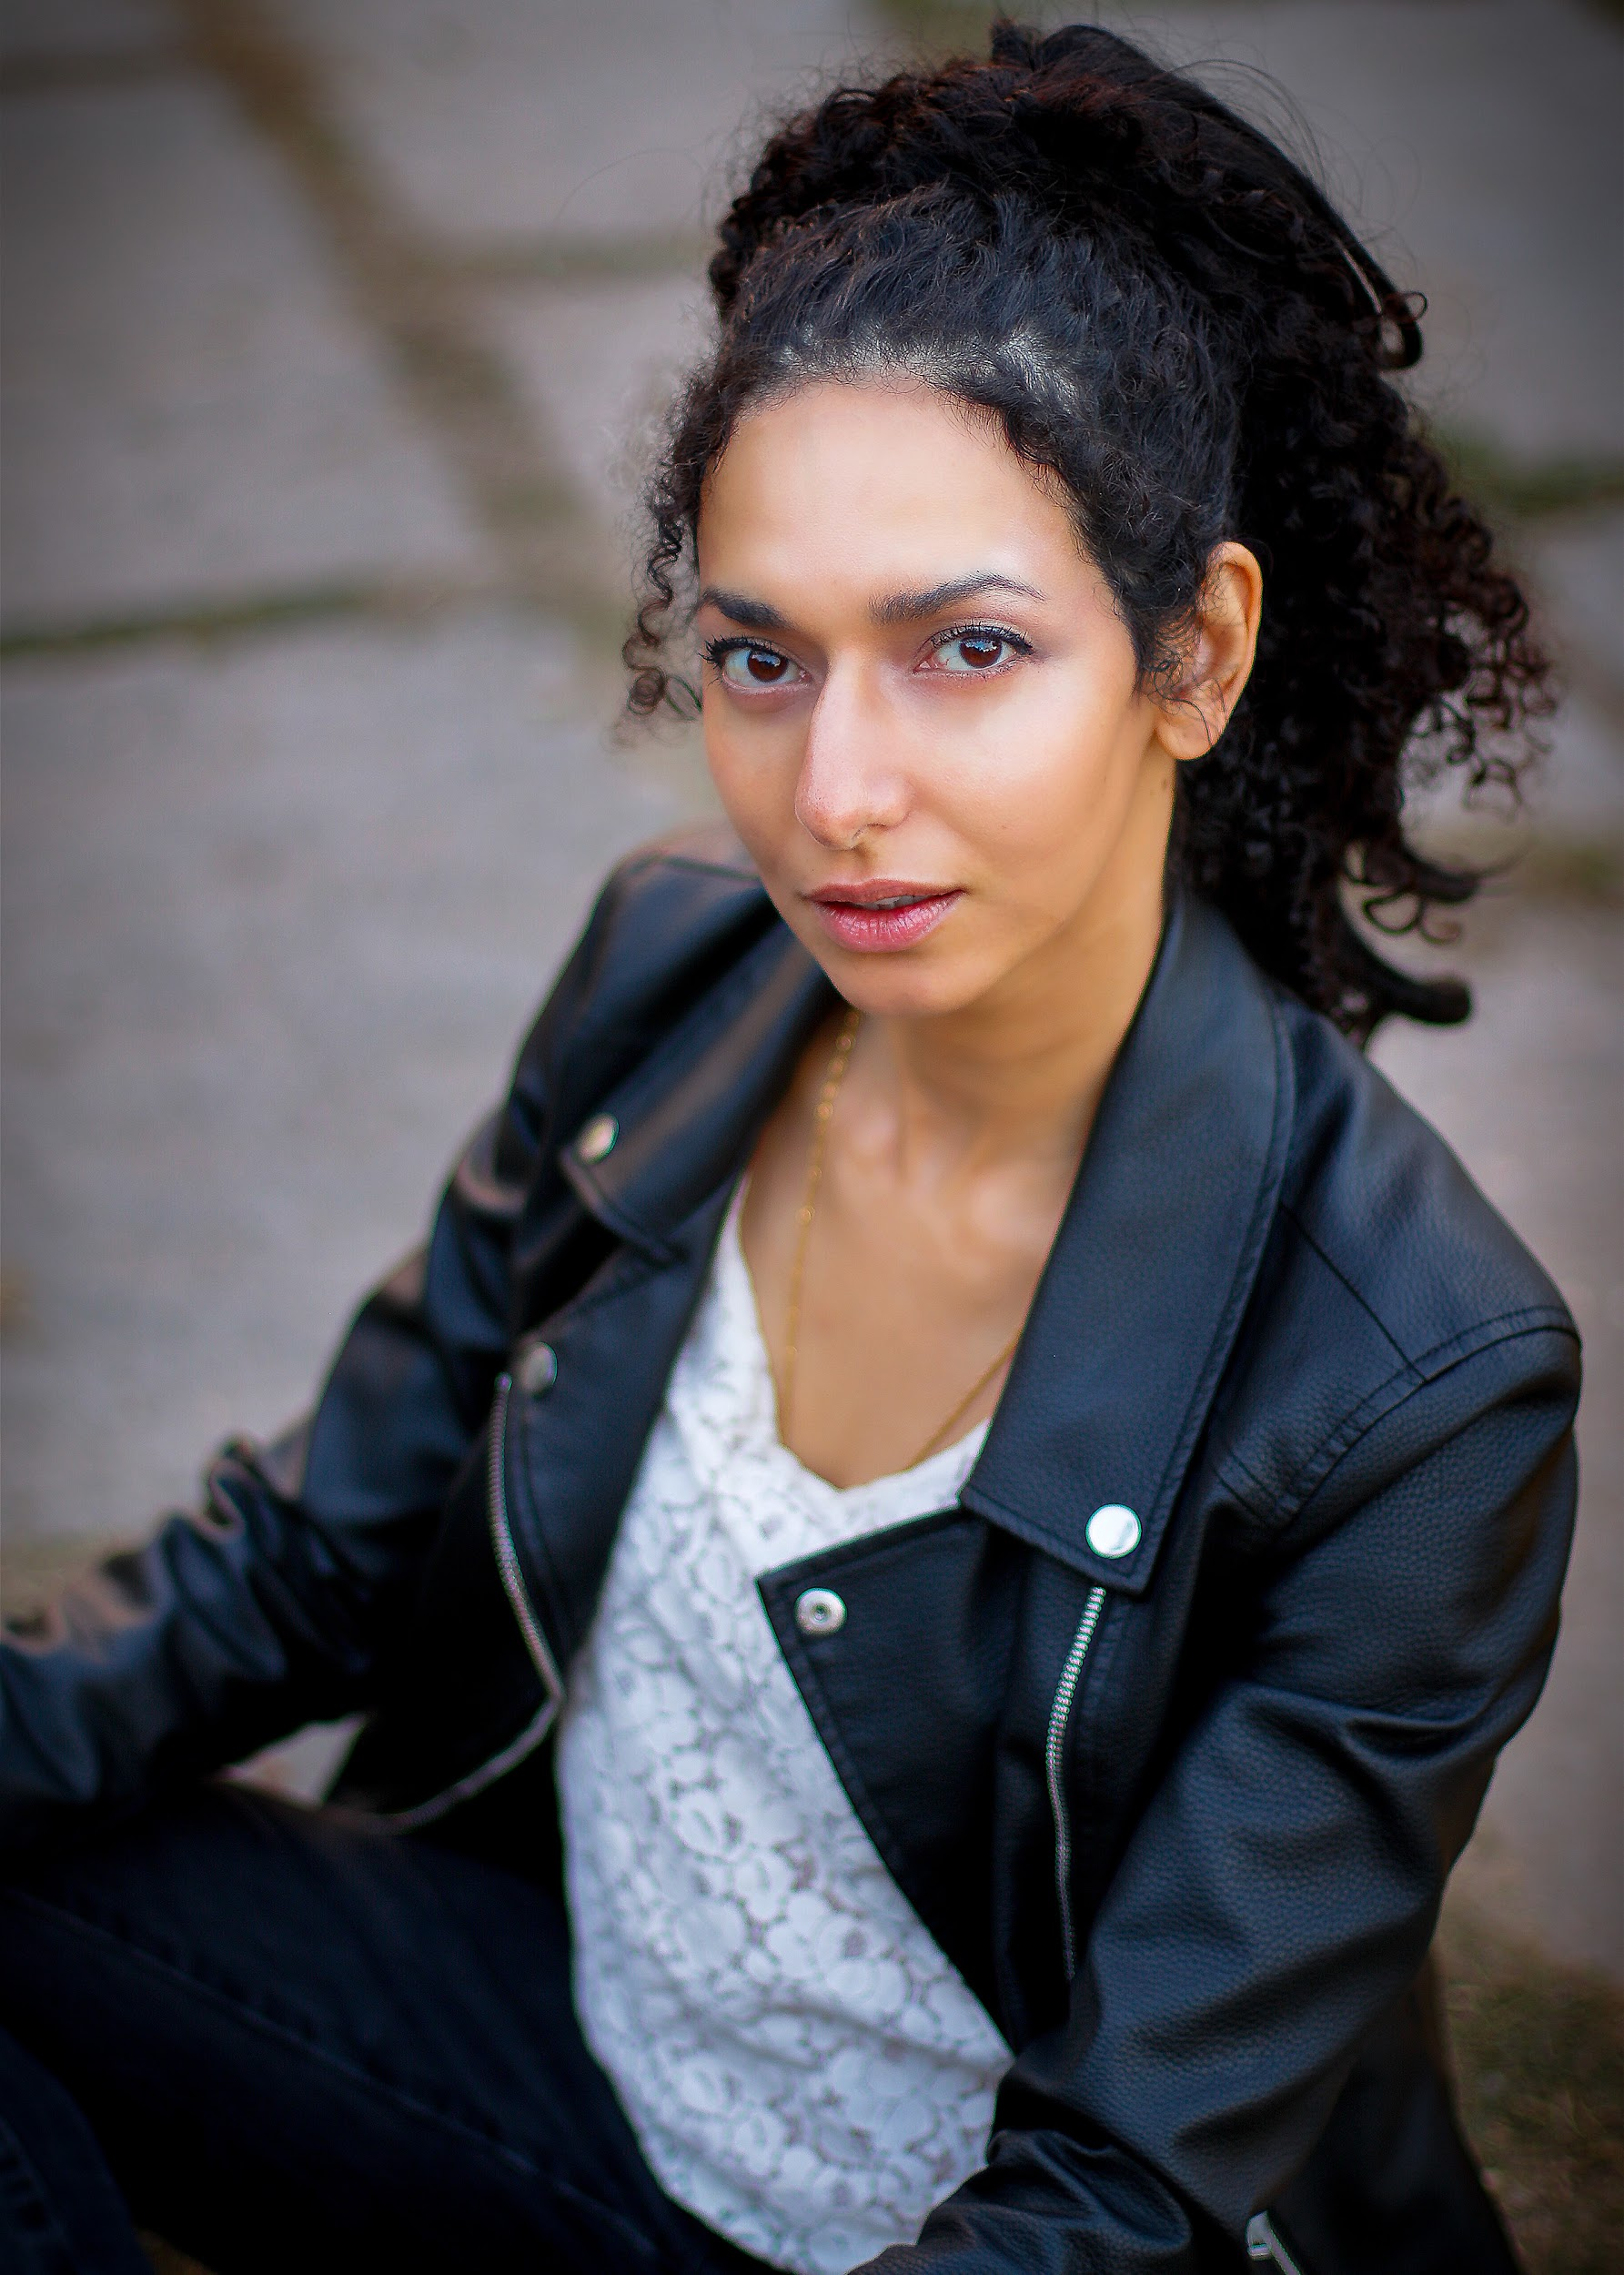

**t: 416 900 5561** [**e**](mailto:info@heroartists.com)**:jessica**[**@heroartists.com**](mailto:info@heroartists.com)[**e**](mailto:info@heroartists.com)**:jbrown**[**@heroartists.com**](mailto:info@heroartists.com)

**t: 416 918 7175 e:**[**info@heroartists.com**](mailto:info@heroartists.com)

**ROSELYN KELADA-SEDRA**

**HEIGHT:** 5’6 **· WEIGHT:** 120 LBS **· EYES:** BROWN **· HAIR: BLACK · ACTRA**

| **FILM/TELEVISION**  Fellow Travellers (episode 104)  Amor Fati  Llorona  In the Dark (s1 episode 1) | Rosa  Rebecca (Lead)  Estrella (Lead)  Rite-Aid Woman | Showtime (James Kent)  Niagara Falls International Film Festival  Horror Film Festival Bloody Mirror  CBS (Michael Showalter) |
| --- | --- | --- |
| IRL: The Series (episode 5) | Tanya (Recurring) | Bell Media Fibe TV1 |
| Side Effects | Evora | Montreal World Film Festival |
|  |  |  |
| **THEATRE (Selected roles)**  After the Trojan Women | Andromache (Lead) | Pleiades Theatre (Rahaf Fasheh) |
| Shakespeare-in-Hospitals  Macbeth’s Head  She Kills Monsters  A Midsummer Night’s Dream Eating Pomegranates Naked Love’s Labours Lost | Katherine (Lead)  Cleopatra ( Lead)  Kalliope  Hermia | Snout  Anaar Bailey  Dumain | Spur of the Moment Shakespeare  Malfi Productions | Toronto Fringe  Orphaned Egret Productions Shakespeare in Action  New Ideas Festival  RADA Shakespeare Summer |
| **TRAINING** |  |  |

Character Study Kris Turner, Russell Sams, Stephen Park, & Krista Morrin

Professional development mandiela rAiz’s ensemble, ahdri zhina mandiela, b current Scene Study Ben Ratner, Andrew Visnevski, RADA; Rosemary Dunsmore Voice David Smukler, Gerry Trentham, Adrienne Thomas, RADA

**MOVEMENT TRAINING**

Alexander TechniqueKathryn Akin. Katya Benjamin, RADA.

Dance Adult I/II ballet. National Ballet School. West African. Lyrical.

**MUSIC TRAINING**

Singing Second Soprano (low E to high C) | Grade 6 Royal Conservatory

Harp Grade 2 Suzuki School of Music

Piano Grade 8 Royal Conservatory | Grade 2 Royal Conservatory Theory

**SPECIAL SKILLS**

**Languages** | English 1st language, conversational French, basic Spanish & Arabic.

**Sports** | Proficient: swimming; Intermediate: skating & skiing; Basic: archery & horse-riding. **Transport** | G Driver (automatic) & M2 Motorcylist. **Degrees |** Bachelor of Arts. & Juris Doctor.