# PDF Audit Procedure

## Summary

This procedure established by the ICT Accessibility Audit and Strategy (ICTAAS) team is to test the compliance with Treasury Board Secretariat’s web standards for accessibility, usability and interoperability of PDF documents. This includes compliance with level A and level AA criteria from [Web Content Accessibility Guidelines (WCAG) 2.1](http://www.w3.org/WAI/WCAG21/quickref/) requirements.

## Contact Information

If you have any further questions or comments regarding the PDF Audit Procedure, or to request an accessibility audit, please submit a [new request](https://a11yrmt.ca/newrequest-en.php).

## Software

Evaluators will ensure they have downloaded the following software, obtained through the [National Service Desk](http://srmis-sigdi-iagent.prv/):

* Foxit PhantomPDF Business (Foxit)
* Adobe Acrobat Reader
* Adobe LiveCycle Designer (Designer) – Optional: useful for PDFs created with Designer
* Colour Contrast Analyser
* JAWS or NVDA

## PDF Types

### Dynamic PDF

A dynamic PDF is an interactive document that allows users to edit, or engage with the content.

* Dynamic PDFs documents are typically forms.
* There are two types of dynamic PDFs: Acroforms and XFA.
  + XFA forms are exclusively created in Designer.
* A dynamic XFA PDF created with Designer will not be compatible if opened with Foxit.
  + Some dynamic PDFs created with Designer are identified as not having tags, and not having an associated language when opened with Foxit. To confirm the document language, the document must be opened in Designer.
  + These PDFs are not recommended, it is best to have a tagged PDF.

### Static PDF

A static PDF is a fixed document, and is meant for users to view, or read the content.

* Static PDFs do not have any user interactive fields.
* There are fewer applicable accessibility criteria to verify.

## PDF Basics

### PDF Source

The application source of the PDF document can be found in the document properties.

Below is a screenshot of the document properties using Adobe Acrobat Reader, with the PDF Producer: Designer 6.4 and Tagged PDF: Yes highlighted.

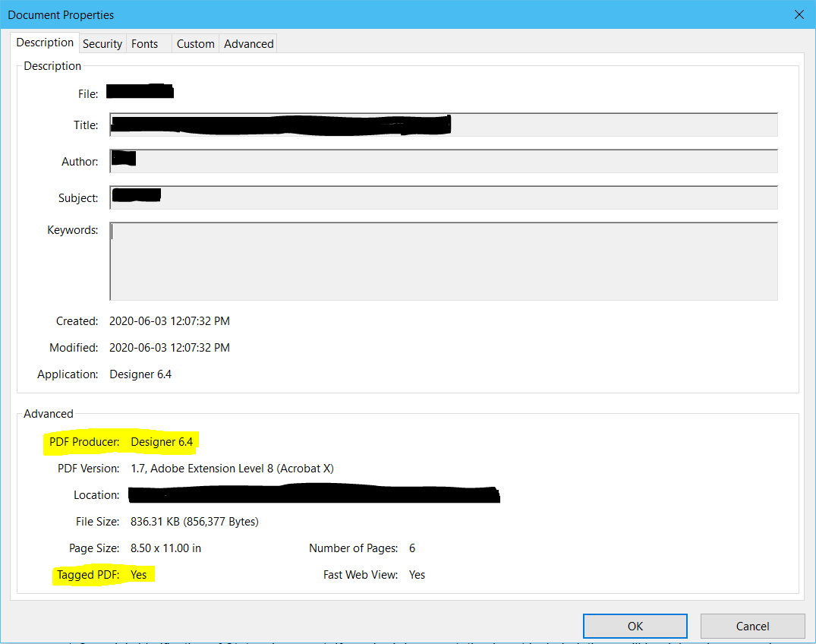In document properties, it identifies whether or not it is a Tagged PDF. If the PDF Producer is Designer and Tagged PDF is No, it may be an XFA form.

### Foxit Accessibility Checker

The Foxit Accessibility Checker is an automated tool to help determine if a PDF is compliant with WCAG 2.1. It is found by opening a PDF in Foxit, navigating to the Accessibility tab, and selecting Full Check. This will bring up a new window asking which categories to be assessed.

Below is an example of the results having selected all categories to be assessed. Displayed is the accessibility checker panel, and the results with three highlighted results as examples:

* Tagged PDF – Passed,
* Logical Reading Order – Needs manual check, and
* Primary language – Failed.

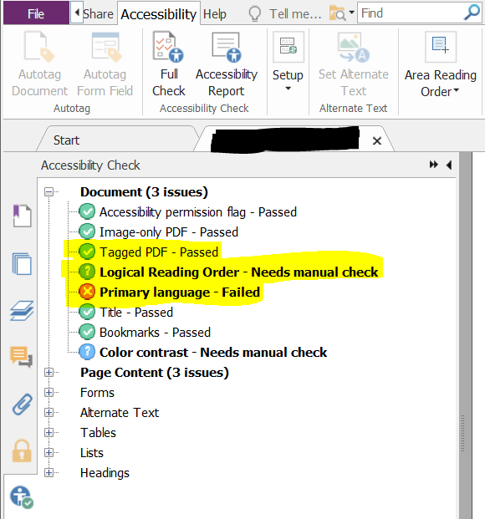

These three examples show the three possible result options of the checker:

* Passed – no errors were found,
* Needs manual check – unable to determine a pass or fail, or
* Failed – at least one error was found.

While the Foxit Accessibility Checker is a helpful tool to identify errors, it is always best to be vigilant for false positives or negatives, and perform a full audit manually in addition to using the checker.

### Foxit Panels

Foxit has many useful panels to perform an audit. These are four most commonly used panels:

* Foxit panels: bookmarks Bookmarks: Add, remove, and manage bookmarks
* Foxit panels: tags Tags: View and edit structured PDF information
* Foxit panels: content Content: View and edit page content information
* Foxit panels: accessibility check Accessibility Check: View the Accessibility Checker results and fix errors

## Web Content Accessibility Guidelines - Techniques

Below is a list of [Web Content Accessibility Guidelines (WCAG) 2.1](http://www.w3.org/WAI/WCAG21/quickref/) accessibility criteria, techniques, and common accessibility failures that apply to PDF documents. The accessibility auditing techniques provided are using Foxit PhantomPDF and focus on tagged PDFs. They are not the only ways to ensure a PDF is WCAG compliant; they are only some methods.

To note:

* A technique can apply to more than one criterion, and
* The lists of auditing techniques and common accessibility failures are not exhaustive.

The links provided for the PDF and general sufficient techniques navigate to the corresponding testing section, provided by WCAG, on how to test for and ensure compliance.

### [2.4.2 - Page Titled](http://www.w3.org/WAI/WCAG21/quickref/#page-titled)

#### Description

Web pages have titles that describe topic or purpose.

* [PDF18:](http://www.w3.org/WAI/WCAG21/Techniques/pdf/PDF18.html#tests) Specifying the document title using the Title entry in the document information dictionary of a PDF document

#### Common accessibility failures

* PDF does not contain a title.
* PDF title is not descriptive.

#### Accessibility auditing technique

1. Select “File” from the top toolbar.
2. Select “Properties” from the second menu.
3. Verify that the title exists and it is descriptive.

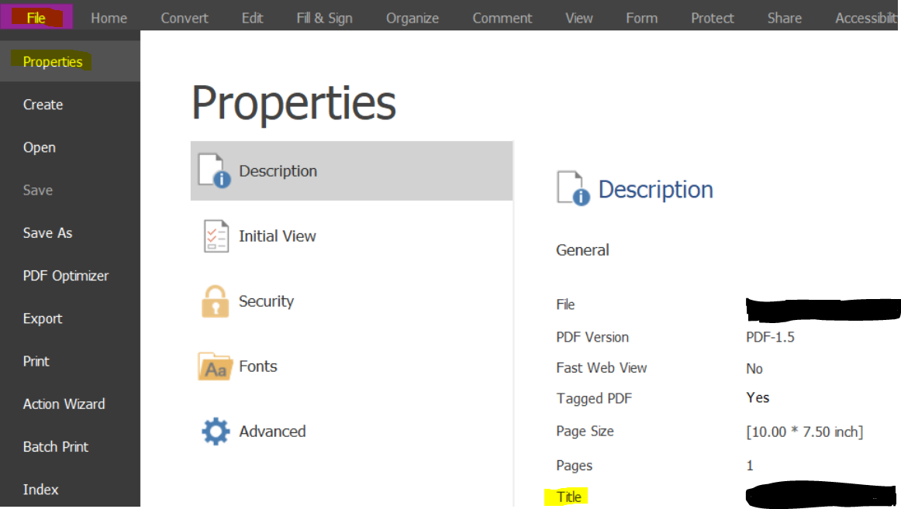

### [3.1.1 - Language of Page](http://www.w3.org/WAI/WCAG21/quickref/#language-of-page)

#### Description

The default human language of each Web page can be programmatically determined.

* [PDF16:](http://www.w3.org/WAI/WCAG21/Techniques/pdf/PDF16#tests) Setting the default language using the /Lang entry in the document catalog of a PDF document
* [PDF19:](http://www.w3.org/WAI/WCAG21/Techniques/pdf/PDF19#tests) Specifying the language for a passage or phrase with the Lang entry in PDF documents

#### Common accessibility failures

* The language of the PDF is unspecified or incorrect.

#### Accessibility auditing technique

Technique one:

1. Select “File” from the top toolbar.
2. Select “Properties” from the second menu.
3. Select “Advanced” from the third menu.
4. Verify that the language exists and that it is accurate.

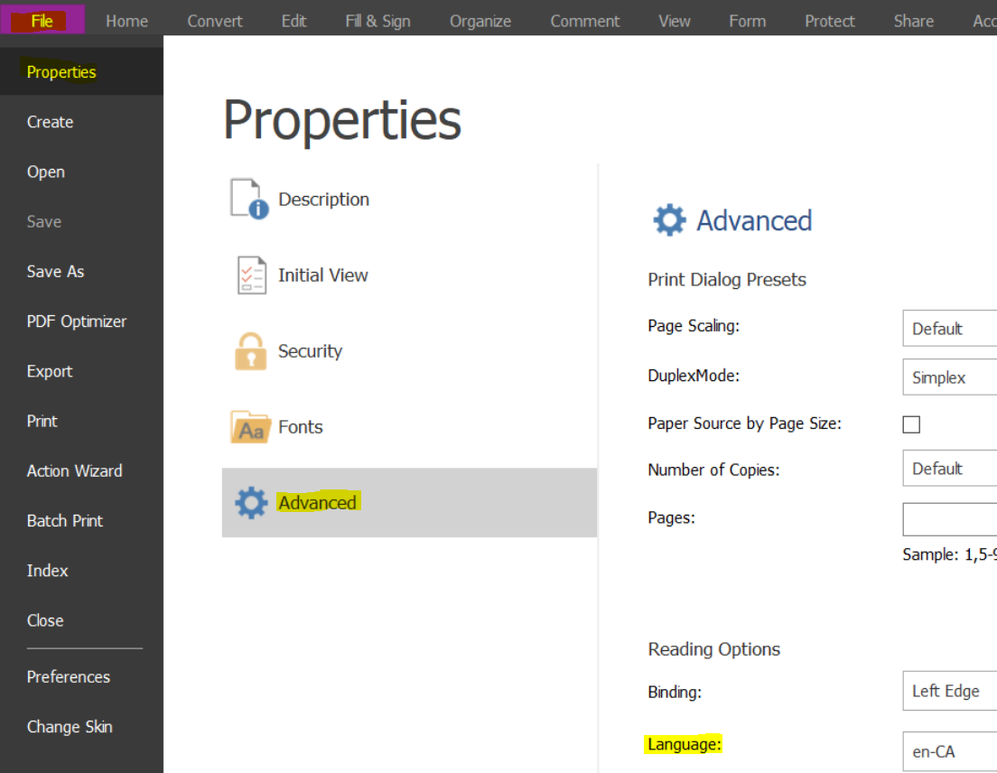

Technique two:

1. Select the “Tags” panel.
2. Right click on the <Document>, <Sect>, or other largest container tag.
3. Select Properties.
4. Verify that the language exists and is accurate for the document, and/or each section.

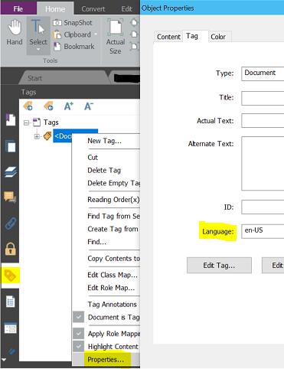

### [3.1.2 - Language of Parts](http://www.w3.org/WAI/WCAG21/quickref/#language-of-parts)

#### Description

The human language of each passage or phrase in the content can be programmatically determined except for proper names, technical terms, words of indeterminate language, and words or phrases that have become part of the vernacular of the immediately surrounding text.

* [PDF19:](http://www.w3.org/WAI/WCAG21/Techniques/pdf/PDF19#tests) Specifying the language for a passage or phrase with the Lang entry in PDF documents

#### Common accessibility failures

* The language of a passage is unspecified or incorrect.

#### Accessibility auditing technique

1. Select the “Tags” panel.
2. Right click on the tag containing text in another language than the document.
3. Select Properties.
4. Verify that the language exists and is accurate for the document, and/or each section.

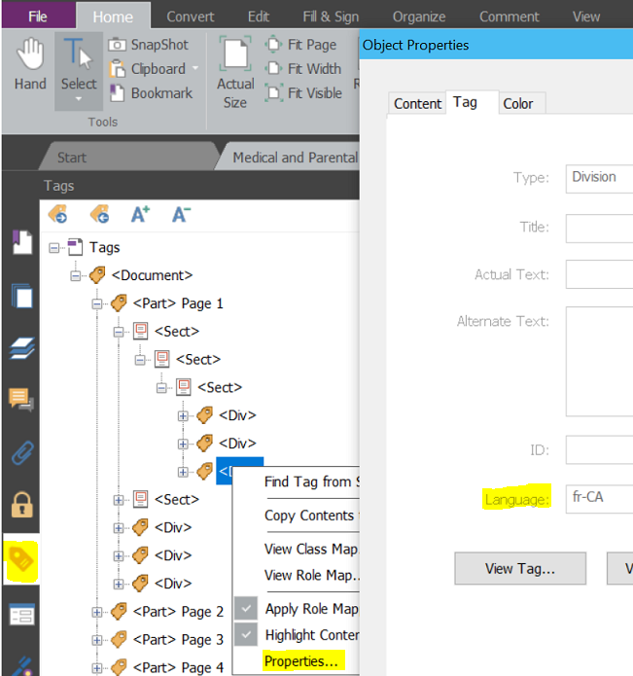

### [2.4.5 - Multiple Ways](http://www.w3.org/WAI/WCAG21/quickref/#multiple-ways)

#### Description

More than one way is available to locate a Web page within a set of Web pages except where the Web Page is the result of, or a step in, a process.

* [PDF2:](http://www.w3.org/WAI/WCAG21/Techniques/pdf/PDF2#tests) Creating bookmarks in PDF documents

#### Common accessibility failures

* The PDF is over 20 pages and does not contain bookmarks.
* The bookmarks do not reflect the content correctly.

#### Accessibility auditing technique

1. Select the “Bookmarks” panel.
2. Verify the existence of bookmarks, required for documents over 20 pages.
3. Verify the bookmarks reflect the content of the document.

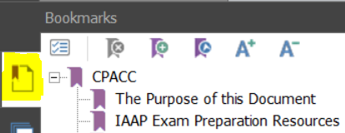

### [3.2.3 - Consistent Navigation](http://www.w3.org/WAI/WCAG21/quickref/#consistent-navigation)

#### Description

Navigational mechanisms that are repeated on multiple Web pages within a set of Web pages occur in the same relative order each time they are repeated, unless a change is initiated by the user.

* [PDF14:](http://www.w3.org/WAI/WCAG21/Techniques/pdf/PDF14#tests) Providing running headers and footers in PDF documents
* [PDF17:](http://www.w3.org/WAI/WCAG21/Techniques/pdf/PDF17#tests) Specifying consistent page numbering for PDF documents
* [G61:](http://www.w3.org/TR/2012/NOTE-WCAG20-TECHS-20120103/G61#G61-tests) Presenting repeated components in the same relative order each time they appear

#### Common accessibility failures

* Running headers and footers are not consistently repeated.
* Page numbering is inconsistent or missing.
* Repeated components are not in the same relative order for each occurrence

#### Accessibility auditing technique

Technique one:

1. Go through the entire document and check if there are headers and footers.
2. If headers and footers are present, verify that they are consistently repeated.
   1. The first page/title page can be different.

Technique two:

1. Go through the entire document and check how many pages there are.
2. If the document is longer than one page, verify that there are consistent page numbers.
   1. E.g. (Page 1 of 3, Page 2 of 3, Page 3 of 3)

Technique three:

1. Go through the entire document and check if there is repeated content.
2. If the document has repeated components, verify they are in the same order each time they are present.
   1. Repeated content is commonly found in headers and footers.

### [1.4.4 - Resize text](http://www.w3.org/WAI/WCAG21/quickref/#resize-text)

#### Description

Except for captions and images of text, text can be resized without assistive technology up to 200 percent without loss of content or functionality.

* [G142:](http://www.w3.org/TR/2012/NOTE-WCAG20-TECHS-20120103/G142#G142-tests) Using a technology that has commonly-available user agents that support zoom

#### Common accessibility failures

* Text cannot be resized to 200% without assistive technology

#### Accessibility auditing technique

1. Select the zoom option and choose the 200% option.
2. Verify that the text can still be read, and there is no loss of functionality.

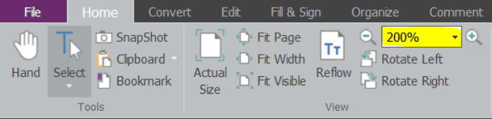

### [1.1.1 - Non-text Content](http://www.w3.org/WAI/WCAG21/quickref/#non-text-content)

#### Description

All non-text content that is presented to the user has a text alternative that serves the equivalent purpose, except for the situations listed: Controls, Input; Time-Based Media; Test; Sensory; CAPTCHA; Decoration, Formatting, Invisible.

* [PDF1:](http://www.w3.org/WAI/WCAG21/Techniques/pdf/PDF1#tests) Applying text alternatives to images with the Alt entry in PDF documents
* [PDF4:](http://www.w3.org/WAI/WCAG21/Techniques/pdf/PDF4#tests) Hiding decorative images with the Artifact tag in PDF documents

#### Common accessibility failures

* Visual either is missing, or has unclear alternative text.
* Visual is not appropriately identified as decorative / an artifact.
* Complex image (i.e. Infographic) does not contain an accurate description.

#### Accessibility auditing technique

Technique one:

1. Go through the entire document and check if there are images.
2. Hover the mouse cursor over the image to verify it has descriptive alternative text.



Technique two:

1. Select the “Tags” panel.
2. Right click on the <Figure> tag.
3. Select Properties.
4. Verify the alternate text correctly describes the image.

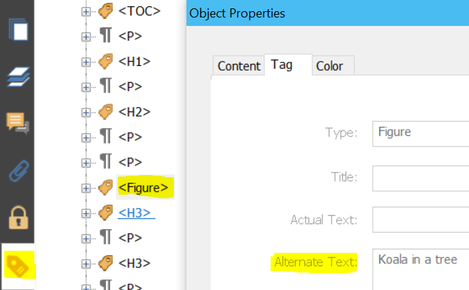

Technique three:

1. If the image is decorative and does not require alternative text, select the “Content” panel.
2. Find the corresponding Container tag for the image.
3. Verify that it is tagged as <Artifact>.

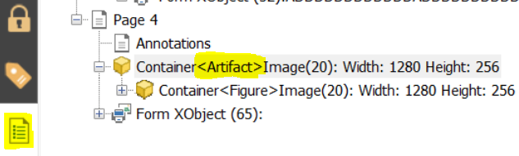

### [1.4.3 - Contrast (Minimum)](http://www.w3.org/WAI/WCAG21/quickref/#contrast-minimum)

#### Description

The visual presentation of text and images of text has a contrast ratio of at least 4.5:1, except for the following: Large Text; Incidental; Logotypes.

* [G18:](http://www.w3.org/WAI/WCAG21/Techniques/general/G18.html#tests) Ensuring that a contrast ratio of at least 4.5:1 exists between text (and images of text)and background behind the text

#### Common accessibility failures

* Text / images of text do not have a contrast ratio of at least 4.5:1.
* Large scale text, text above 18 points, or 14 points and bolded, do not have a contrast ratio of at least 3:1.

#### Accessibility auditing technique

1. Open the Colour Contrast Analyser.
2. Select the Foreground dropper icon.
3. Using the dropper, select the foreground/text to test.
4. Select the Background dropper icon.
5. Using the dropper, select the background of the text to test.
6. Verify that the text meets the appropriate colour contrast standards.

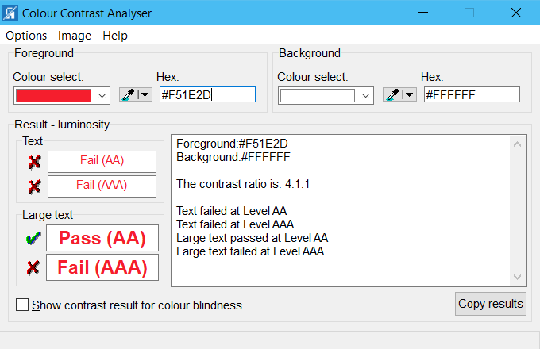

### [1.4.1 - Use of Color](http://www.w3.org/WAI/WCAG21/quickref/#use-of-color)

#### Description

Color is not used as the only visual means of conveying information, indicating an action, prompting a response, or distinguishing a visual element.

* [G14:](http://www.w3.org/WAI/WCAG21/Techniques/general/G14.html#tests) Ensuring that information conveyed by color differences is also available in text
* [G182:](http://www.w3.org/WAI/WCAG21/Techniques/general/G182.html#tests) Ensuring that additional visual cues are available when text color differences are used to convey information

#### Common accessibility failures

* Colour is the only means to distinguish / convey information.

#### Accessibility auditing technique

1. Read through document and determine if there are areas where colour is used to convey information.
2. Verify that the information is also provided through text.
   1. Good example: All required fields are identified by “Required”.
   2. Bad example: All required fields are in red.

### [1.3.3 - Sensory Characteristics](http://www.w3.org/WAI/WCAG21/quickref/#sensory-characteristics)

#### Description

Instructions provided for understanding and operating content do not rely solely on sensory characteristics of components such as shape, color, size, visual location, orientation, or sound.

* [G96:](http://www.w3.org/WAI/WCAG21/Techniques/general/G96.html#tests) Providing textual identification of items that otherwise rely only on sensory information to be understood

#### Common accessibility failures

* Shape, colour, size, location, orientation, or sound is the only means to distinguish / convey information.

#### Accessibility auditing technique

1. Go through the document and determine if there are areas where information relies on sensory characteristics.
2. Verify that the information is also provided through text.
   1. Good example: All activities handled by Team A are identified with a blue circle, and include “Team A”, while all activities handled by Team B are identified with a red square, and include “Team B”. (Team A and Team B)
   2. Bad example: All activities handled by Team A are identified with a blue circle, while all activities handled by Team B are identified with a red square. (,)

### [1.3.1 - Info and Relationships](http://www.w3.org/WAI/WCAG21/quickref/#info-and-relationships)

#### Description

Information, structure, and relationships conveyed through presentation can be programmatically determined or are available in text.

* [PDF6:](http://www.w3.org/WAI/WCAG21/Techniques/pdf/PDF6#tests) Using table elements for table markup in PDF Documents
* [PDF9:](http://www.w3.org/WAI/WCAG21/Techniques/pdf/PDF9#tests) Providing headings by marking content with heading tags in PDF documents
* [PDF10:](http://www.w3.org/WAI/WCAG21/Techniques/pdf/PDF10#tests) Providing labels for interactive form controls in PDF documents
* [PDF11:](http://www.w3.org/WAI/WCAG21/Techniques/pdf/PDF11#tests) Providing links and link text using the /Link structure element in PDF documents
* [PDF12:](http://www.w3.org/WAI/WCAG21/Techniques/pdf/PDF12#tests) Providing name, role, value information for form fields in PDF documents
* [PDF17:](http://www.w3.org/WAI/WCAG21/Techniques/pdf/PDF17#tests) Specifying consistent page numbering for PDF documents
* [PDF20:](http://www.w3.org/WAI/WCAG21/Techniques/pdf/PDF20#tests) Using Adobe Acrobat Pro's Table Editor to repair mistagged tables
* [PDF21:](http://www.w3.org/WAI/WCAG21/Techniques/pdf/PDF21#tests) Using List tags for lists in PDF documents

#### Common accessibility failures

* Headings do not have the correct tags.
* Headings levels are not in the correct order. (ie. H1, H2, H3, etc.)
* Tables do not have the correct tags. (ie. TR, TH, TD)
* Lists do not have the correct tags.
* Nested list items are not tagged correctly.
* Links do not have the correct tags.

#### Accessibility auditing technique

1. Select the “Tags” panel.
2. Open each container tag fully.
3. Verify that the document content correctly aligns with the tag.
   1. Headings are tagged as H1, H2, H3, etc. and appear in the correct order without skipping a level.

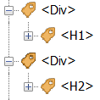

* 1. Tables are not used for formatting purposes, but are truly a table and have the correct tags: Table <Table> contains - Table Row <TR> contains - Table Header <TH> for the header row/column, and Table Data cells <TD> for the data.

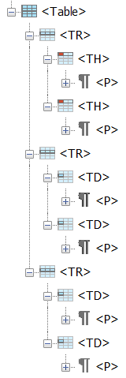

* 1. Lists have the correct tags: List <L> contains – List Item <LI>, which can contain – Labels <Lbl> (bullets) and/or List item Body <LBody> the contents of the list or in the case of a nested list, may contain another <L> tag.

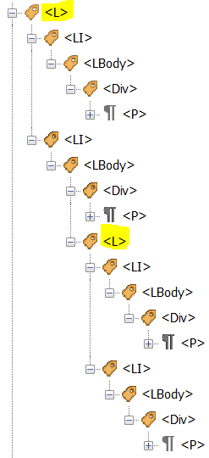

* 1. Links have the correct <Link> tag that contains the “Link – OBJR” and the appropriate text item within it.

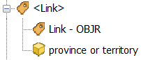

### [2.4.4 - Link Purpose (In Context)](http://www.w3.org/WAI/WCAG21/quickref/#link-purpose-in-context)

#### Description

The purpose of each link can be determined from the link text alone or from the link text together with its programmatically determined link context, except where the purpose of the link would be ambiguous to users in general.

* [PDF11:](http://www.w3.org/WAI/WCAG21/Techniques/pdf/PDF11#tests) Providing links and link text using the /Link structure element in PDF documents
* [PDF13:](http://www.w3.org/WAI/WCAG21/Techniques/pdf/PDF13#tests) Providing replacement text using the /Alt entry for links in PDF documents

#### Common accessibility failures

* Complete URL links are missing clear alternative text.
* Link text is unclear, purpose of link is ambiguous.

#### Accessibility auditing technique

1. Use the tab button to read through the document and identify links.
2. Verify that links are clearly identified (i.e. Blue underlined text)
3. Verify that the purpose of the link can be clearly determined by the document context, or by its link text.

### [2.4.6 - Headings and Labels](http://www.w3.org/WAI/WCAG21/quickref/#headings-and-labels)

#### Description

Headings and labels describe topic or purpose.

* [G130:](http://www.w3.org/WAI/WCAG20/quickref/#qr-navigation-mechanisms-descriptive) Providing descriptive headings
* [G131:](http://www.w3.org/WAI/WCAG21/Techniques/general/G131.html#tests) Providing descriptive labels

#### Common accessibility failures

* Heading content does not match section.
* Heading is missing.
* Label does not match section.
* Label is missing.
* Radio button label does not contain the initial prompt in the first label.

#### Accessibility auditing technique

Technique one:

1. Select the “Tags” panel.
2. Open each container tag fully.
3. Verify that the heading tags content correctly corresponds with the document.
4. Verify that visual headings are also tagged as headings correctly.

Technique two:

1. Select the Hand icon at the top of the Home toolbar.
2. Hover the mouse cursor over each form field.
3. Verify the label matches the text in the body of the document.
   1. There should not be any additional information in the body of the document or in the label, should be the same information.
4. Verify there are labels for each form field.

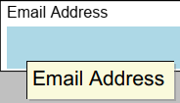

Technique three:

1. Open JAWS or NVDA to start reading aloud.
2. Go through the document with a screen reader and ensure the form field labels are being read aloud correctly, and they match the body of the document.

### [3.3.2 - Labels or Instructions](http://www.w3.org/WAI/WCAG21/quickref/#labels-or-instructions)

#### Description

Labels or instructions are provided when content requires user input.

* [PDF5:](http://www.w3.org/WAI/WCAG21/Techniques/pdf/PDF5#tests) Indicating required form controls in PDF forms
* [PDF10:](http://www.w3.org/WAI/WCAG21/Techniques/pdf/PDF10#tests) Providing labels for interactive form controls in PDF documents
* [G89:](https://www.w3.org/WAI/WCAG21/Techniques/general/G89#tests) Providing expected data format and example

#### Common accessibility failures

* Required fields are not clearly identified.
* A specific format is required: instructions and an example are missing/incorrect.

#### Accessibility auditing technique

Technique one:

1. Read through the document and identify if there are required fields.
2. Verify that these fields are clearly identified as required.

Technique two:

1. Enter responses into all form fields.
2. Verify that if a specific format is required by the user, that there are clear instructions/examples.
   1. Example: Date (DD/MM/YYYY)

### [4.1.2 - Name, Role, Value](http://www.w3.org/WAI/WCAG21/quickref/#name-role-value)

#### Description

For all user interface components (including but not limited to: form elements, links and components generated by scripts), the name and role can be programmatically determined; states, properties, and values that can be set by the user can be programmatically set; and notification of changes to these items is available to user agents, including assistive technologies.

* [PDF10:](http://www.w3.org/WAI/WCAG21/Techniques/pdf/PDF10#tests) Providing labels for interactive form controls in PDF documents
* [PDF12:](http://www.w3.org/WAI/WCAG21/Techniques/pdf/PDF12#tests) Providing name, role, value information for form fields in PDF documents

#### Common accessibility failures

* Radio buttons / checkboxes are not identified as being selected.
* Radio buttons / checkboxes / dropdown values are unable to be selected.

#### Accessibility auditing technique

1. Open JAWS or NVDA to start reading aloud.
2. Go through the document and identify all interactive form fields: radio buttons, checkboxes, dropdowns, etc.
3. Verify that the state (i.e. checked/unchecked) is identified correctly with a screen reader.
4. Verify that the interactive form fields can change states correctly.

### [3.2.4 - Consistent Identification](http://www.w3.org/WAI/WCAG21/quickref/#consistent-identification)

#### Description

Components that have the same functionality within a set of Web pages are identified consistently.

* [G197:](http://www.w3.org/WAI/WCAG21/Techniques/general/G197.html#tests) Using labels, names, and text alternatives consistently for content that has the same functionality

#### Common accessibility failures

* Radio buttons/Checkboxes have inconsistent styles once selected.

#### Accessibility auditing technique

1. Go through the document and identify all interactive form fields: radio buttons, checkboxes, dropdowns, etc.
2. Verify that once selected, each type has a consistent style.
   1. Example: all radio buttons are shown as selected with a black circle, and all checkboxes are shown as selected with a black “X”.

### [1.3.2 - Meaningful Sequence](http://www.w3.org/WAI/WCAG21/quickref/#meaningful-sequence)

#### Description

When the sequence in which content is presented affects its meaning, a correct reading sequence can be programmatically determined.

* [PDF3:](http://www.w3.org/WAI/WCAG21/Techniques/pdf/PDF3#tests) Ensuring correct tab and reading order in PDF documents

#### Common accessibility failures

* The reading order with a screen reader does not match the reading order of a sighted person.
* Not all content is being read aloud with a screen reader.

#### Accessibility auditing technique

1. Open JAWS or NVDA to start reading aloud.
2. Go through the entire document.
3. Verify that all content is being read aloud with the screen reader.
4. Verify that the content is in the correct, logical reading order, left to right, top to bottom, etc.

### [2.4.3 - Focus Order](http://www.w3.org/WAI/WCAG21/quickref/#focus-order)

#### Description

If a Web page can be navigated sequentially and the navigation sequences affect meaning or operation, focusable components receive focus in an order that preserves meaning and operability.

* [PDF3:](http://www.w3.org/WAI/WCAG21/Techniques/pdf/PDF3#tests) Ensuring correct tab and reading order in PDF documents

#### Common accessibility failures

* Tabbing order of fields/links do not receive focus in order.

#### Accessibility auditing technique

1. Use the tab key to navigate the entire document.
2. Verify that all interactive items, links and form fields, receive focus.
3. Verify that the focus is in the correct, logical order.

### [2.4.7 - Focus Visible](http://www.w3.org/WAI/WCAG21/quickref/#focus-visible)

#### Description

Any keyboard operable user interface has a mode of operation where the keyboard focus indicator is visible.

* [G149:](http://www.w3.org/TR/2012/NOTE-WCAG20-TECHS-20120103/G149#G149-tests) Using user interface components that are highlighted by the user agent when they receive focus
* [G165:](http://www.w3.org/TR/2012/NOTE-WCAG20-TECHS-20120103/G165#G165-tests) Using the default focus indicator for the platform so that high visibility default focus indicators will carry over
* [G195:](http://www.w3.org/TR/2012/NOTE-WCAG20-TECHS-20120103/G195#G195-tests) Using an author-supplied, highly visible focus indicator

#### Common accessibility failures

* A field/link does not have a visible focus indicator.

#### Accessibility auditing technique

1. Use the tab key to navigate the entire document.
2. Verify that all interactive items, links and form fields, receive focus.
3. Verify that the focus is visible.

### [3.2.1 - On Focus](http://www.w3.org/WAI/WCAG21/quickref/#on-focus)

#### Description

When any user interface component receives focus, it does not initiate a change of context.

* [G107:](http://www.w3.org/WAI/WCAG21/Techniques/general/G107.html#tests) Using "activate" rather than "focus" as a trigger for changes of context

#### Common accessibility failures

* Upon receiving focus, component changes context of the document.

#### Accessibility auditing technique

1. Use the tab key to navigate the entire document.
2. Verify that all interactive items, links and form fields, receive focus.
3. Verify that the focus does not trigger any changes automatically.

### [3.3.1 - Error Identification](http://www.w3.org/WAI/WCAG21/quickref/#error-identification)

#### Description

If an input error is automatically detected, the item that is in error is identified and the error is described to the user in text.

* [PDF5:](http://www.w3.org/WAI/WCAG21/Techniques/pdf/PDF5#tests) Indicating required form controls in PDF forms
* [PDF22:](http://www.w3.org/WAI/WCAG21/Techniques/pdf/PDF22#tests) Indicating when user input falls outside the required format or values in PDF forms

#### Common accessibility failures

* A specific format is required, but there is no error message provided.
* Input errors are not clearly identified and/or described.

#### Accessibility auditing technique

1. Use the tab key to navigate the entire document.
2. Verify that all interactive form fields either:
   1. Have no required format and no error message
   2. Have a required format and an appropriate error message

### [3.3.3 - Error Suggestion](http://www.w3.org/WAI/WCAG21/quickref/#error-suggestion)

#### Description

If an input error is automatically detected and suggestions for correction are known, then the suggestions are provided to the user, unless it would jeopardize the security or purpose of the content.

* [PDF5:](http://www.w3.org/WAI/WCAG21/Techniques/pdf/PDF5#tests) Indicating required form controls in PDF forms
* [PDF22:](http://www.w3.org/WAI/WCAG21/Techniques/pdf/PDF22#tests) Indicating when user input falls outside the required format or values in PDF forms

#### Common accessibility failures

* Example of the required format is not provided for the input error.

#### Accessibility auditing technique

1. Use the tab key to navigate the entire document.
2. Verify that all interactive form fields with an error message also include a suggestion of the required format.

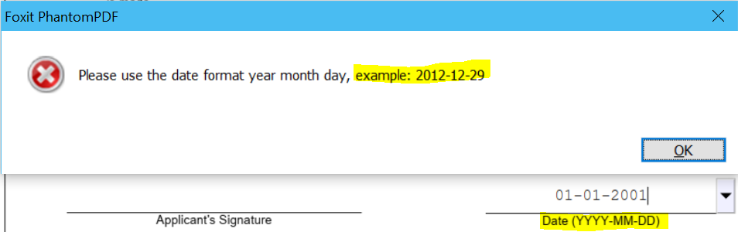

### [2.4.1 - Bypass Blocks](http://www.w3.org/WAI/WCAG21/quickref/#bypass-blocks)

#### Description

A mechanism is available to bypass blocks of content that are repeated on multiple Web pages.

* [PDF9:](http://www.w3.org/WAI/WCAG21/Techniques/pdf/PDF9#tests) Providing headings by marking content with heading tags in PDF documents

#### Common accessibility failures

* Document contains no headings.

#### Accessibility auditing technique

Technique one:

1. Verify the document has headings for easy navigation, and ability to bypass blocks.

Technique two:

1. Verify that the entire document is able to be accessed without being blocked.

### [2.1.1 - Keyboard](http://www.w3.org/WAI/WCAG21/quickref/#keyboard)

#### Description

All functionality of the content is operable through a keyboard interface without requiring specific timings for individual keystrokes, except where the underlying function requires input that depends on the path of the user's movement and not just the endpoints.

* [PDF3:](http://www.w3.org/WAI/WCAG21/Techniques/pdf/PDF3#tests) Ensuring correct tab and reading order in PDF documents
* [PDF11:](http://www.w3.org/WAI/WCAG21/Techniques/pdf/PDF11#tests) Providing links and link text using the /Link structure element in PDF documents
* [PDF23:](http://www.w3.org/WAI/WCAG21/Techniques/pdf/PDF23#tests) Providing interactive form controls in PDF documents

#### Common accessibility failures

* Links cannot be tabbed to or selected using a keyboard interface.
* Fields cannot be tabbed to or used using a keyboard interface.

#### Accessibility auditing technique

1. Use the tab key to navigate the entire document.
2. Verify that all interactive items, links and form fields, receive focus.

### [2.1.2 - No Keyboard Trap](http://www.w3.org/WAI/WCAG21/quickref/#no-keyboard-trap)

#### Description

If keyboard focus can be moved to a component of the page using a keyboard interface, then focus can be moved away from that component using only a keyboard interface, and, if it requires more than unmodified arrow or tab keys or other standard exit methods, the user is advised of the method for moving focus away.

* [G21:](http://www.w3.org/TR/2012/NOTE-WCAG20-TECHS-20120103/G21#G21-tests) Ensuring that users are not trapped in content

#### Common accessibility failures

* Focus cannot be moved away using a keyboard interface.

#### Accessibility auditing technique

1. Use the tab key to navigate the entire document.
2. Verify that all interactive items, links and form fields, can have focus moved away using the keyboard.

### [2.2.1 - Timing Adjustable](http://www.w3.org/WAI/WCAG21/quickref/#timing-adjustable)

#### Description

For each time limit that is set by the content, at least one of the following is true: Turn off, Adjust, Extend, Real-time Exception, Essential Exception, or 20 Hour Exception.

* [G133:](http://www.w3.org/TR/WCAG20-TECHS/G133.html#G133-tests) Providing a checkbox on the first page of a multipart form that allows users to ask for longer session time limit or no session time limit

#### Common accessibility failures

* No time limit extensions or exceptions available for timed content.

#### Accessibility auditing technique

1. Go through the entire document and check if there are time limits.
2. Verify that time extensions or exceptions exist.

### [3.2.2 - On Input](http://www.w3.org/WAI/WCAG21/quickref/#on-input)

#### Description

Changing the setting of any user interface component does not automatically cause a change of context unless the user has been advised of the behavior before using the component.

* [PDF15:](http://www.w3.org/TR/WCAG20-TECHS/PDF15.html#PDF15-tests) Providing submit buttons with the submit-form action in PDF forms

#### Common accessibility failures

* Form contains a submit button that is not plainly identified, or explained.
* Form contains a submit button that does not function properly.

#### Accessibility auditing technique

1. Go through the entire document and check if there is a submit button.
2. Verify the submit button is plainly identified and functions properly.

### [3.3.4 - Error Prevention (Legal, Financial, Data)](http://www.w3.org/WAI/WCAG21/quickref/#error-prevention-legal-financial-data)

#### Description

For Web pages that cause legal commitments or financial transactions for the user to occur, that modify or delete user-controllable data in data storage systems, or that submit user test responses, at least one of the following is true: Reversible; Checked; Confirmed.

* [G98:](http://www.w3.org/WAI/WCAG21/Techniques/general/G98.html#tests) Providing the ability for the user to review and correct answers before submitting
* [G155:](http://www.w3.org/WAI/WCAG21/Techniques/general/G155.html#tests) Providing a checkbox in addition to a submit button
* [G168:](http://www.w3.org/WAI/WCAG21/Techniques/general/G168.html#tests) Requesting confirmation to continue with selected action

#### Common accessibility failures

* Legal or financial transactions do not have a review or confirmation before submission.

#### Accessibility auditing technique

1. Go through the entire document and check if there are legal or financial transactions.
2. Verify they have a confirmation before submission.

### [1.4.5 - Images of Text](http://www.w3.org/WAI/WCAG21/quickref/#images-of-text)

#### Description

If the technologies being used can achieve the visual presentation, text is used to convey information rather than images of text except for the following: Customizable; Essential.

* [PDF7:](http://www.w3.org/WAI/WCAG21/Techniques/pdf/PDF7#tests) Performing OCR on a scanned PDF document to provide actual text

#### Common accessibility failures

* Images of text or scanned text is used in lieu of actual text.

#### Accessibility auditing technique

1. If the PDF is scanned, ensure Optical Character Recognition is performed to provide tags.

### [2.2.2 - Pause, Stop, Hide](http://www.w3.org/WAI/WCAG21/quickref/#pause-stop-hide)

#### Description

For moving, blinking, scrolling, or auto-updating information, all of the following are true: Moving, blinking, scrolling or Auto-updating.

* [G4:](http://www.w3.org/WAI/WCAG21/Techniques/general/G4.html#tests) Allowing the content to be paused and restarted from where it was paused
* [G11:](http://www.w3.org/WAI/WCAG21/Techniques/general/G11.html#tests) Creating content that blinks for less than 5 seconds
* [G186:](http://www.w3.org/WAI/WCAG21/Techniques/general/G186.html#tests) Using a control in the Web page that stops moving, blinking, or auto-updating content

#### Common accessibility failures

* Unable to pause, stop, or hide moving / auto-updating content.

#### Accessibility auditing technique

1. Go through the entire document and check if there is auto-updating or moving content.
2. Verify it is able to be paused, stopped or hidden.

### [2.3.1 - Three Flashes or Below Threshold](http://www.w3.org/WAI/WCAG21/quickref/#three-flashes-or-below-threshold)

#### Description

Web pages do not contain anything that flashes more than three times in any one second period, or the flash is below the general flash and red flash thresholds.

* [G15:](http://www.w3.org/WAI/WCAG21/Techniques/general/G15.html#tests) Using a tool to ensure that content does not violate the general flash threshold or red flash threshold
* [G19:](http://www.w3.org/WAI/WCAG21/Techniques/general/G19.html#tests) Ensuring that no component of the content flashes more than three times in any 1-second period

#### Common accessibility failures

* Content flashes more than three times in a one-second period.
* Flashes are above the general flash or red flash thresholds.

#### Accessibility auditing technique

1. Go through the entire document and check if there is flashing content.
2. Verify it is fewer than three times in 1 second, and it is below flash thresholds.

### [1.2.1 - Audio-only and Video-only (Prerecorded)](http://www.w3.org/WAI/WCAG21/quickref/#audio-only-and-video-only-prerecorded)

#### Description

For prerecorded audio-only and prerecorded video-only media, the following are true, except when the audio or video is a media alternative for text and is clearly labeled as such: Prerecorded Audio-only or Prerecorded Video-only.

* [G158:](http://www.w3.org/WAI/WCAG21/Techniques/general/G158.html#tests) Providing an alternative for time-based media for audio-only content
* [G159:](http://www.w3.org/WAI/WCAG21/Techniques/general/G159.html#tests) Providing an alternative for time-based media for video-only content
* [G166:](http://www.w3.org/WAI/WCAG21/Techniques/general/G166.html#tests) Providing audio that describes the important video content and describing it as such

#### Common accessibility failures

* Pre-recorded audio-only content does not have alternative text.
* Pre-recorded video-only content does not have alternative text.

#### Accessibility auditing technique

1. Go through the entire document and check if there is pre-recorded content.
2. Verify pre-recorded content has alternative text.

### [1.2.2 - Captions (Prerecorded)](http://www.w3.org/WAI/WCAG21/quickref/#captions-prerecorded)

#### Description

Captions are provided for all prerecorded audio content in synchronized media, except when the media is a media alternative for text and is clearly labeled as such.

* [G87:](http://www.w3.org/WAI/WCAG21/Techniques/general/G87.html#tests) Providing closed captions
* [G93:](http://www.w3.org/WAI/WCAG21/Techniques/general/G93.html#tests) Providing open (always visible) captions

#### Common accessibility failures

* Pre-recorded audio content does not have captions / closed captions.

#### Accessibility auditing technique

1. Go through the entire document and check if there is pre-recorded audio content.
2. Verify pre-recorded audio content has captions.

### [1.2.3 - Audio Description or Media Alternative (Prerecorded)](http://www.w3.org/WAI/WCAG21/quickref/#audio-description-or-media-alternative-prerecorded)

#### Description

An alternative for time-based media or audio description of the prerecorded video content is provided for synchronized media, except when the media is a media alternative for text and is clearly labeled as such.

* [G69:](http://www.w3.org/WAI/WCAG21/Techniques/general/G69.html#tests) Providing an alternative for time based media
* [G78:](http://www.w3.org/WAI/WCAG21/Techniques/general/G78.html#tests) Providing a second, user-selectable, audio track that includes audio descriptions

#### Common accessibility failures

* No alternative for pre-recorded time-based media is available.

#### Accessibility auditing technique

1. Go through the entire document and check if there is time-based media content.
2. Verify media content has an audio description, or other alternative.

### [1.2.4 - Captions (Live)](http://www.w3.org/WAI/WCAG21/quickref/#captions-live)

#### Description

Captions are provided for all live audio content in synchronized media.

* [G9:](http://www.w3.org/WAI/WCAG21/Techniques/general/G9.html#tests) Creating captions for live synchronized media
* [G87:](http://www.w3.org/WAI/WCAG21/Techniques/general/G87.html#tests) Providing closed captions
* [G93:](http://www.w3.org/WAI/WCAG21/Techniques/general/G93.html#tests) Providing open (always visible) captions

#### Common accessibility failures

* Live media content does not have captions / closed captions.

#### Accessibility auditing technique

1. Go through the entire document and check if there is live audio content.
2. Verify pre-recorded audio content has captions.

### [1.2.5 - Audio Description (Prerecorded)](http://www.w3.org/WAI/WCAG21/quickref/#audio-description-prerecorded)

#### Description

Audio description is provided for all prerecorded video content in synchronized media.

* [G78:](http://www.w3.org/WAI/WCAG21/Techniques/general/G78.html#tests) Providing a second, user-selectable, audio track that includes audio descriptions

#### Common accessibility failures

* Pre-recorded media does not have an audio description.

#### Accessibility auditing technique

1. Go through the entire document and check if there is pre-recorded video content.
2. Verify media content has an audio description.

### [1.4.2 - Audio Control](http://www.w3.org/WAI/WCAG21/quickref/#audio-control)

#### Description

If any audio on a Web page plays automatically for more than 3 seconds, either a mechanism is available to pause or stop the audio, or a mechanism is available to control audio volume independently from the overall system volume level.

* [G60:](http://www.w3.org/WAI/WCAG21/Techniques/general/G60.html#tests) Playing a sound that turns off automatically within three seconds
* [G170:](http://www.w3.org/WAI/WCAG21/Techniques/general/G170.html#tests) Providing a control near the beginning of the Web page that turns off sounds that play automatically

#### Common accessibility failures

* Automatic audio plays for more than 3 seconds.

#### Accessibility auditing technique­­

1. Go through the entire document and check if there is automatic audio content longer than 3 seconds.
2. Verify the audio is able to be paused, stopped, or controlled.