Chapter 1
The Problem and Its Background
This chapter serves as the foundation upon which the entire study is built. It introduces the readers to the situation that led to the development of the project and explains why the study was conducted in the first place. This section establishes the context by describing the current situation, identifying the gaps or challenges in existing systems, and presenting the real-world issues that the project seeks to address.
Introduction
Drug stores play an important role in supporting the healthcare needs of the community by providing medicines, health products, and other essential pharmacy items to customers. As the demand for these products continues to increase, the number of sales transactions and inventory records also grows. Because of this, monitoring stock levels and processing sales efficiently becomes more difficult, especially for drug stores that still rely on manual or partially computerized methods.
Many small to medium drug stores still use handwritten records, paper receipts, or simple spreadsheet files to manage inventory and sales. Although these methods may be sufficient for small-scale operations, they are often time-consuming, prone to human error, and difficult to update in real time. As business operations expand, these limitations may lead to inaccurate stock records, delays in sales transactions, and unreliable reports, which can affect decision-making and customer service.

At MMB Drug Store, inventory monitoring and sales recording are still handled through manual or less organized processes. Transactions may be recorded manually, while stock checking may depend on lists or spreadsheet-based monitoring. This setup makes it difficult to immediately determine product availability, track stock
movement accurately and prepare timely and reliable reports. As the number of products and daily transactions increases, the current process becomes more inefficient and challenging to manage.
With the continuous advancement of information technology, web-based systems have become useful tools for improving business operations through automation. A web-based inventory and point-of-sale system can help speed up transaction processing, improve the accuracy of records, and provide better monitoring of stock levels. It can also generate reports that may assist management in restocking decisions, sales monitoring, and overall operational planning while reducing errors caused by manual recording.
For these reasons, this study aims to develop a Web-Based Inventory and Point-of-Sale System for MMB Drug Store. The proposed system is intended to automate daily inventory and sales operations, improve the accuracy of stock monitoring, and enhance overall operational efficiency. It is also expected to support faster customer service, better inventory control, and more reliable reports that may help the store in planning and decision-making.

Review of Related Literature
Bekele et al. (2025) investigated the inventory management performance of essential medicines in public health facilities and found that inventory practices have a strong effect on medicine availability, storage conditions, and the accuracy of stock records. Their findings showed that weak stock monitoring and poor record updating may lead to frequent stock-outs, emergency purchases, and inconsistencies in inventory records, which can negatively affect service quality.

Malasari and Sudrajat (2024) designed an expired medication detection information system that uses the First Expired, First Out (FEFO) method in a pharmacy in Bandung. Their study pointed out that pharmacies often have difficulty identifying expired medicines due to limited staff, human error, overstocking, and slow stock movement. The system they proposed was able to monitor medicines approaching expiration and prioritize products with earlier expiry dates. This indicates that a computerized system for expiry monitoring can improve inventory handling and help reduce losses.

Jaju et al. (2023) examined the inventory control practices of a pharmacy store and highlighted several common problems, including manual stock handling, poor demand forecasting, limited real-time visibility, and challenges in managing expiry-sensitive items. Their study recommended improved inventory categorization and the use of barcode technology to minimize manual mistakes and increase the accuracy of stock management. These findings support the use of barcode-supported product tracking in the proposed system, as barcode technology can make medicine identification faster, reduce encoding errors, and improve inventory control within pharmacy

operations.
Sinha and Singh (2025) highlighted that effective pharmaceutical inventory management is essential for uninterrupted service, while poor stock control may result in shortages and financial inefficiencies. Their study stressed the importance of structured monitoring and optimization in handling pharmaceutical products. This is relevant to a web-based inventory system because digital tools can improve the tracking, recording, and analysis of stock movement needed for better inventory control.

Girish et al. (2025) discussed how barcode technology in healthcare systems improves medication safety, accuracy, efficiency, and inventory management by minimizing errors and allowing faster identification and tracking of products. The review also noted that barcode systems improve operational workflows in pharmacy settings. These findings support the proposed system, as barcode technology can improve product identification, minimize manual errors, and enhance the efficiency of inventory and sales operations.

The reviewed literature provides support for the development of a web-based inventory and point-of-sale system for MMB Drug Store. The studies emphasize that effective pharmacy inventory management, proper stock monitoring, organized record updating, and systematic control of medicines are essential in maintaining product availability, reducing stock shortages, preventing losses due to expired medicines, and improving operational efficiency. The literature also highlights the importance of computerized expiry monitoring, the First Expired, First Out (FEFO) method, and barcode technology in improving product identification, minimizing manual errors, and increasing the accuracy and reliability of inventory processes. Overall, the reviewed

literature suggests that integrating inventory control, computerized monitoring, expiry-date management, and barcode-supported tracking into one system can improve efficiency, accuracy, and record management in a drug store.
Review of Related Systems
The McKesson Pharmacy Management System is designed for large-scale pharmacies and healthcare institutions. It offers features such as real-time inventory tracking, prescription processing, and integrated point-of-sale (POS) functionality. The system is highly reliable and widely used in the healthcare industry, making it effective for managing large volumes of transactions. However, it is often expensive and complex to implement, which may not be suitable for small drug stores with limited resources. This system demonstrates how automation can improve efficiency, but it may require simplification to match the needs of smaller businesses.

The MocDoc Pharmacy Management System is a cloud-based solution that supports billing, inventory management, and report generation. It allows users to access data in real time and provides centralized system control. Its strength lies in its accessibility and ease of generating reports, which improves decision-making. However, the system depends heavily on internet connectivity and requires subscription costs, which may limit its usability in some settings. This system is relevant as it highlights the importance of real-time data access and automation in pharmacy operations.

The Wasp Barcode Technologies Inventory Control System focuses on barcode-based inventory management. It enables fast and accurate tracking of products through barcode scanning, reducing manual errors and improving efficiency in stock monitoring. One of its major strengths is its accuracy and speed in handling inventory data. However, it requires additional hardware such as barcode scanners, which may increase implementation costs. This system supports the use of barcode technology in the proposed study to enhance inventory accuracy and efficiency.

The Windward Software Retail Inventory and POS System integrate inventory management with sales processing and reporting features. It allows businesses to track sales, manage stock levels, and generate detailed reports for analysis. The system is comprehensive and supports multi-user access, making it suitable for larger retail operations. However, its complexity may require user training, and it may not be ideal for small businesses seeking a simpler system. This system is relevant as it demonstrates the integration of inventory and POS functions in a single platform.

The BestRx Pharmacy POS System is specifically designed for pharmacy operations, offering features such as prescription management, inventory tracking, and sales processing. It improves workflow efficiency and ensures accurate record-keeping. While it provides a complete set of features, it may include functionalities that are unnecessary for smaller drug stores and may require training for effective use. This system highlights the benefits of a specialized pharmacy system but also shows the need for a more tailored and user-friendly solution.

Although these systems provide automation and improve operational efficiency, some are limited by high cost, system complexity, dependency on internet connectivity, or lack of customization for small-scale businesses. Therefore, there is a need to develop a tailored Web-Based Inventory and Point-of-Sale System for MMB Drug Store that focuses on user-friendliness, affordability, and features specifically designed to meet the actual workflow and operational needs of the store.

Conceptual Framework:
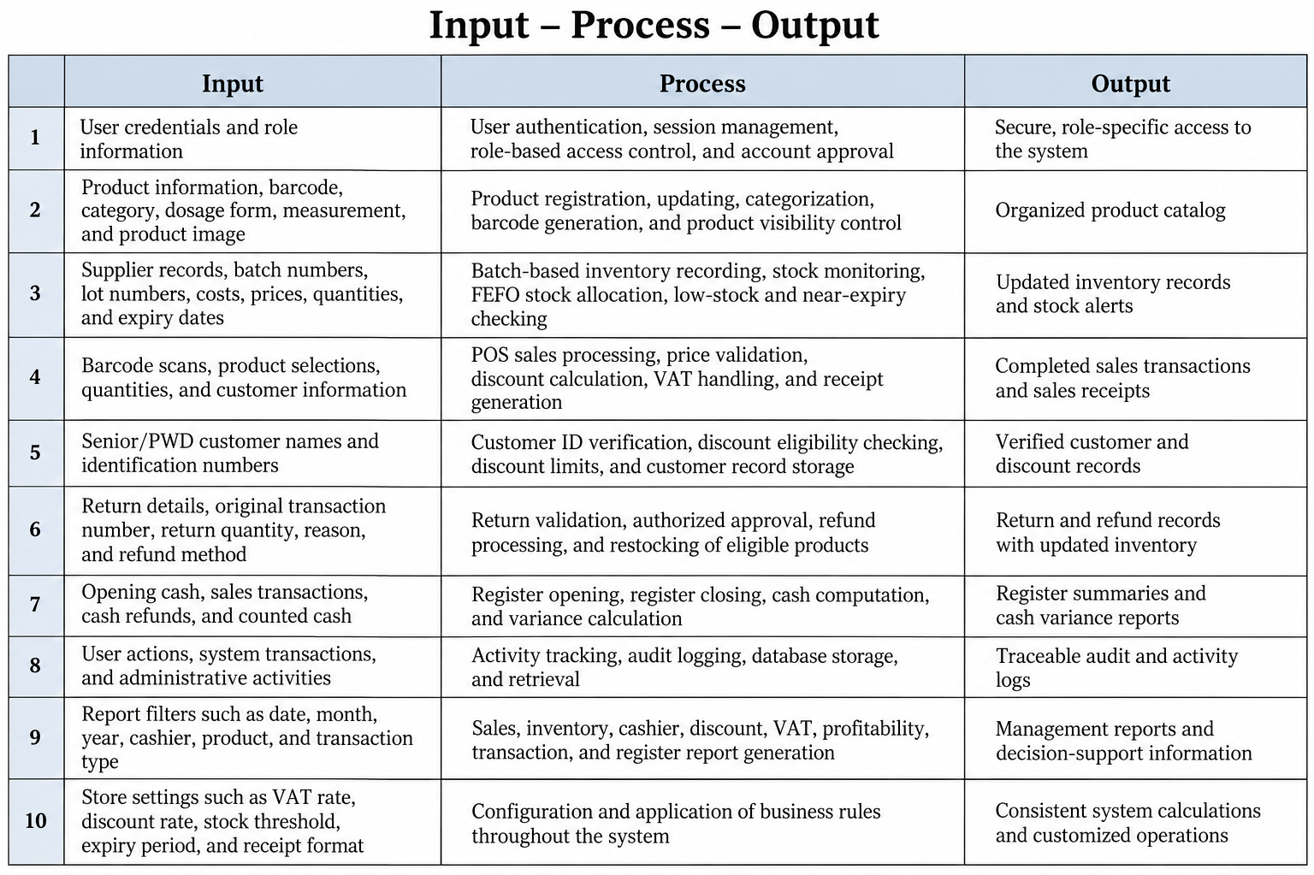

The proposed Web-Based Inventory and Point-of-Sale System follows the Input-Process-Output (IPO) Model. The inputs include user credentials, product information, barcode and classification data, supplier records, batch and lot details, inventory costs and quantities, sales and customer information, Senior Citizen and PWD identification details, return and refund information, register records, audit activities, report filters, and store settings. These inputs are processed through system functions such as user authentication and access control, product registration and categorization, batch-based inventory management, stock monitoring and FEFO allocation, point-of-sale transaction processing, price and discount calculation, VAT handling, customer verification, return and refund processing, register management, audit logging, report generation, and application configuration. The system then produces outputs such as secure user access, an organized product catalog, updated inventory records and stock alerts, completed sales transactions and receipts, verified customer and discount records, return and refund records with updated inventory, register summaries and cash variance reports, traceable audit logs, management reports, and consistent system calculations. This framework provides a structured flow of information that supports accurate data processing, organized record management, and efficient business operations.

Statement of the Problem:
General Problem
MMB Drug Store encounters challenges in managing inventory and sales transactions due to manual or less organized processes. These practices may lead to inaccurate stock monitoring, delays in transaction processing, difficulty in tracking product movement, and problems in generating reliable reports. Moreover, staff may spend considerable time locating products and processing sales because they are not immediately aware of product availability and pricing. This may result in slower customer service and reduced operational efficiency. There are also instances when sales are not properly recorded, which may lead to missing transactions and shortages in sales records. Hence, there is a need to develop a web-based inventory and point-of-sale system that can improve inventory monitoring, sales transaction processing, barcode generation and barcode-supported product tracking, and record management.

Specific Problems
Specifically, this study seeks to answer the following questions:
- How may the current inventory and sales transaction processes of MMB Drug Store be described?
- What problems are encountered in the existing inventory and sales management processes in terms of:
  - stock monitoring
  - transaction processing
  - product price checking

  - sales recording
  - recordkeeping
  - report generation
- What web-based inventory and point-of-sale system may be developed to improve the management of inventory and sales transactions of MMB Drug Store?
- How may the proposed system be designed in terms of:
  - user login and authentication
  - product entry and updating
  - barcode generation and barcode-supported product tracking
  - inventory monitoring
  - sales transaction processing
  - purchase recording
  - report generation
  - database storage and retrieval
- How acceptable is the proposed system based on the following criteria:
  - functionality
  - usability
  - reliability
  - efficiency
  - security

Scope of the Study
This study focuses on the design and development of a Web-Based Inventory and Point-of-Sale System for MMB Drug Store. The proposed system aims to automate key store operations, including inventory monitoring, sales transaction processing, purchase recording, barcode-supported product identification and barcode generation for product labeling and tracking, and report generation.

The system will include the following modules:
- User login, authentication, and role-based access control
- User account and profile management
- Product entry and updating
- Barcode generation and barcode-supported product tracking
- Supplier and purchase recording
- Batch-based inventory monitoring
- Stock alert and expiry monitoring
- Sales transaction processing
- Customer identification and discount verification
- Return, refund, and restocking management
- Cash register management
- Report generation
- Audit trail and activity monitoring
- Store and system settings management

- Database storage and retrieval
The system will be accessible only to authorized users through a web browser and will operate using an internet connection with a server-based setup. The primary users of the system are the store owner, administrator, and authorized staff of MMB Drug Store.

The system will be developed using PHP for server-side processing, MySQL for database management, and HTML, CSS, and JavaScript for the user interface. The study will be conducted during the Academic Year 2025–2026 and will be implemented exclusively at MMB Drug Store.

Delimitations of the Study
This study is subject to the following limitations:
- The system is developed exclusively for MMB Drug Store.
- The system is focuses intended for small-scale, single-store operations.
- The system on inventory management, purchasing, sales, returns, customer discount.
- verification, cash register management, and report generation.
- The system does not support multi-branch or multi-store operations.
- The system does not include online ordering or delivery services.
- Online payment integration is not included.
- The system is web-based and accessible through a web browser only.
- A dedicated mobile application is not included.
- Access is limited to authorized MMB Drug Store personnel, including Owner, Admin, and Staff users.
- The system does not provide public or customer-side access.

- Supplier access portals and customer portals are not included.
- Full accounting, payroll, banking, and external business-system integration are excluded.
- Predictive analytics, automated demand forecasting, and artificial intelligence features are not included.
- The accuracy of inventory, sales, customer, and report data depends on the correctness of
- information entered by authorized users.
- The system does not replace physical procedures such as product inspection, stock counting, customer identity verification, or cash handling.
- Features not specifically stated within the scope of the study are excluded.

Significance of the Study
The development of the Web-Based Inventory and Point-of-Sale System for MMB Drug Store is expected to benefit the following:

- MMB_Drug_Store
The proposed system will improve the overall efficiency of store operations by automating inventory monitoring, sales transaction processing, purchase recording, barcode generation and barcode-supported product tracking, and report generation. It will also reduce manual errors and enhance the accuracy and reliability of store records.

- Store_Owner
The system will provide the store owner with a more organized and efficient way of monitoring stock levels, sales performance, and purchase records. It will also support better decision-making through timely and accurate reports.

- Administrator_and_Authorized_Staff
The system will reduce the manual workload of administrators and authorized staff by simplifying product recording, stock monitoring, and sales processing. It will also improve efficiency and accuracy in managing store operations and records.

- Customers
Customers will benefit from faster and more accurate transaction processing. The system will also help ensure that product availability and pricing information are reliable, improving overall customer service.

- Future_Researchers
This study may serve as a reference for future researchers who plan to develop or enhance similar inventory and point-of-sale systems. It may provide insights into system design, development processes, and evaluation methods.

- BSIT_Students_and_System_Developers
The study may serve as a learning resource for students and developers who aim to understand the development of web-based systems. It may also provide practical knowledge in database management, system design, and software development.

Definition of Terms
Administrator – The authorized user responsible for managing system operations, including product records, inventory monitoring, and report generation in MMB Drug Store.
Authentication – The process used in the system to verify the identity of users before granting access to authorized functions.
Barcode Generation – The process of creating unique machine-readable codes for products, which are used for identification, tracking, and faster transaction processing within the system.
Barcode-Supported Product Tracking – A system feature that uses barcode scanning to identify, record, and track products accurately during inventory and sales transactions.
Customer Information – The data recorded in the system related to customers, such as transaction history and purchase details.
Database – The structured digital storage used in this study to store product information, user accounts, inventory records, and transaction data.
Inventory Monitoring – The process of tracking stock levels, product availability, and movement of items within MMB Drug Store.
Point-of-Sale (POS) System – The component of the system that processes sales transactions, calculates totals, and generates receipts.
Product Entry and Updating – The process of adding new product information and modifying existing product details in the system database.
Purchase Recording – The process of documenting newly acquired or restocked items to maintain accurate inventory levels.
Report Generation – The system function that produces summaries of inventory, sales, and purchase transactions for monitoring and decision-making.

Sales Transaction Processing – The system function that records sales, calculates total costs, updates inventory, and generates transaction outputs.
Stock Details – The recorded information about product quantities, availability, and status within the system.
Supplier Records – The stored information about suppliers, including product sources and purchase transactions.
User Credentials – The username and password used by authorized users to access the system securely.
Web-Based Inventory and Point-of-Sale System – The application developed in this study to automate inventory monitoring, sales processing, barcode tracking, and report generation for MMB Drug Store through a web browser.

References
Bekele, A., Boche, B., Anagaw, Y. K., Ayenew, W., Worku, M. C., Geremew, D. T., Minwagaw, T., Melkamu, E., Woldeyohanins, A. E., Tefera, B. B., & Duguma, M. (2025). Inventory management performance of essential medicines in public health facilities of Jimma Zone, Southwest Ethiopia. PLOS Global Public Health, 5(4), e0004379. https://doi.org/10.1371/journal.pgph.0004379
Jaju, R., Varshney, S., Gupta, P., Bihani, P., & Karim, H. M. R. (2023). Inventory control mechanism of the pharmacy store of a recently established national institute in Eastern India: A cross-sectional, investigative analysis. Cureus, 15(11), e49632. https://doi.org/10.7759/cureus.49632
Malasari, N. N., & Sudrajat, J. (2024). Expired medication detection information system using the First Expired First Out method: Case study of one pharmacy in Bandung. Jurnal Computech & Bisnis, 17(2), 97–103. https://doi.org/10.56447/jcb.v17i2.243
Salas-Navarro, K., Pardo-Meza, J., Torres-Prentt, J., & Rivera-Alvarado, J. (2025). A multi-product and multi-period inventory planning model to optimize the supply of medicines in a pharmacy in Barranquilla, Colombia. Logistics, 9(4), 151. https://doi.org/10.3390/logistics9040151
Sinha, S., & Singh, B. (2025). Evaluation and optimization of pharmaceutical inventory management in a tertiary care teaching hospital in Jharkhand, India, using ABC-VED analysis. Cureus. https://pmc.ncbi.nlm.nih.gov/articles/PMC12807746/

McKesson Corporation. (2024). Pharmacy management and technology solutions. Retrieved from https://www.mckesson.com/Pharmacy-Technology/
MocDoc. (2024). Pharmacy management system. Retrieved from https://mocdoc.com/pharmacy-management-system/
Wasp Barcode Technologies. (2024). Inventory control systems for medical supplies. Retrieved from https://www.waspbarcode.com/inventory-control/
Windward Software Systems Inc. (2024). Medical store inventory and POS system. Retrieved from https://www.windwardsoftware.com/en-us/business-types/medical-store
BestRx. (2024). Pharmacy management system and POS solutions. Retrieved from https://bestrx.com/

