CHAPTER III
RESULTS AND DISCUSSIONS
This chapter presents and interprets the results of the development and evaluation of the Web-Based Inventory and Point-of-Sale System for MMB Drug Store. It explains how the developed system addressed the problems encountered in managing product stocks, processing sales transactions, checking prices, recording purchases, maintaining records, and generating reports. The chapter also presents the different stages followed in developing the system based on the System Development Life Cycle (SDLC). It discusses how the system was planned, designed, developed, tested, deployed, reviewed, and maintained. Furthermore, the chapter provides the basis for evaluating the system in terms of functionality, usability, reliability, efficiency, and security.
1. Development of the Web-Based Inventory and Point-of-Sale System for MMB Drug Store
The development of the Web-Based Inventory and Point-of-Sale System for MMB Drug Store followed the stages of the System Development Cycle. These stages provided a systematic process for identifying the needs of the drug store, designing the system, developing its features, testing its performance, and preparing it for actual implementation.
1.1. Planning Phase
The planning phase focused on establishing the foundation for the development of the Web-Based Inventory and Point-of-Sale System for MMB Drug Store. This phase involved identifying the existing problems in inventory and sales management, determining the objectives of the project, defining the scope of the system, and assessing the feasibility of its implementation.
The study was initiated after recognizing the challenges experienced by MMB Drug Store in managing its inventory and sales transactions. The drug store relied on manual or less organized procedures for monitoring stocks, recording sales, checking product prices, and preparing reports. These processes could result in inaccurate inventory records, delays in locating products, inconsistent sales documentation, and difficulty in determining the actual movement of products.
The existing process also made it difficult for staff to immediately determine the availability and price of medicines and other products. As a result, employees could spend additional time searching for products and verifying their prices before completing a customer transaction. Manual recording could also lead to missing sales transactions, incorrect stock balances, and discrepancies between the recorded and actual inventory.
To address these concerns, the researchers identified the need for a centralized and web-based system that would organize inventory and sales-related information in one database. The proposed system was planned to include user login and authentication, product entry and updating, barcode generation, barcode-supported product tracking, inventory monitoring, sales transaction processing, purchase recording, report generation, and database storage and retrieval.
The planning phase also considered the operational requirements of MMB Drug Store. The system needed to be simple enough for store personnel to use during daily operations while providing accurate and timely information. It also needed to support the fast processing of customer purchases because point-of-sale transactions are performed regularly and require immediate recording of product quantities and prices.
By the end of this phase, the researchers had defined the project's goals, scope, requirements, resources, and timeline. Key outputs included the project proposal, feasibility study, system requirements, and development schedule, which guided the next phases.
Gantt Chart
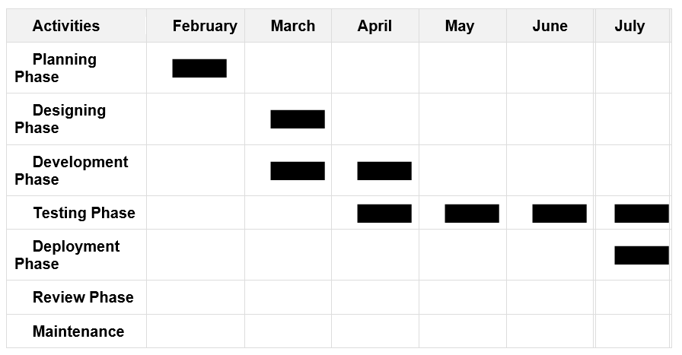
1.2. Designing Phase
The designing phase converted planning requirements into a technical blueprint for the Web-Based Inventory and Point-of-Sale System for MMB Drug Store. The design followed three main stages: security first, then database and system architecture, and finally user interface design.

Security Framework
The researchers started with authentication and access control since the system would handle sensitive sales data, inventory records, and pricing information. A role-based access system was created where cashiers can only process sales and view products, while managers have full access to reports, inventory adjustments, and price modifications. Password encryption was implemented to protect user credentials, and data encryption was planned for all stored business
information. This security-first approach ensured that every subsequent design decision would maintain data protection.

Database and System Architecture
With security in place, the team designed a web-based three-tier architecture connecting the user interface, backend logic, and database. This allows multiple users to work simultaneously from different computers while keeping data secure. The database applied normalization to eliminate duplicates and maintain accuracy across products, stock levels, sales history, and user accounts.

User Interface and Experience
The interface was designed for speed and simplicity, recognizing that pharmacy staff serve customers quickly. Common actions like barcode scanning, adding to cart, and payment processing require minimal clicks. Visual indicators automatically show low-stock alerts, expiry warnings, and daily sales summaries. The checkout screen was streamlined to reduce transaction time and errors. Clear labels and intuitive navigation ensure that staff with varying technical skills can use the_system_effectively.
Use case Diagram
The Web-Based Inventory and Point-of-Sale System for MMB Drug Store enables authorized users to manage pharmacy operations. Main actors are administrators (full access), cashiers (sales only), and inventory staff (stock management). Core functions include secure login, product management with barcode scanning, real-time inventory tracking, sales processing, purchase recording, and automated reporting.

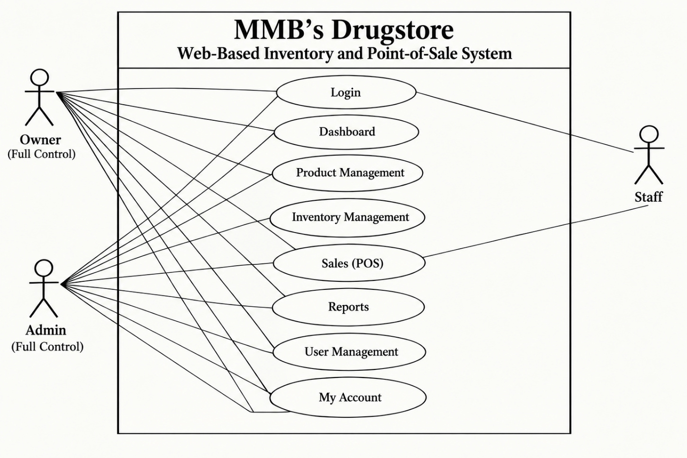
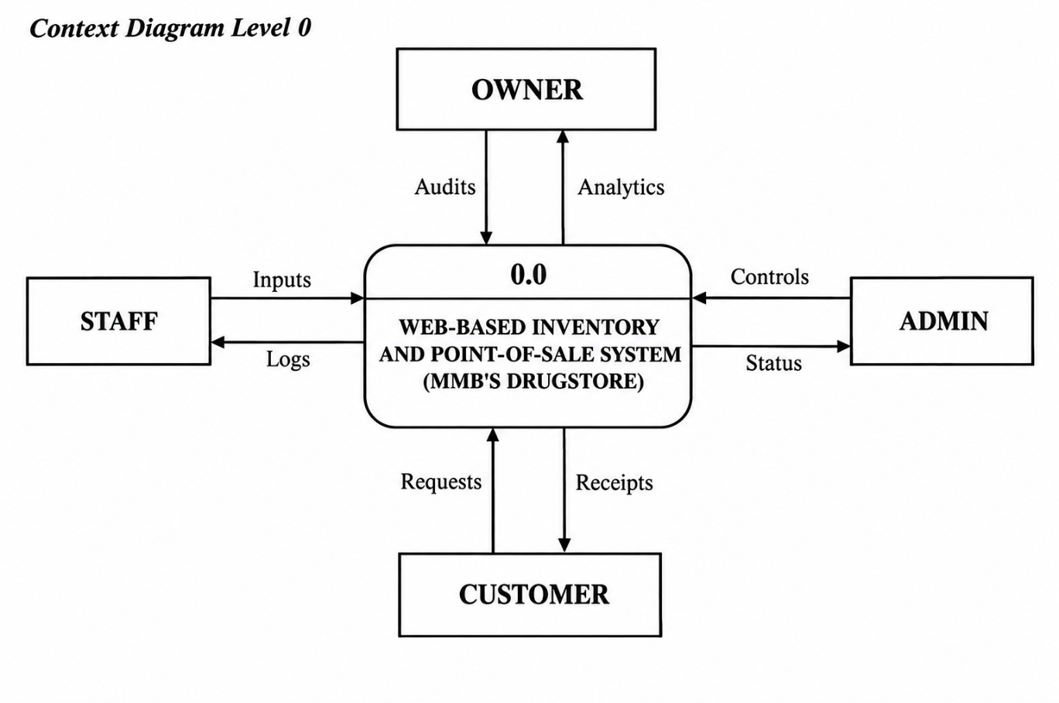

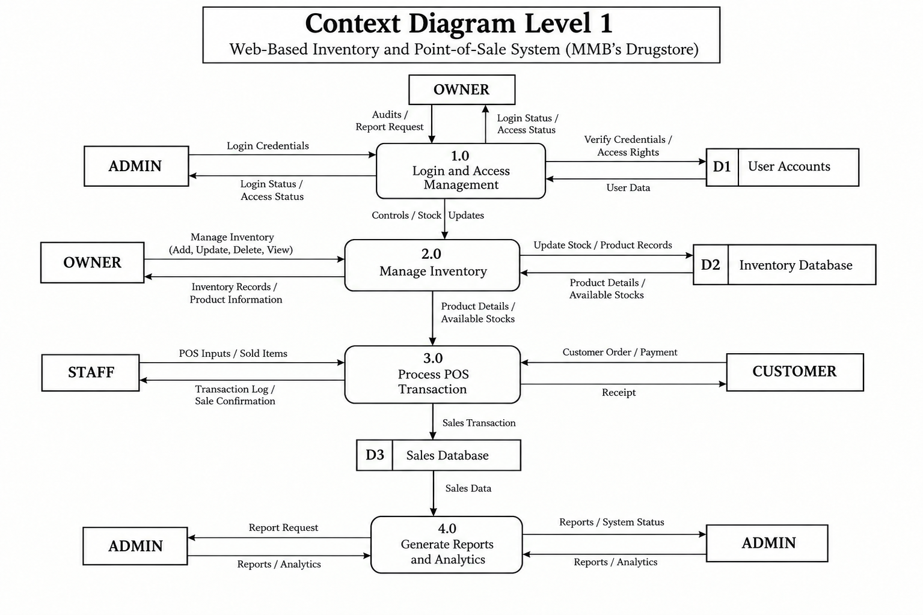
1.3. Development Phase
The development phase of the Web-Based Inventory and Point-of-Sale System for MMB Drug Store focused on creating the actual system. It included programming, database creation, interface design, and the connection of all system features. The system included product registration, inventory management, sales processing, receipt generation, supplier management, user accounts, and report generation. Each feature was developed and tested separately before being combined into one complete system.
A database was created to store product names, categories, prices, stock quantities, expiration dates, supplier information, sales records, and user accounts. The system interface was designed to be simple and easy to use. It allowed authorized users to add products, update stock, search for medicines, process sales, calculate totals, record payments, print receipts, and generate reports. Login and user roles were also included to protect the system and its records.
By the end of the development phase, the Web-Based Inventory and Point-of-Sale System for MMB Drug Store had been fully coded and integrated, with all functional modules implemented according to the design specifications. The completed system included a fully structured database, a user-friendly interface, and role-based access controls, and was deemed ready to proceed to the integration and testing phase for validation of performance, security, and usability.
Application Programs PHP
In developing the Web-Based Inventory and Point-of-Sale System for MMB Drug Store, PHP (Hypertext Preprocessor) was used as the main programming language, together with MySQL as the database management system. The development was done using Visual Studio Code (VSCode) as the primary code editor, which provided efficient coding features such as syntax highlighting, auto-completion, and integrated debugging tools. This technology stack was selected because of its stability, scalability, and strong support for web applications that need to handle large amounts of data, such as product information, stock levels, sales records, and user accounts. With PHP and MySQL, the system was able to provide a secure, dynamic, and responsive platform for managing the drug store's daily operations.
The system follows a client-server architecture, where users access the application through a web interface built with PHP, HTML, CSS, and JavaScript, while the server-side PHP code handles all the back-end processes and communicates with the MySQL database to store and retrieve data. Each module in the system was designed to perform a specific task, such as adding products, updating inventory, processing sales, printing receipts, managing suppliers, handling user accounts, and generating reports.
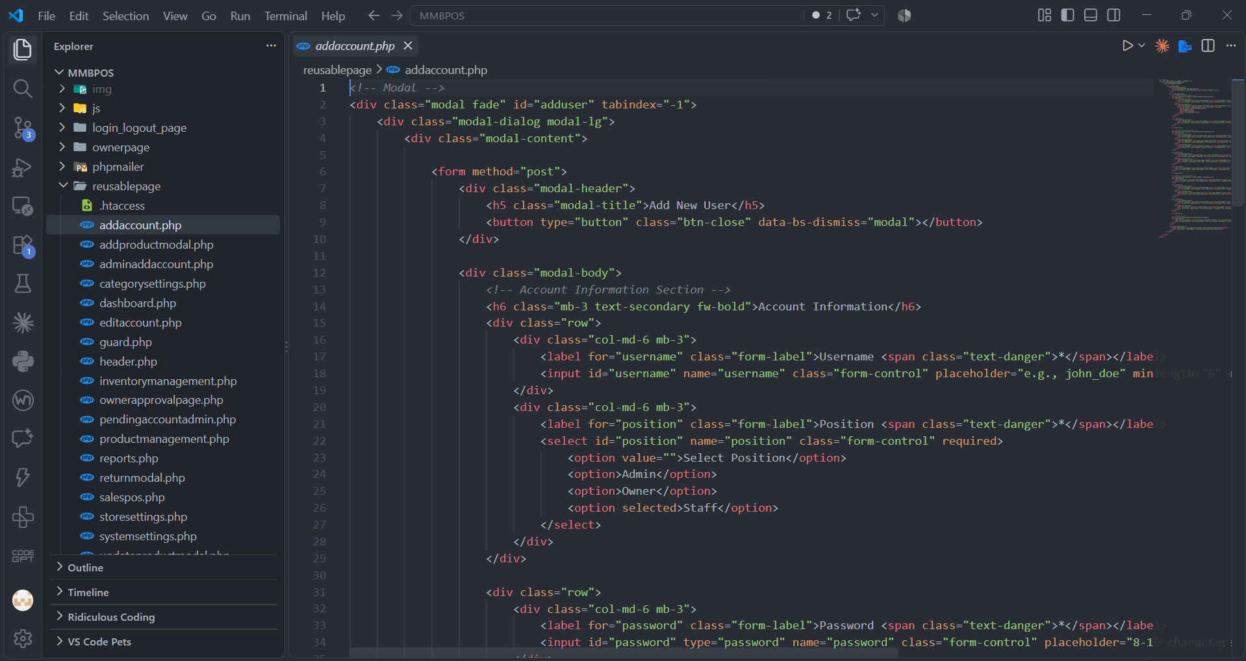

GITHUB
In developing the Web-Based Inventory and Point-of-Sale System for MMB Drug Store, GitHub was used as a version control and source code management platform. It provided a centralized repository where the developers could store, organize, and manage the system's source code, including PHP files, HTML, CSS, JavaScript, and other project resources. GitHub helped ensure that the different components of the system were properly organized and that changes made during development could be tracked and reviewed.
GitHub also supported the development process by allowing the developers to record changes, maintain previous versions of the system, and manage updates to the source code. Through its version control features, developers were able to identify modifications, restore previous versions when necessary, and maintain a more organized development workflow. The use of GitHub contributed to the efficient development and maintenance of the system by providing a reliable platform for managing the project's source code and documentation.

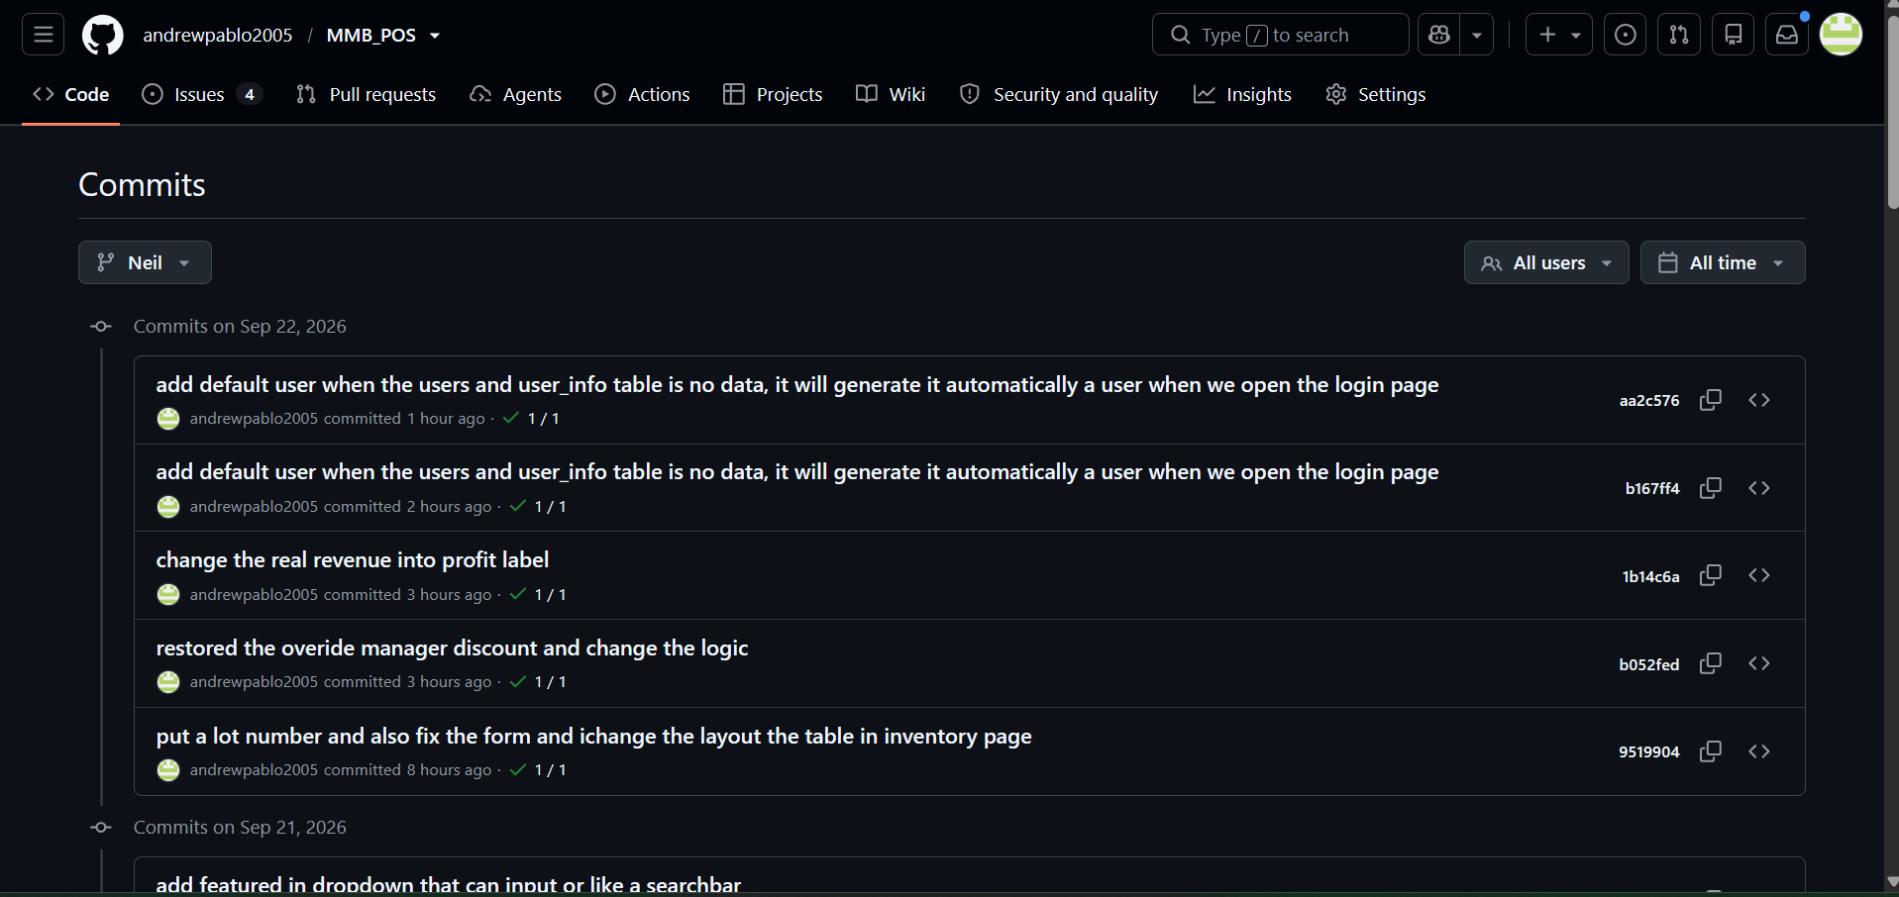
MySQL(XAMPP)
MySQL, accessed through the XAMPP (Cross-Platform, Apache, MySQL, PHP, and Perl) server environment, played a vital role as the database management system (DBMS) in developing the Web-Based Inventory and Point-of-Sale System for MMB Drug Store. It served as the backbone of the system's data storage, organization, and retrieval processes. MySQL was used to manage important information such as product records, inventory quantities, sales transactions, customer information, supplier details, user accounts, and generated reports.
By utilizing MySQL within the XAMPP server environment, the developers were able to create an organized, reliable, and efficient database for the system. Its relational database capabilities allowed the different types of information to be properly stored and connected, ensuring accurate data management and easier retrieval of records. This helped support the daily inventory and sales operations of MMB Drug Store while maintaining consistent and organized data throughout the system.

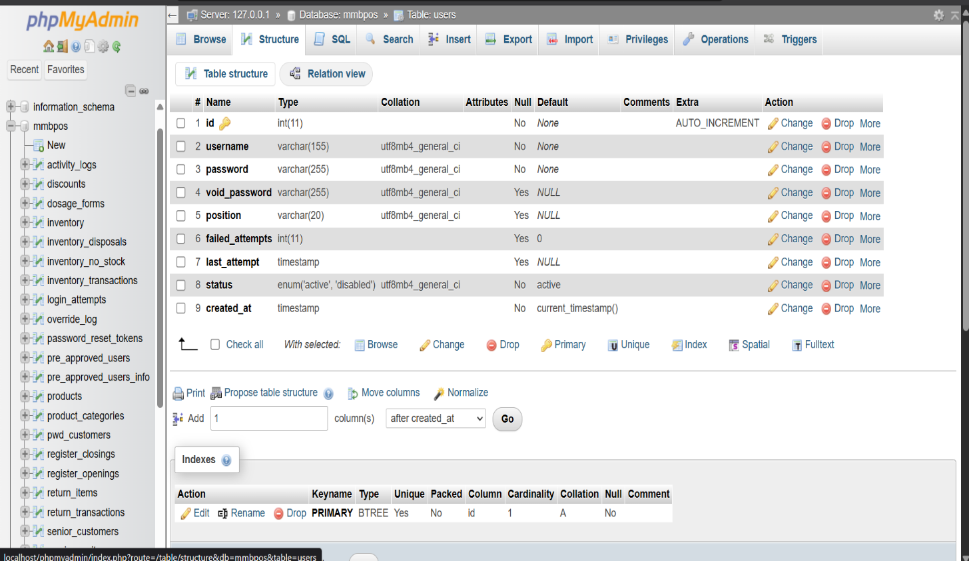
Database Normalization
Database normalization is an important process in designing the Web-Based Inventory and Point-of-Sale System for MMB Drug Store, as it ensures the accuracy, consistency, and efficiency of stored data. It organizes data into related tables to minimize redundancy and prevent data inconsistencies. The normalization process followed the three fundamental normal forms: 1NF, 2NF, and 3NF, to maintain a well-structured and organized database.
Through normalization, the system can efficiently manage product information, inventory records, sales transactions, suppliers, and user accounts. It also improves data retrieval, reporting, and database maintenance while ensuring data integrity and consistency.

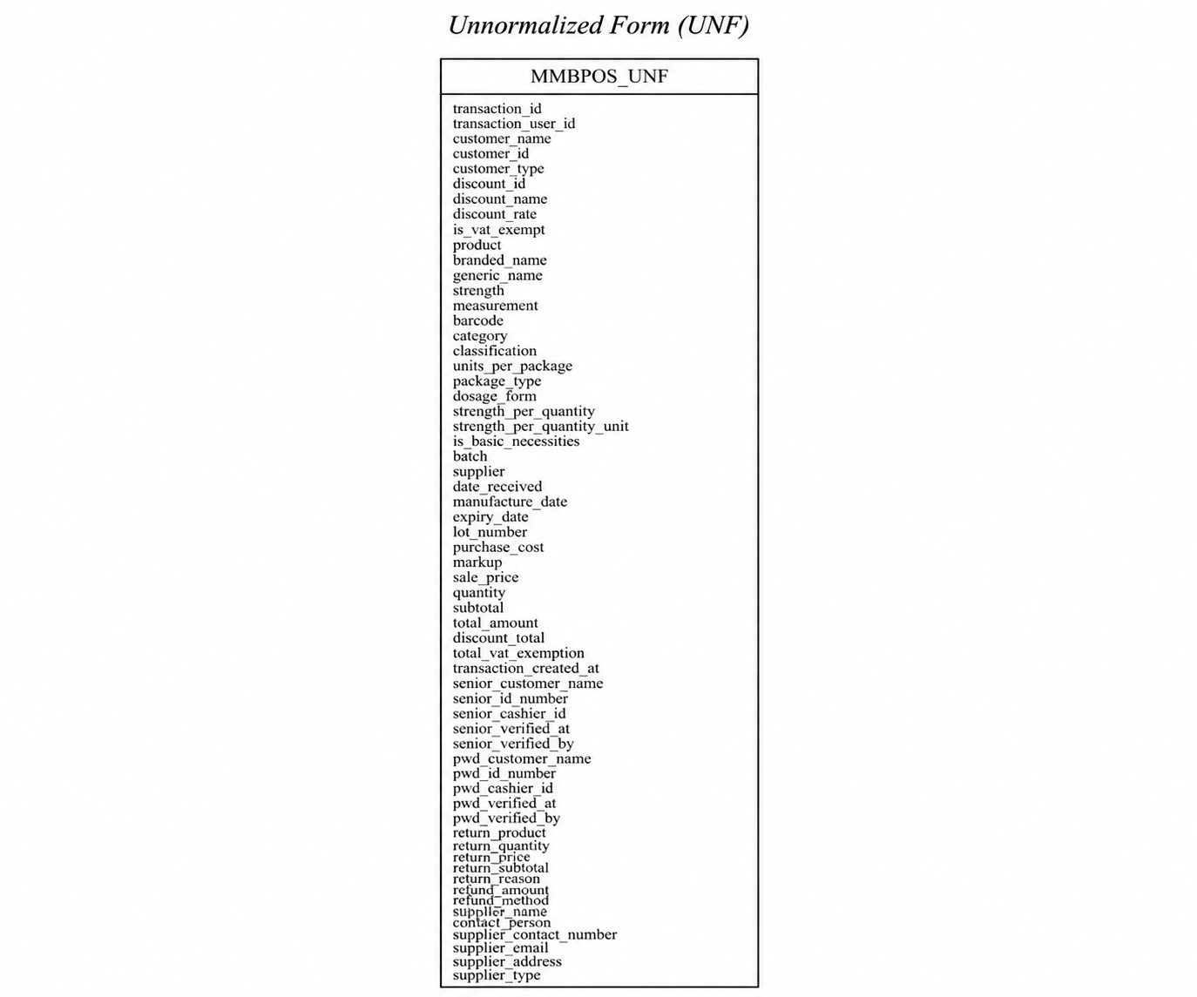
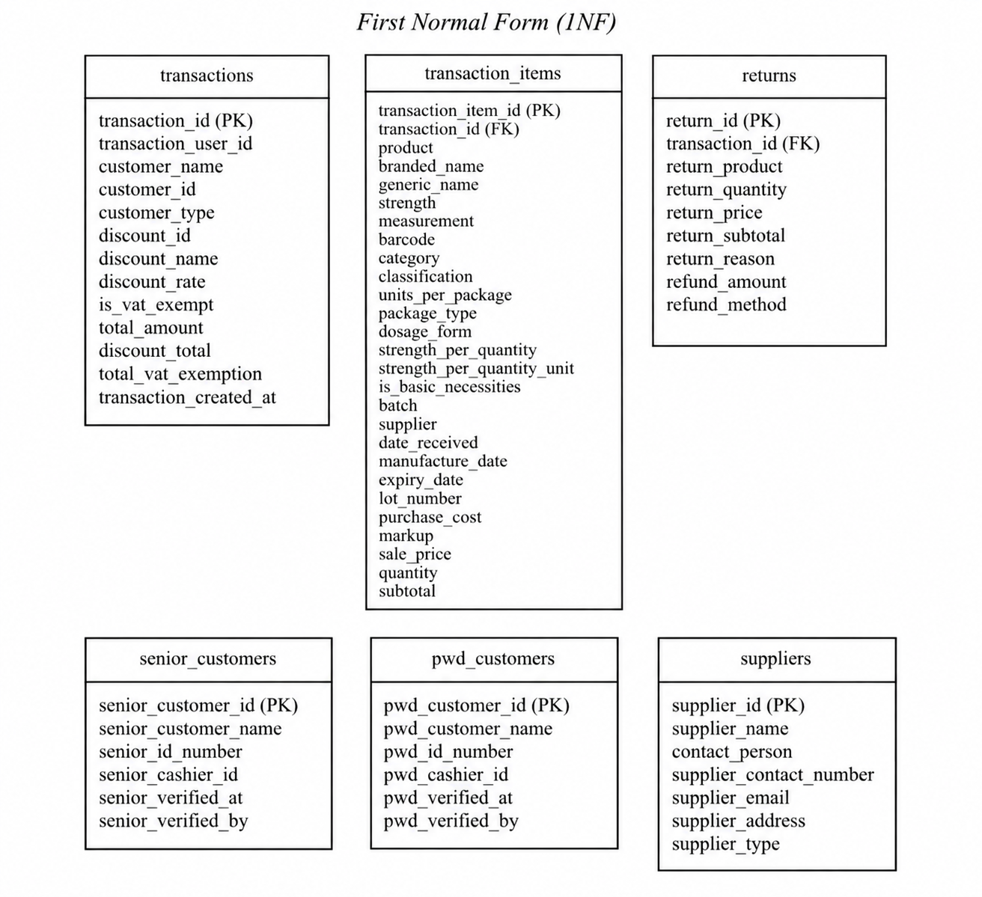

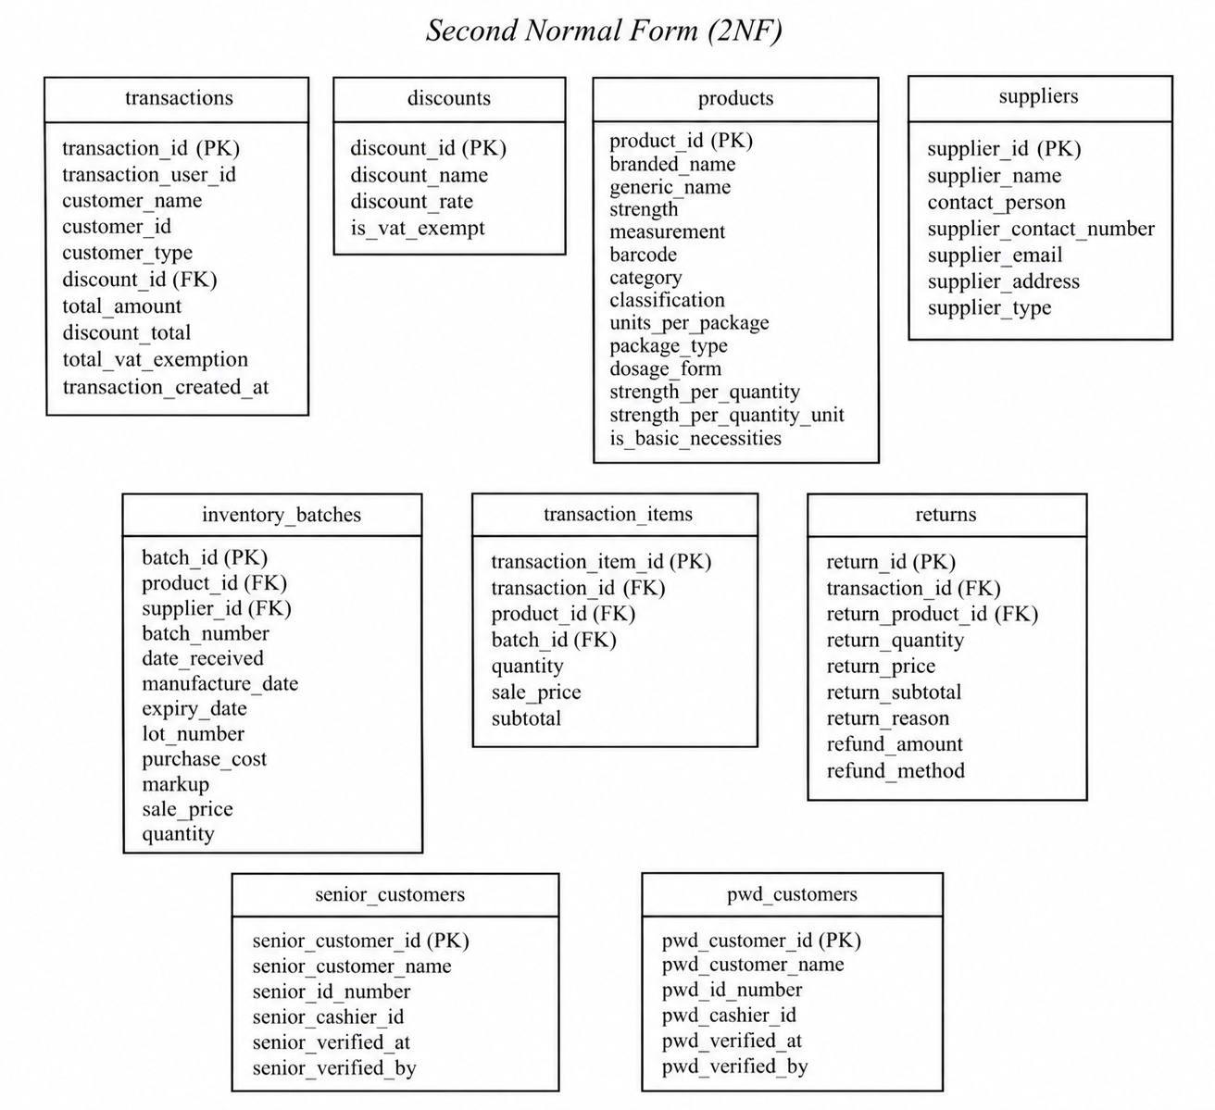
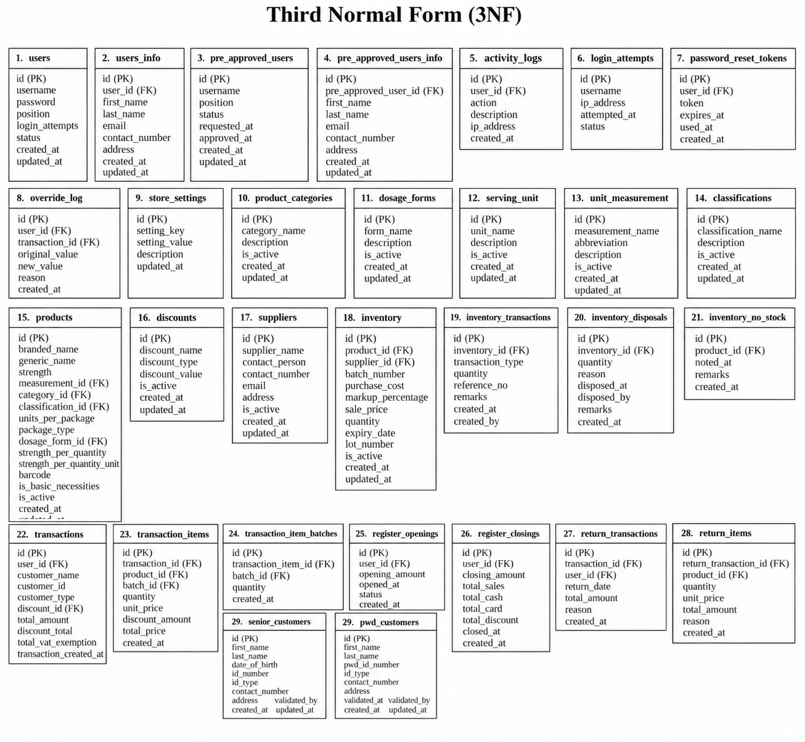

The Entity-Relationship Diagram (ERD) serves as the conceptual blueprint of the MMBPOS: Web-Based Inventory and Point-of-Sale System for MMB Drug Store. It illustrates the logical structure of the database and defines how data elements are interrelated within the system. The ERD was developed to ensure that all data entities, their attributes, and relationships accurately reflect the operational needs of the drugstore in managing products, inventory, suppliers, customers, users, and sales transactions.
The relationships between entities in the ERD are established using appropriate cardinalities—such as one-to-one, one-to-many, and many-to-many—depending on the logical associations among data sets. Each relationship is further strengthened using primary and foreign keys, ensuring referential integrity and preventing data inconsistencies across the database. The ERD also represents the relationship between products, batches, suppliers, transactions, and discounts to support accurate inventory and sales management.

The Entity-Relationship Diagram provides a clear and organized visualization of the MMBPOS database architecture. It ensures that every data interaction is systematically mapped, supporting efficient data retrieval, accurate inventory monitoring, reliable sales processing, and proper transaction recording. By grounding the system’s design on this ERD, the project provides a structured, reliable, and scalable data model that aligns with the operational needs of MMB Drug Store.

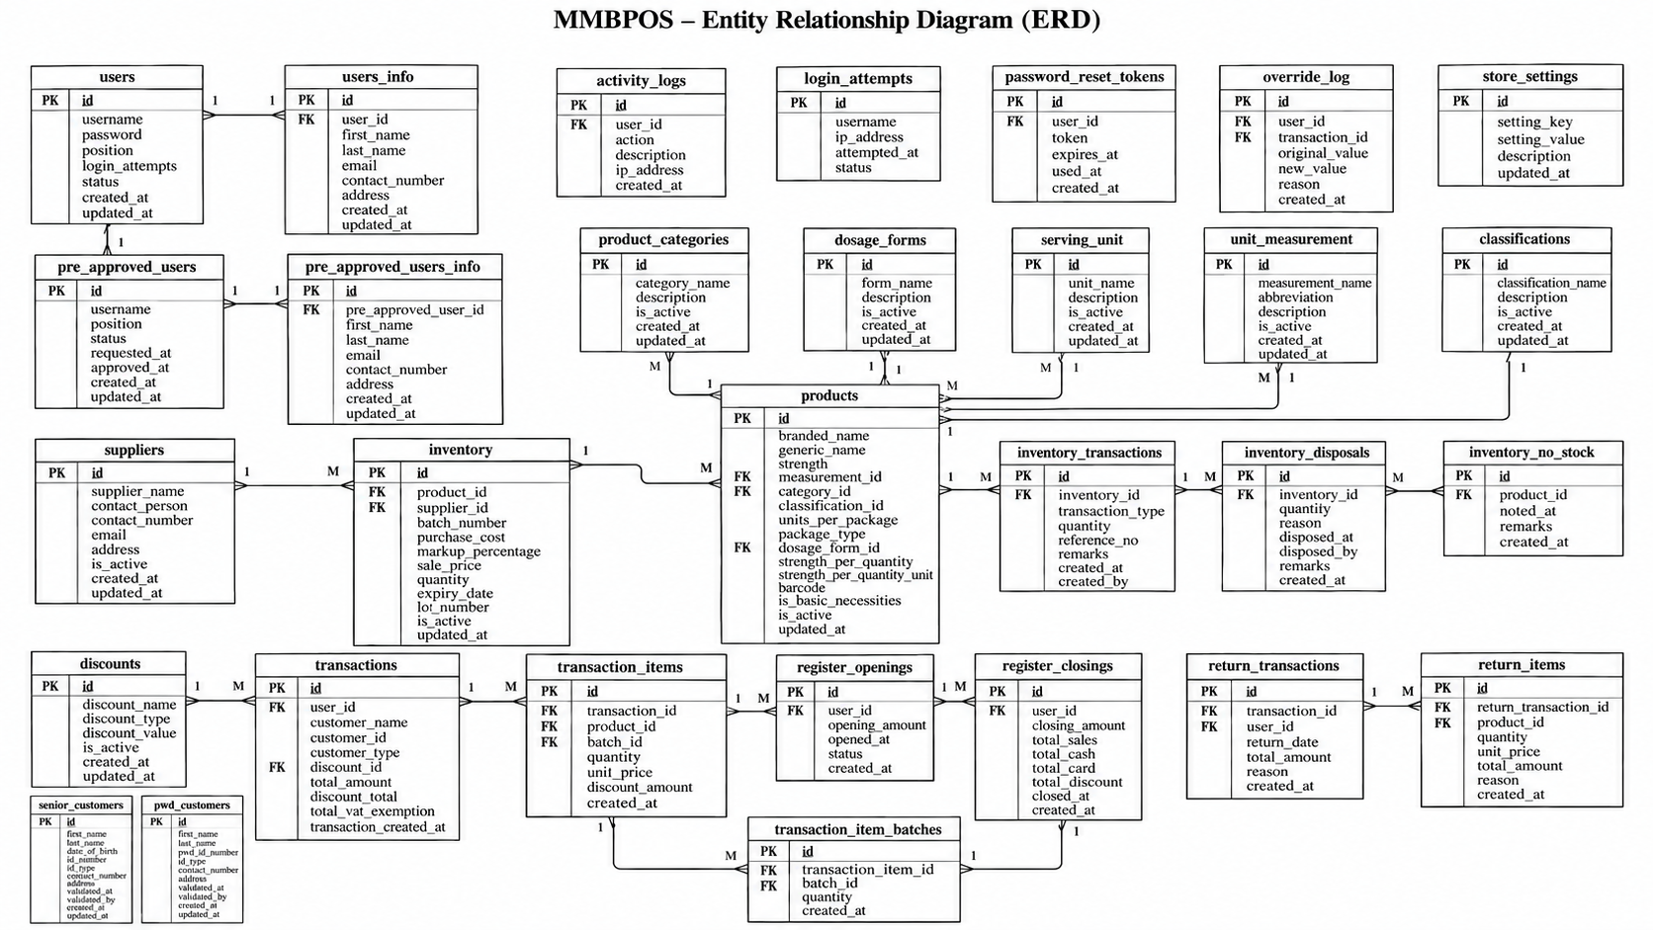

Data Dictionary
The Data Dictionary of the MMBPOS: Web-Based Inventory and Point-of-Sale System for MMB Drug Store provides a structured reference for the information stored and processed by the system. It identifies the different data fields used in managing products, inventory, suppliers, customers, sales transactions, users, and other system functions. Each data element is documented according to its purpose and role in the database, helping ensure that information is properly defined and consistently used throughout the system.
The data dictionary is designed to support the database structure established through the Entity-Relationship Diagram (ERD) and normalization process. It contains important details such as the field name, data type, length, description, and corresponding table. These specifications help developers understand the purpose and proper use of each field, while also providing a reliable reference for database implementation, maintenance, and future system modifications.
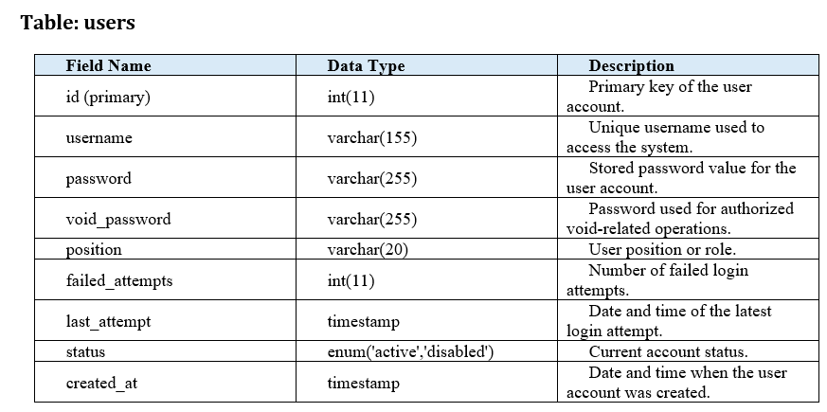
Table: user_info
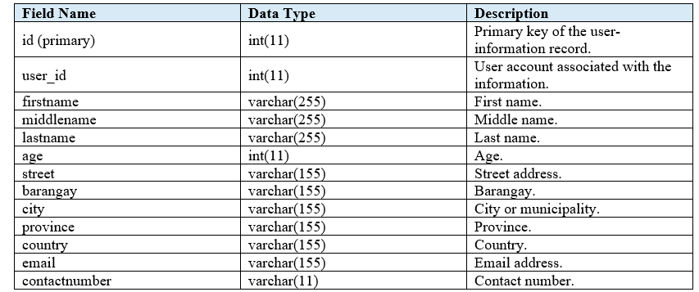
Table: pre_approved_users
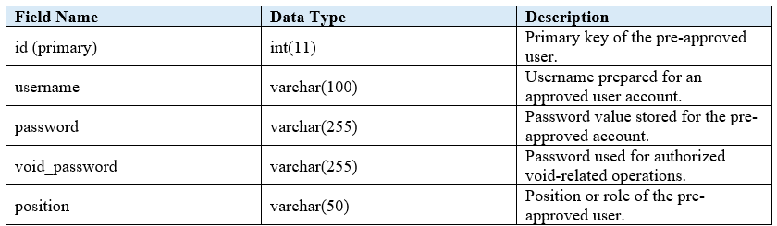

Table: pre_approved_users_info
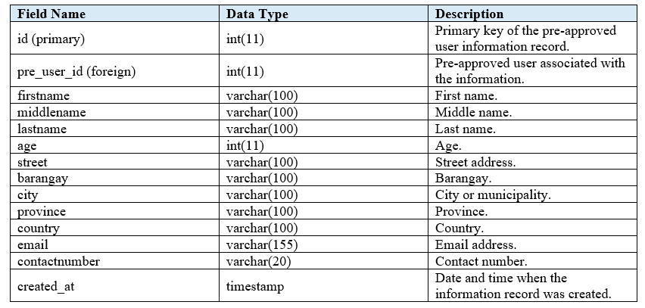
Table: activity_logs
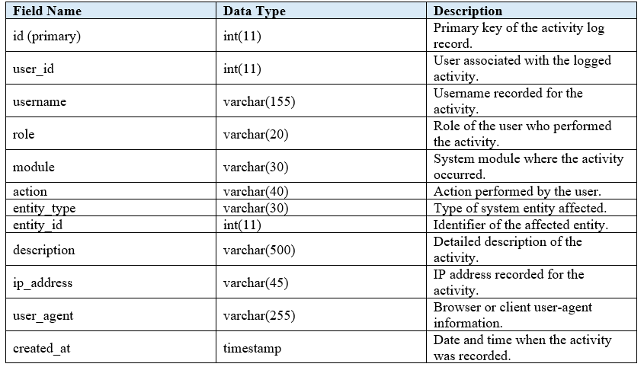
Table: login_attempts
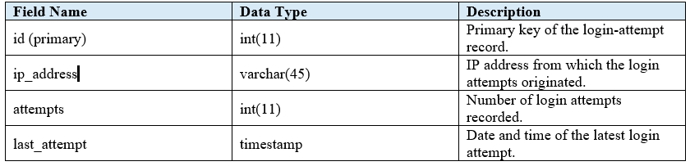
Table: password_reset_tokens
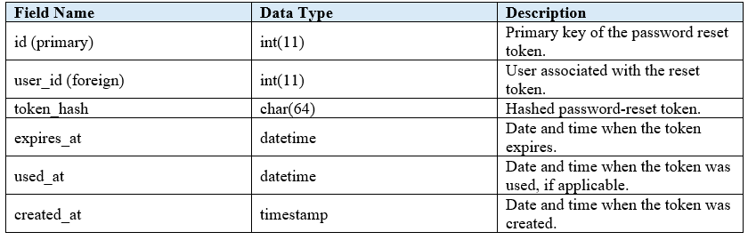

Table: products
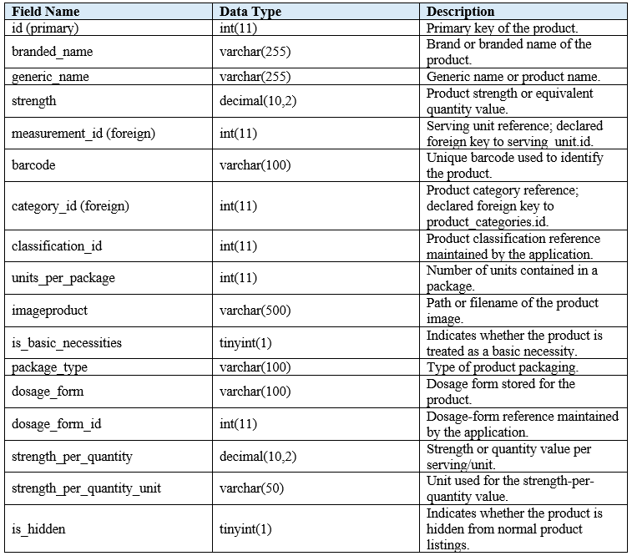

Table: product_categories
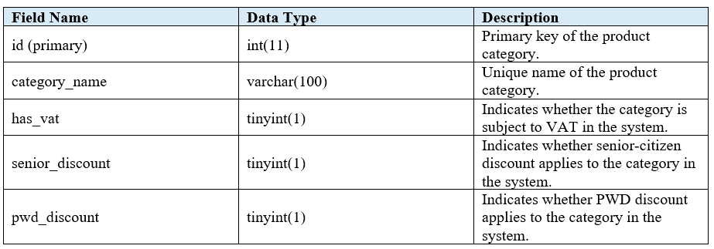
Table: dosage_forms
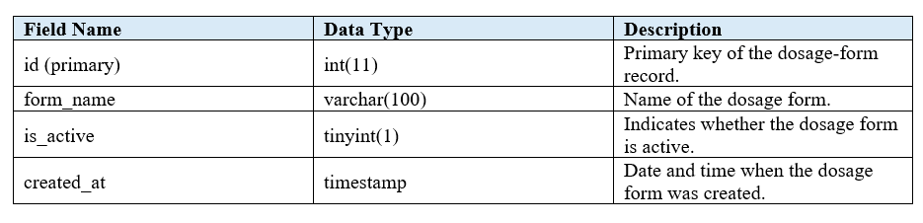
Table: serving_unit
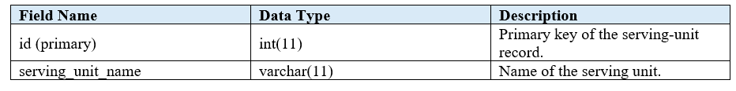

Table: unit_measurement
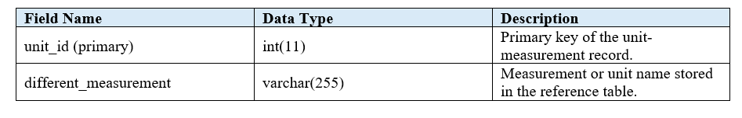
Table: discounts
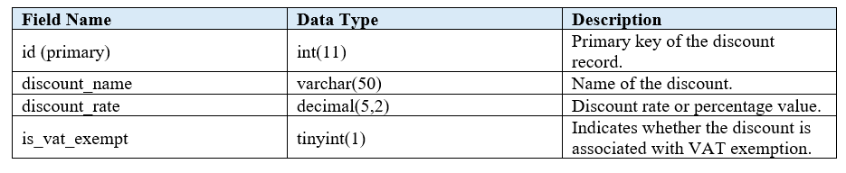
Table: suppliers
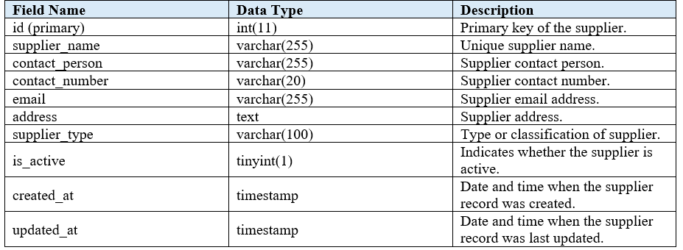

Table: store_settings
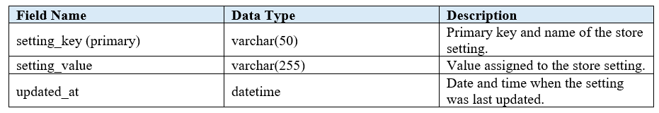
Table: inventory
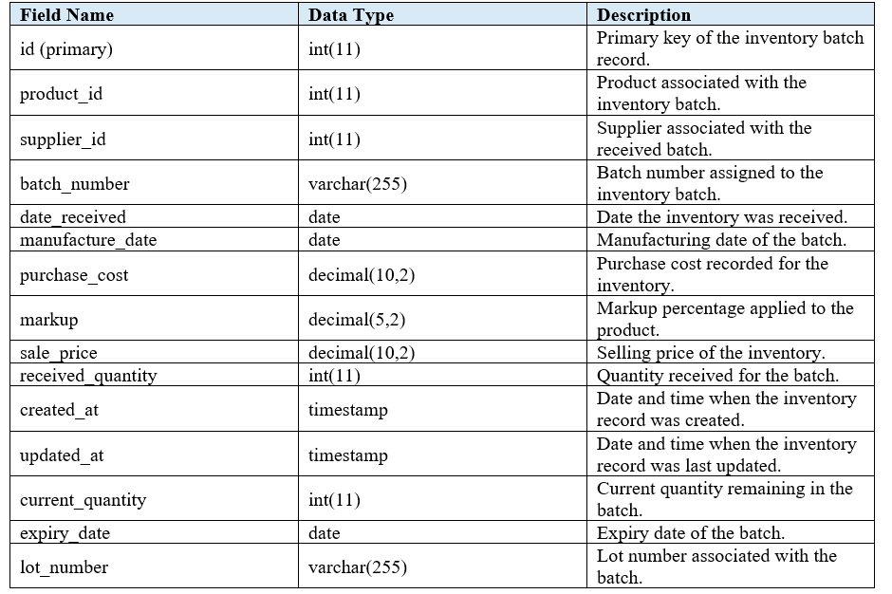

Table: inventory_transactions
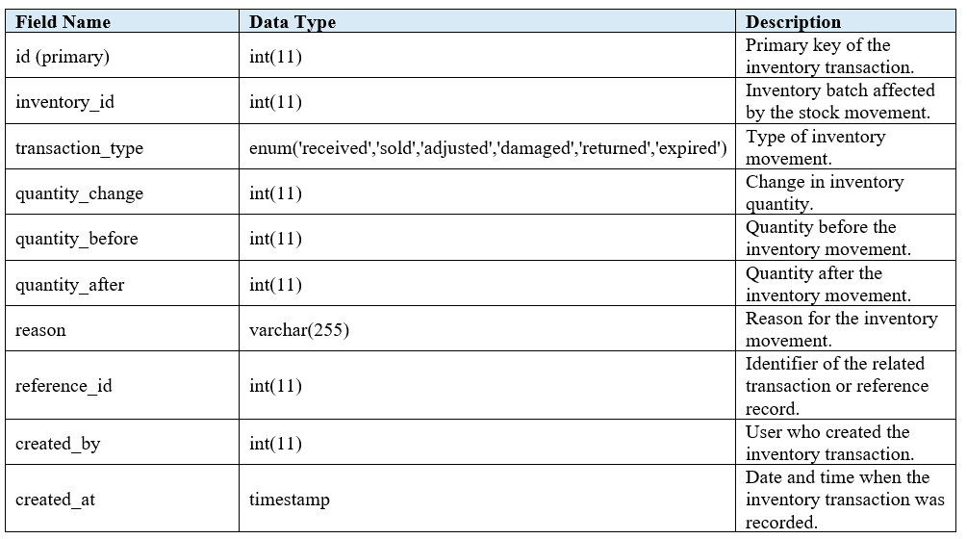
Table: inventory_disposals
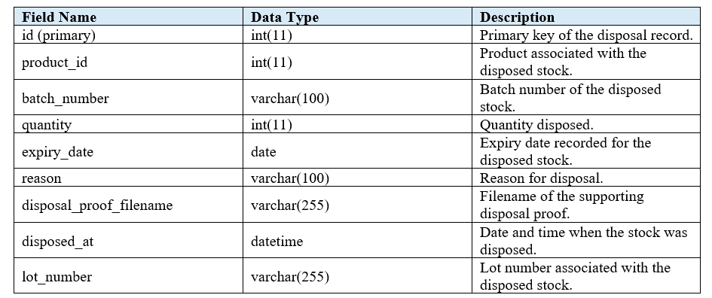
Table: inventory_no_stock
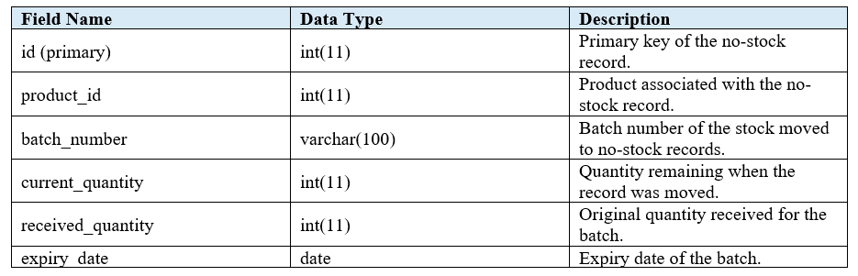
Table: transactions
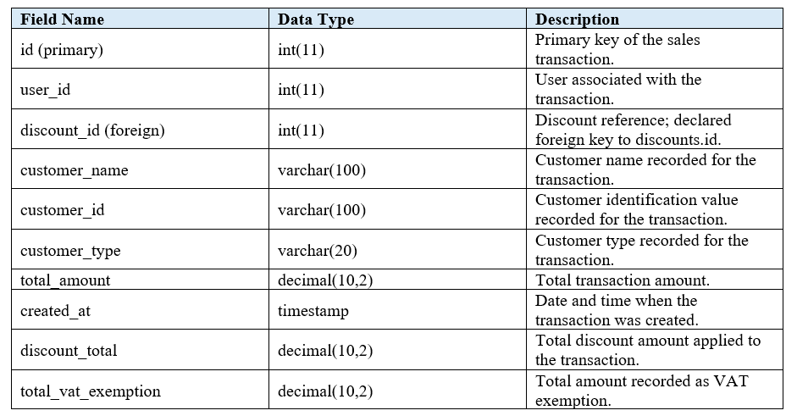

Table: transaction_items
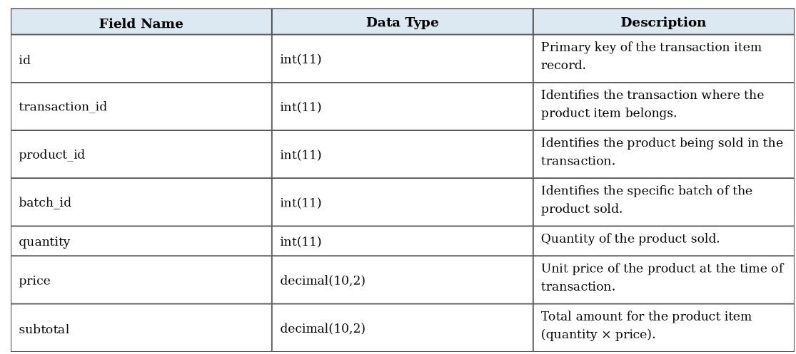
Table: transaction_item_batches
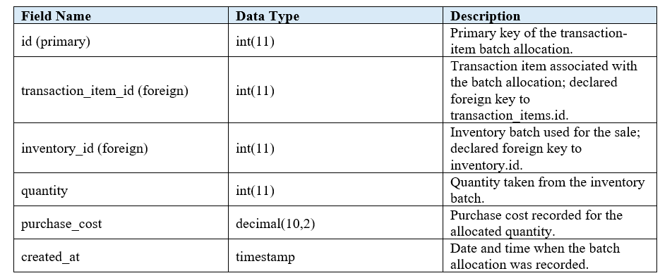

Table: register_openings
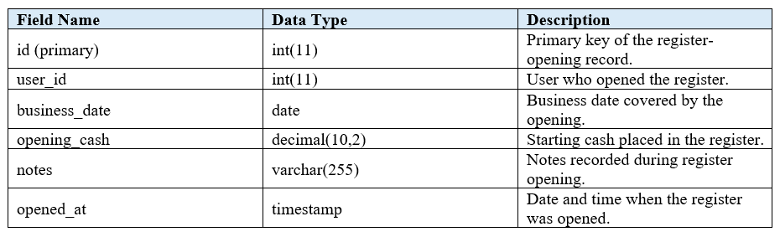
Table: register_closings
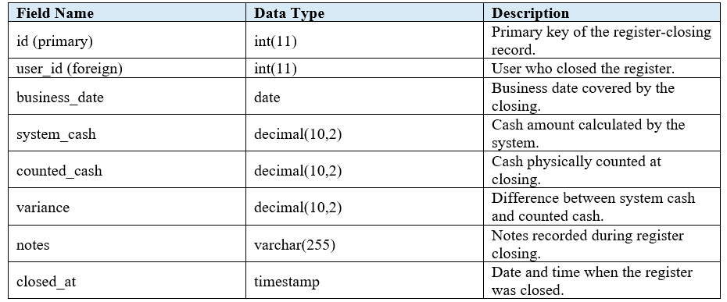

Table: return_transactions
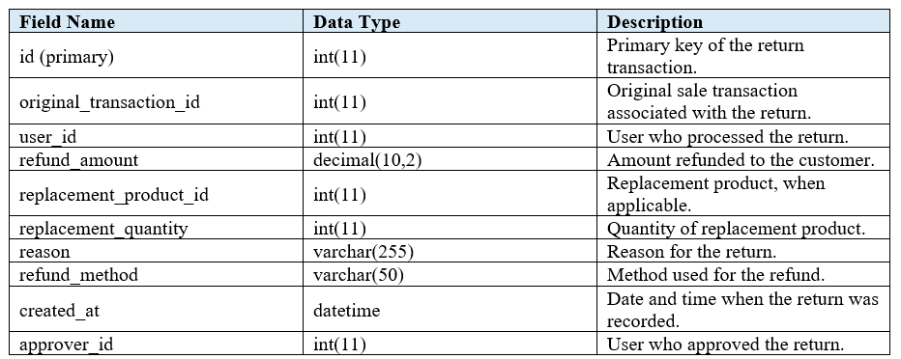
Table: return_items
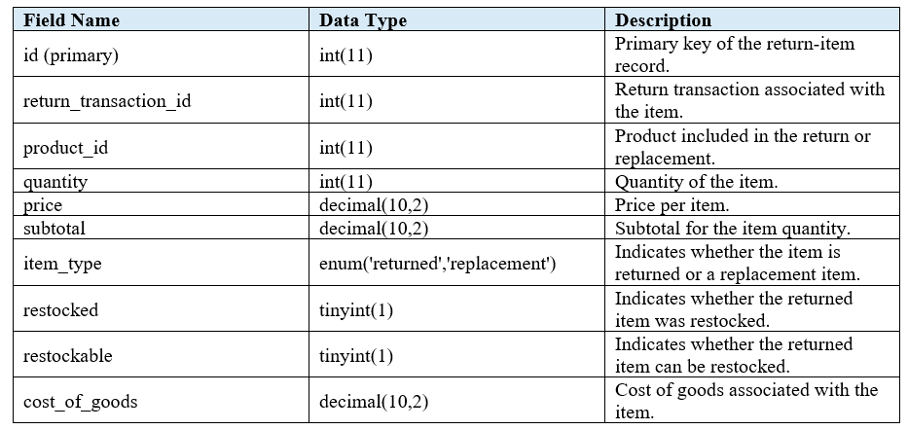

Table: senior_customers
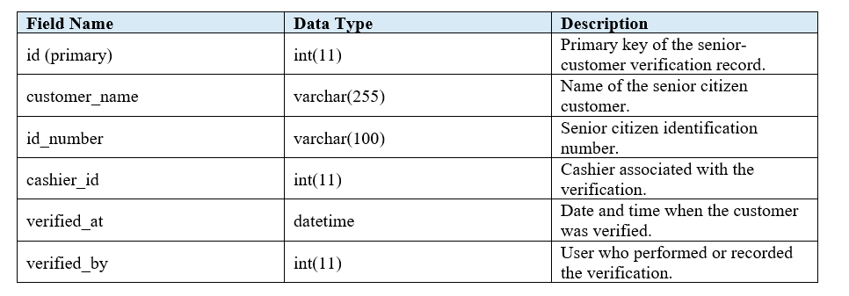
Table: pwd_customers
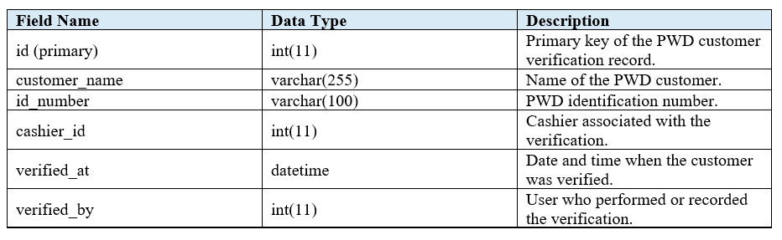

Table: override_log
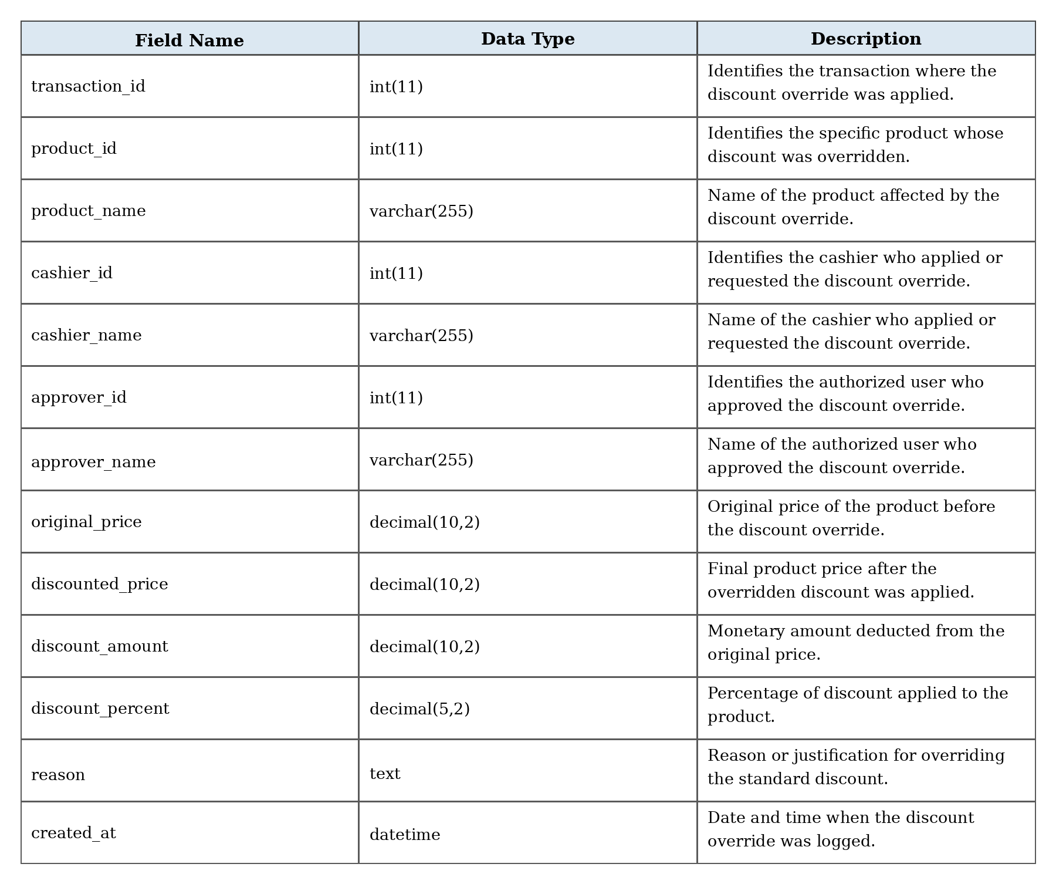

1.4. Testing Phase
The testing phase of the Web-Based Inventory and Point-of-Sale System for MMB Drug Store was conducted to ensure that the developed system performed according to its intended functions and requirements. This stage focused on evaluating the functionality, accuracy, and usability of the system, as well as identifying errors that might affect its operation. The testing process was carried out throughout the development of the system to ensure that each feature was working properly before final implementation.
The testing process began with debugging the different features of the system. Each module was examined to identify errors and determine whether the functions were producing the expected results. Features such as product registration, inventory management, sales processing, receipt generation, supplier management, user account management, and report generation were tested individually. Errors encountered during testing were reviewed and corrected to ensure that the affected functions operated properly.
The system was also tested by other users to identify errors or problems that might not have been noticed during the development and debugging process. The users were allowed to perform common tasks within the system, such as adding products, checking inventory, processing sales transactions, and viewing records. Their experience while using the system helped identify areas that needed further checking or improvement.
Feedback and suggestions from the users were also considered during the testing phase. Suggestions regarding the system's layout, navigation, functionality, and ease of use were reviewed and applied when necessary. This helped improve the overall usability of the system and made the different features easier to understand and use.
Additional debugging was performed after the identified errors and suggestions were reviewed. The affected functions were tested again to verify that the corrections were properly applied and that no new problems were introduced. The process of testing, correcting, and retesting was repeated as needed until the major errors encountered during development and user testing were addressed.
The testing phase helped ensure that the Web-Based Inventory and Point-of-Sale System for MMB Drug Store was functioning properly and could support its intended operations. It also provided an opportunity to improve the system based on actual usage and feedback before its final implementation.
1.5. Deployment Phase
The deployment phase of the Web-Based Inventory and Point-of-Sale System for MMB Drug Store will focus on making the system accessible through an online hosting environment. This stage will involve uploading the developed system to a web server, configuring the database, preparing the hardware, and setting up the necessary resources for actual use. The primary goal of deployment will be to provide a centralized and accessible platform for managing the drug store's inventory and point-of-sale operations.
The process will begin with preparing the required hardware for the system, including computers or laptops, barcode scanners, receipt printers, and other necessary peripherals for point-of-sale operations. A stable internet connection will also be prepared to ensure continuous access to the online system. The system files will then be uploaded to the selected web hosting service, while the MySQL database will be created and configured in the online server environment.
User accounts will be prepared according to the assigned roles of the owner, admin, and staff. Access permissions will be configured based on their responsibilities within the system. The online system will then be tested using the prepared hardware to verify that the login, inventory management, sales processing, receipt generation, supplier management, and report generation functions are working properly.
Training will also be provided to the intended users before the system is fully implemented. The training will introduce users to the system's interface and demonstrate basic operations such as logging in, managing products and inventory, processing sales transactions, printing receipts, managing user accounts, and viewing reports. Users will also be guided on the proper use of the hardware and peripherals connected to the system.
After the training, the system will be tested in the actual store environment using the prepared hardware and internet connection. Any errors or difficulties encountered during the initial use will be addressed through necessary adjustments and additional guidance. User feedback will also be considered to improve the system's usability and operation.
Security, maintenance, and backup procedures will also be established during deployment. Regular database backups will be performed to protect important product, inventory, sales, supplier, and user records. System updates and maintenance will be carried out when necessary to address errors and maintain the reliability of the online system.
Once the deployment process is completed, the Web-Based Inventory and Point-of-Sale System for MMB Drug Store will be accessible online to authorized users. The system will support the store's daily operations through centralized inventory management, sales processing, receipt generation, supplier management, and report generation.

1.6. Review Phase
The review phase of the Web-Based Inventory and Point-of-Sale System for MMB Drug Store will serve as a critical evaluation stage, where the system's overall performance, effectiveness, and usability will be assessed after deployment. This phase will determine whether the system meets the objectives defined during the planning and development stages, whether it addresses the challenges encountered in the existing inventory and sales processes, and whether further improvements will be necessary to enhance its use in the drug store.
During this stage, feedback will be gathered from the owner, admin, staff, and other users who interact with the system. Their feedback will be collected through interviews, questionnaires, and observation of system use during actual operations. The evaluation will focus on important aspects of the system, such as functionality, performance, usability, reliability, and security. This feedback will provide information on how the system performs in actual inventory and point-of-sale operations and how easily users will be able to perform their assigned tasks.
The feedback and observations will be documented and reviewed to identify areas that may require improvement. Issues related to product management, inventory monitoring, sales processing, receipt generation, user accounts, supplier management, and report generation will be considered during the review. The results will serve as a basis for planning future updates, corrections, and maintenance activities to ensure that the system remains useful and responsive to the needs of MMB Drug Store.
In conclusion, the review phase will determine whether the Web-Based Inventory and Point-of-Sale System for MMB Drug Store will achieve its intended purpose of improving the store's inventory and sales operations. It will provide an opportunity to evaluate the system's performance based on actual user experience while identifying areas for continuous improvement and future development.
1.7. Maintenance and Support
The maintenance and support phase of the Web-Based Inventory and Point-of-Sale System for MMB Drug Store will ensure the continued functionality, reliability, and adaptability of the system after deployment. This phase will focus on maintaining system performance, resolving technical issues, and implementing improvements based on user feedback. The goal will be to ensure that the system continues to meet the changing needs of the drug store while providing accurate, secure, and efficient inventory and sales management.
During maintenance, regular system updates will be performed to fix errors, improve performance, and strengthen security. These updates will help ensure that the database operates properly, the user interface remains responsive, and important inventory and sales records remain accessible. Technical assistance will also be provided to store staff whenever problems such as login difficulties, system errors, or data retrieval issues occur.
Adaptive maintenance will also be performed when changes in software, web browsers, or operating systems require system adjustments. Improvements such as enhanced reports, updated features, and additional security measures may be incorporated based on user feedback and operational requirements. These improvements will help maintain the system’s effectiveness and reliability.
The support phase will include continuous guidance and training for MMB Drug Store staff. Users will receive orientation whenever new features or system updates are introduced. User manuals and system documentation will also be updated to provide guidance for basic operations and troubleshooting.
Periodic system audits, backups, and recovery tests will be conducted to maintain data accuracy, security, and availability. These activities will help protect inventory, product, and sales records from system failures, power interruptions, connectivity problems, and other unexpected incidents.
Ultimately, the maintenance and support phase will ensure that the Web-Based Inventory and Point-of-Sale System remains a reliable and sustainable tool for MMB Drug Store. Through regular maintenance, technical support, user feedback, and system improvements, the project will continue to support efficient inventory and sales management and adapt to the future needs of the drug store.
2. Assessment of the Technical Quality of the Barangay-Connect by IT Experts based on the ISO 25010 standards.
The assessment conducted by IT experts on the MMBPOS: Web-Based Inventory and Point-of-Sale System for MMB Drug Store shows that the system performed excellently across the major software quality parameters based on the ISO 25010 standards. The evaluation results indicate that the system demonstrates a high level of quality in terms of functional suitability, performance efficiency, compatibility, usability, reliability, security, maintainability, and portability, reflecting its ability to support the operational requirements of the drugstore effectively.
2.1. Functional Suitability
The table shows the results of the assessment conducted by the IT Experts on the functional suitability of the developed MMBPOS: Web-Based Inventory and Point-of-Sale System for MMB Drug Store.
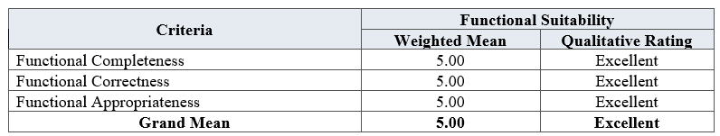
In general, the Functional Suitability of the MMBPOS obtained a grand mean of 5.00, which is qualitatively rated as Excellent. The sub-criteria under this parameter, namely functional completeness, functional correctness, and functional appropriateness, each obtained a weighted mean of 5.00. These results indicate that the system provides the required functions for inventory and point-of-sale operations, produces accurate results, and effectively supports users in completing their intended tasks. The consistent ratings indicate that the MMBPOS meets the functional requirements of the system and provides appropriate outputs for the operational needs of MMB Drug Store.

2.2. Performance Efficiency
The table shows the results of the assessment conducted by the IT Experts on the functional effiecincy of the developed MMBPOS: Web-Based Inventory and Point-of-Sale System for MMB Drug Store.
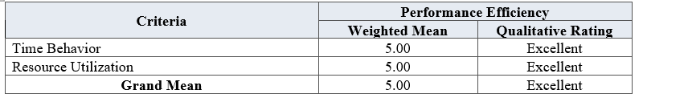
In general, the Performance Efficiency of the MMBPOS obtained a grand mean of 5.00, which is qualitatively rated as Excellent. The sub-criteria under this parameter, namely time behavior and resource utilization, each obtained a weighted mean of 5.00. These results indicate that the system can process data efficiently, respond to user actions promptly, and operate smoothly while utilizing system resources appropriately. The consistent ratings indicate that the MMBPOS performs efficiently and can support multiple tasks or users without significant delays or system lags.

2.3. Compatibility
The table shows the results of the assessment conducted by the IT Experts on the compatibility of the developed MMBPOS: Web-Based Inventory and Point-of-Sale System for MMB Drug Store.
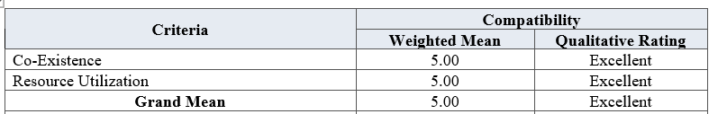
In general, the Compatibility of the MMBPOS obtained a grand mean of 5.00, which is qualitatively rated as Excellent. The sub-criteria under this parameter, namely co-existence and resource utilization, each obtained a weighted mean of 5.00. These results indicate that the system can operate effectively alongside other software and hardware without conflicts, errors, or disruptions. The consistent ratings indicate that the MMBPOS is compatible with the technological environment and can effectively support the operational needs of MMB Drug Store.

2.4 Usability
The table shows the results of the assessment conducted by the IT Experts on the usability of the developed MMBPOS: Web-Based Inventory and Point-of-Sale System for MMB Drug Store.
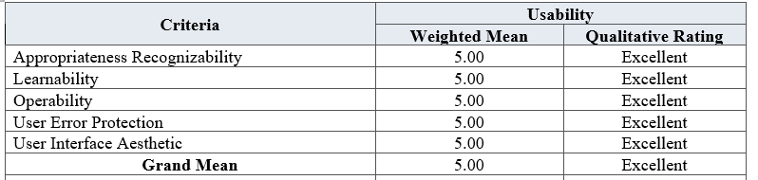
In the area of Usability, the MMBPOS obtained a grand mean of 5.00, which is qualitatively rated as Excellent. The sub-criteria, namely appropriateness recognizability, learnability, operability, user error protection, and user interface aesthetics, each obtained a weighted mean of 5.00. These results indicate that the system is easy to understand, learn, navigate, and operate, while providing an organized and user-friendly interface. The consistent ratings demonstrate that users can effectively perform their tasks using the MMBPOS with minimal assistance or training.

2.5. Reliability
The table shows the results of the assessment conducted by the IT Experts on the reliability of the developed MMBPOS: Web-Based Inventory and Point-of-Sale System for MMB Drug Store.
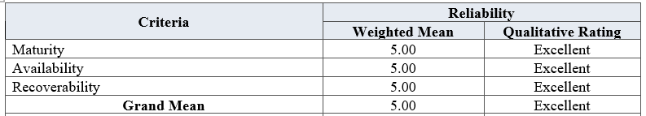
In general, the Reliability of the MMBPOS obtained a grand mean of 5.00, which is qualitatively rated as Excellent. The sub-criteria under this parameter, namely maturity, availability, and recoverability, each obtained a weighted mean of 5.00. These results indicate that the system performs consistently, remains available during normal operations, and can recover effectively from potential disruptions or failures. The consistent ratings indicate that the MMBPOS is stable and dependable for day-to-day operations while maintaining the integrity and availability of stored data.

2.6. Security
The table shows the results of the assessment conducted by the IT Experts on the security of the developed MMBPOS: Web-Based Inventory and Point-of-Sale System for MMB Drug Store.

In general, the Security of the MMBPOS obtained a grand mean of 5.00, which is qualitatively rated as Excellent. The sub-criteria under this parameter, namely confidentiality and integrity, each obtained a weighted mean of 5.00. These results indicate that the system provides appropriate measures for protecting sensitive information and preventing unauthorized access or modification of stored data. The consistent ratings indicate that the MMBPOS can effectively safeguard important inventory, transactions, customer, and user information required for the operations of MMB Drug Store.

2.7. Maintainability
The table shows the results of the assessment conducted by the IT Experts on the maintability of the developed MMBPOS: Web-Based Inventory and Point-of-Sale System for MMB Drug Store.
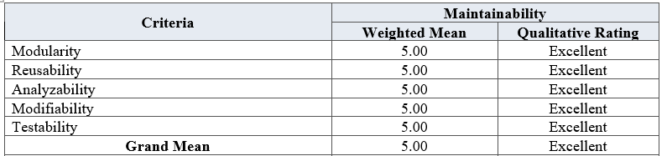
In general, the Maintainability of the MMBPOS obtained a grand mean of 5.00, which is qualitatively rated as Excellent. The sub-criteria under this parameter, namely modularity, reusability, analyzability, modifiability, and testability, each obtained a weighted mean of 5.00. These results indicate that the system has a well-structured design that allows its components to be analyzed, modified, tested, and reused when necessary. The consistent ratings indicate that the MMBPOS can be efficiently maintained and updated, supporting its continued use and future system enhancements.

2.8. Portability
The table shows the results of the assessment conducted by the IT Experts on the portability of the developed MMBPOS: Web-Based Inventory and Point-of-Sale System for MMB Drug Store.
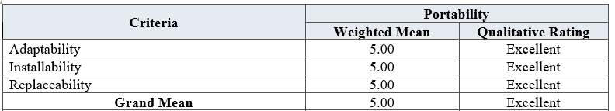
In general, the Portability of the MMBPOS obtained a grand mean of 5.00, which is qualitatively rated as Excellent. The sub-criteria under this parameter, namely adaptability, installability, and replaceability, each obtained a weighted mean of 5.00. These results indicate that the system can be installed, configured, and adapted to compatible operating environments with minimal difficulty. The consistent ratings indicate that the MMBPOS can be effectively deployed and utilized in suitable store environments while maintaining its intended functionality.

Summary of Assessment of IT Experts on the Technical Quality of the MMBPOS Based on the ISO 25010 Software Quality Standards
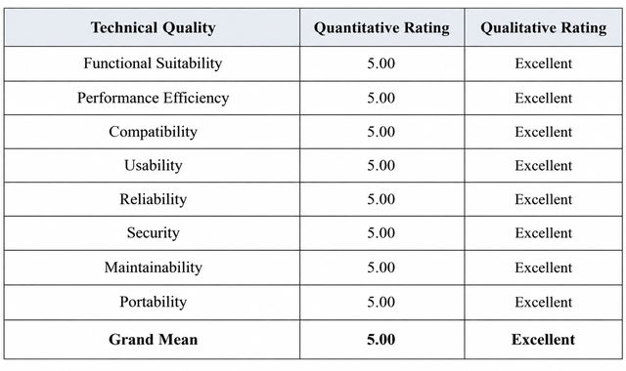

Overall Assessment
Overall, the IT Expert evaluation shows that the MMBPOS obtained a grand mean of 5.00, which is qualitatively rated as Excellent across all ISO 25010 software quality parameters. The Functional Suitability, Performance Efficiency, Compatibility, Usability, Reliability, Security, Maintainability, and Portability all received a rating of 5.00. These results indicate that the system is functional, efficient, reliable, secure, user-friendly, maintainable, and compatible with its intended environment, effectively supporting the operational needs of MMB Drug Store.

3. Assessment on the Use of the Application by the Drugstore Personnel
The assessment results provided by the Drugstore Personnel of MMB Drug Store on the MMBPOS: Web-Based Inventory and Point-of-Sale System reveal an excellent overall evaluation across all assessed software quality parameters. The consistently high weighted means and qualitative ratings indicate that the system effectively meets the needs and expectations of its intended users. The results further demonstrate that MMBPOS is useful, reliable, and easy operate, and suitable for supporting the daily inventory, sales, and administrative operations of MMB Drug Store.

3.1. Functional Suitability
The table shows the results of the assessment conducted by the Drugstore Personnel on the functional suitability of the developed MMBPOS: Web-Based Inventory and Point-of-Sale System for MMB Drug Store.
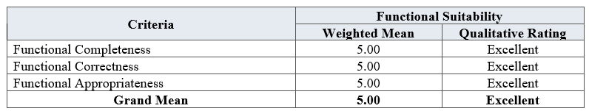
For Performance Efficiency, the MMBPOS obtained a grand mean of 5.00, which is qualitatively rated as Excellent. The sub-criteria of time behavior, resource utilization, and capacity each received a weighted mean of 5.00. These results indicate that the system processes data efficiently, uses system resources appropriately, and can handle increasing workloads without significant delays or performance issues.

3.2. Performance Efficiency
The table shows the results of the assessment conducted by the Drugstore Personnel on the performance efficiency of the developed MMBPOS: Web-Based Inventory and Point-of-Sale System for MMB Drug Store
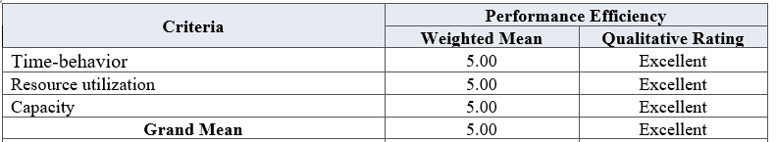

In terms of Functional Suitability, the MMBPOS obtained a grand mean of 5.00, rated as Excellent. The sub-criteria of functional completeness, functional correctness, and functional appropriateness each received a weighted mean of 5.00. These results indicate that the system provides the necessary functions, produces accurate outputs, and effectively supports the inventory and point-of-sale operations of MMB Drug Store.

3.2. Usability
The table shows the results of the assessment conducted by the Drugstore Personnel on the usability of the developed MMBPOS: Web-Based Inventory and Point-of-Sale System for MMB Drug Store.
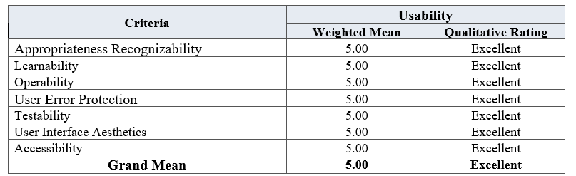
In terms of Usability, the MMBPOS obtained a grand mean of 5.00, which is qualitatively rated as Excellent. The sub-criteria of appropriateness recognizability, learnability, operability, user error protection, testability, user interface aesthetics, and accessibility each received a weighted mean of 5.00. These results indicate that the system is easy to understand, learn, navigate, and operate while providing an organized interface and minimizing user errors. The perfect ratings also indicate that the MMBPOS is accessible and can effectively support the operational requirements of the Drugstore Personnel.

Summary of Assessment of Drugstore Personnel on the Technical Quality of the MMBPOS Based on the ISO 25010 Software Quality Standards
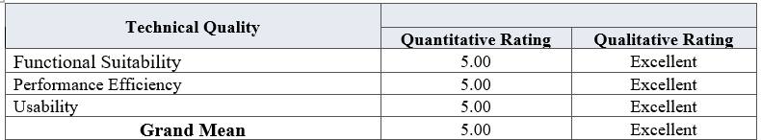
Overall, the assessment results demonstrate that the MMBPOS achieved a grand mean of 5.00, interpreted as Excellent, based on the evaluations of the Drugstore Personnel. The system obtained perfect ratings in Functional Suitability, Performance Efficiency, Usability, Reliability, and Security, indicating that it provides the necessary functions, performs efficiently, is easy to use, operates consistently, and protects system and business information. These results show that the MMBPOS effectively supports the operational requirements of MMB Drug Store and meets the expectations of its intended users.

4. Assessment on the Use of the Application by the Customers
The assessment results provided by the Customers of MMB Drug Store on the MMBPOS: Web-Based Inventory and Point-of-Sale System reveal an overall excellent evaluation across all assessed software quality parameters. The consistently high weighted means and qualitative ratings indicate that the system effectively meets the needs and expectations of its customers. The results further demonstrate that the MMBPOS is easy to use, reliable, secure, and suitable for supporting a convenient and efficient transaction experience at MMB Drug Store.
4.1 Usability
The table shows the results of the assessment conducted by the Drugstore Personnel on the usability of the developed MMBPOS: Web-Based Inventory and Point-of-Sale System for MMB Drug Store
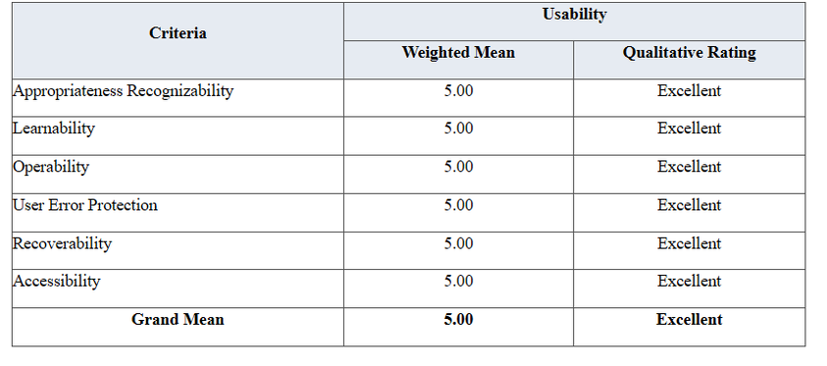
In terms of Usability, the MMBPOS obtained a grand mean of 5.00, which is qualitatively rated as Excellent. The criteria of appropriateness recognizability, learnability, operability, user error protection, recoverability, and accessibility each received a weighted mean of 5.00. These results indicate that customers can easily understand the transaction process, interact with the system, and navigate its features effectively. The findings demonstrate that MMBPOS provides user-friendly and accessible experience for customers.

4.2 Reliability
The table shows the results of the assessment conducted by the Drugstore Personnel on the usability of the developed MMBPOS: Web-Based Inventory and Point-of-Sale System for MMB Drug Store.
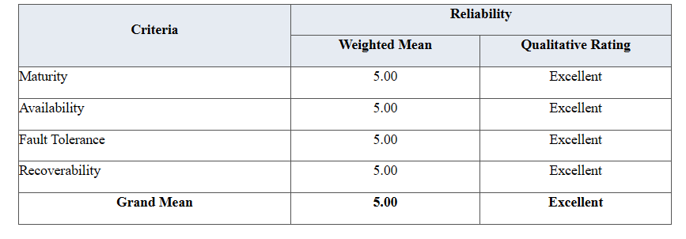
In terms of Reliability, the MMBPOS obtained a grand mean of 5.00, rated as Excellent. The criteria of maturity, availability, fault tolerance, and recoverability each received a weighted mean of 5.00. These results indicate that the system performs consistently, remains available when needed, and can recover effectively from possible interruptions. The findings demonstrate that MMBPOS provides a stable and dependable transaction experience for customers.

4.3 security
The table shows the results of the assessment conducted by the Drugstore Personnel on the security of the developed MMBPOS: Web-Based Inventory and Point-of-Sale System for MMB Drug Store.

The evaluation of Security yielded a grand mean of 5.00, interpreted as Excellent. Both confidentiality and integrity received a weighted mean of 5.00. These results indicate that customers perceive the MMBPOS as capable of protecting their personal and transaction information while maintaining the accuracy and security of stored data. The findings demonstrate that the system provides a secure environment for customer transactions.

Summary of Assessment of Customers on the MMBPOS Based on the ISO 25010 Software Quality Standards
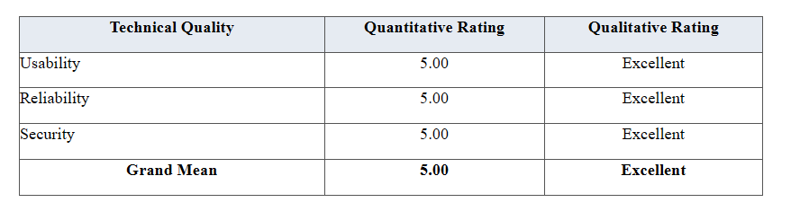
Overall, the customer assessment demonstrates a positive perception of the MMBPOS across all assessed software quality parameters. Usability, Reliability, and Security each obtained a quantitative rating of 5.00 and a qualitative rating of Excellent, resulting in an overall Grand Mean of 5.00, also rated Excellent. These results indicate that customers perceive the MMBPOS as easy to use, reliable in supporting their transactions, and capable of protecting their personal and transaction information. The consistent ratings demonstrate that the system meets the expectations of its customers and provides a satisfactory and dependable transaction experience at MMB Drugstore.

