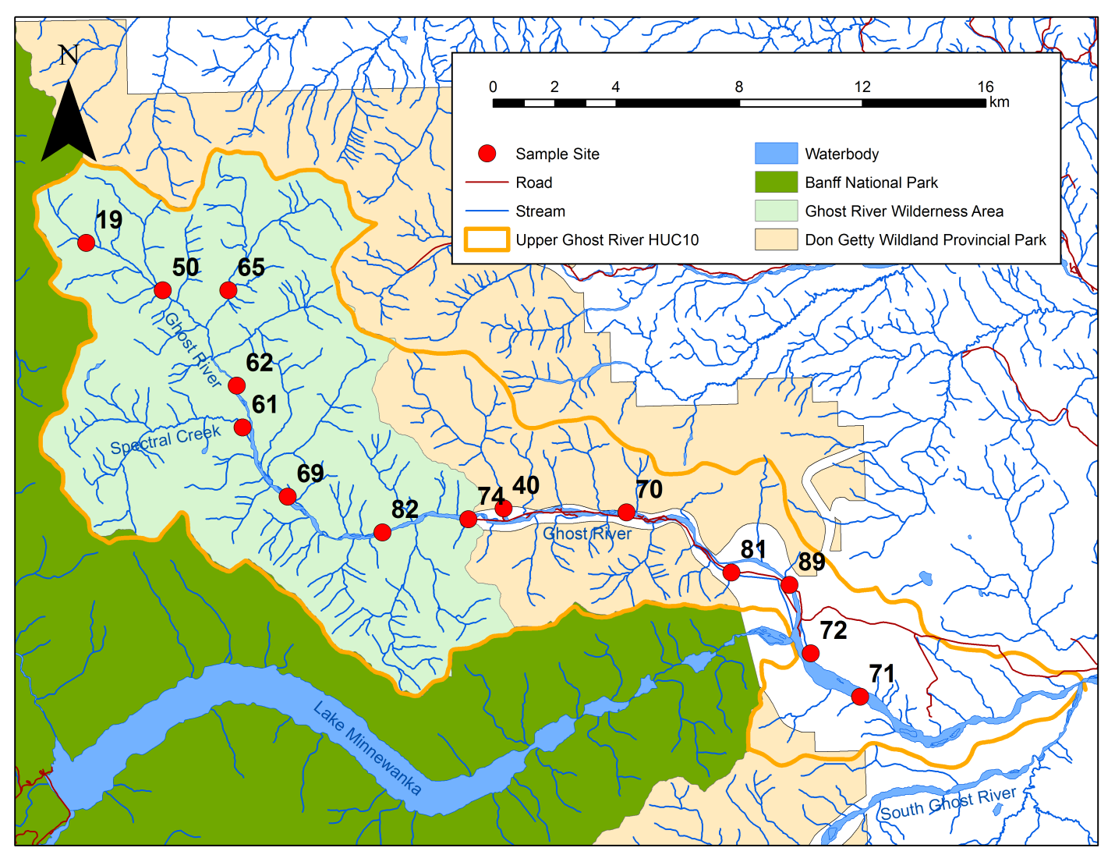

Upper Ghost River watershed, showing sampling sites for 2016