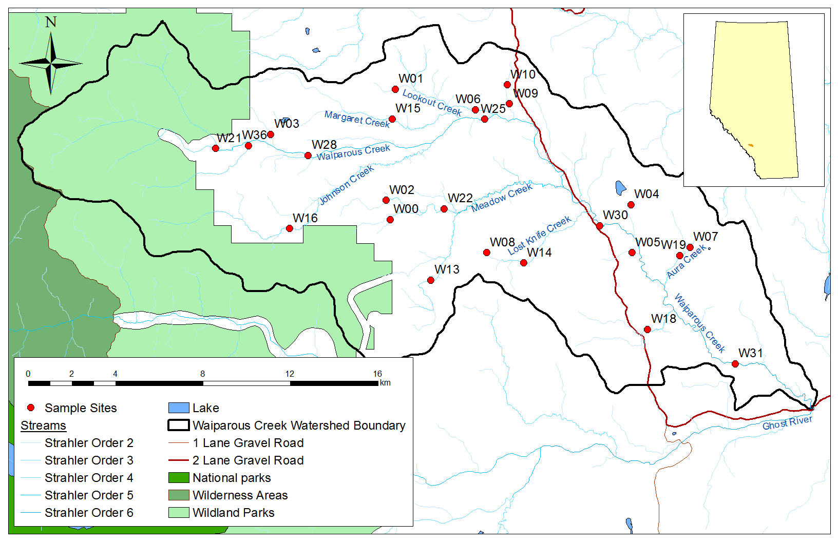

Waiparous Creek watershed, showing randomly selected sampling sites for 2015